**Course Description**

Before you can analyze data, you first have to acquire it. This course teaches you how to build pipelines to import data kept in common storage formats.

You’ll use pandas, a major Python library for analytics, to get data from a variety of sources, from spreadsheets of survey responses, to a database of public service requests, to an API for a popular review site.

Along the way, you’ll learn how to fine-tune imports to get only what you need and to address issues like incorrect data types. Finally, you’ll assemble a custom dataset from a mix of sources.

**1. Importing Data from Flat Files**

Practice using pandas to get just the data you want from flat files, learn how to wrangle data types and handle errors, and look into some U.S. tax data along the way.



In this course, we will focus on ingesting data and some techniques to clean messy data.

  
To do this, we will use the Python library pandas. This makes it easy to load and manipulate data, and it integrates with loads of analysis and visualization libraries. Central to pandas is the data frame.

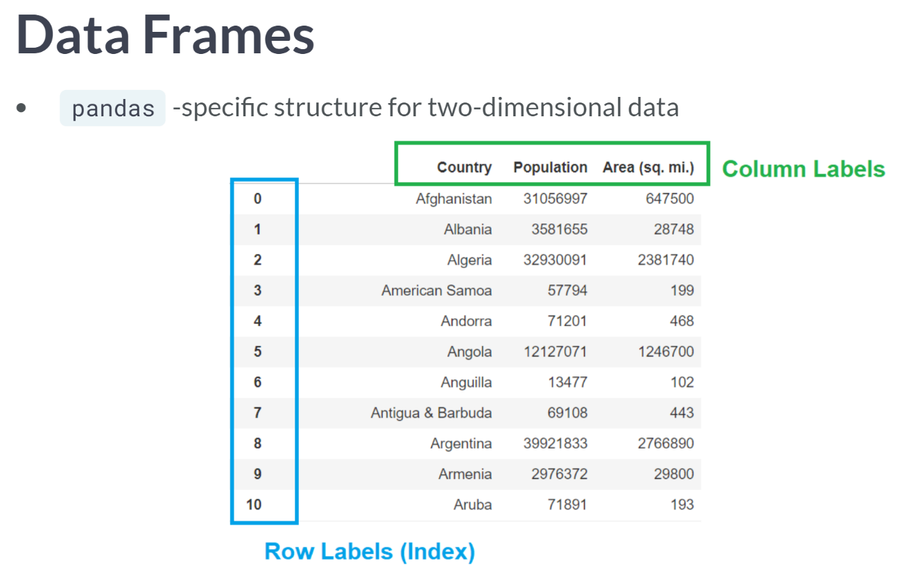  
Data Frames is central to pandas, being two-dimensional data structures containing columns typically labeled with variable names and rows, which also have labels, known as an index in pandas. The default index is the row number, but you can specify a column as the index and many types of data can be used. While you can create data frames by hand, you will want to load existing data.

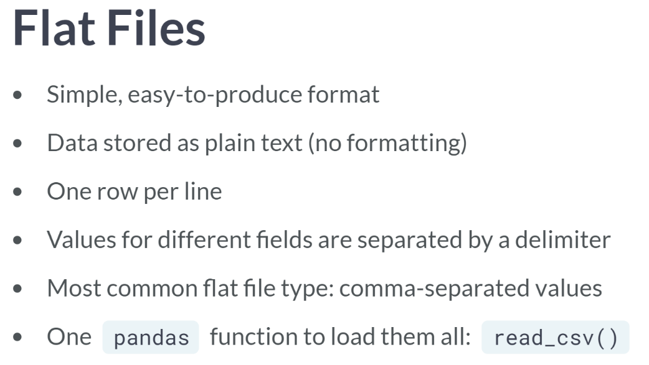

Pandas handles many data formats, but let's start with a basic one: flat files.

* They can be exported from database management systems and spreadsheet applications, and many online data portals provide flat file downloads.
* In a flat file, data is stored as plain text, with no formatting like colors or bold type.
* Each line in the file represents one row, with column values separated by a chosen character called a delimiter.
* Usually, the delimiter is a comma, and such files are called CSVs, but other characters can be used.
* A single pandas function loads all flat files, no matter the delimiter: read CSV.

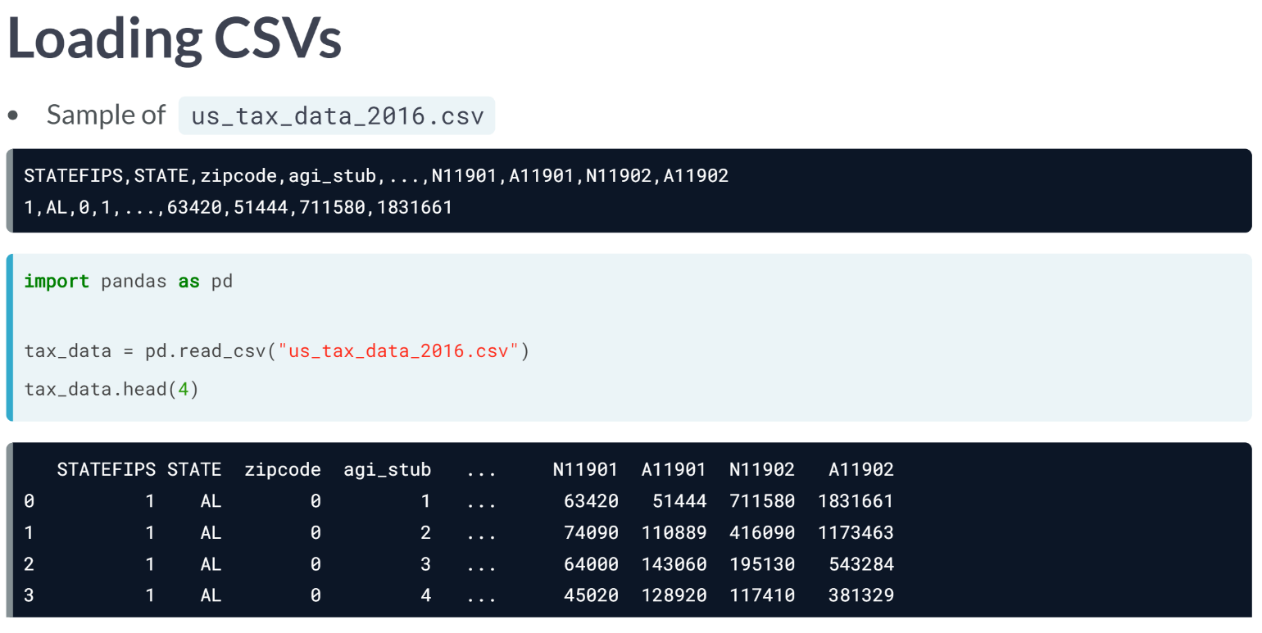  
Let's import some tax data published as a CSV by the IRS, the us_tax_data_2016. This file has information about household composition and income by zip code, making it useful for social and economic analyses.

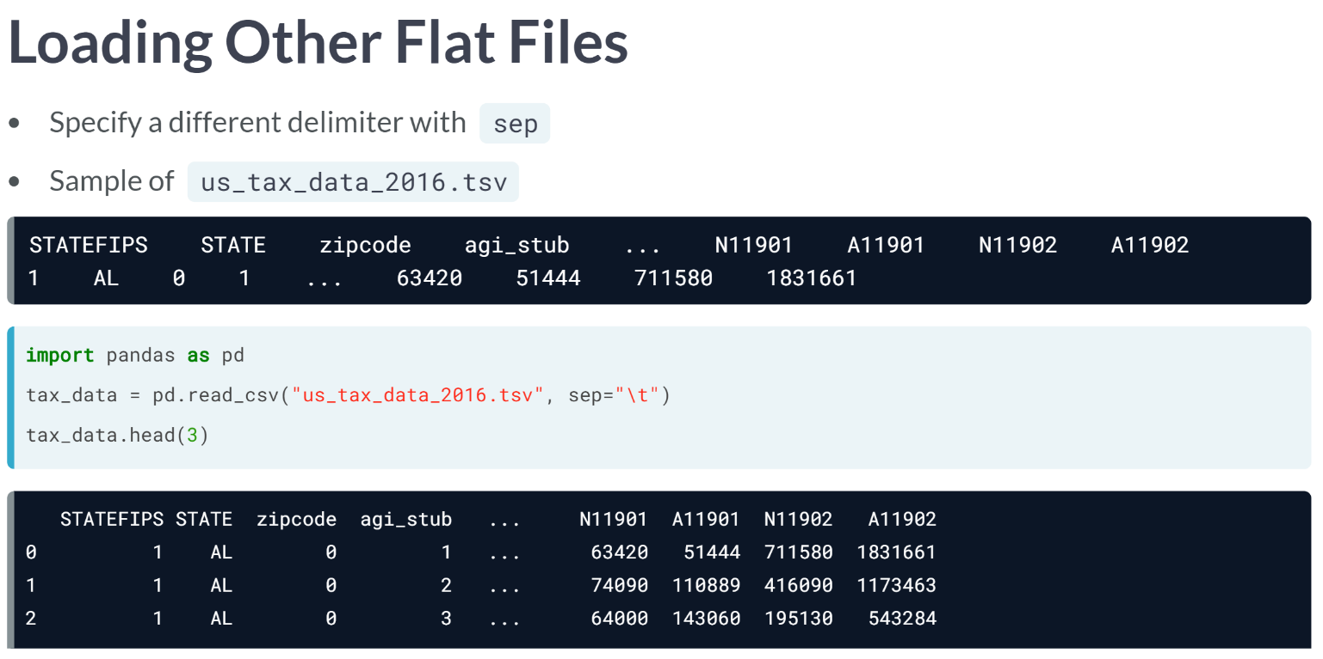

* The pandas lets you import any flat file with read CSV and its *sep* keyword argument.
  + Let's use a tab-separated version of the same tax file to see what this looks like. Again, we import pandas as pd.
  + Then we pass the file path string to read CSV, but this time, we include another argument, *sep*. "\t" represents a tab.

# Get data from CSVs

In this exercise, you'll create a data frame from a CSV file. The United States makes available CSV files containing tax data by ZIP or postal code, allowing us to analyze income information in different parts of the country. We'll focus on a subset of the data, vt_tax_data_2016.csv, which has selected tax statistics by ZIP code in Vermont in 2016.

To load the data, you'll need to import the pandas library, then read vt_tax_data_2016.csv and assign the resulting data frame to a variable. Then we'll have a look at the data.

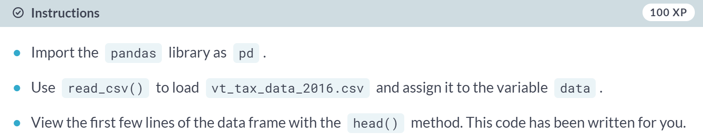

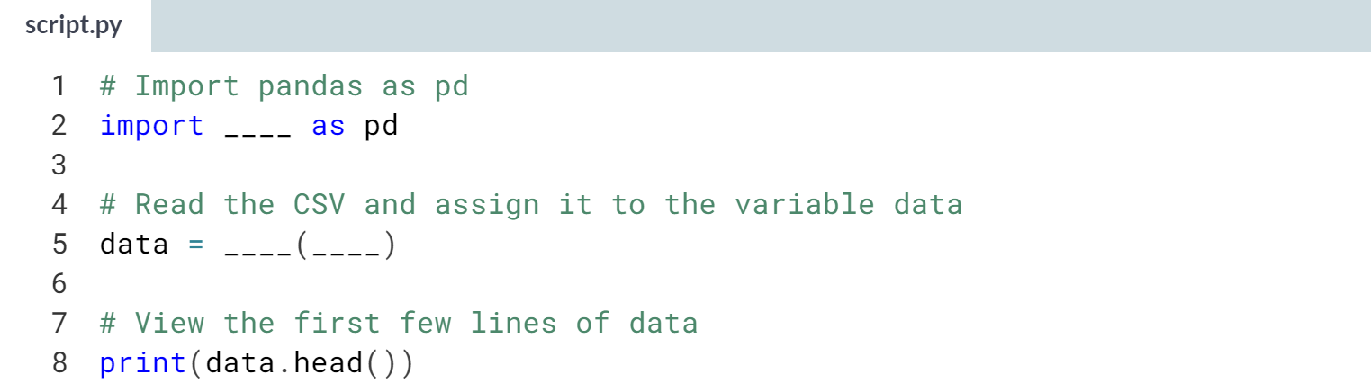

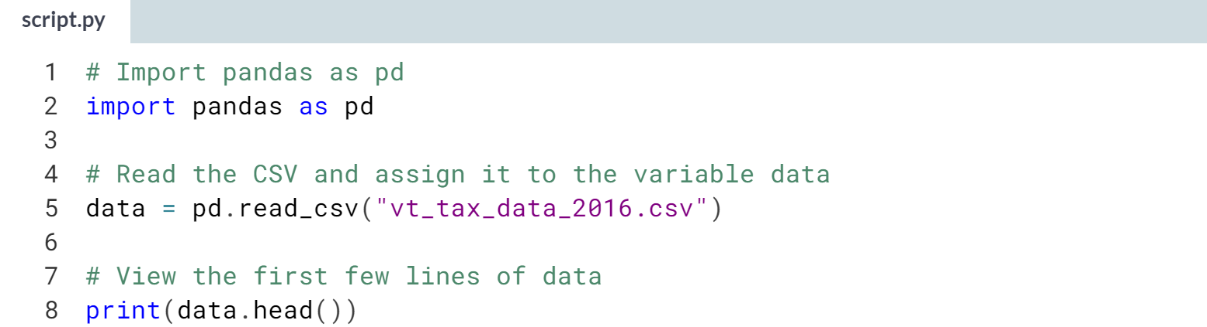  
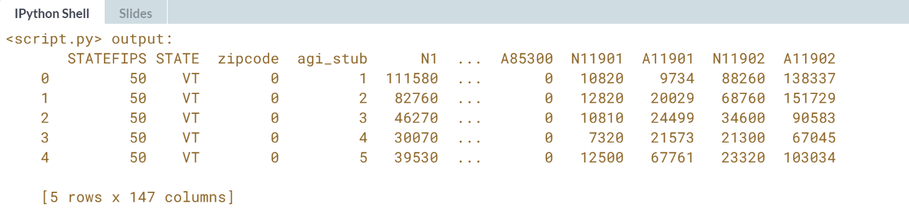  
Nice work! ***read_csv()*** has lots of parameters for customizing imports, but many CSVs can be loaded as data frames just by passing the file path. It even works with URLs that end in '.csv'.

# Get data from other flat files

While CSVs are the most common kind of flat file, you will sometimes find files that use different delimiters. read_csv() can load all of these with the help of the sep keyword argument. By default, pandas assumes that the separator is a comma, which is why we do not need to specify sep for CSVs.

The version of Vermont tax data here is a tab-separated values file (TSV), so you will need to use sep to pass in the correct delimiter when reading the file. Remember that tabs are represented as \t. Once the file has been loaded, the remaining code groups the N1 field, which contains income range categories, to create a chart of tax returns by income category.

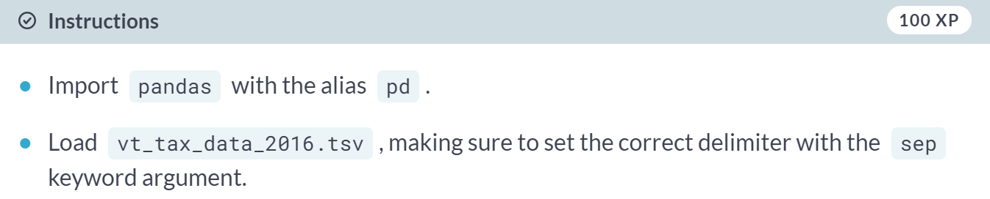

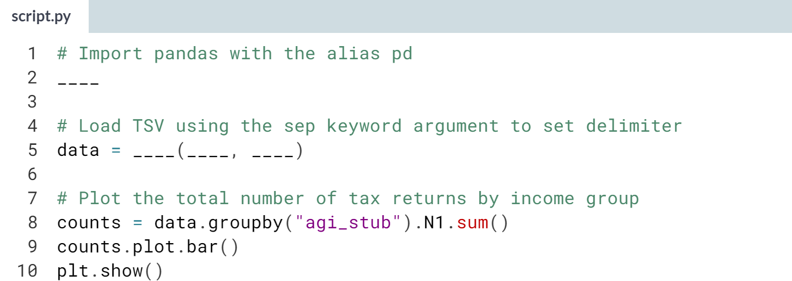

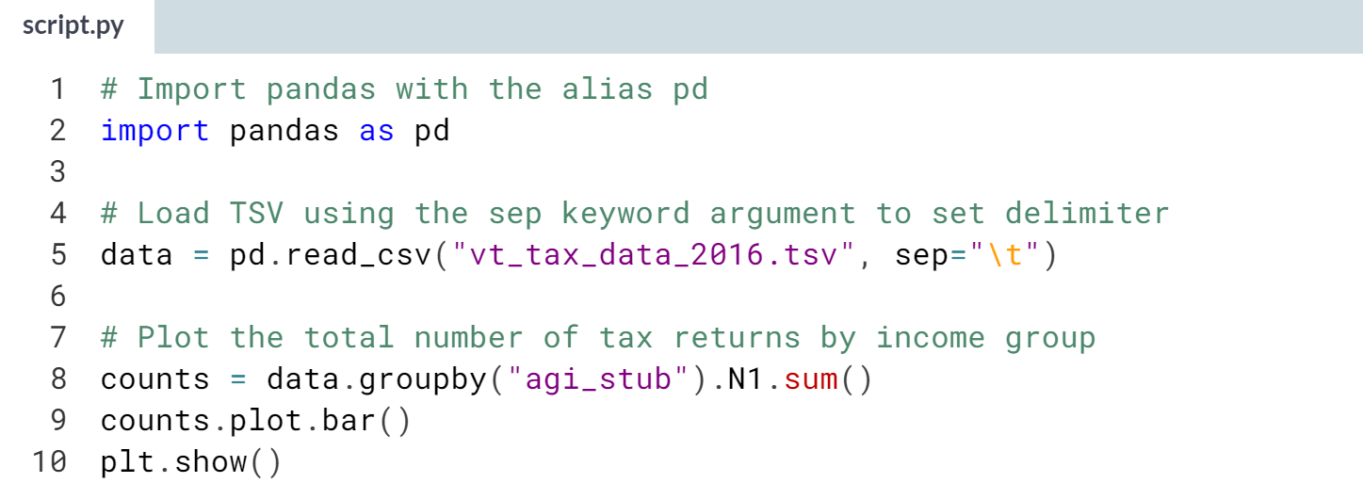  
(Result below…)

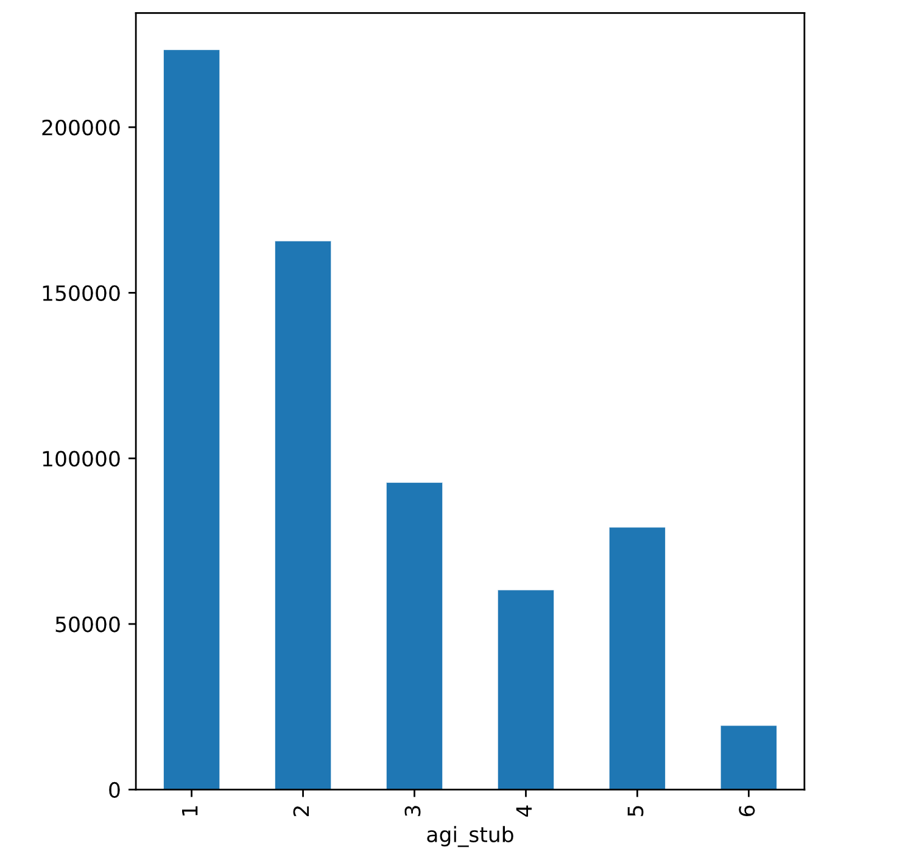  
Well done! When in doubt about the separator being used, you can always examine the file in a spreadsheet program, text editor, or with Python itself.



We will look at ways to limit the amount of data imported, and how to make that data easier to work with by naming columns.

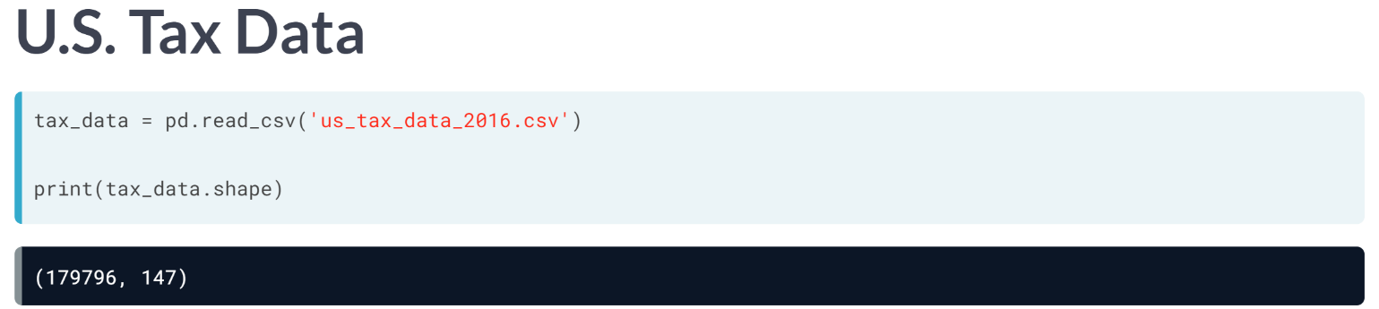  
Checking the data's shape attribute, we see that it has almost 180,000 rows and 147 columns. Unless your computer has very little memory or is running several other programs, pandas can easily handle data this size, but it is more than we need. We have some options to whittle it down.

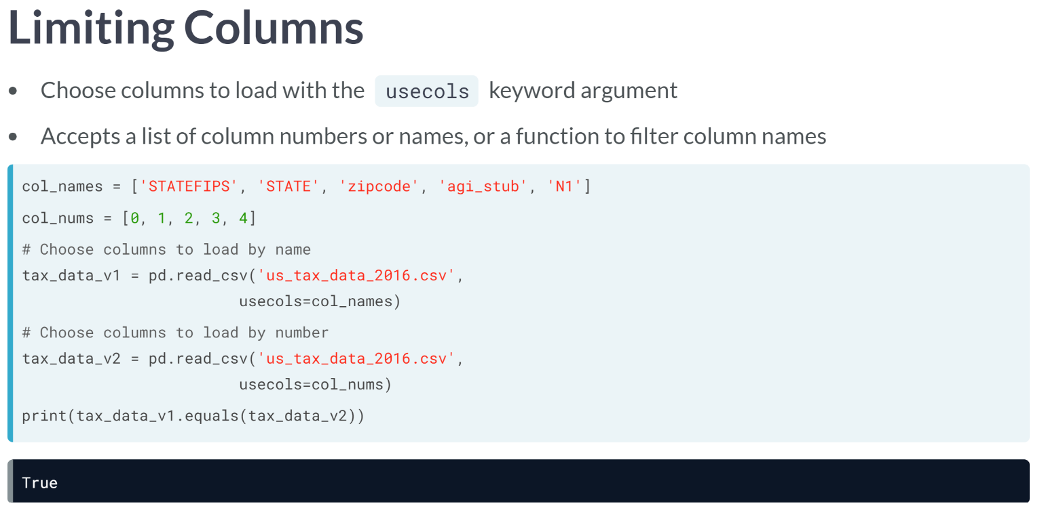  
The first way is to choose columns to load with the *usecols* keyword argument. To focus on the number of tax returns by income band and zip code, we can set up a list of either the relevant column names or their numbers. We supply the file path as a string to read CSV as usual.

This time, we also pass *usecols* argument the list of column names or numbers to load. We can check to make sure the two ways produce the same result, and they do.

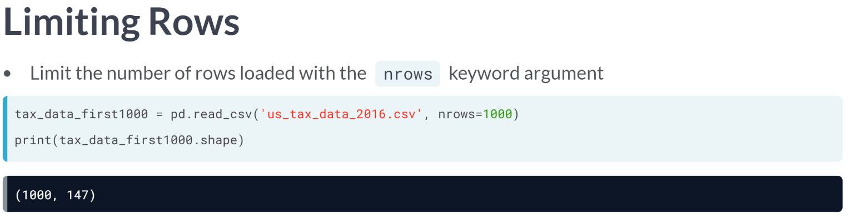  
Another option is to reduce the number of rows imported with the nrows argument. When reading the file, we pass an integer of the maximum number of rows we want, 1000 here in this case. Checking the data frame's shape, we see we have exactly the number of rows we asked for.

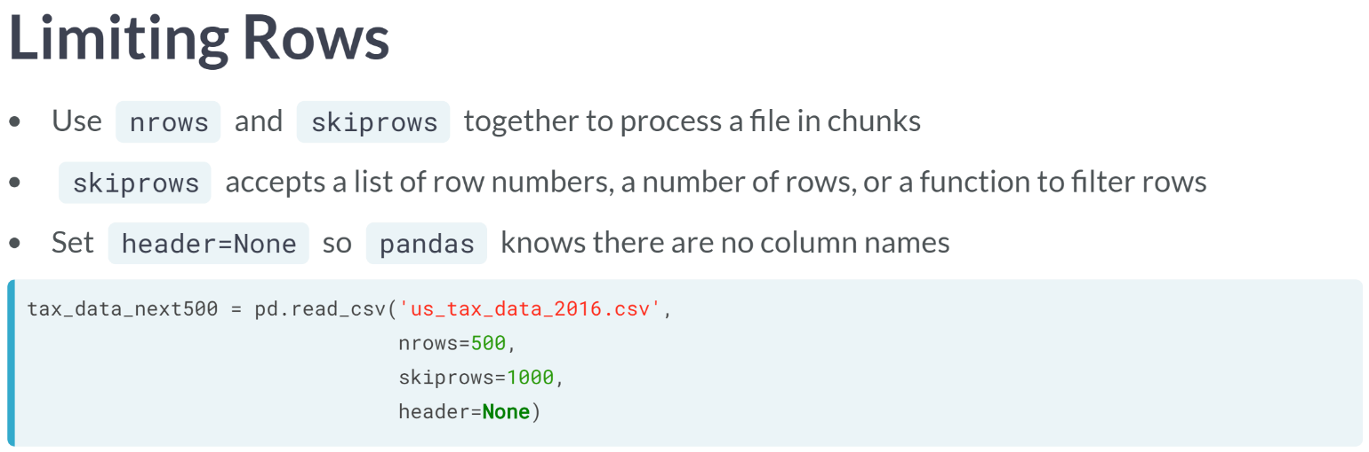  
*nrows* is especially handy when combined with the skiprows argument to process a file in chunks.

*skiprows* accepts a list of row numbers to skip, a function to determine whether to skip a row, or the number of rows to skip.

Note that pandas automatically make the first row imported the *header*, so if you skip the row with column names, you should also specify that *header* equals none.

Like before, we use *nrows* to specify how many rows we want but add that *skiprows* equals 1000. We skipped the *header* row, so we also specify there isn't one here.

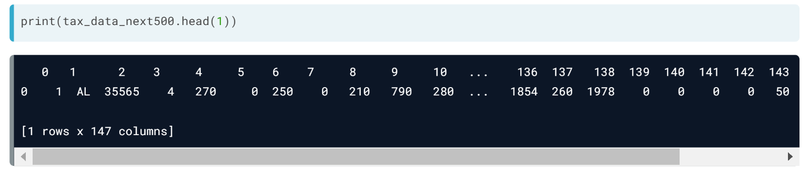  
Checking the head of the data frame, we see there are no column names. Let's fix this.

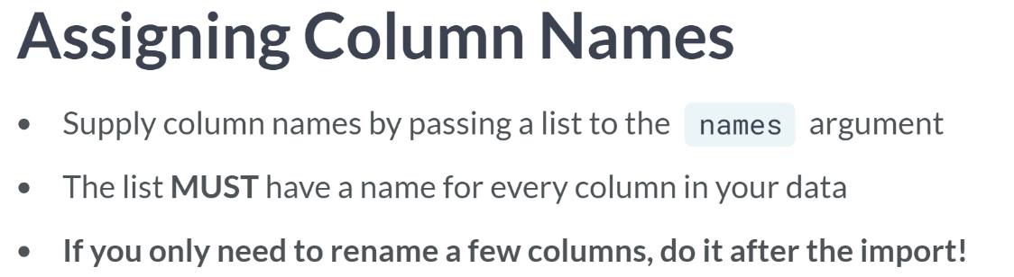  
To assign column names when there aren't any, we use another *read_csv* argument: names. As you probably guessed, names take a list of column names to use.

The list must include a name for every column in the data. If you only want to rename some columns, it should be done after import.

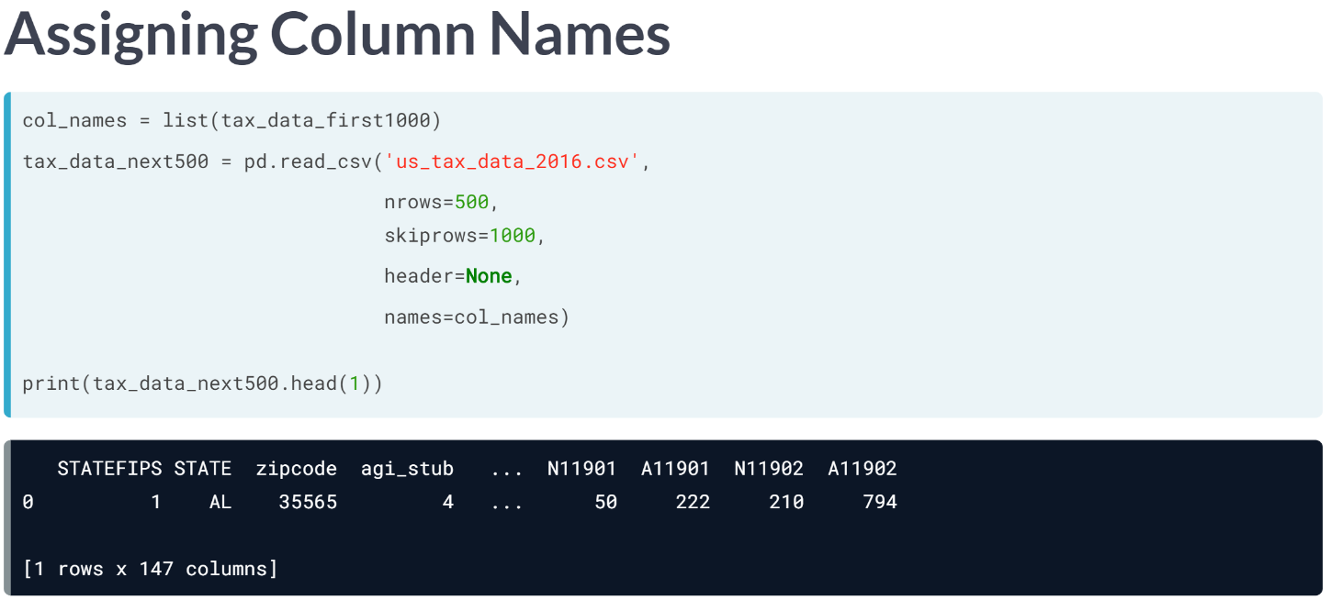  
For dataset with fewer columns, you might manually build the names list with the help of a data dictionary.

We want to copy a long list of column names from an existing data frame, so we'll pass the first tax subset to the ***list()*** function to get the column labels.

Then we read the CSV, using nrows and skiprows to get the next 500 records, setting header to none, and passing the list of column names to names. Now our data frames have column names! We just learned workflows to manage the amount of data loaded from a flat file. Now, you will get a chance to practice these techniques.

# Import a subset of columns

The Vermont tax data contains 147 columns describing household composition, income sources, and taxes paid by ZIP code and income group. Most analyses don't need all these columns. In this exercise, you will create a data frame with fewer variables using read_csv()s usecols argument.

Let's focus on household composition to see if there are differences by geography and income level. To do this, we'll need columns on income group, ZIP code, tax return filing status (e.g., single or married), and dependents. The data uses codes for variable names, so the specific columns needed are in the instructions.

pandas has already been imported as pd.

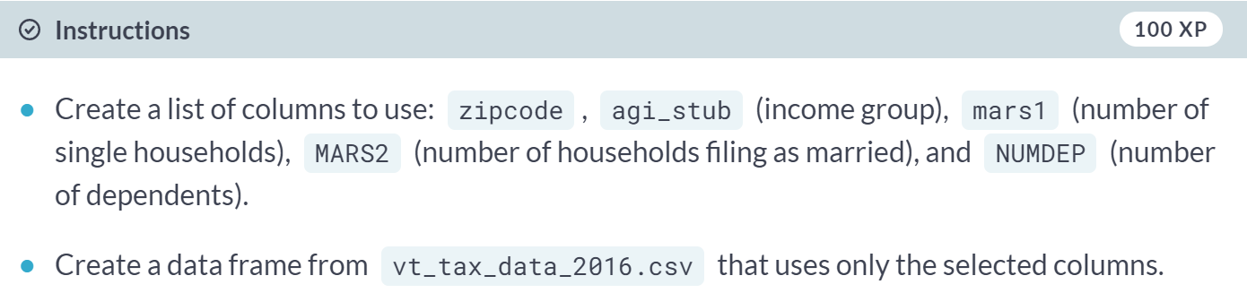

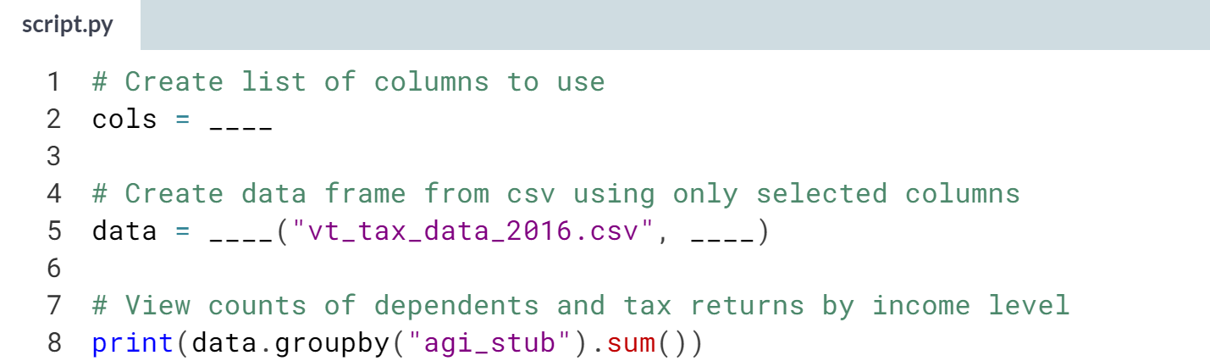

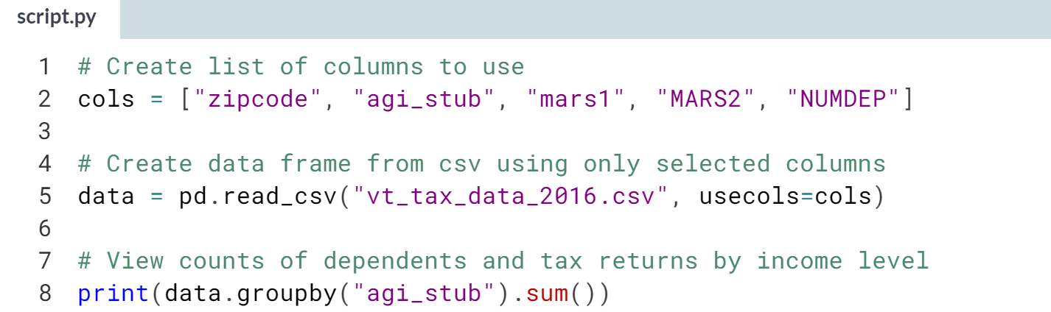

(Result on the next page)

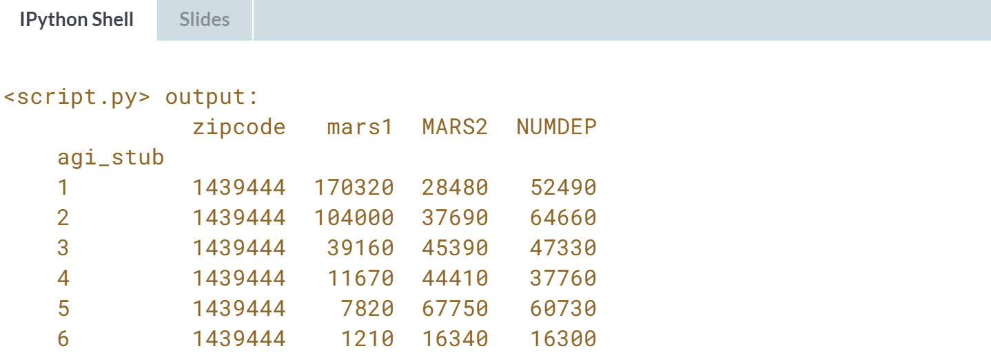  
There is a saying that rows are cheap, but columns are expensive. Limiting datasets to only variables of interest makes them more manageable and streamlines pipelines, but make sure you aren't losing confounding data in the process.

# Import a file in chunks

When working with large files, it can be easier to load and process the data in pieces. Let's practice this workflow on the Vermont tax data.

The first 500 rows have been loaded as vt_data_first500. You'll get the next 500 rows. To do this, you'll employ several keyword arguments: nrows and skiprows to get the correct records, header to tell pandas the data does not have column names, and names to supply the missing column names. You'll also want to use the list() function to get column names from vt_data_first500 to reuse.

pandas has been imported as pd.

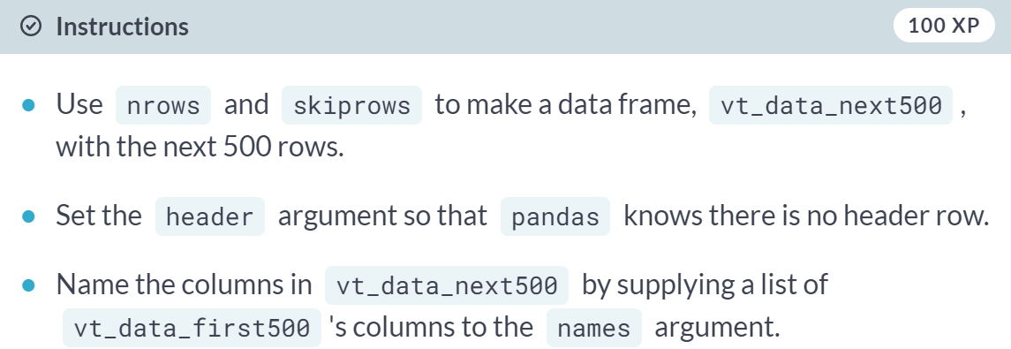

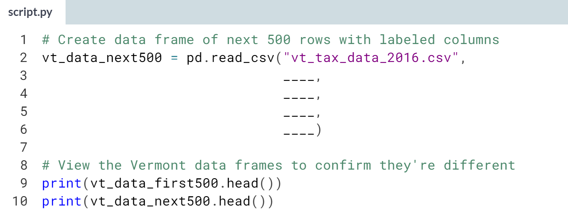  
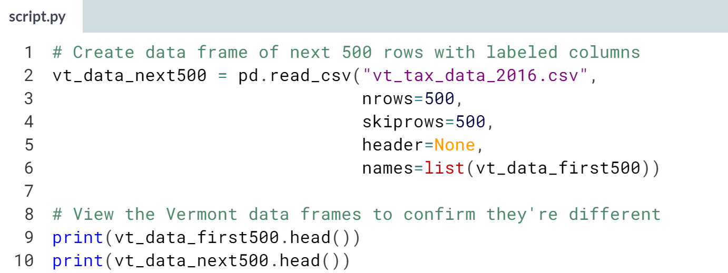

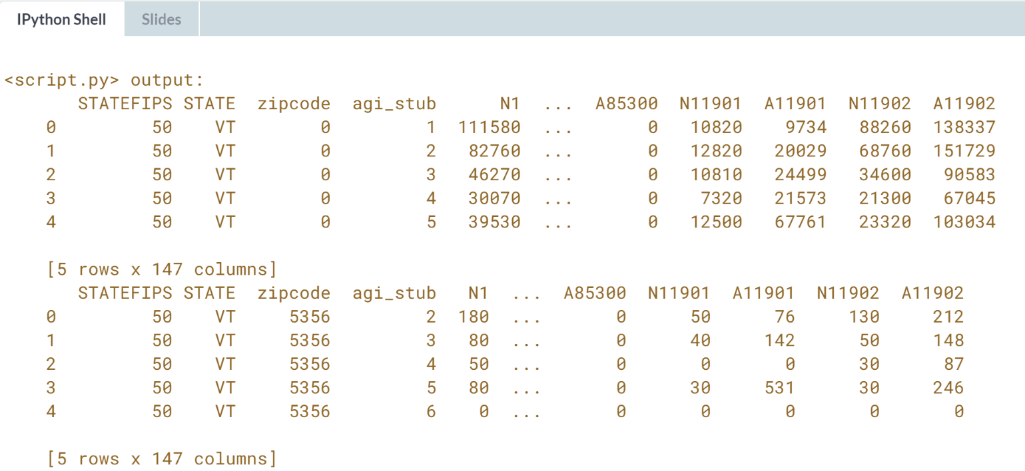  
Nicely done! The techniques you used here can also be employed to explore data before committing to loading all of it, to skip rows you know don't contain useful data, or to relabel all columns in a dataset.



What if there are issues with data or the import?

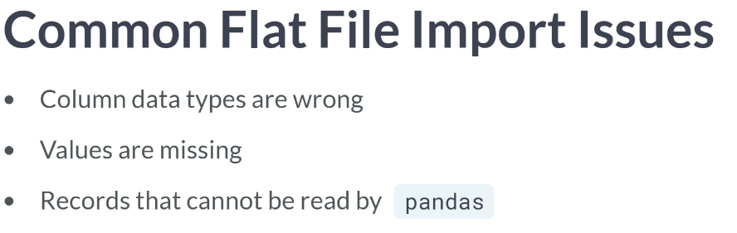  
Such issues include having incorrect column data types that can hinder analysis, missing values indicated with custom designators, or records that pandas cannot read. Luckily, read CSV offers ways to address these issues during import, reducing the wrangling needed later on.

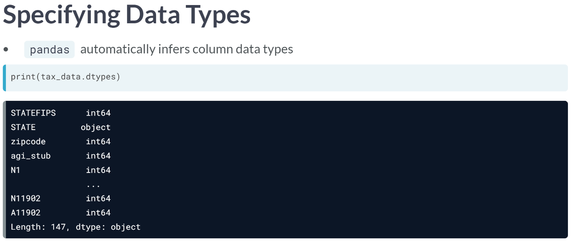  
Checking data types in the tax data, we see the pandas interpreted ZIP codes as integers, but they are more accurately modeled as strings - Zip codes are not quantities and include meaningful leading zeros.

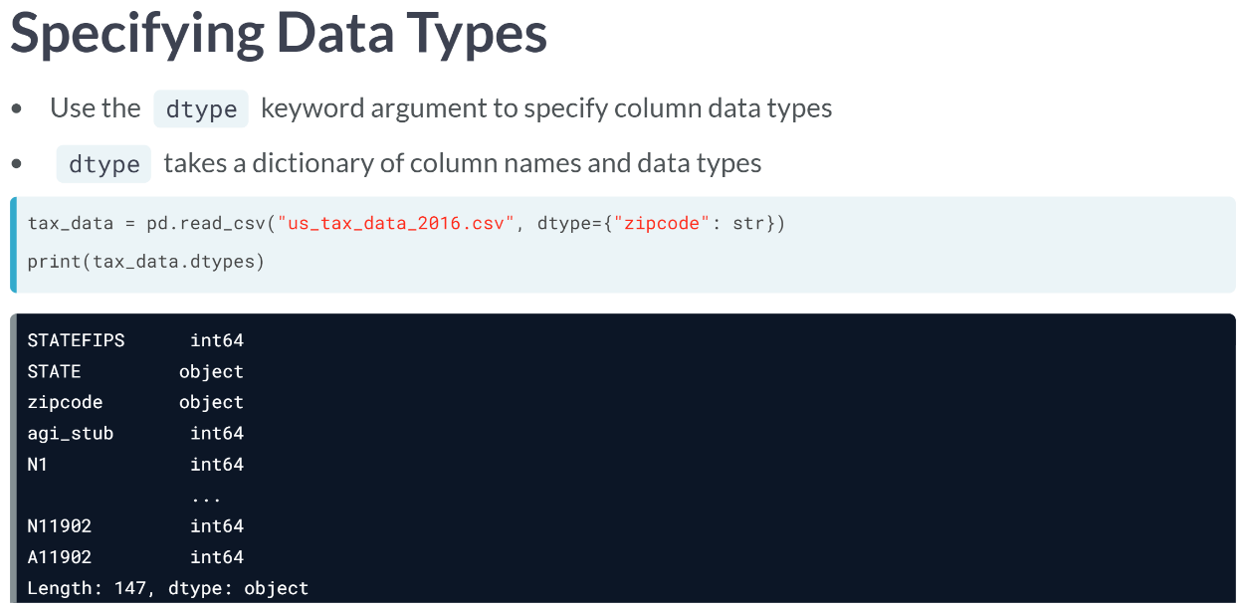  
Instead of letting pandas guess, we can set the data type of any or all columns with read CSV's *dtype* keyword argument. *dtype* takes a dictionary, where each key is a column name and each value is the data type that column should be. Note that non-standard data types, such as pandas categories, must be passed in quotations.

Here, we specify that zipcode column should contain str(strings) while leaving pandas to infer the other columns. Printing the new data frame's dtypes, we see that zipcode's *dtype* is "object", which is the pandas counterpart to Python strings.

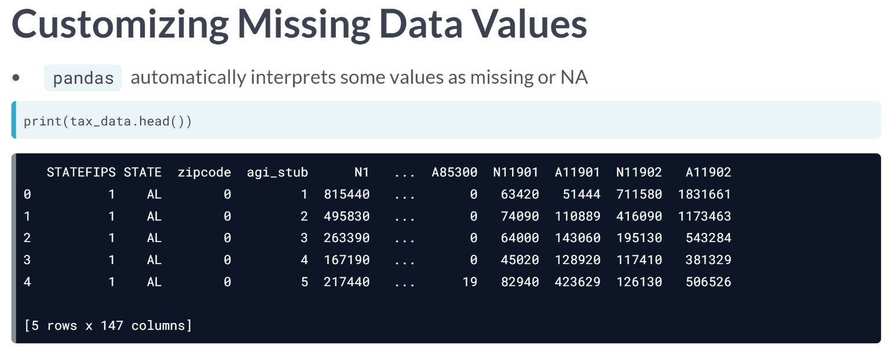  
Sometimes, missing values are represented in ways that pandas won't catch, such as with dummy codes. In the tax data, records were sorted so that the first few have the zip code 0, which is not a valid code and should be treated as missing.

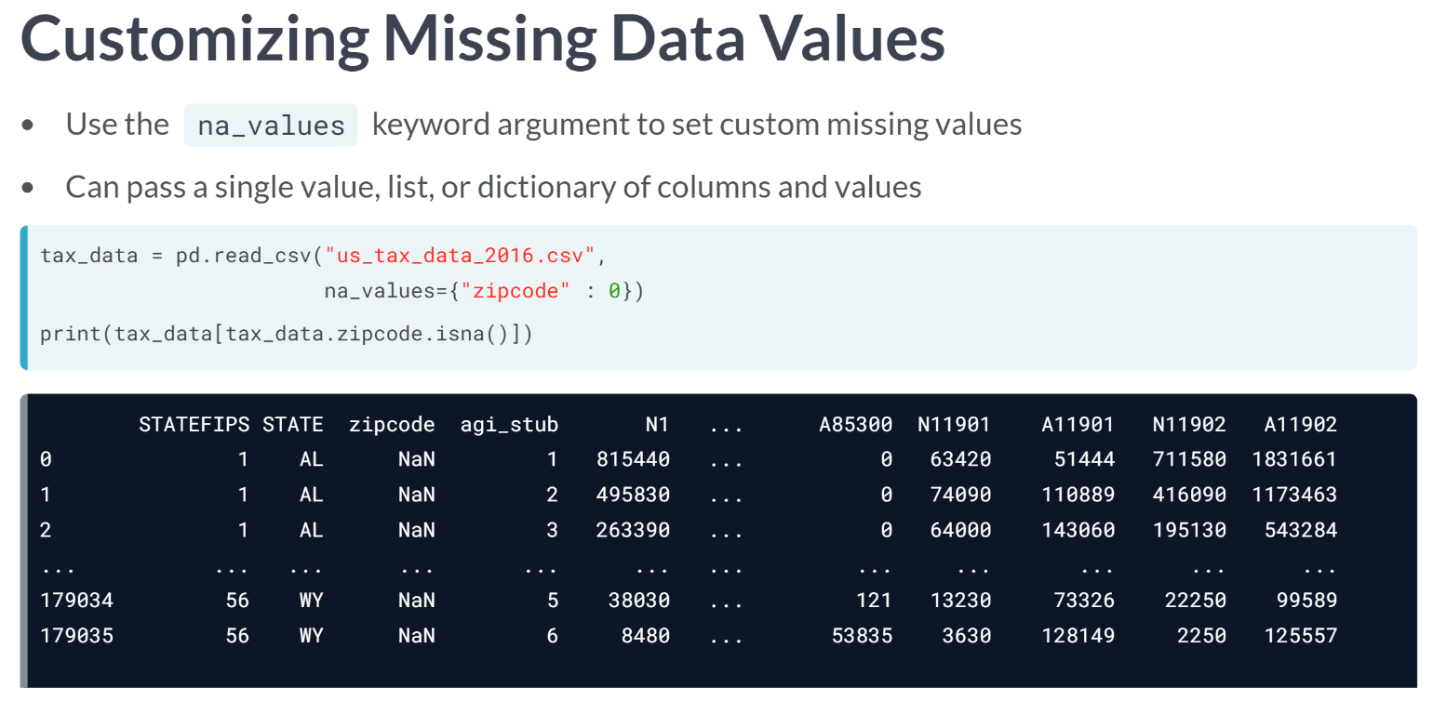  
We can tell pandas to consider these missing data with the *na_values* keyword argument, which accepts either a single value, a list of values, or a dictionary of columns and values in that column to treat as missing.

Let's pass a dictionary specifying that any zeros in zipcode should be treated as missing data. Then, we filter the data using the ***isna()*** method on the zipcode column to view rows with missing postal codes.

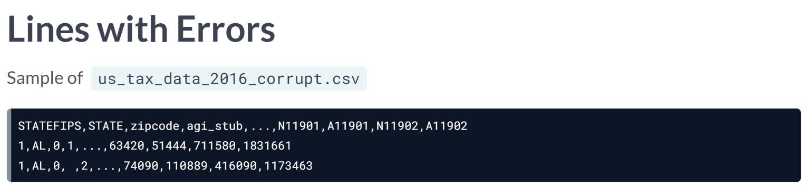  
One last issue we may face are lines that pandas can't just parse. For example, a record could have more values than there are columns, like the second record in this corrupted version of the tax data.

  
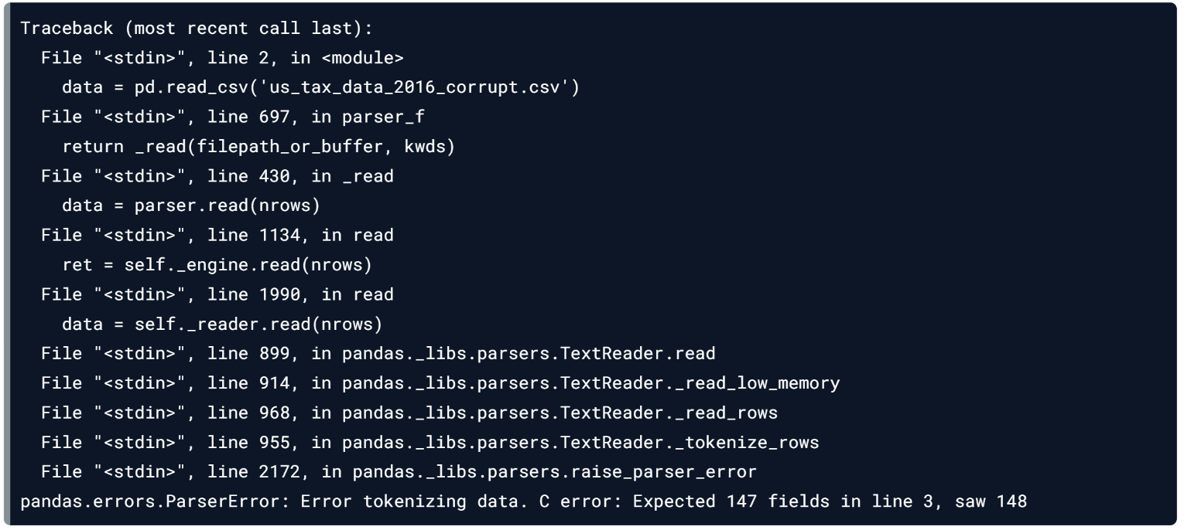  
By default, trying to load this file results in a long error, and no data is imported.

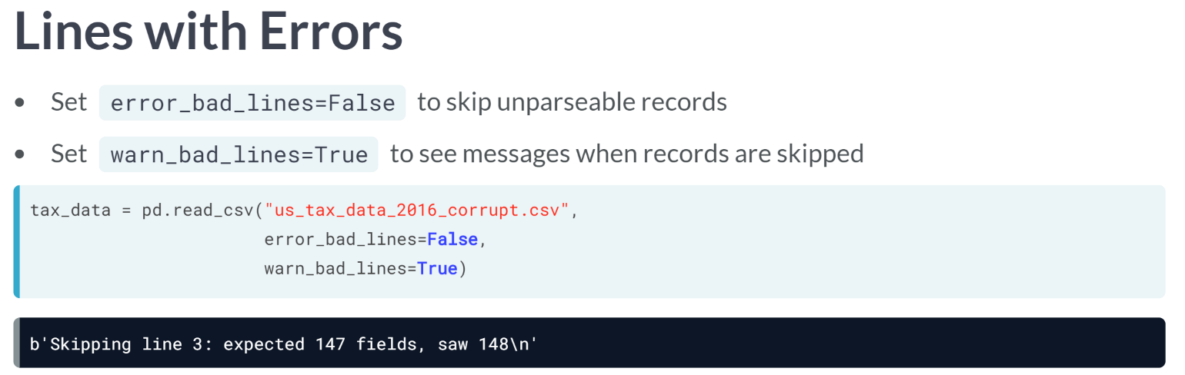  
Luckily, we can change this behavior with two arguments, error bad lines and warn bad lines. Both take Boolean, or true/false values. Setting error bad lines to False makes pandas skip bad lines and load the rest of the data, instead of throwing an error. Warn bad lines tell pandas whether to display messages when unparseable lines are skipped.

Let's try importing a corrupted file again, this time with error bad lines set to False and warn bad lines equal to True. Success! A word of caution: if lines were skipped, it's worth investigating what was left out to see if there are underlying issues that should be addressed.

# Specify data types

When loading a flat file, pandas infers the best data type for each column. Sometimes its guesses are off, particularly for numbers that represent groups or qualities instead of quantities.

Looking at the data dictionary for vt_tax_data_2016.csv reveals two such columns. The agi_stub column contains numbers that correspond to income categories, and zipcode has 5-digit values that should be strings -- treating them as integers means we lose leading 0s, which are meaningful. Let's specify the correct data types with the dtype argument.

pandas has been imported for you as pd.

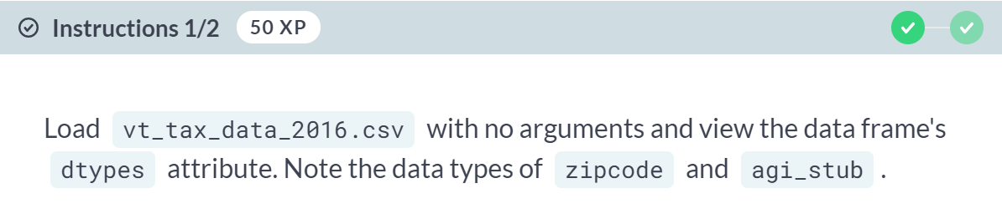

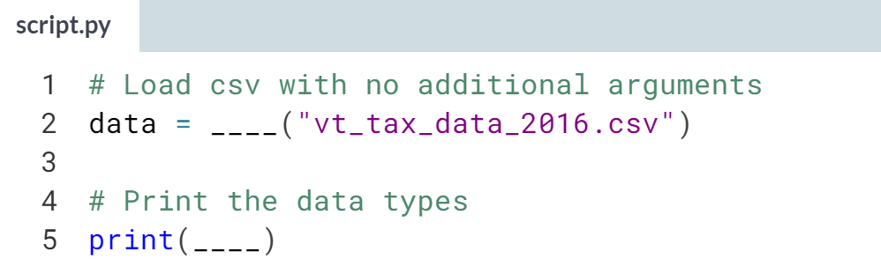

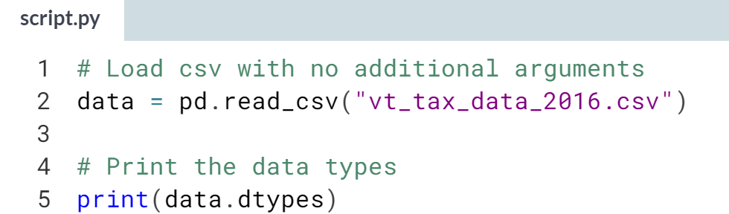

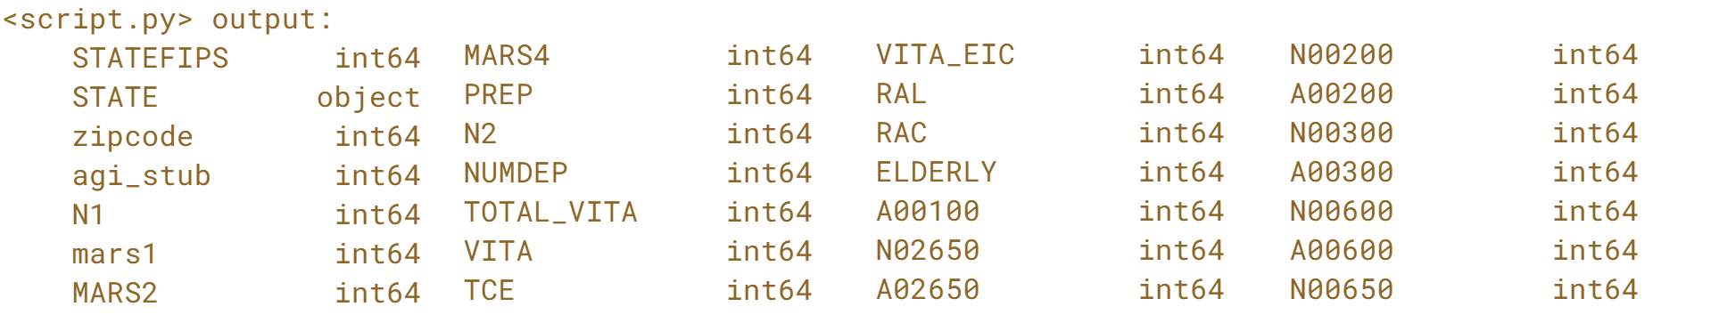  
(more data types exist but not shown; exercise continues on the next page)

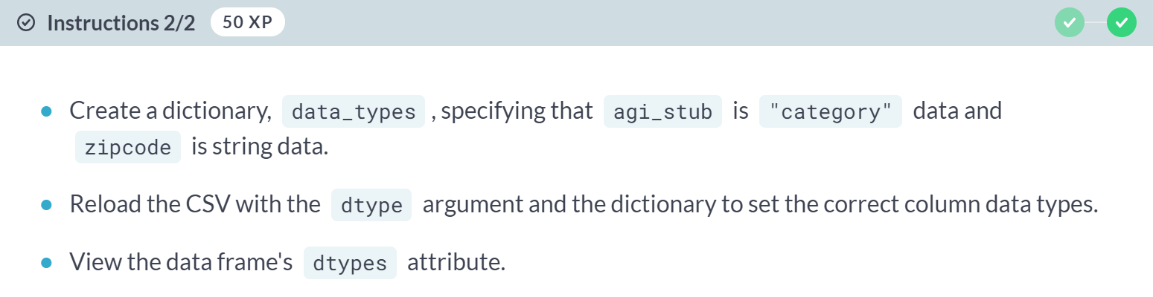

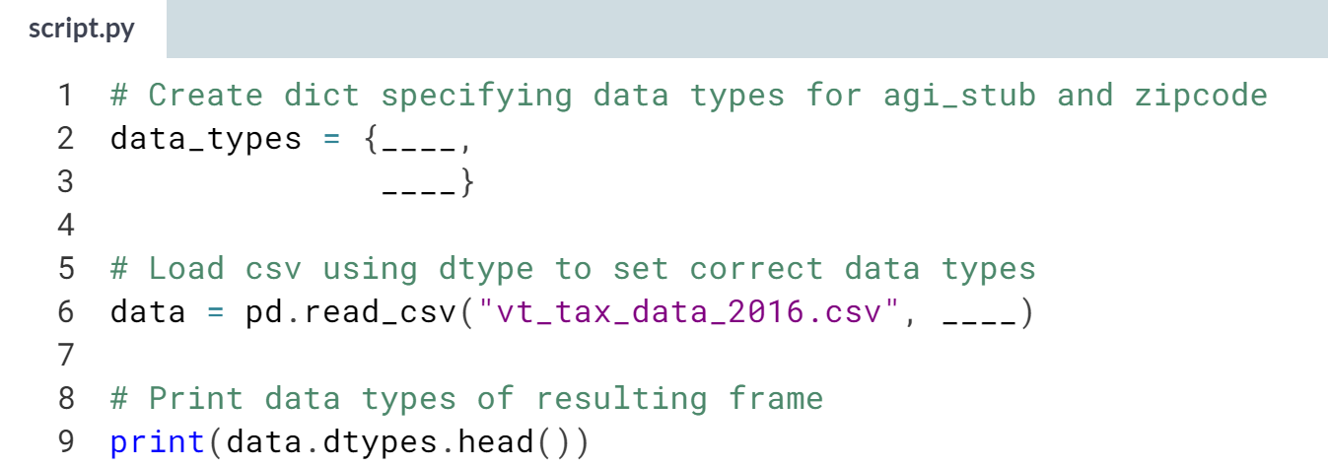

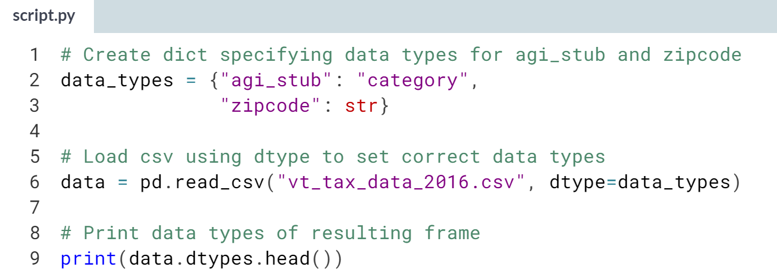  
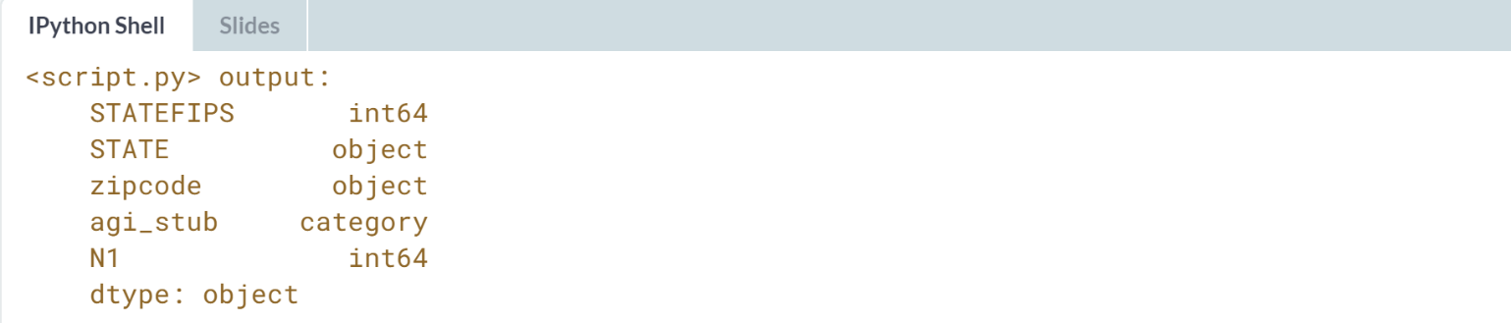  
Nice work! Setting data types at import requires becoming familiar with the data first, but it can save effort later on. A common workflow is to load the data and explore it, then write code that sets data types at import to share with colleagues or other audiences.

# Set custom NA values

Part of data exploration and cleaning consists of checking for missing or NA values and deciding how to account for them. This is easier when missing values are treated as their own data type. and there are pandas functions that specifically target such NA values.

pandas automatically treat some values as missing, but we can pass additional NA indicators with the na_values argument. Here, you'll do this to ensure that invalid ZIP codes in the Vermont tax data are coded as NA.

pandas has been imported as pd.

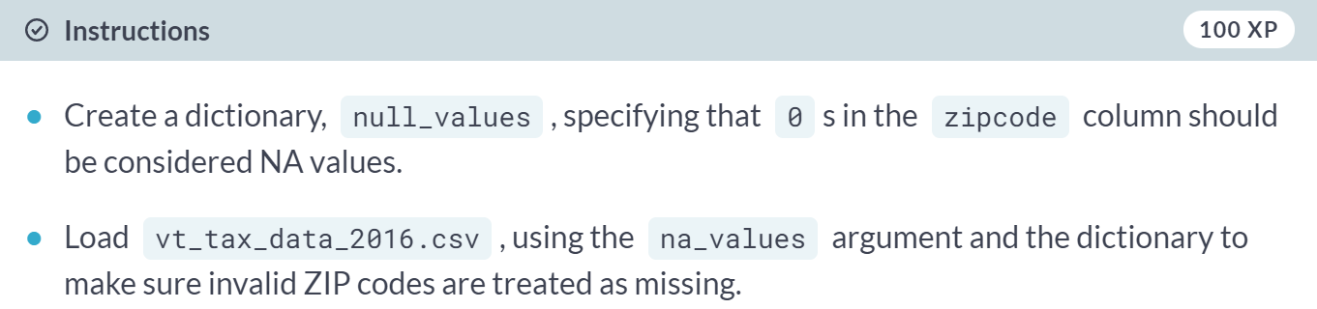

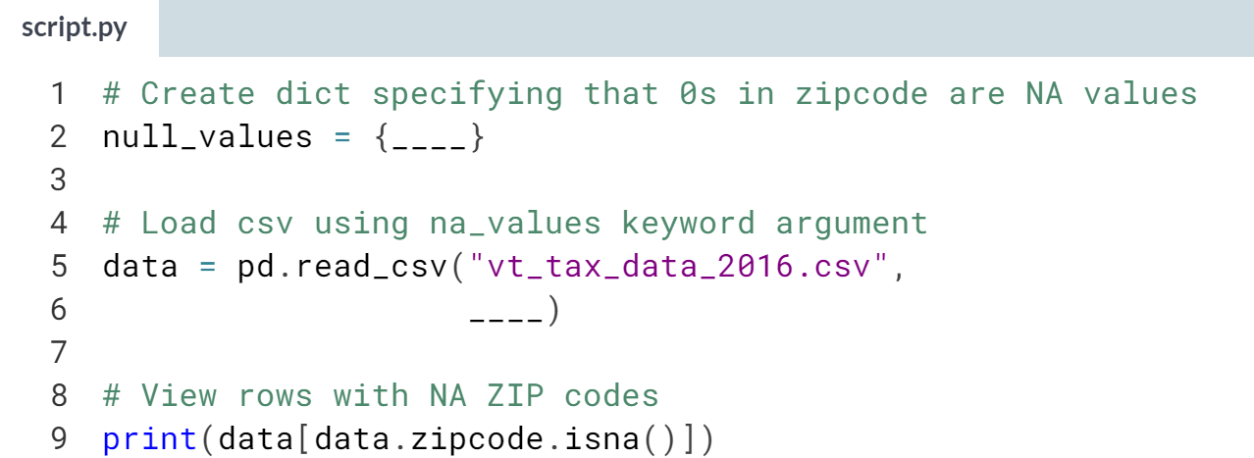  
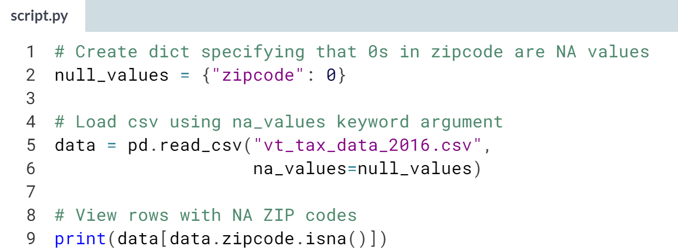  
(Result on the next page)

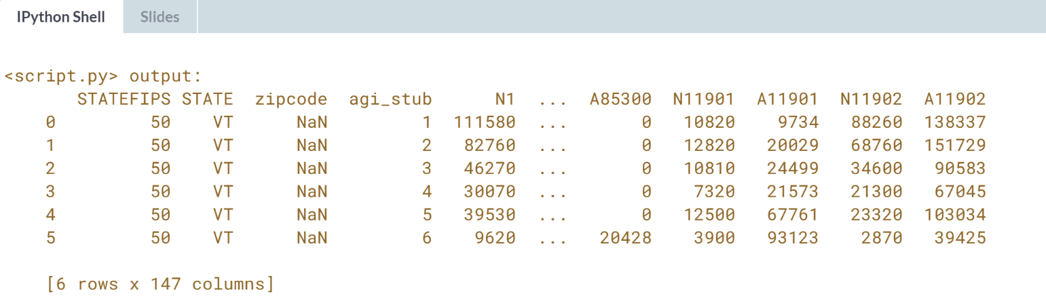

Now that NA values are marked as such, it's possible to use NA-specific functions to do things like count missing values, as we did here, or drop records with missing values.

# Skip bad data

In this exercise you'll use read_csv() parameters to handle files with bad data, like records with more values than columns. By default, trying to import such files triggers a specific error, pandas.io.common.CParserError.

Some lines in the Vermont tax data here are corrupted. In order to load the good lines, we need to tell pandas to skip errors. We also want pandas to warn us when it skips a line so we know the scope of data issues.

pandas has been imported as pd. The exercise code will try to read the file. If there is a pandas.io.common.CParserError, the code in the except block will run.

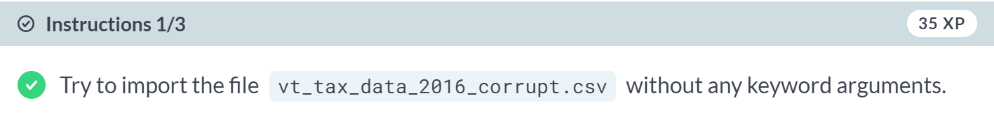

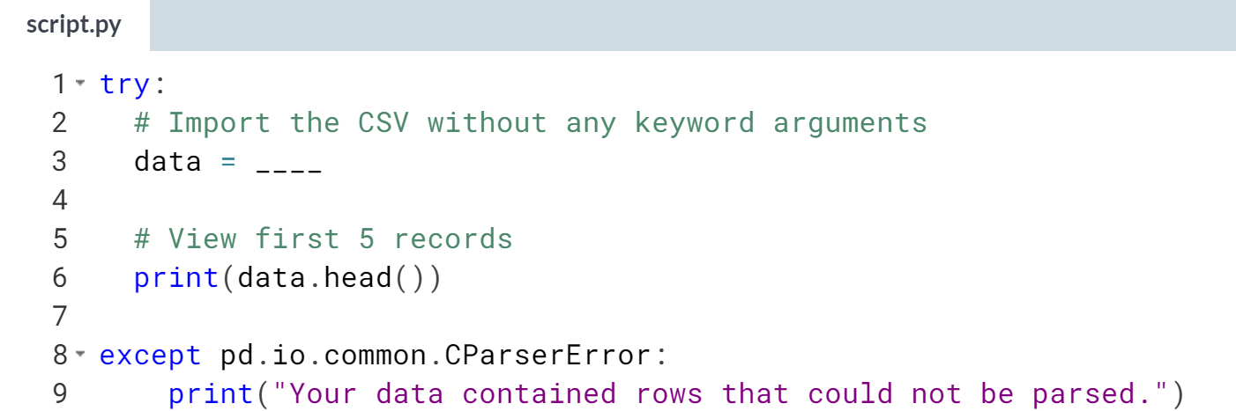

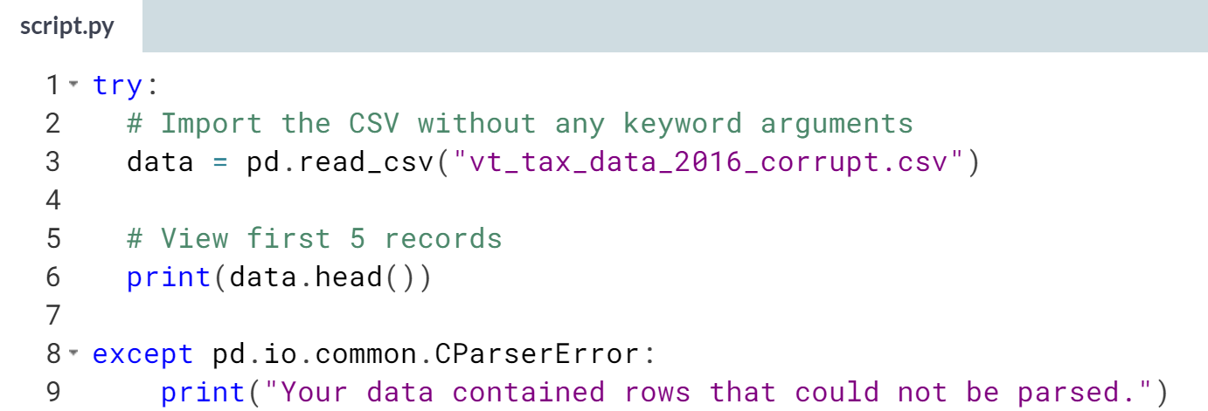  
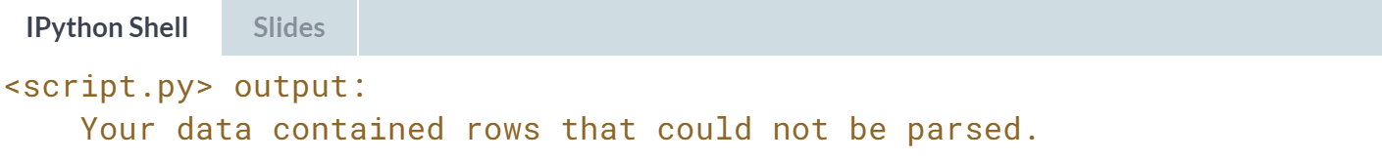

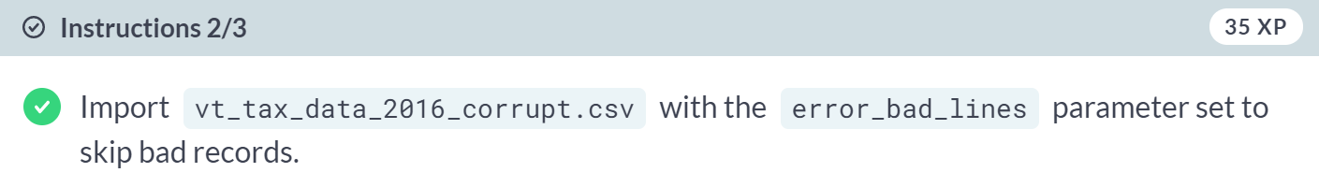

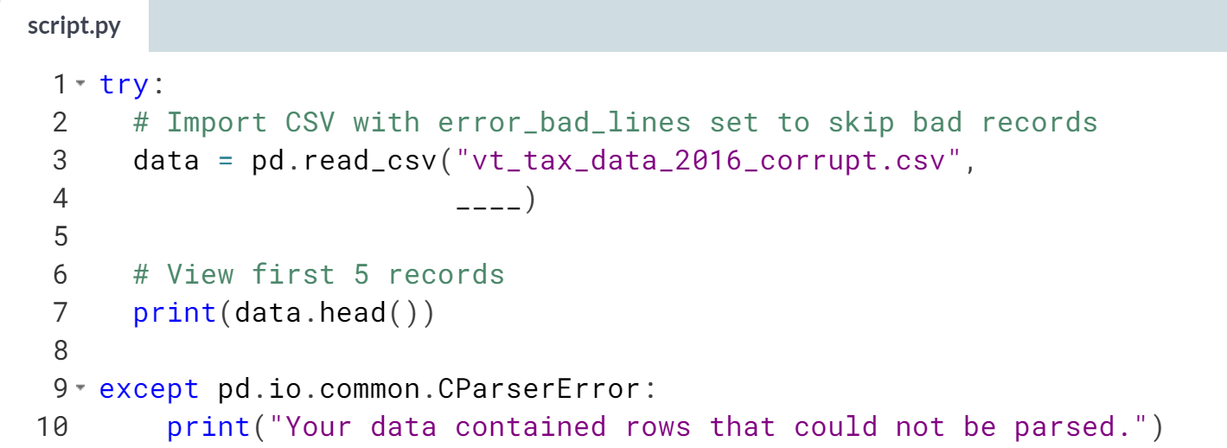

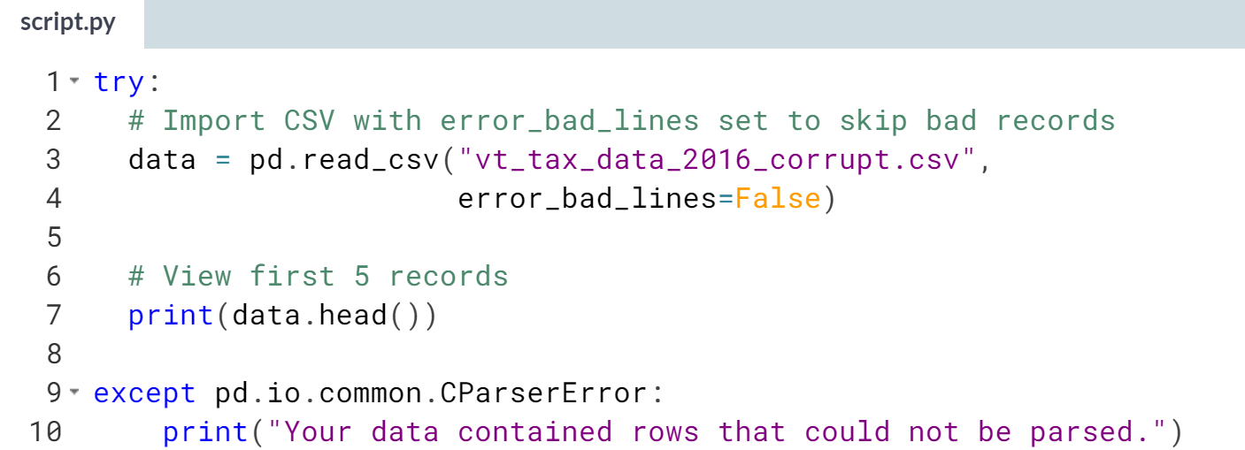

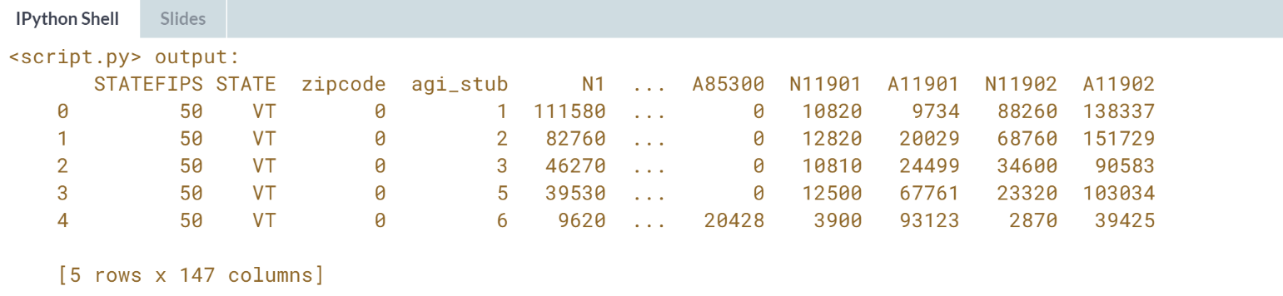



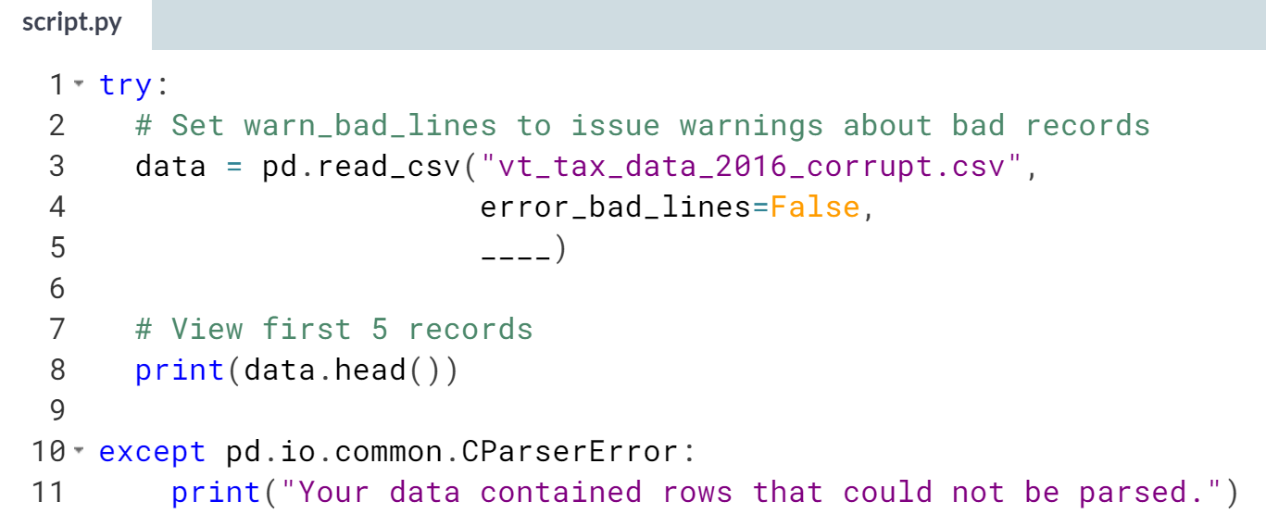

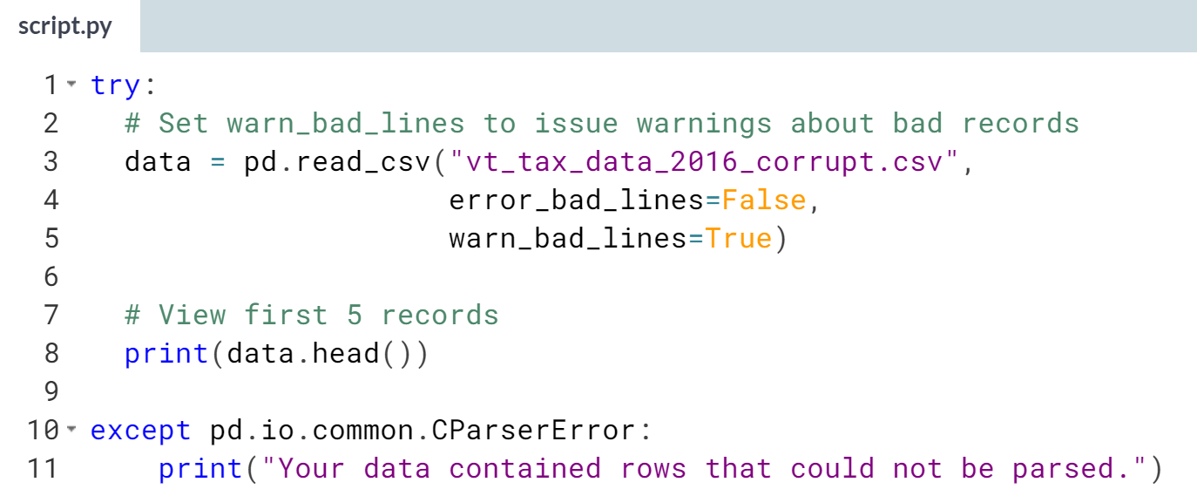  
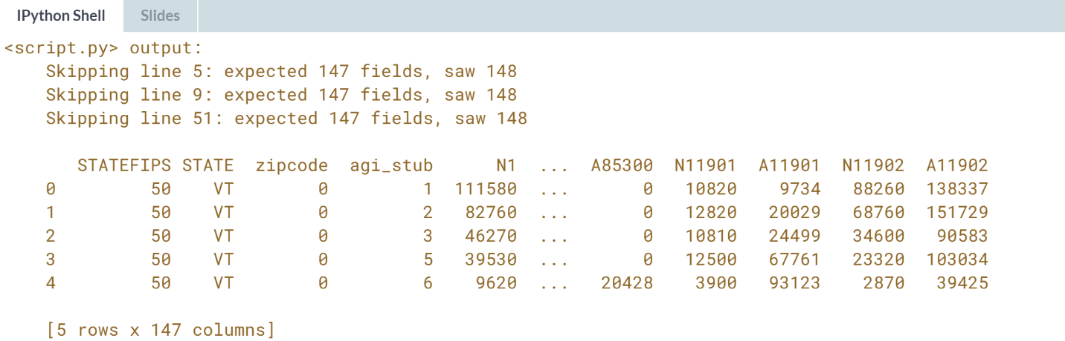  
Well done! Flat files are just the beginning when it comes to data ingestion. In the next chapters, you'll learn how to automate data imports from other sources, plus more ways to fine-tune imports.

**2. Importing Data from Excel Files**

Automate data imports from that staple of office life, Excel files. Import part or all of a workbook and ensure Boolean and datetime data are properly loaded, all while learning about how other people are learning to code.



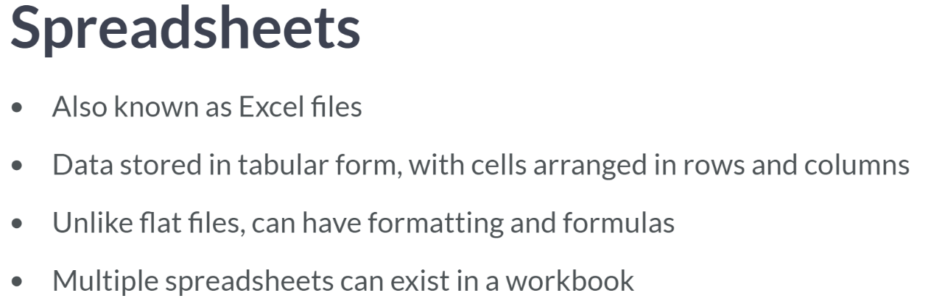  
Spreadsheets also support formatting that flat files do not. While data frames can be formatted for presentation purposes, like in Jupyter notebooks, pandas does not import spreadsheet formatting, so check that spreadsheets you want to load do not use formatting to convey important information.

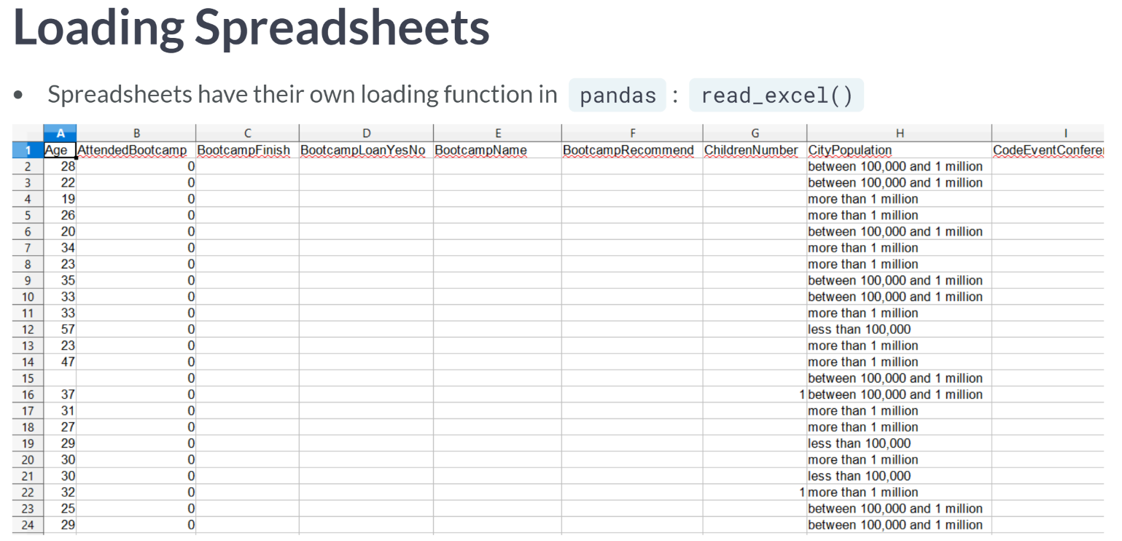  
At its simplest, reading data from a spreadsheet resembles reading a flat file, just with its own function: ***read_excel()***. Let's demonstrate with an excel file of responses from FreeCodeCamp's New Developer Survey, which asks new developer about their employment, education, job goals, and learning resources used.

This file has been modified to make it easier to practice with, but you can grab the full dataset from Kaggle or FreeCodeCamp's GitHub. Previewing the file in a spreadsheet program, we see that it's pretty straightforward: tabular data with no formatting.

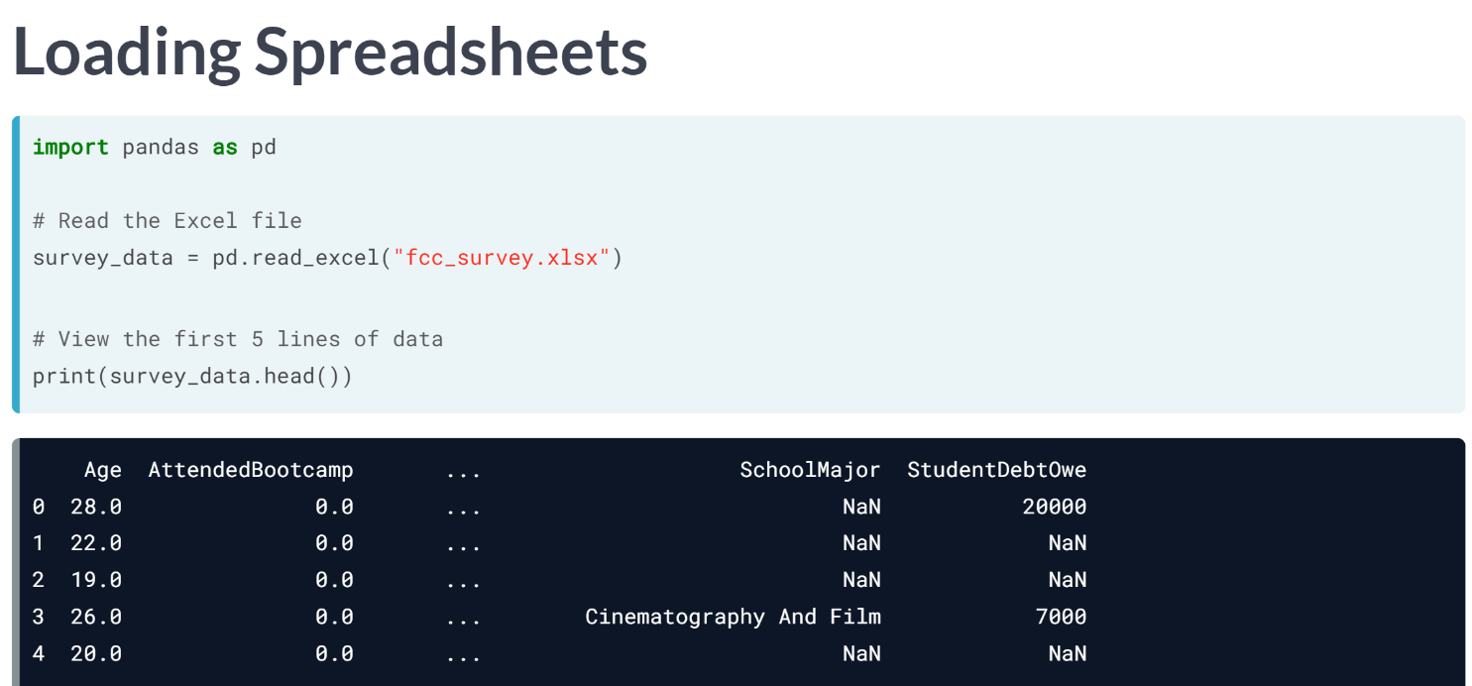  
As always, we first import pandas as pd, then pass the spreadsheet path as a string to ***pd.read_excel()*** and assign the result to a variable. When we check the head, the data frame looks as expected.

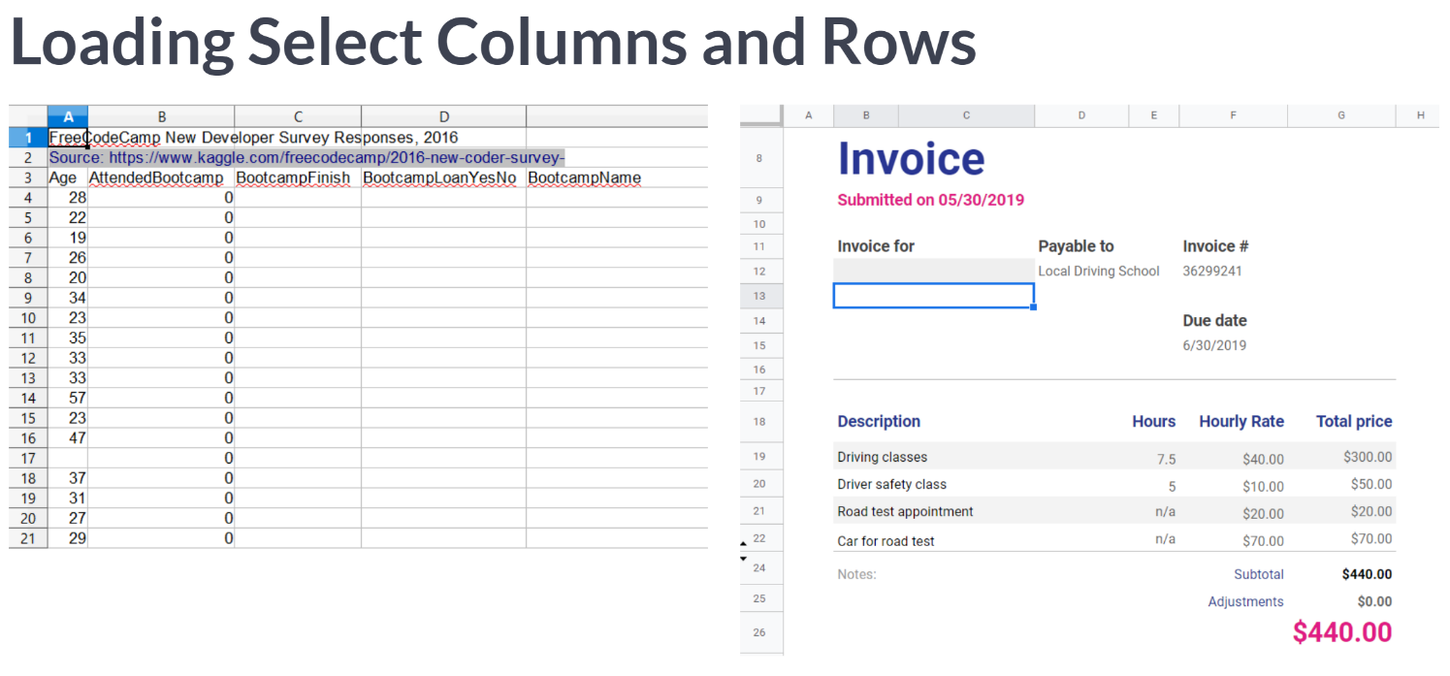  
Spreadsheets commonly contain non-tabular information, such as metadata headers, or have smaller tables of information, like this invoice. Fortunately, ***read_excel()***, like ***read_csv()***, has keyword arguments to select columns and skip or limit rows to get only the cells you want.

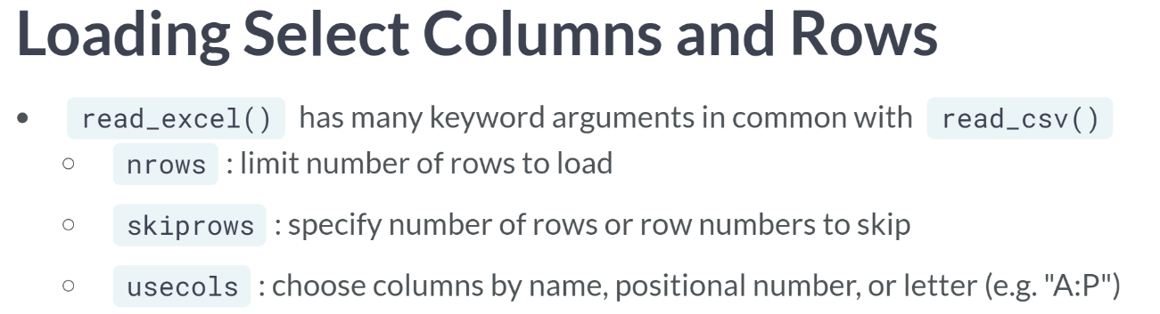  
Read Excel shares many parameters with read CSV, but some work slightly differently, so check pandas documentation if you are unsure.

* *nrows* is the same, taking an integer of rows to load.
* *skiprows* argument is also similar: it takes either a number of rows to skip at the beginning, or a list of row numbers to skip.
* Finally, *usecols* argument accepts a list of either column numbers or column names, or a function to decide whether to load a column, just like ***read_csv()***'s usecols. However, it also accepts an integer of columns to load, or string of Excel column letter or ranges, like "A:P".

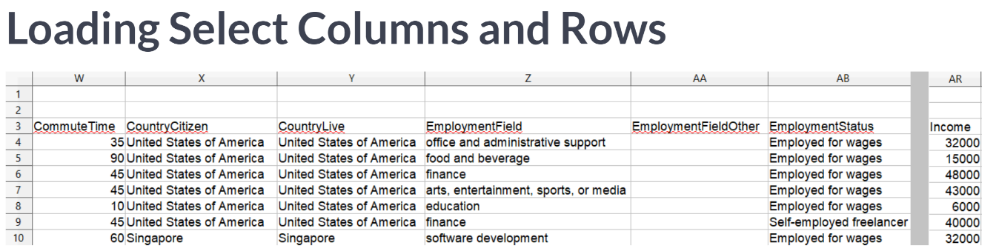  
Let's use these things to get a subset of survey response data, focusing on employment. Note that this version of the data has a two-row header providing linked to the source that we will want to exclude.

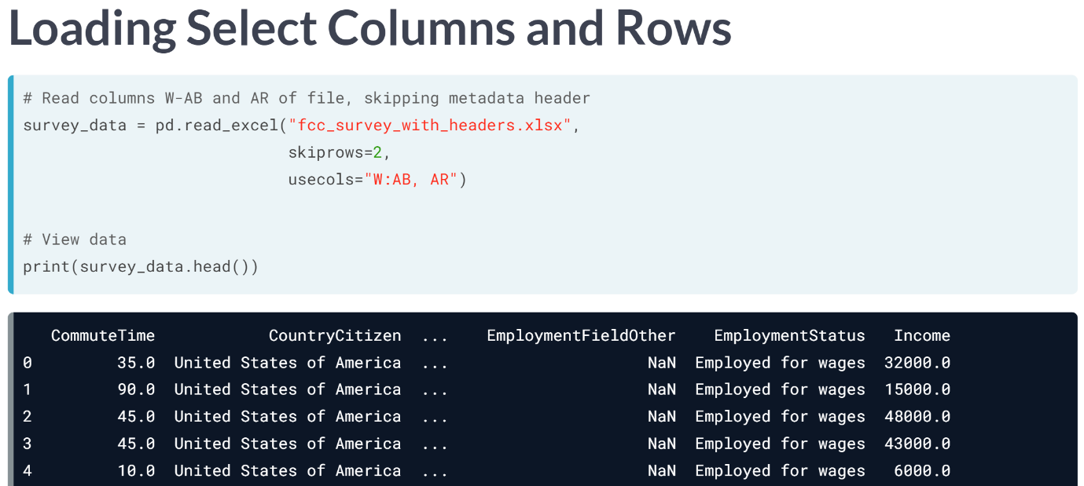  
We load the data with ***read_excel()*** as before but set skiprows to 2 to exclude the metadata. Since we know which column letters we want, we can pass the range and standalone income column as a single string to usecols. Checking the data frame, we see there are only a few columns loaded, and no metadata. In this lesson, we learned about creating data frames from Excel data.

# Get data from a spreadsheet

In this exercise, you'll create a data frame from a "base case" Excel file: one with a single sheet of tabular data. The fcc_survey.xlsx file here has a sample of responses from FreeCodeCamp's annual New Developer Survey. This survey asks participants about their demographics, education, work and home life, plus questions about how they're learning to code. Let's load all of it.

pandas has not been pre-loaded in this exercise, so you'll need to import it yourself before using read_excel() to load the spreadsheet.

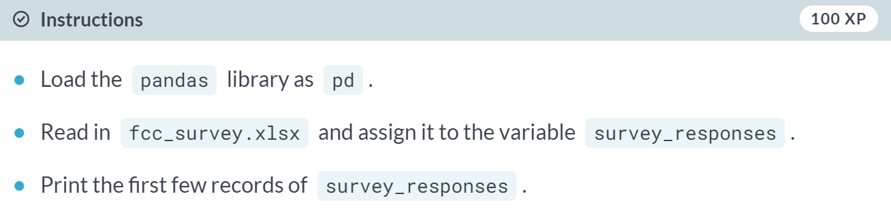

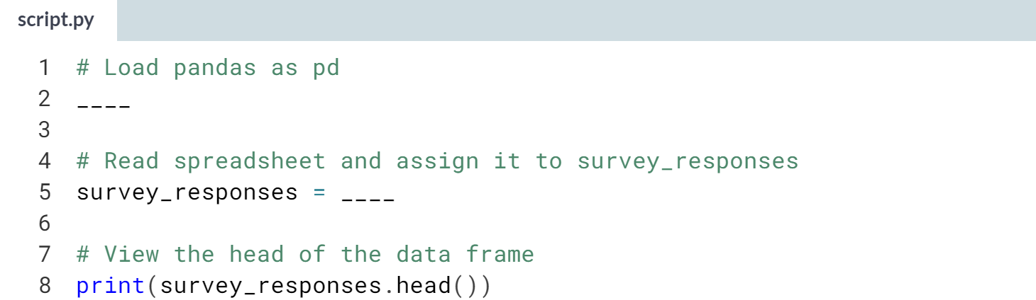

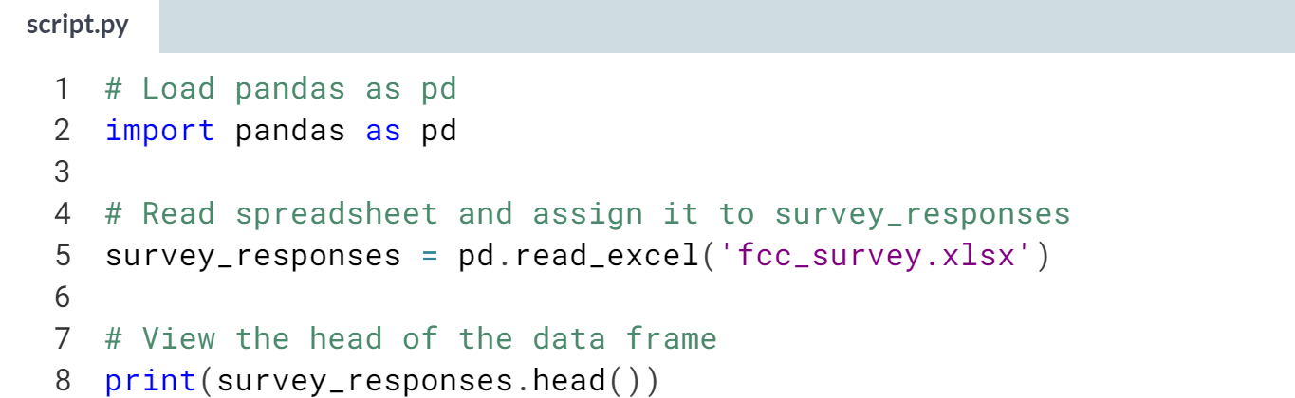

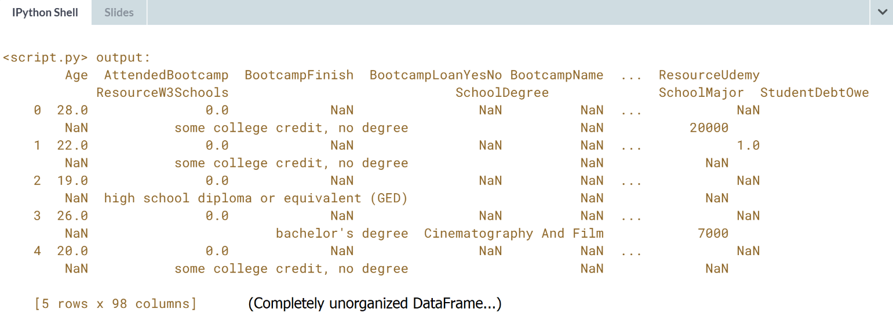  
Depending on how and why an Excel file was generated, you might find spreadsheet imports as painless as this. Excel files created for human readers can get quite complicated, with headers, charts, and multiple tables on a sheet.

# Load a portion of a spreadsheet

Spreadsheets meant to be read by people often have multiple tables, e.g., a small business might keep an inventory workbook with tables for different product types on a single sheet. Even tabular data may have header rows of metadata, like the New Developer Survey data here. While the metadata is useful, we don't want it in a data frame.

You'll use read_excel()'s skiprows keyword to get just the data. You'll also create a string to pass to usecols to get only columns AD and AW through BA, about future job goals.

pandas has been imported as pd.

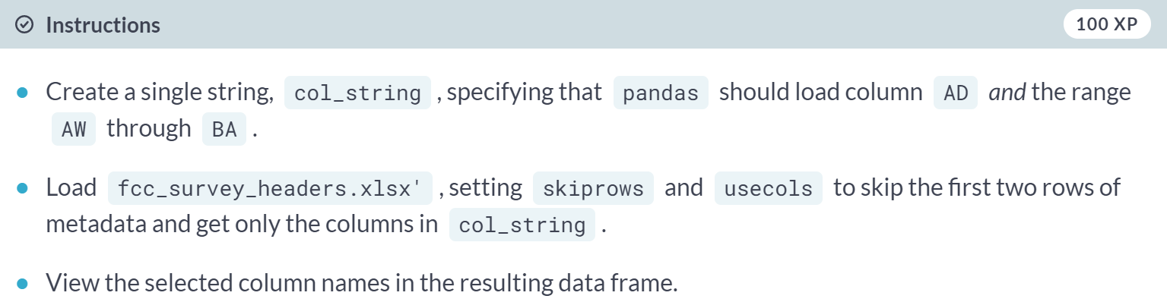

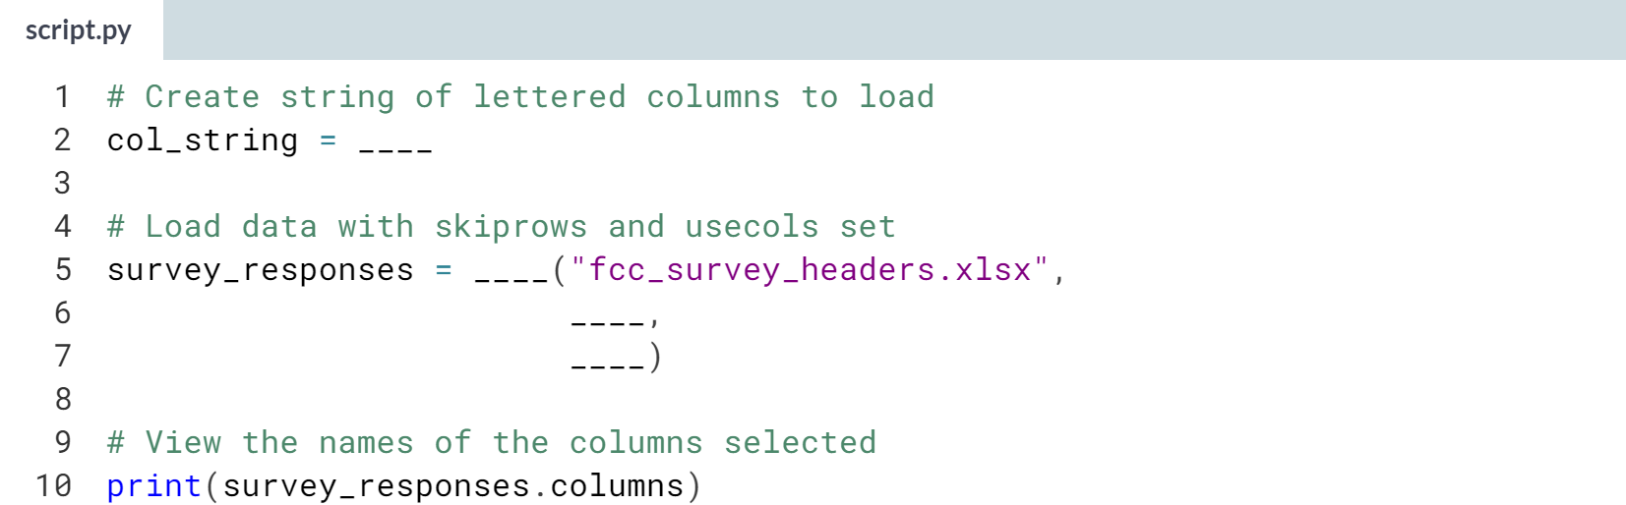  
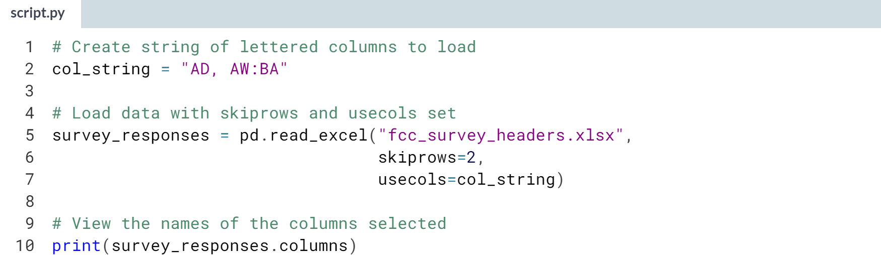

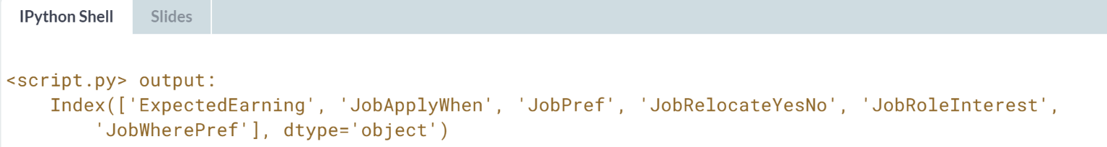  
Nice job! If you need to get a table of data from a sheet with multiple tables on it, you can use *skiprows*, *nrows*, and *usecols* together to delineate which cells of data to read in.



In this lesson, we will learn how to specify sheets to get data from, as well as a workflow to combine multiple sheets into a single data frame. Even though the term 'spreadsheet' and 'excel' can be used interchangeably, an excel file can be a workbook with multiple sheets, containing data as well as charts and metadata. We will focus on sheets with tabular data.

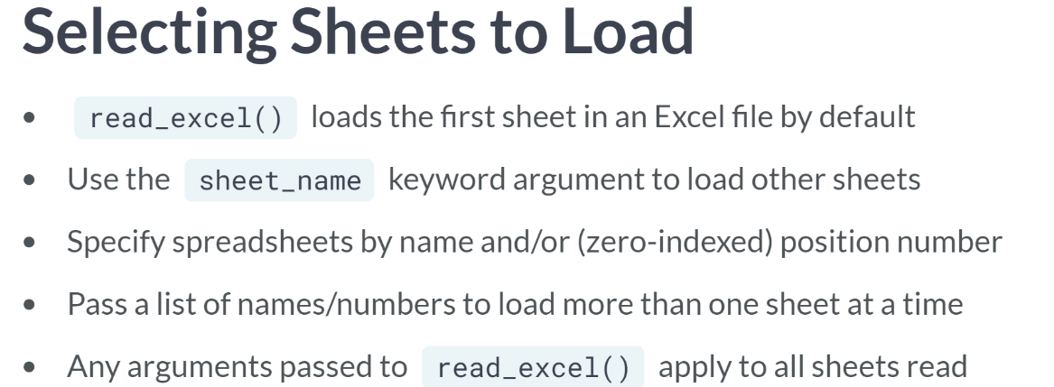

* Sheet name accepts the name of the desired sheet as a string, an integer indicating the desired sheet's position in the workbook or a list containing any combination of sheet names and position numbers to read.
* Two things to note:
  + Sheets are zero-indexed
  + If you load multiple sheets at once, any other arguments passed to read excel apply to all sheets.
* For example, if you set nrows to 50, the first 50 rows of each sheet listed in sheet name will be loaded. If sheet need different parameters, load them with separate ***read_excel()*** calls.

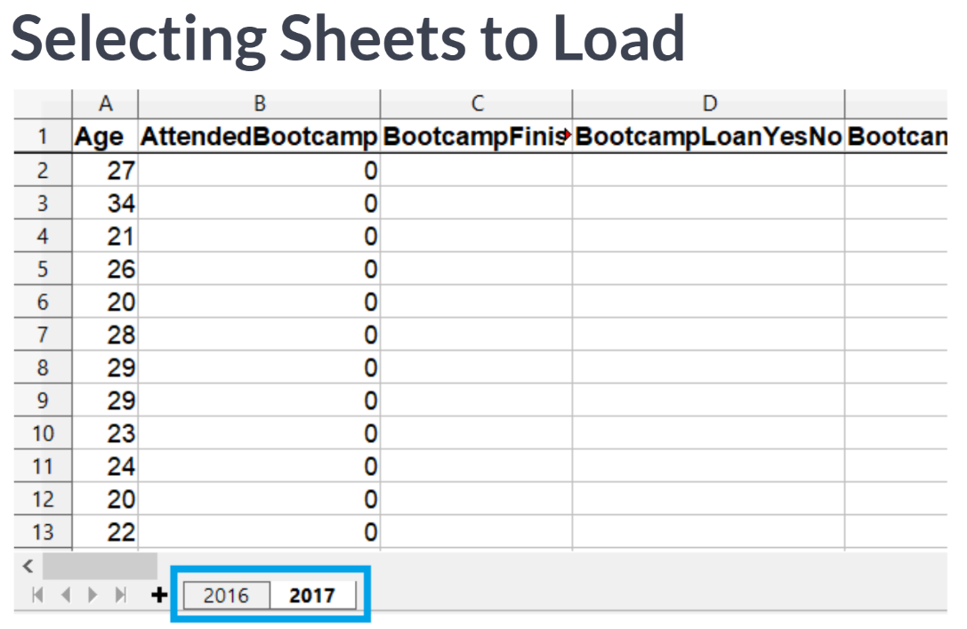  
The new developer survey file actually contain two sheets: we've already got the response from 2016 data, so let's also get the one from 2017.

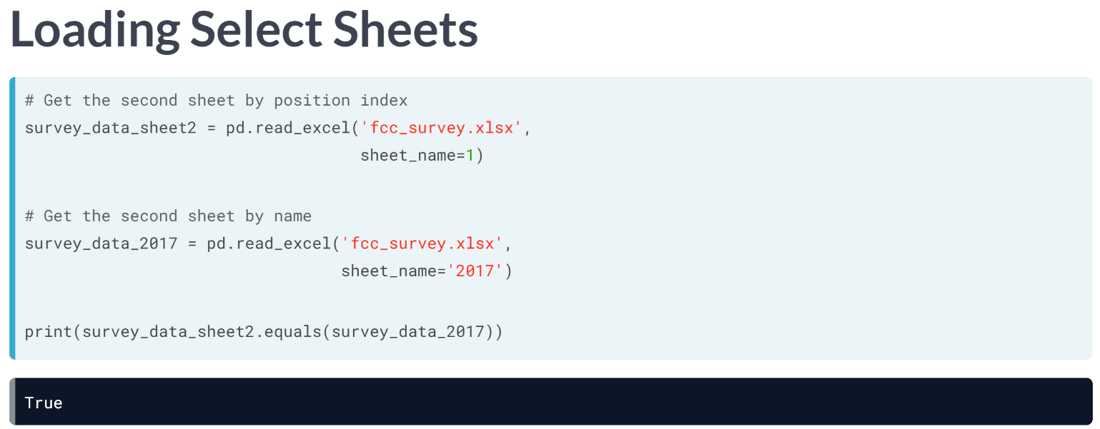  
To get the second sheet, we can either pass its position index, 1, to sheet name, or the actual sheet name. Either method gets the same result.

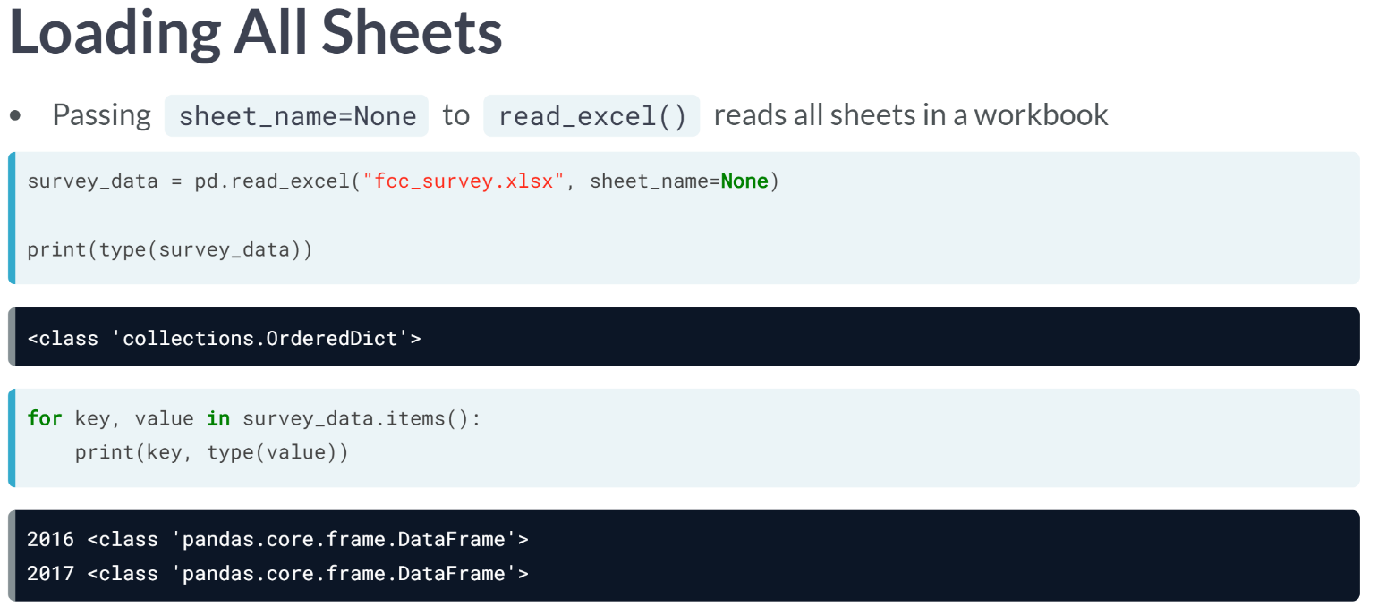  
When we pass the argument *sheet_name = none*, we got an ordered dictionary instead of getting a data frame. Iterating through the items reveals that the keys are sheet names, and the values are data frames for each sheet.

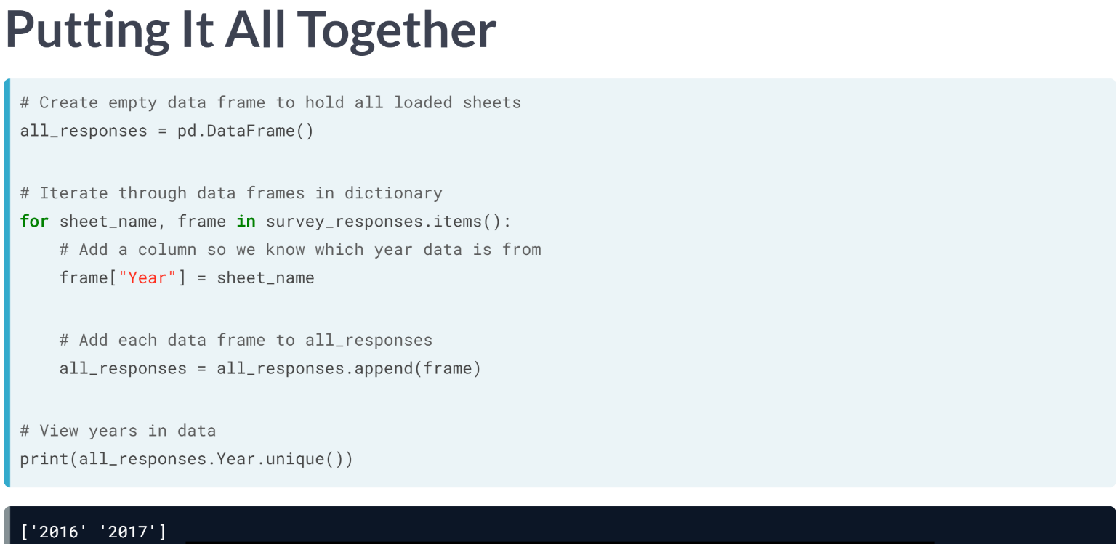  
We have one data frame per sheet, which is great if sheets have different columns or describe different subjects. For the survey data, each sheet has the same columns, jus for different years. Let's combine them into one data frame.

* First, we create an empty data frame, all responses.
* Then, we loop through items in the survey responses dictionary. Remember, each value is a data frame corresponding to a worksheet, and each key is a sheet name.
* For each data frame, we add a column, year, containing the sheet name, so we know which dataset a record came from.
* Finally, we append the data frames to all responses.
* We can check unique values in the year column to confirm that all responses have both years.

In this case, we only combined two sheets, so we could have appended one to the other, but looping has the advantage of working for any number of sheets.

# Select a single sheet

An Excel workbook may contain multiple sheets of related data. The New Developer Survey response workbook has sheets for different years. Because read_excel() loads only the first sheet by default, you've already gotten survey responses for 2016. Now, you'll create a data frame of 2017 responses using read_excel()'s sheet_name argument in a couple different ways.

pandas has been imported as pd.



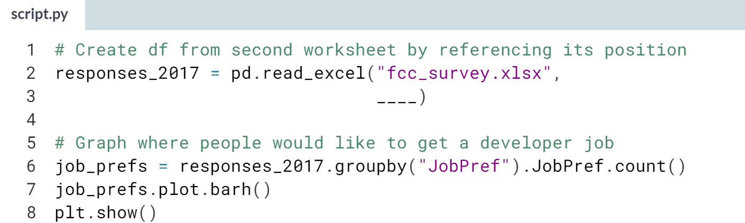

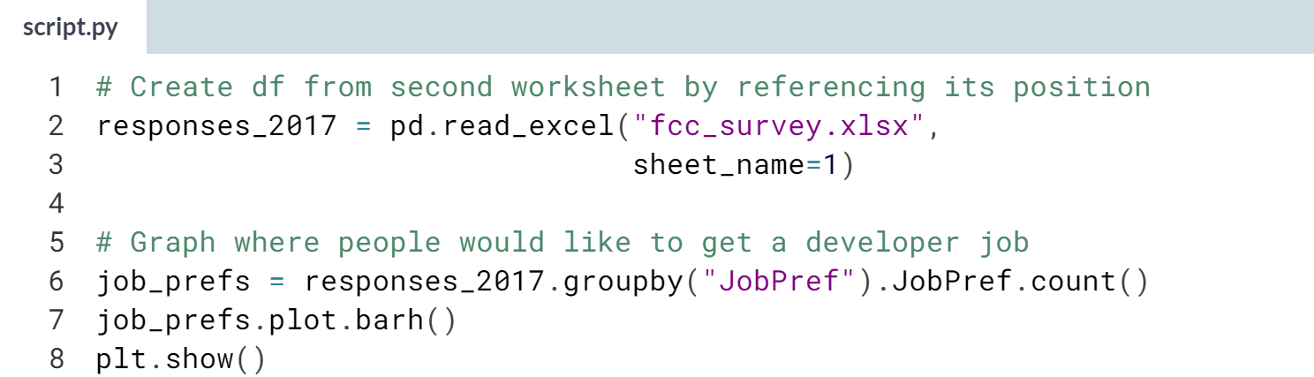

(Plot on the next page)

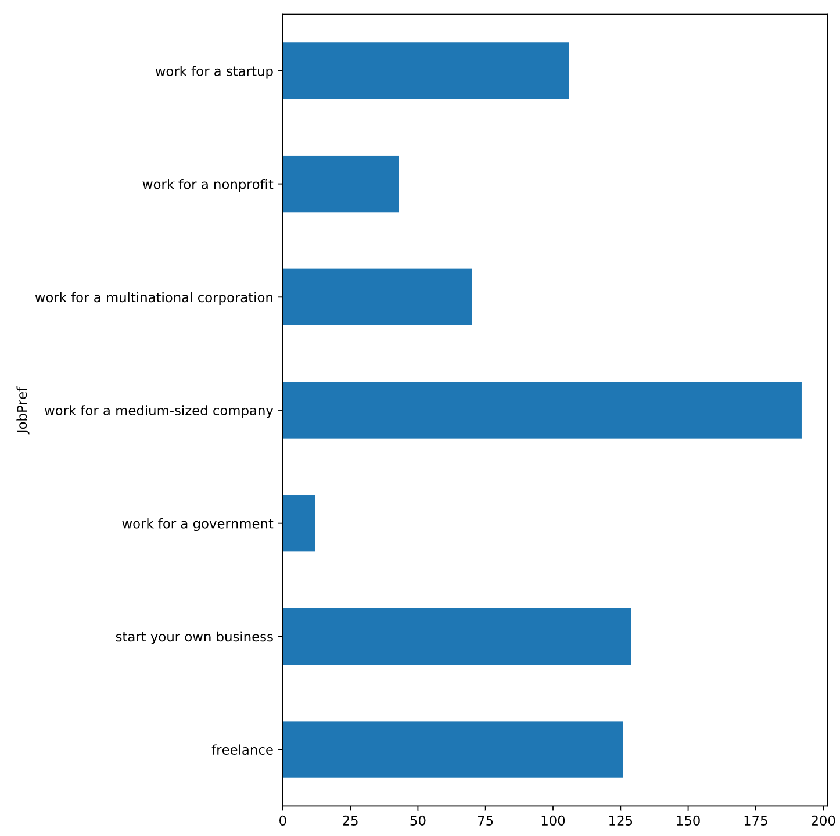

(Exercise continues on the next page)

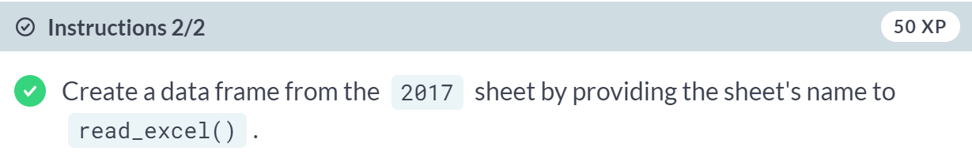  
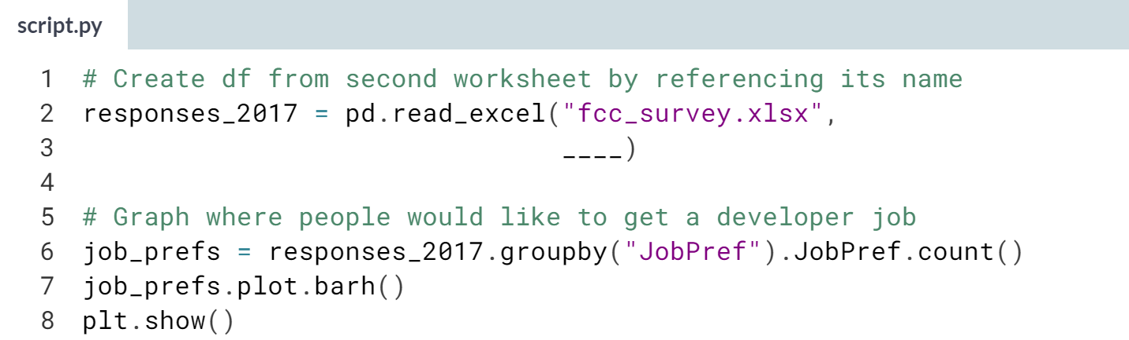

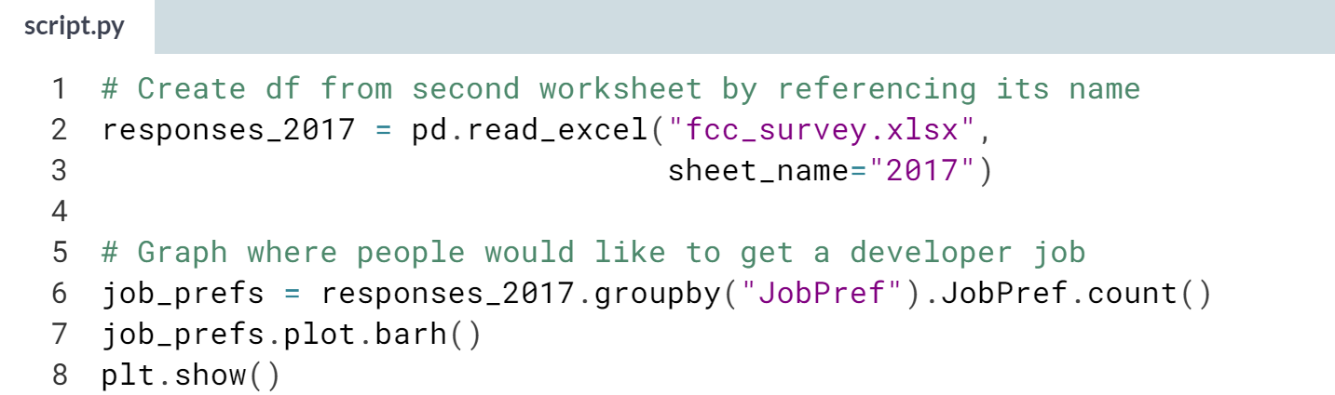

(Plot on the next page)

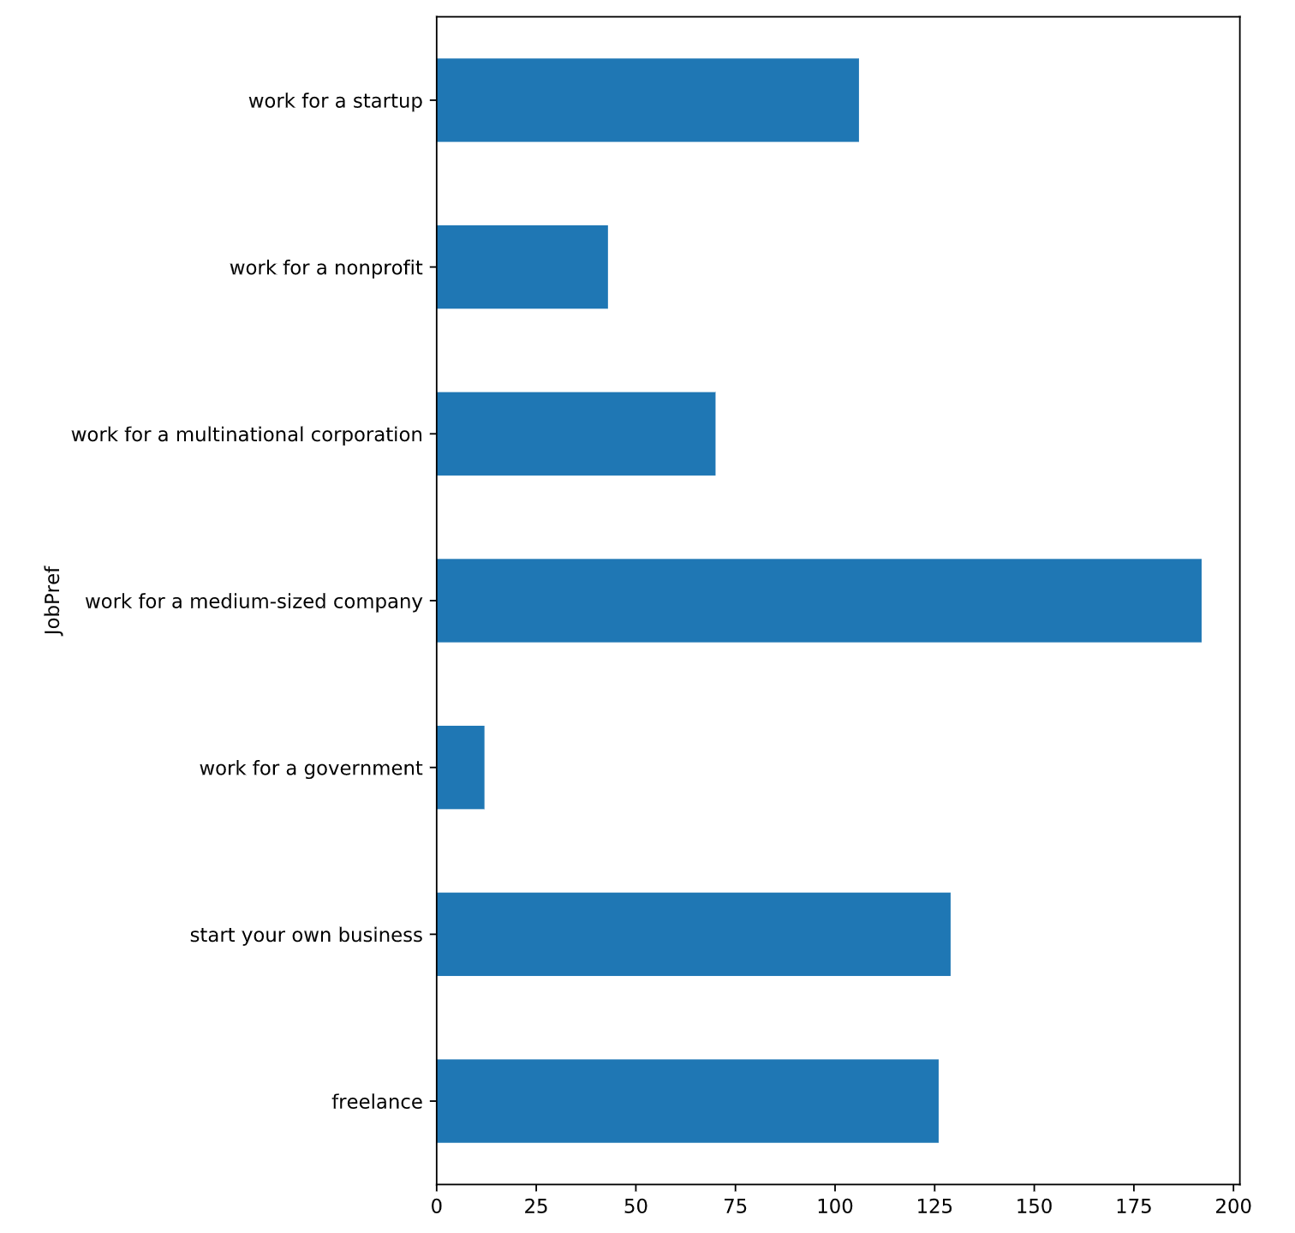

Although it's possible to get multiple spreadsheets in an Excel file with one call to ***read_excel()***, it can make more sense to use multiple calls if sheets contain very different data or layouts. That way, you can customize other arguments for each sheet.

# Select multiple sheets

So far, you've read Excel files one sheet at a time, which lets you you customize import arguments for each sheet. But if an Excel file has some sheets that you want loaded with the same parameters, you can get them in one go by passing a list of their names or indices to read_excel()'s sheet_name keyword.

To get them all, pass None. You'll practice both methods to get data from fcc_survey.xlsx, which has multiple sheets of similarly-formatted data.

pandas has been loaded as pd.

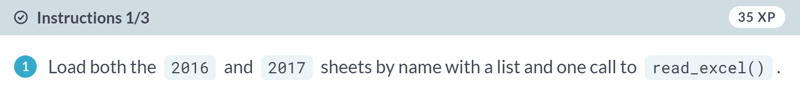

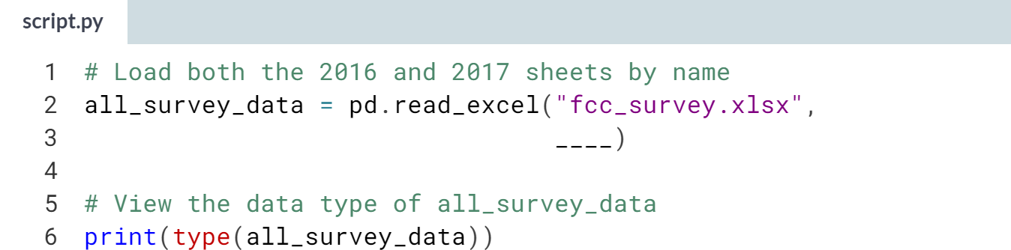

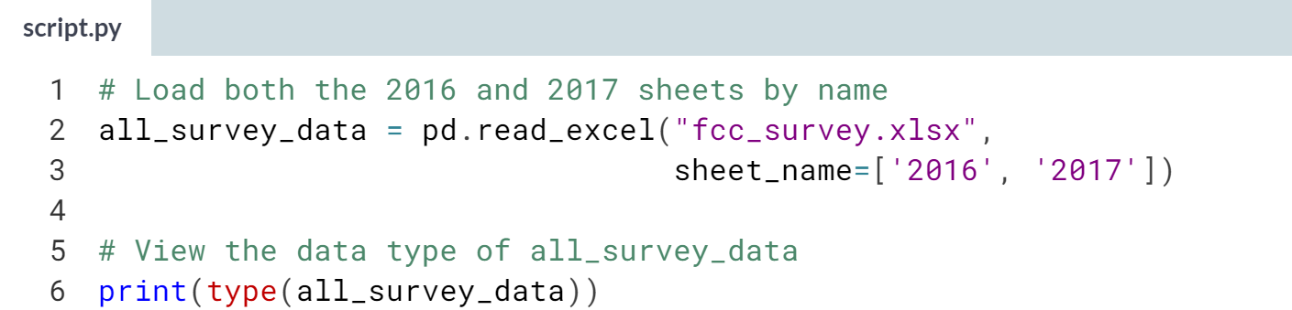

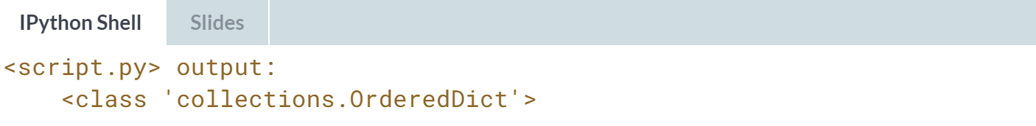

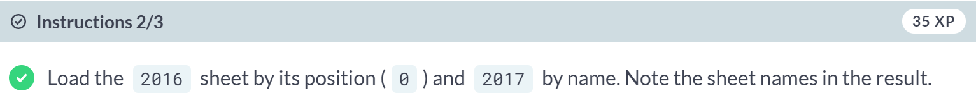

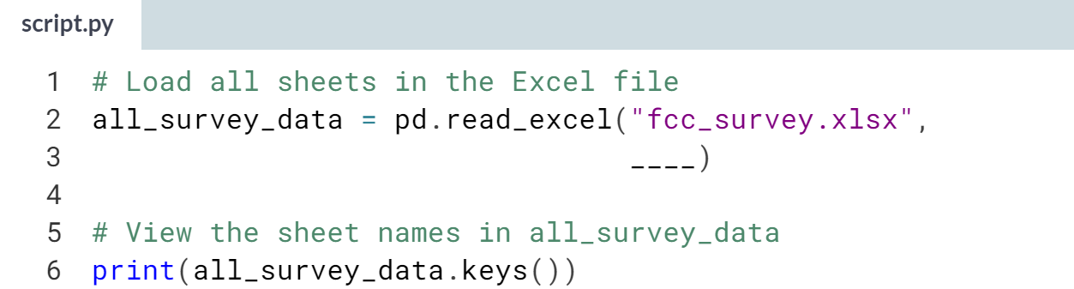

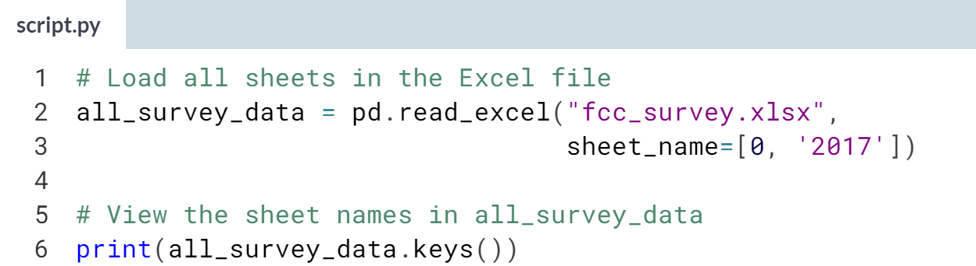

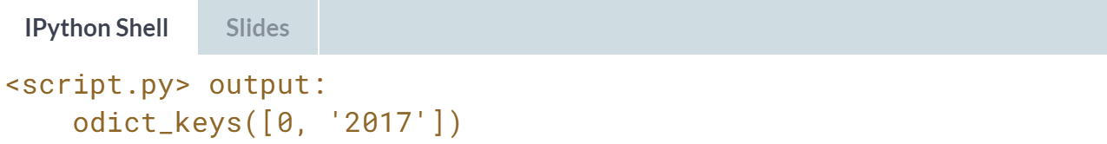

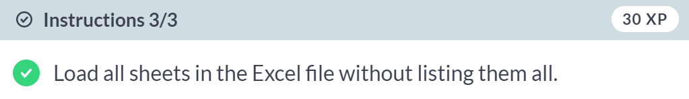

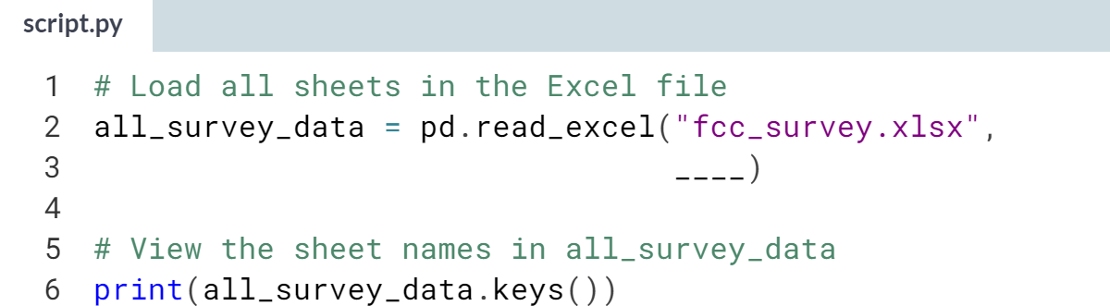

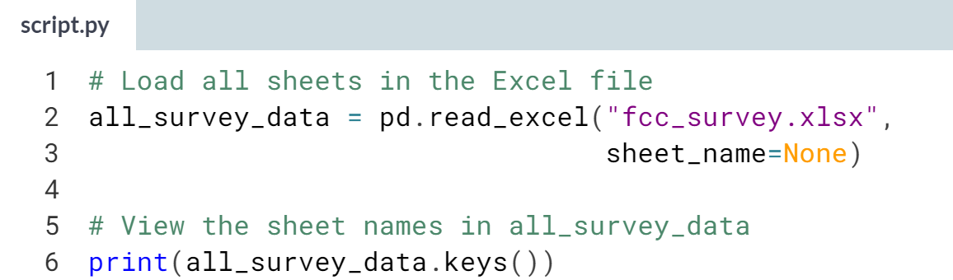

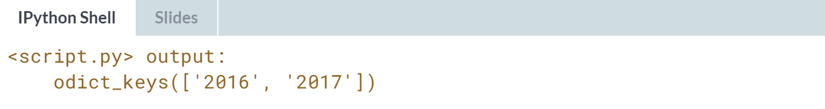

# Work with multiple spreadsheets

Workbooks meant primarily for human readers, not machines, may store data about a single subject across multiple sheets. For example, a file may have a different sheet of transactions for each region or year in which a business operated.

The FreeCodeCamp’s New Developer Survey file is set up similarly, with samples of responses from different years in different sheets. Your task here is to compile them in one data frame for analysis.

pandas has been imported as pd. All sheets have been read into the ordered dictionary responses, where sheet names are keys and data frames are values, so you can get data frames with the values() method.

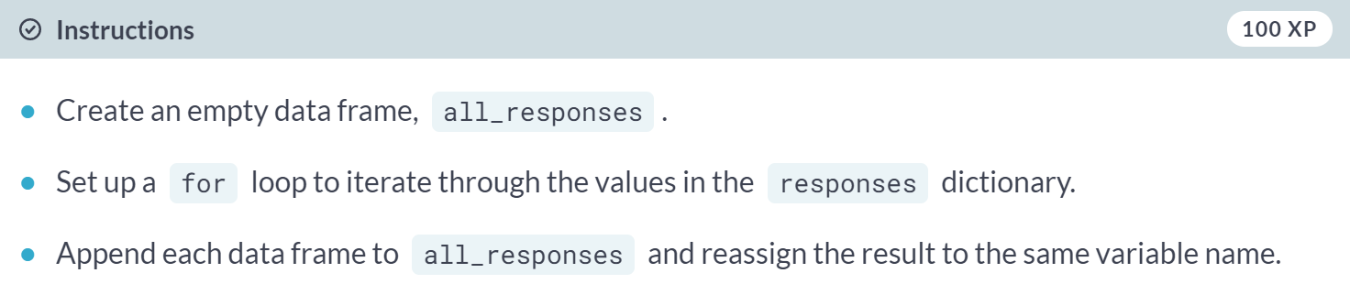

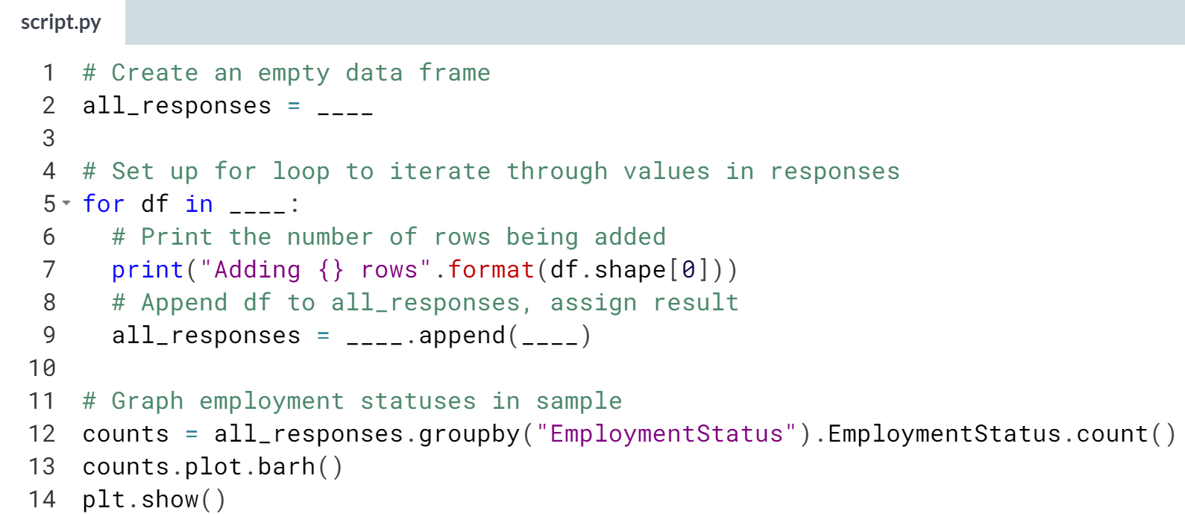

(Solution on the next page)

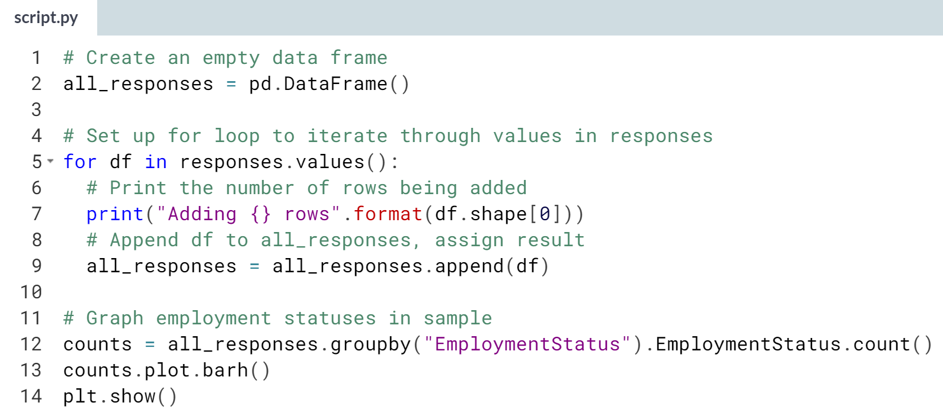

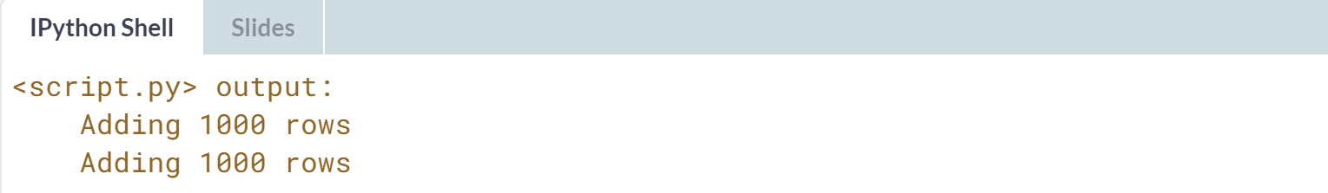  
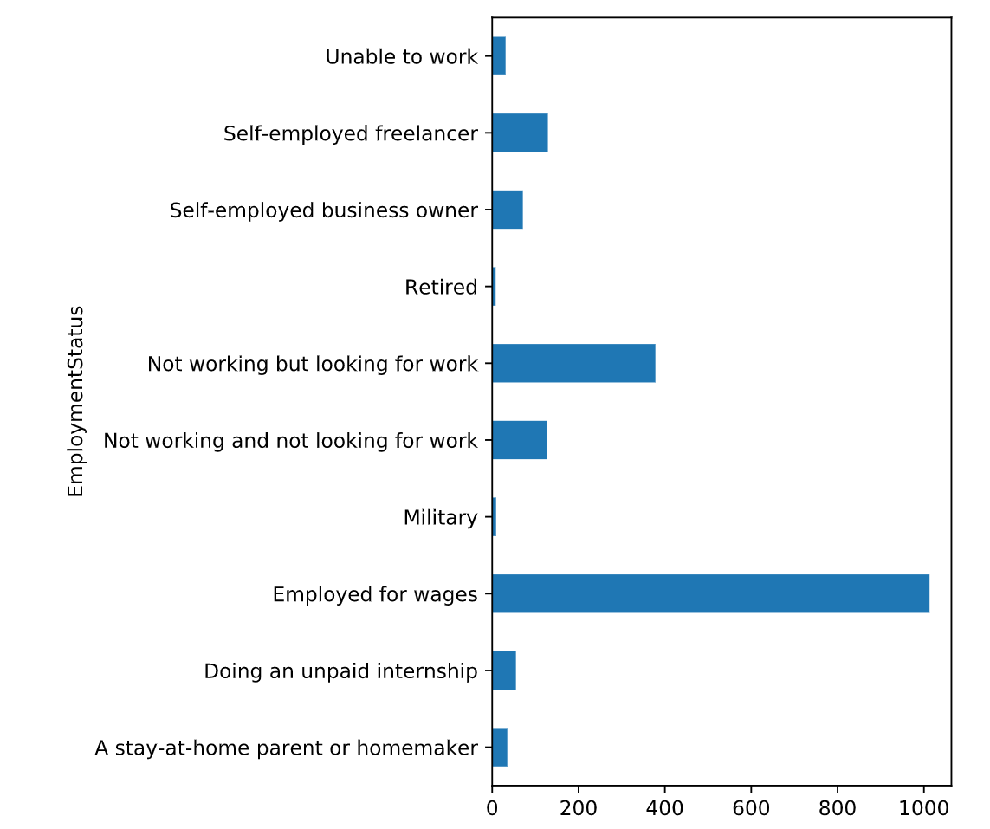  
Good work! You compiled similar spreadsheets into one dataset. This method works well when you know your spreadsheets use the same column names. If they don't, you can end up with lots of NA values where column names don't align.



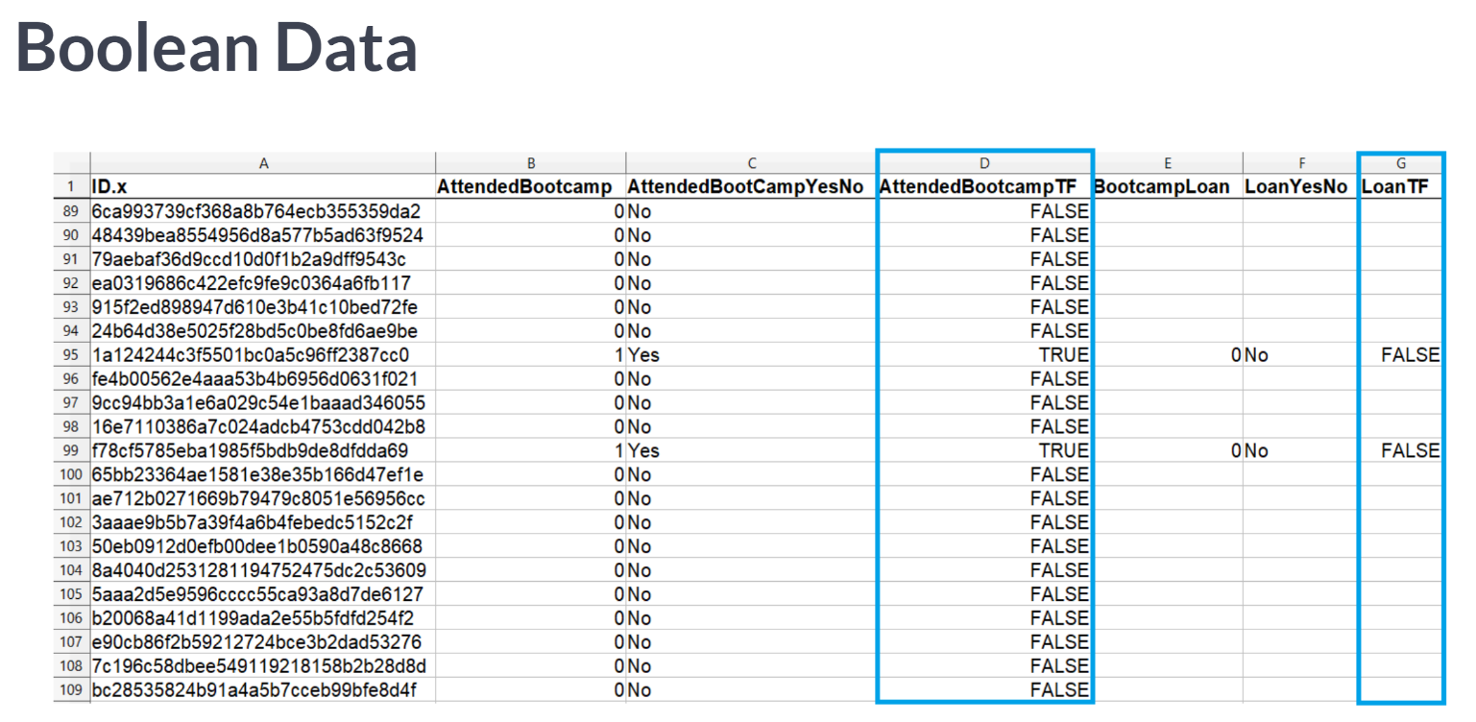  
We will use a subset of New Developer Survey data to examine Boolean data. True and False or 0 and 1 are represented in a few ways for demonstration purpose.

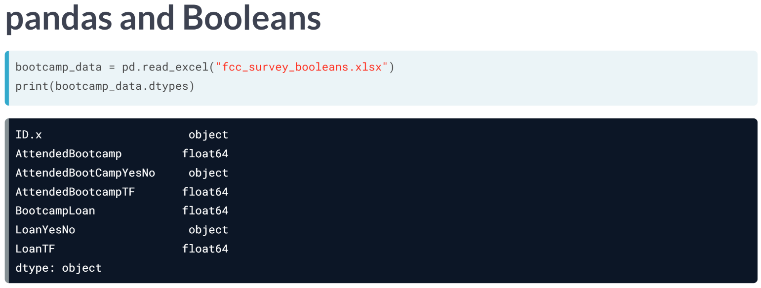  
Let's load this data with no additional arguments and check dtypes. Pandas interpreted no columns as Boolean! Even True/False columns were loaded as floats.

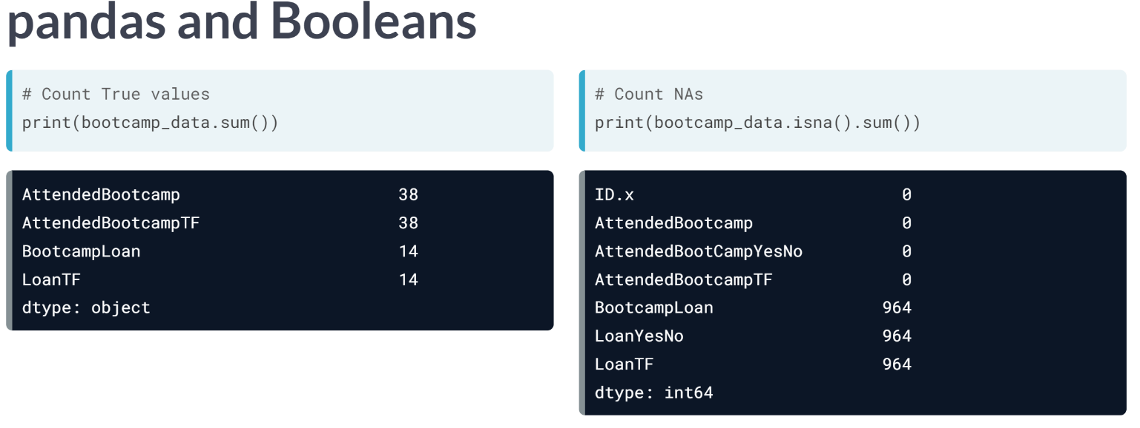  
Let's sum the data frame's columns to see how many Trues each float column has.

Recall that these column code True as 1 and False as 0. In our data subset, 38 attended a bootcamp and 14 took out a loan for it. Let's also check how many values in each column are missing by summing the results of ***isna()***.

Every record has a value for bootcamp attendance, but most of the loan values are blank, even for some students who attended a bootcamp.

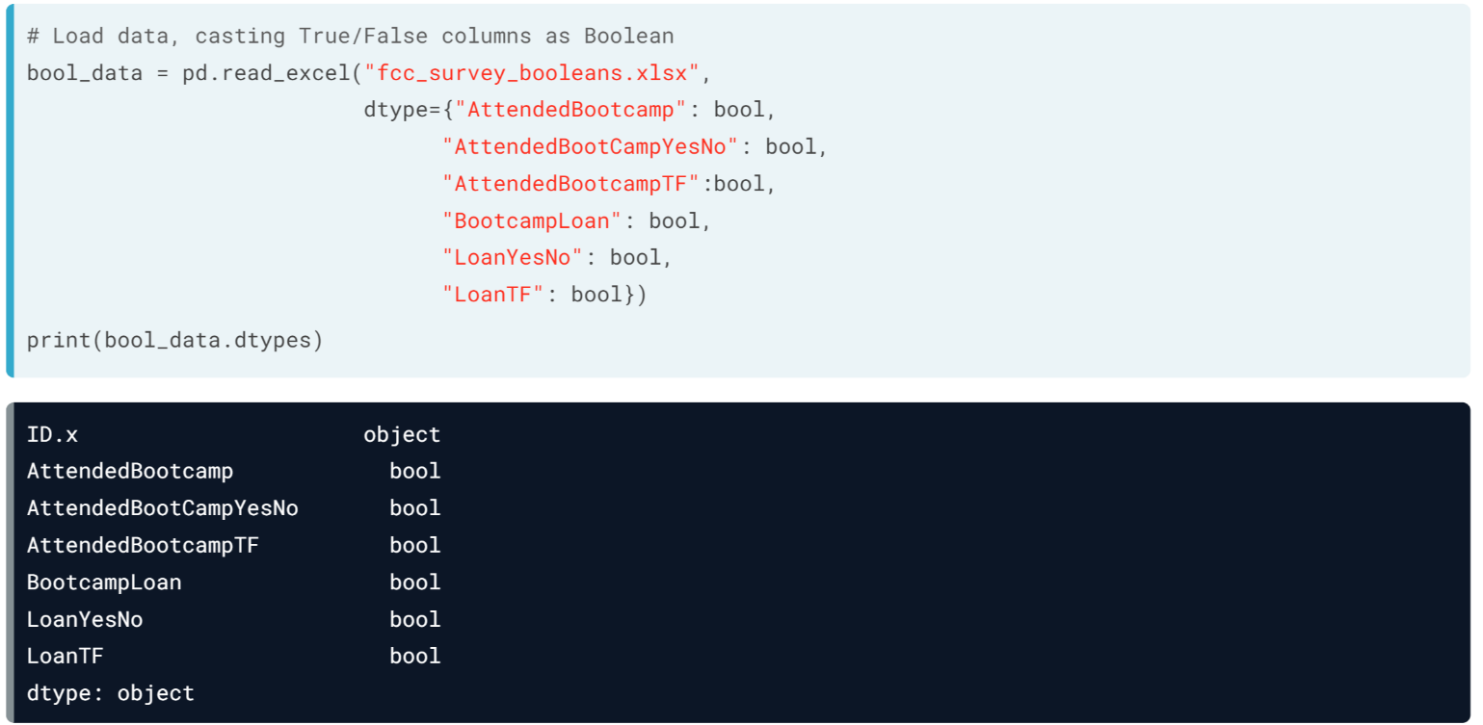  
Now let's cast these columns as Booleans with the *dtype* argument. ***read_excel()*** ‘s dtype works exactly like ***read_csv()***'s, so we pass a dictionary specifying which columns should be Boolean. Checking dtypes, it looks like it worked.

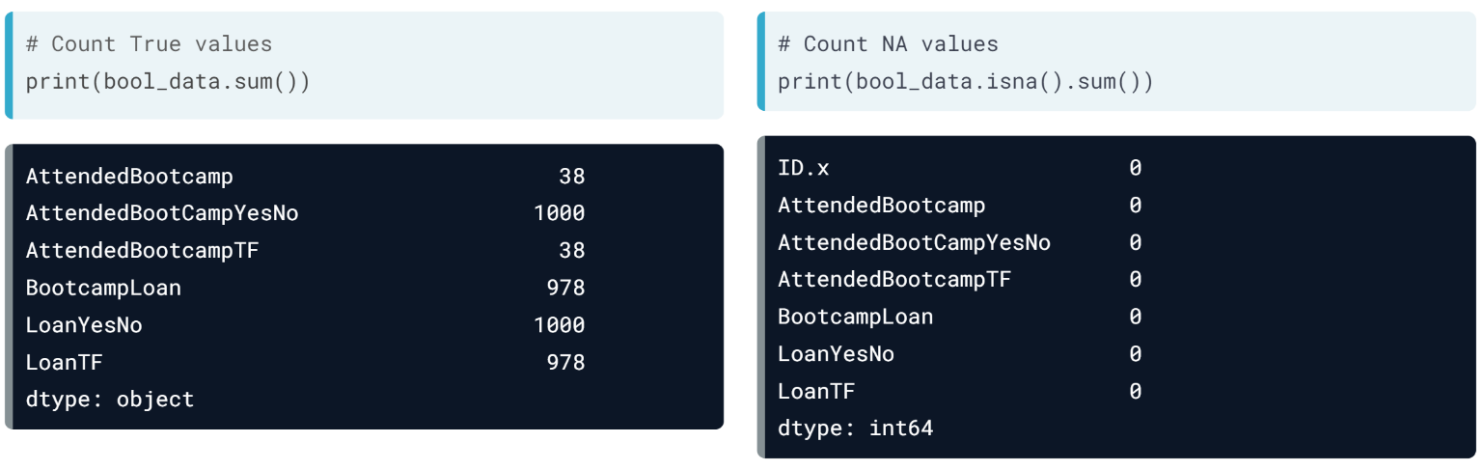

Checking counts of True reveals issues. The loan columns have too many Trues, and the yes/no ones are all True. Checking NA values by column, we see there aren't any. What happened?

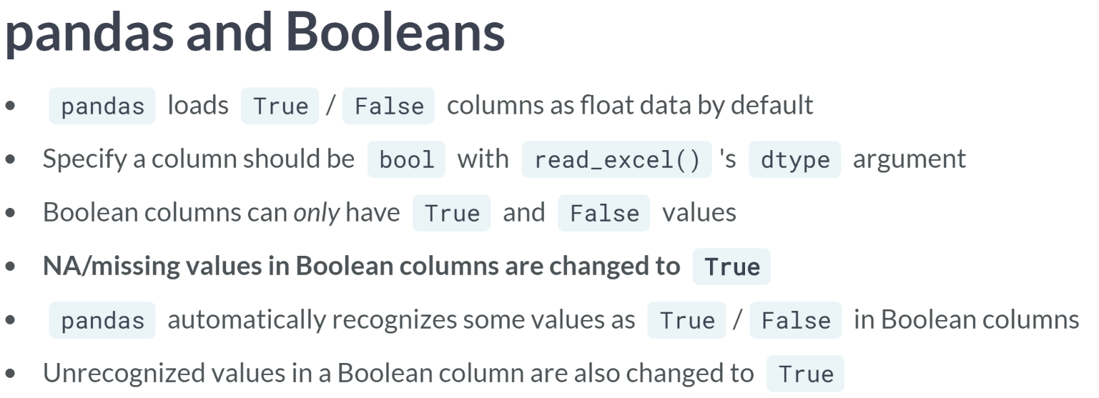

Pandas automatically loads True/False columns as floats, but that can be changed with dtype. Boolean values must be either True or False, so NAs were re-coded as True. While pandas recognized that zeros and ones are False and True, respectively, it didn't know what to do with Yes and No, so they were coded as True.

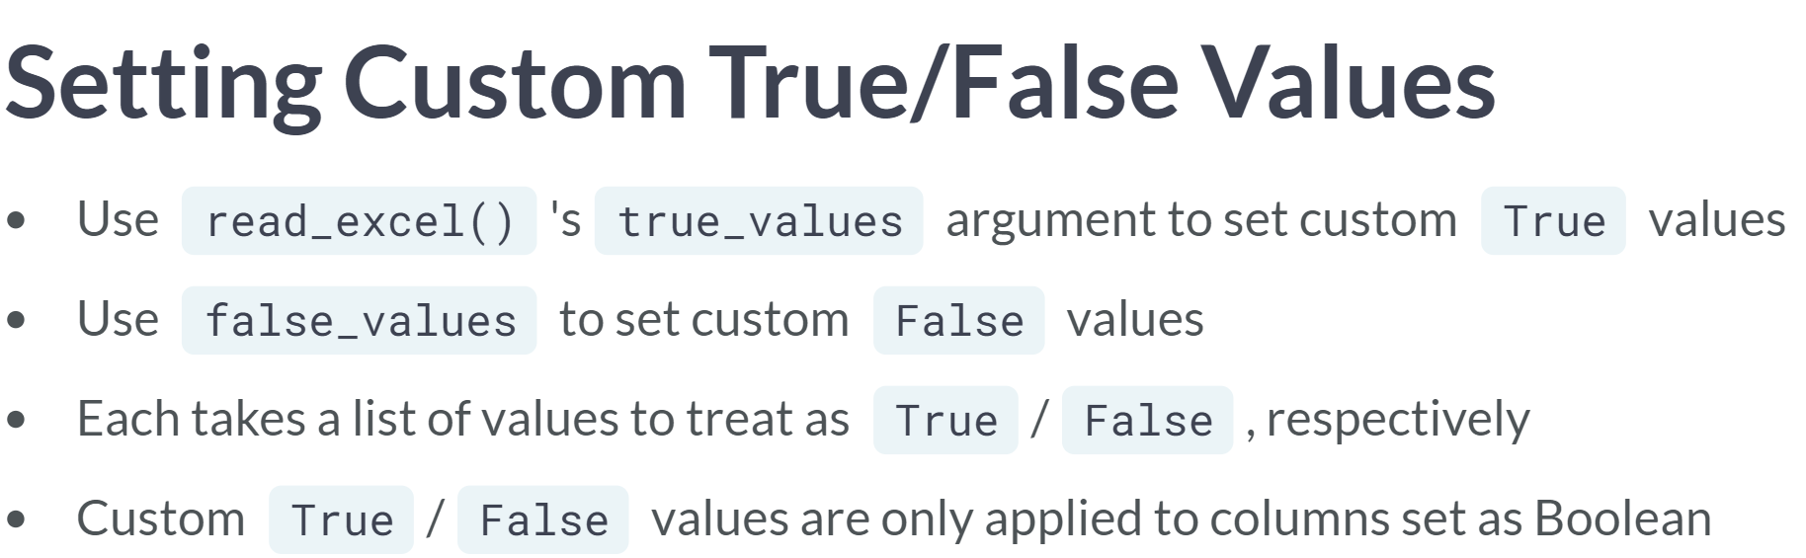  
We can solve the issue of yes/no columns being misinterpreted with ***read_excel()***'s true_values and false_values arguments.

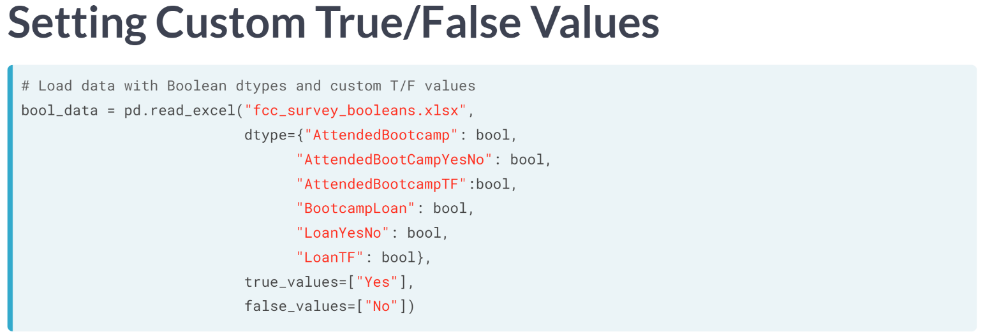  
Let's pass "Yes" and "No" as single-item lists to True values and False values.

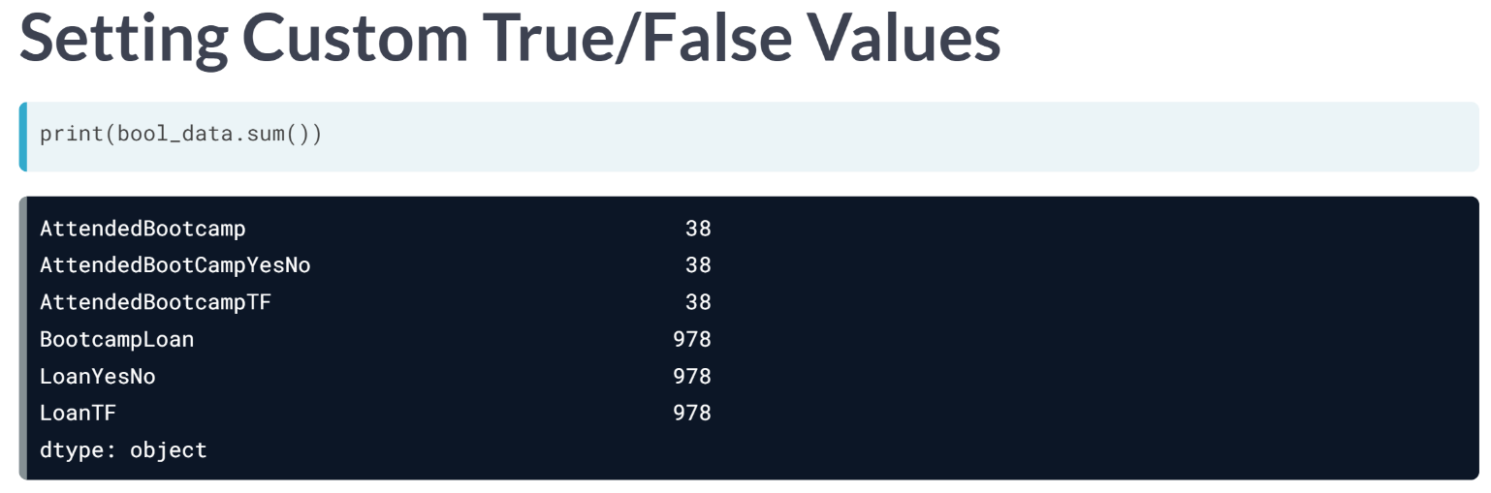  
Then, we can check True counts with the ***sum()*** method. Now the yes/no columns match their counterparts. But there is still the issue of NA's being coded ad True.

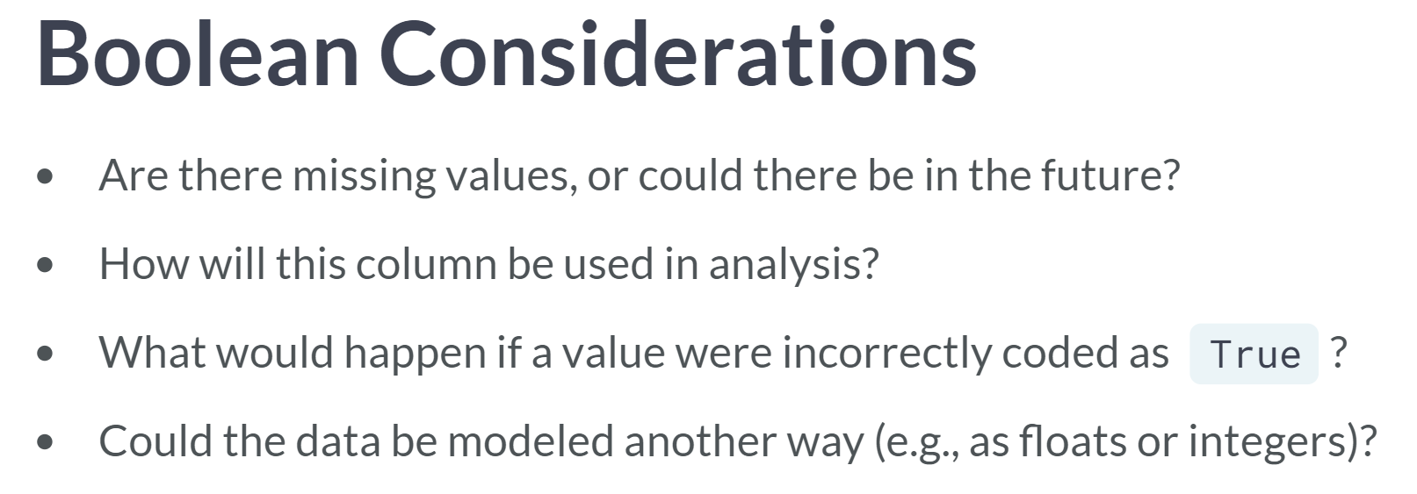  
What to do depends on the data. In our case, we don't want fake Trues, so we might decide to keep the loan columns as floats. Things to consider when casting a column as Boolean include the presence of NA values, how the column will be used in the analysis, the consequences of fake True values, and whether alternative representations like floats would do.

# Set Boolean columns

Datasets may have columns that are most accurately modeled as Boolean values. However, pandas usually loads these as floats by default, since defaulting to Booleans may have undesired effects like turning NA values into Trues.

fcc_survey_subset.xlsx contains a string ID column and several True/False columns indicating financial stressors. You'll evaluate which non-ID columns have no NA values and therefore can be set as Boolean, then tell read_excel() to load them as such with the dtype argument.

pandas is loaded as pd.

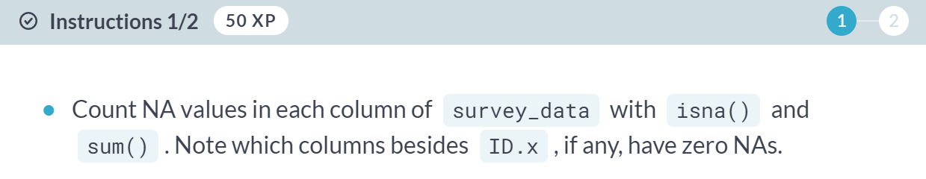

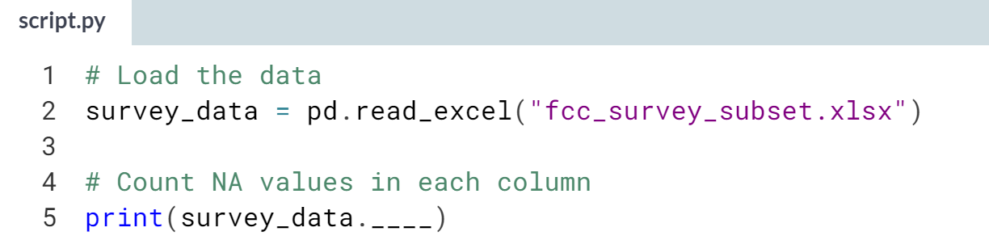

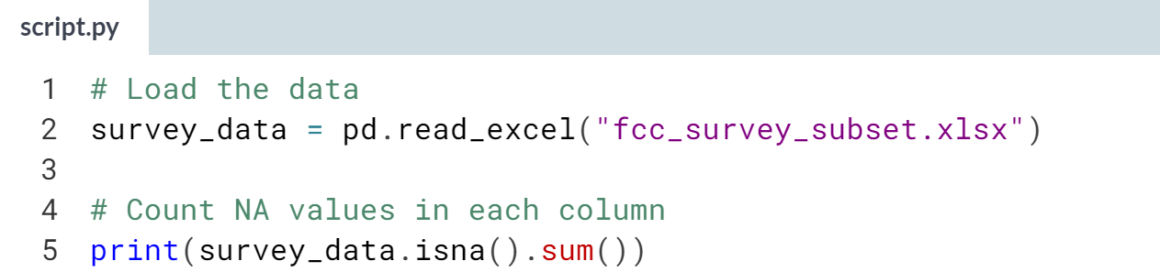

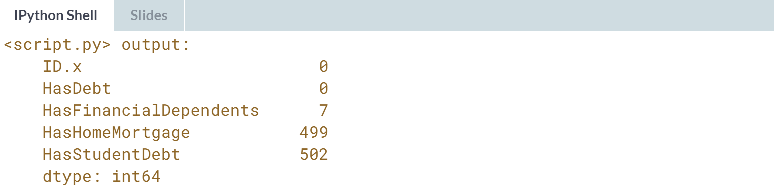  
(Exercise continues on the next page)

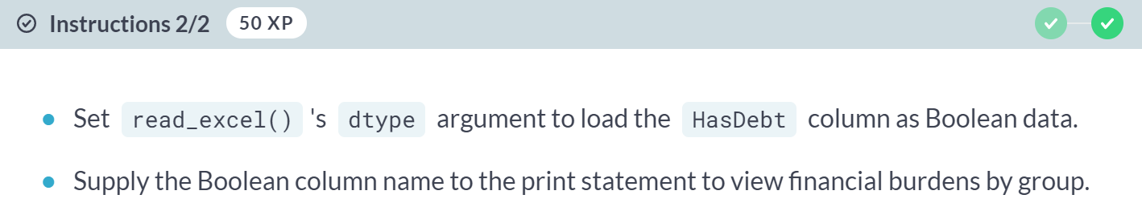

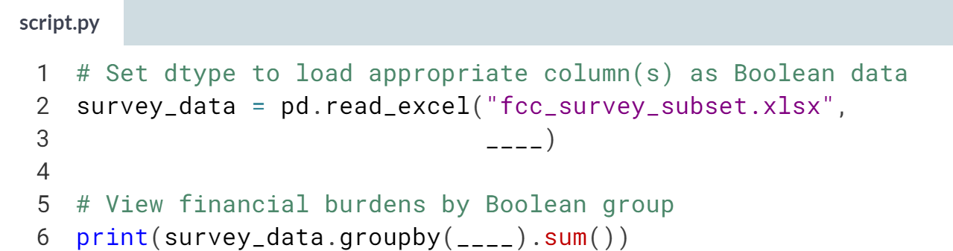

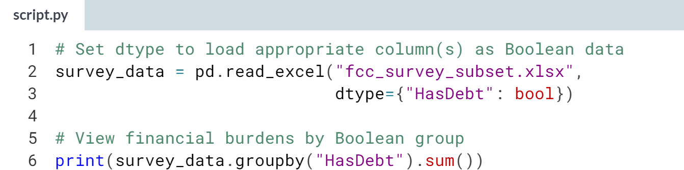

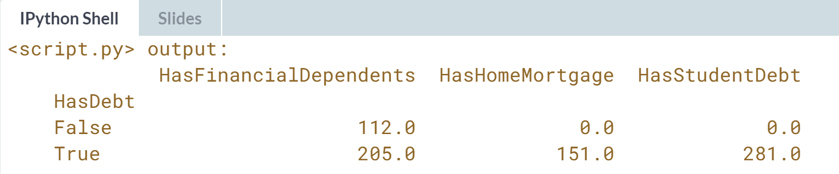

Great work! Modeling True/False data as Booleans can streamline some data manipulation functions and keep spurious summary statistics, like quartile values, from being calculated. If you want to make a column with NA values Boolean, you can load the data, impute missing values, then re-cast the column as Boolean.

# Set custom true/false values

In Boolean columns, pandas automatically recognizes certain values, like "TRUE" and 1, as True, and others, like "FALSE" and 0, as False. Some datasets, like survey data, can use unrecognized values, such as "Yes" and "No".

For practice purposes, some Boolean columns in the New Developer Survey have been coded this way. You'll make sure they're properly interpreted with the help of the true_values and false_values arguments.

pandas is loaded as pd. You can assume the columns you are working with have no missing values.

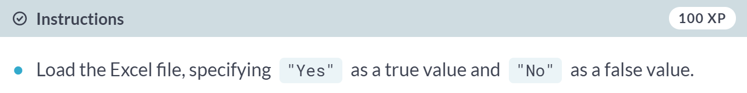

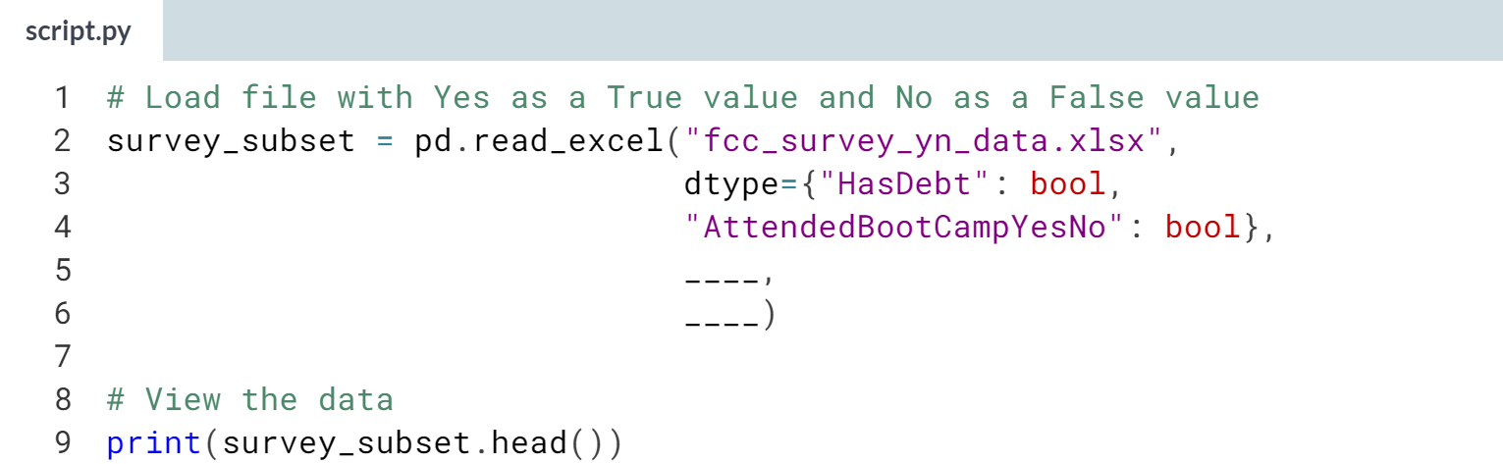

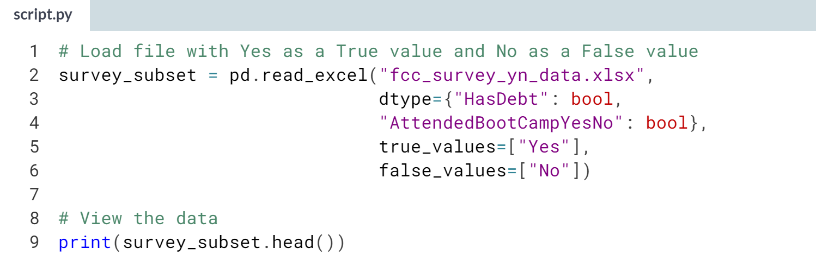  
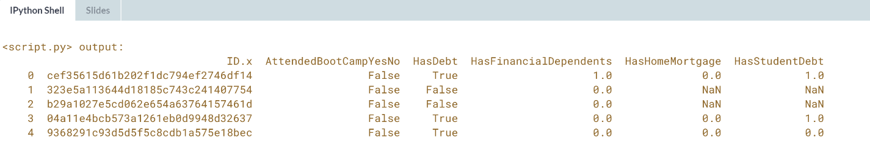  
Bravo! Building a data pipeline that sets Boolean dtypes and uses custom true and false values requires being very familiar with the data. It's a good idea to import the data as-is and explore it before doing so.



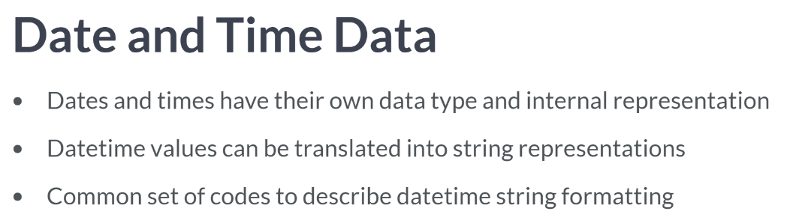

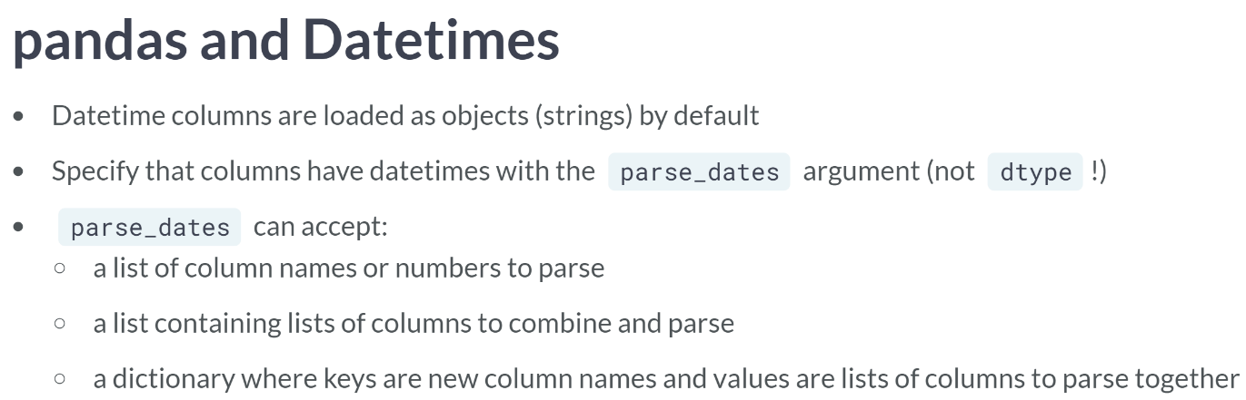

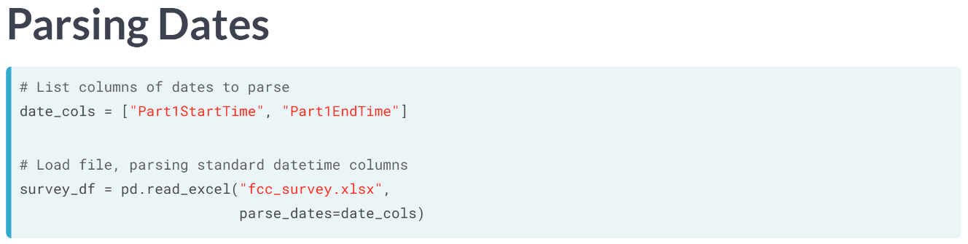  
To parse the dates in standard format, we pass the column names in a list to read Excel's *parse_dates* argument.

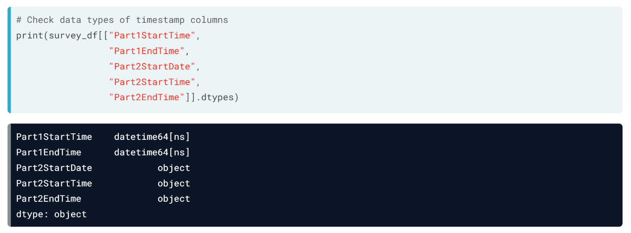  
When we check the dtypes of the timestamp columns, we see the two columns were parsed successfully.

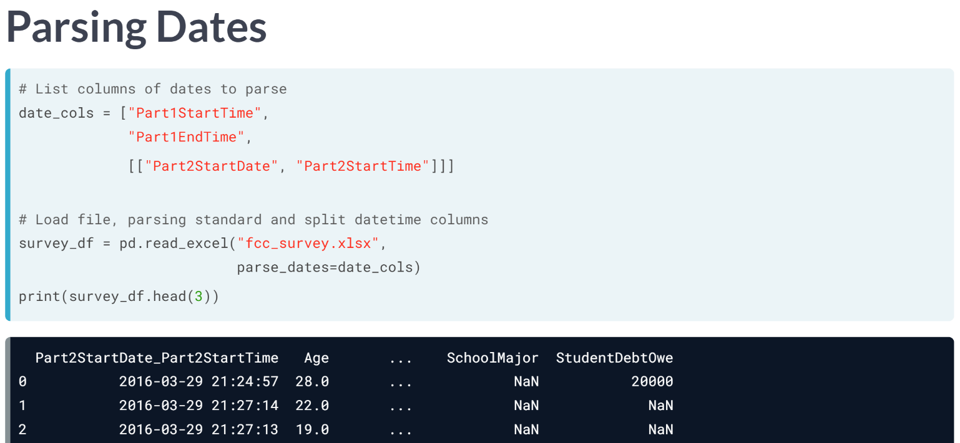  
To parse the split_up timestamp columns, we can add a list within the list, containing Par2StartDate and Part2StartTime, and pass that to parse dates. pandas creates a new combined datetime column, Part2StartDate_Part2StartTime.

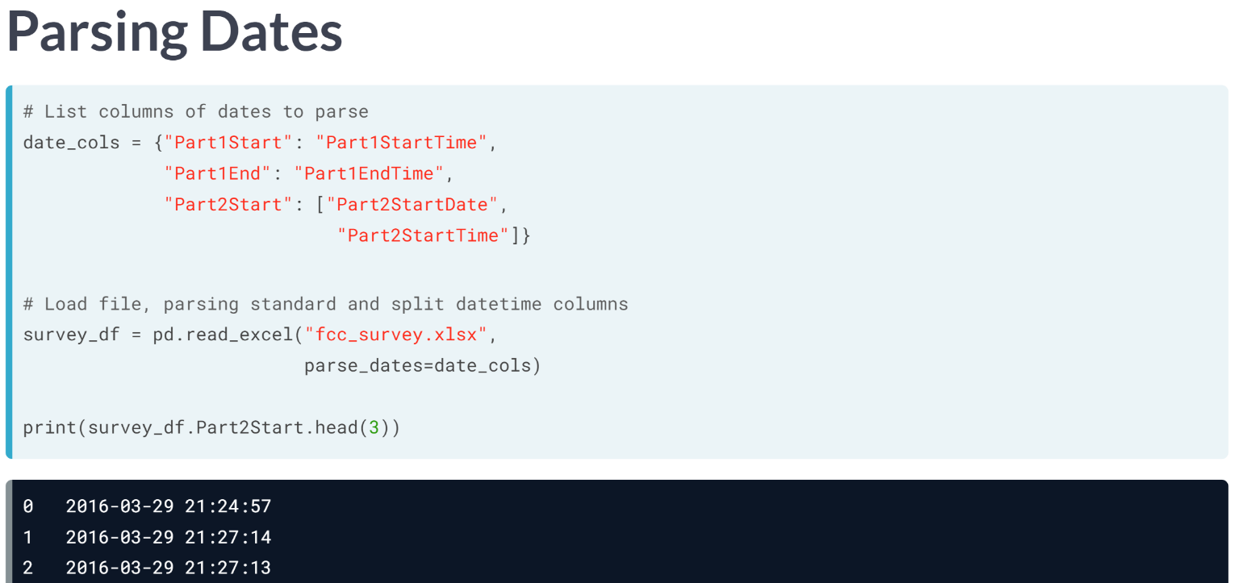  
To control the column names, let's create a dictionary, pass that instead, and view the resulting column.

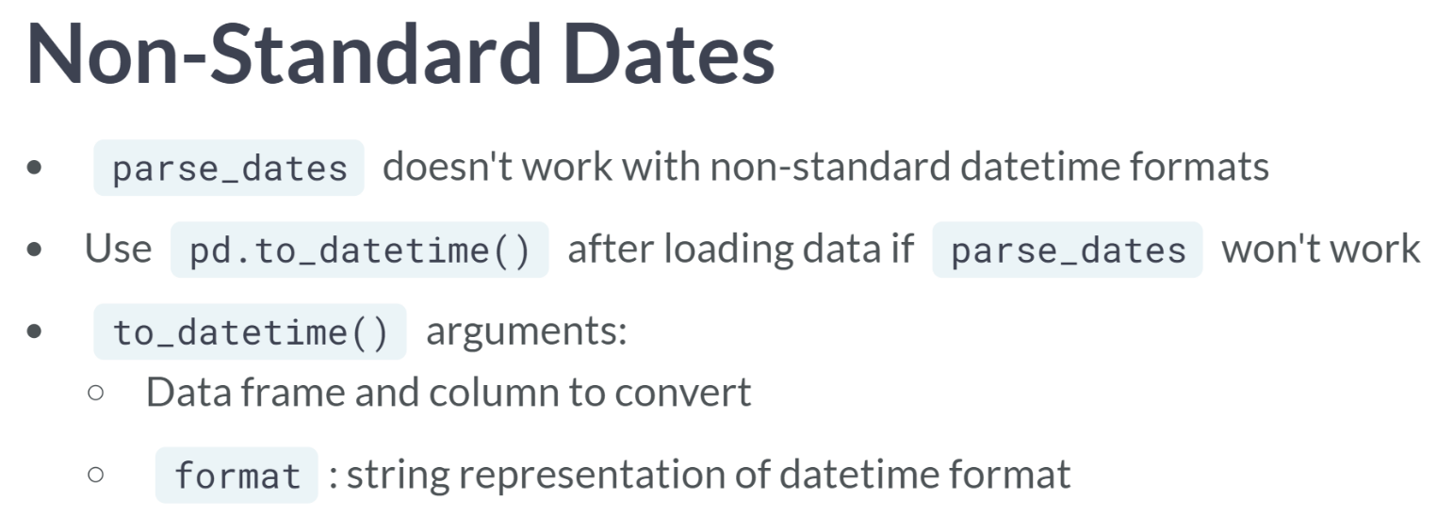

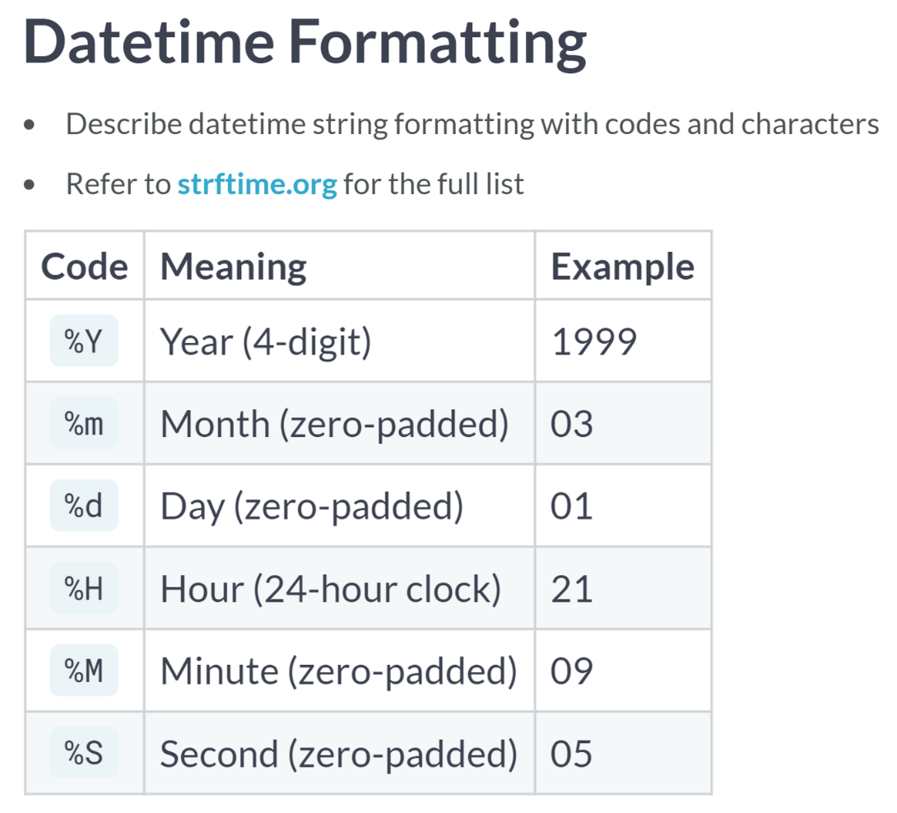

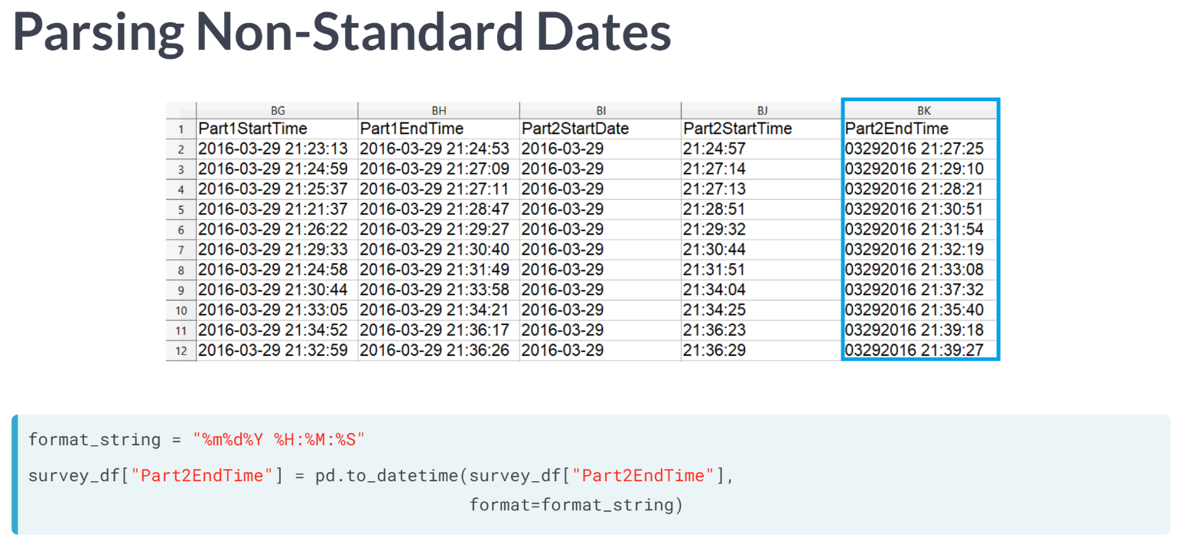

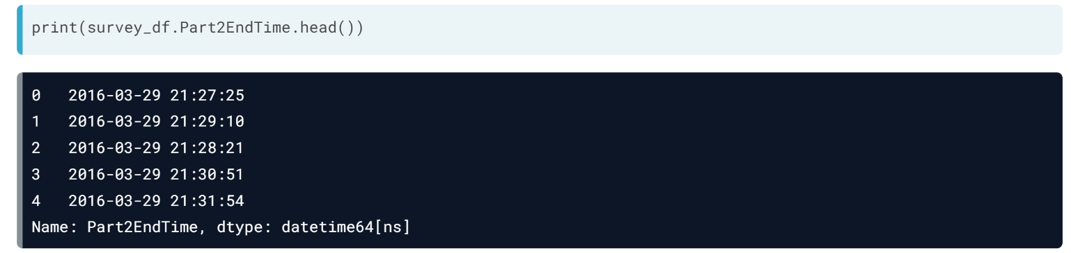

# Parse simple dates

pandas does not infer that columns contain datetime data; it interprets them as object or string data unless told otherwise. Correctly modeling datetimes is easy when they are in a standard format -- we can use the parse_dates argument to tell read_excel() to read columns as datetime data.

The New Developer Survey responses contain some columns with easy-to-parse timestamps. In this exercise, you'll make sure they're the right data type.

pandas has been loaded as pd.

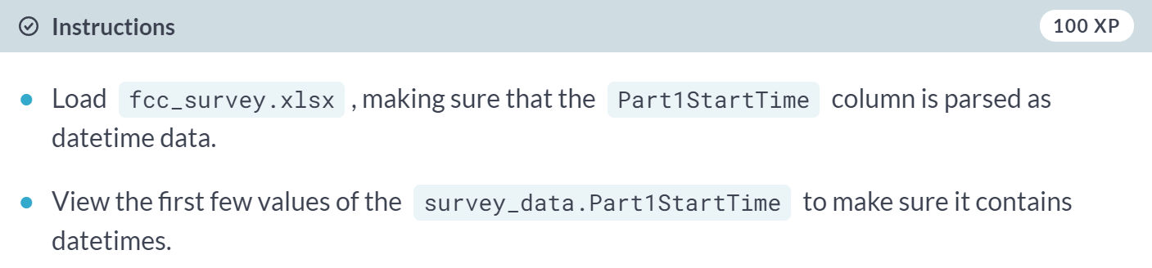

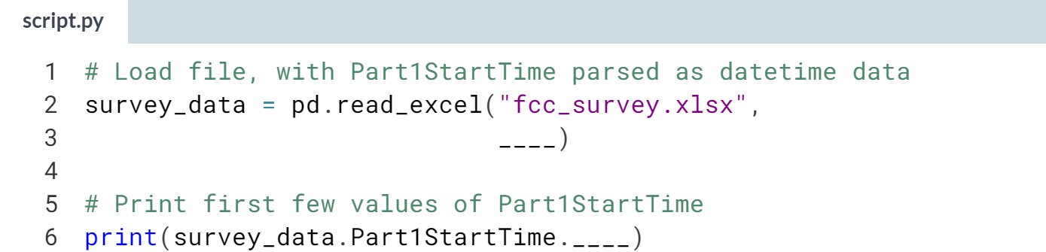

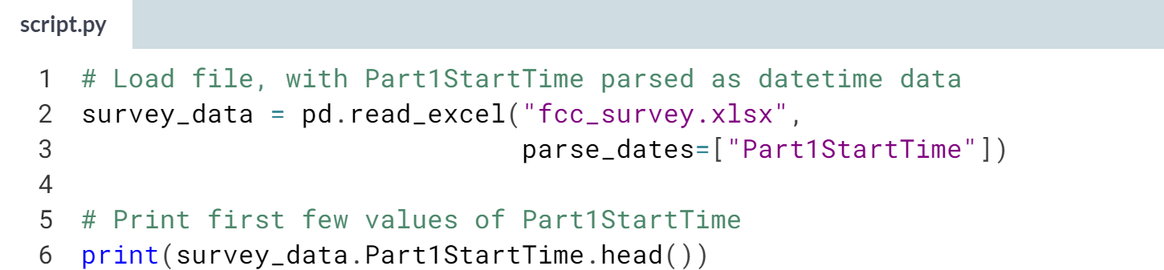  
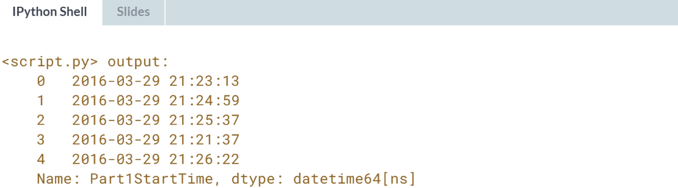  
pandas can automatically parse many common date and time formats. It can even parse standalone times, without dates, but the parsed times will have the date the code was run.

# Get datetimes from multiple columns

Sometimes, datetime data is split across columns. A dataset might have a date and a time column, or a date may be split into year, month, and day columns.

A column in this version of the survey data has been split so that dates are in one column, Part2StartDate, and times are in another, Part2StartTime. Your task is to use read_excel()'s parse_dates argument to combine them into one datetime column with a new name.

pandas has been imported as pd.

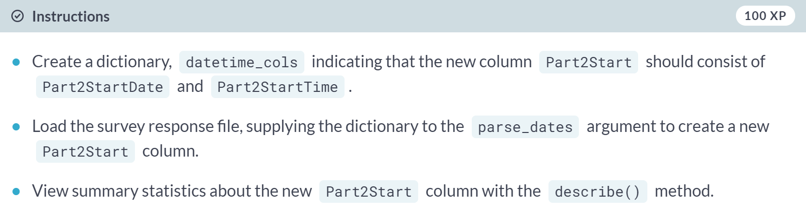

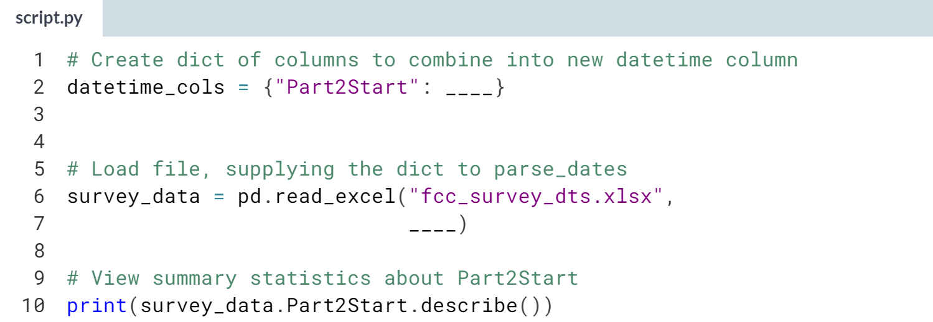  
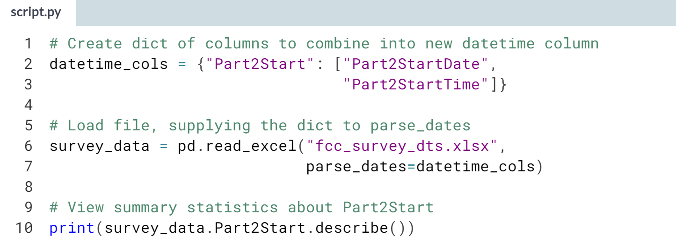

(Result on the next page)

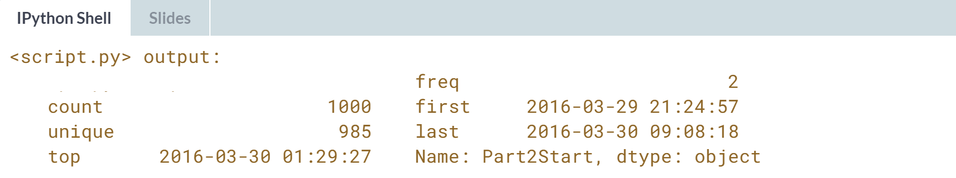

Well done! Note that the keys in a dictionary passed to *parse_dates* cannot be names of columns already in the data frame.

Also, when combining columns to parse, their order in the list does not matter.

# Parse non-standard date formats

So far, you've parsed dates that pandas could interpret automatically. But if a date is in a non-standard format, like 19991231 for December 31, 1999, it can't be parsed at the import stage. Instead, use pd.to_datetime() to convert strings to dates after import.

The New Developer Survey data has been loaded as survey_data but contains an unparsed datetime field. We'll use to_datetime() to convert it, passing in the column to convert and a string representing the date format used.

For more on date format codes, see [**this reference**](http://strftime.org/). Some common codes are year (%Y), month (%m), day (%d), hour (%H), minute (%M), and second (%S).

pandas has been imported as pd.

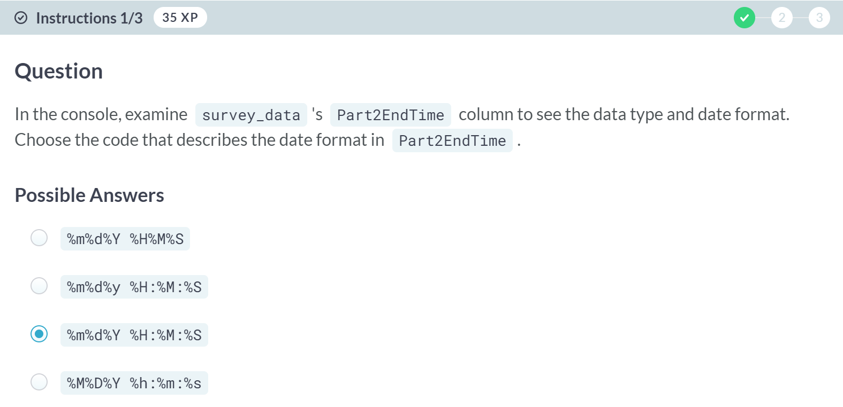

A: Nope, the delimiters in this answer don't match the ones in the data.

B: So close! However, %y represents a year without the century, while these dates have centuries. What should the code be instead?

D: Close, but not quite. Capitalization matters with datetime codes.

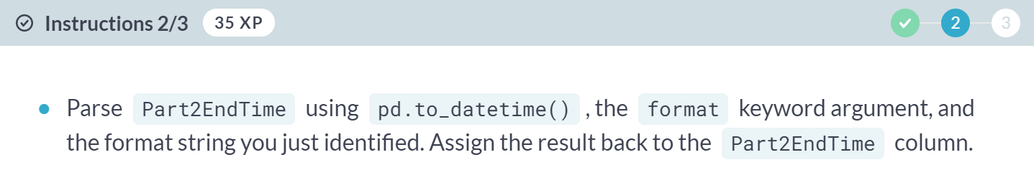

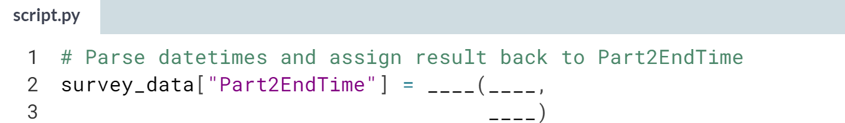

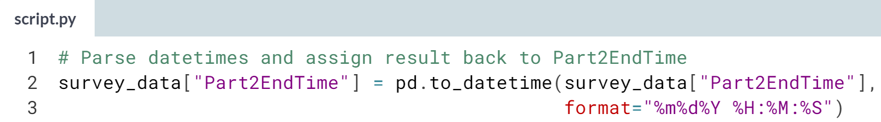

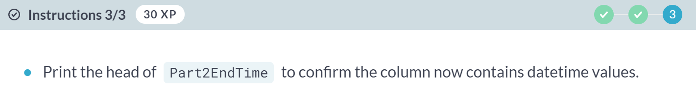

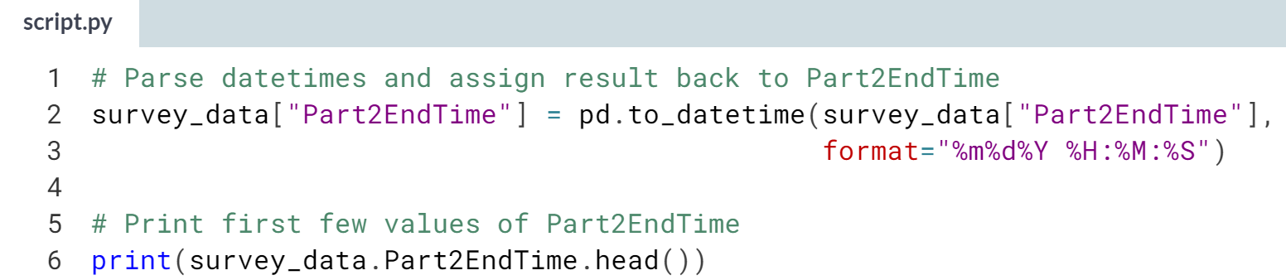

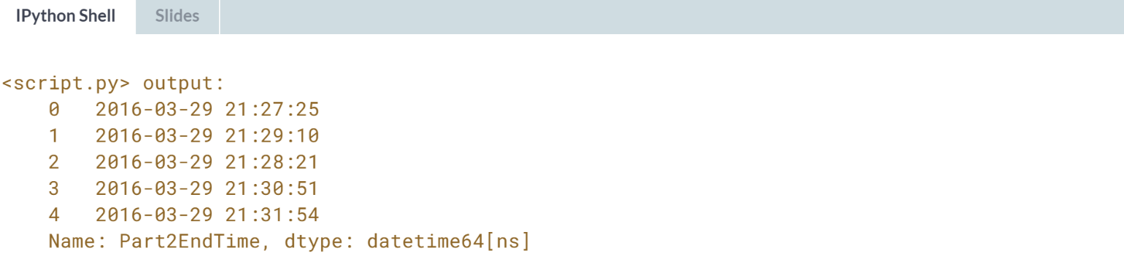

Nice work! Datetime information comes in a variety of formats, and having the skills to parse them lets you perform time-specific operations like calculating intervals.

**3. Importing Data from Databases**

Combine pandas with the powers of SQL to find out just how many problems New Yorkers have with their housing. This chapter features introductory SQL topics like WHERE clauses, aggregate functions, and basic joins.



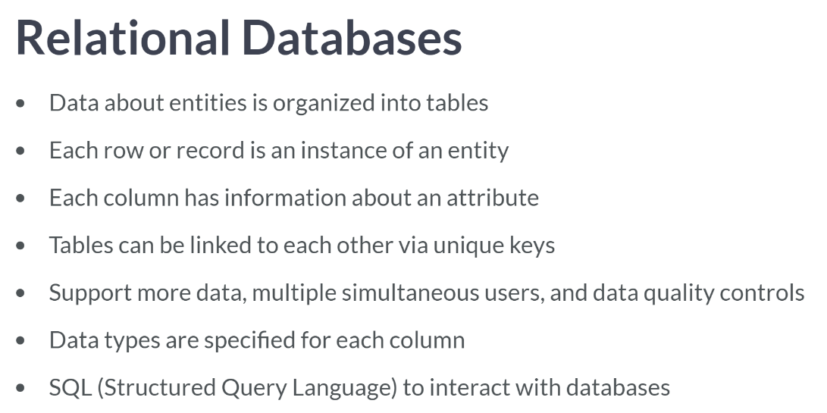

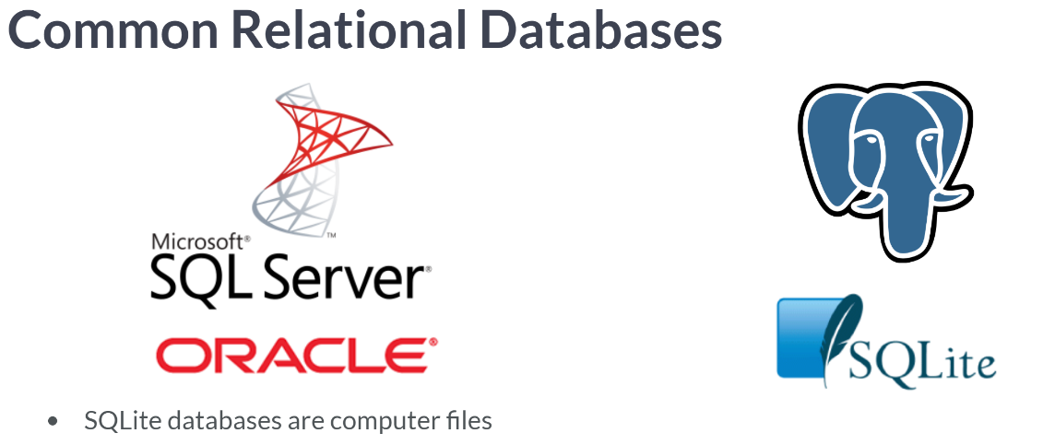

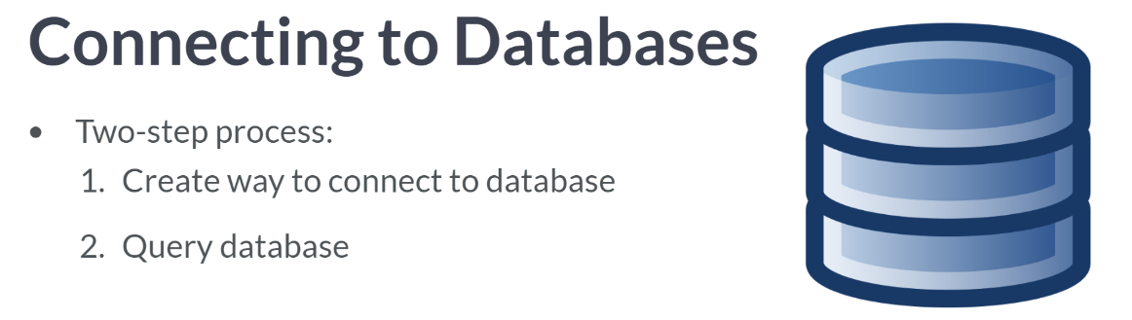

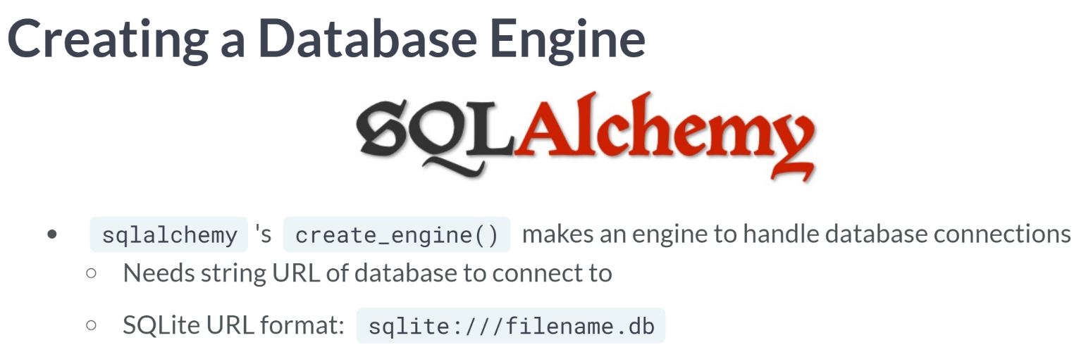  
***create_engine()*** takes a string URL to a database and makes an engine object that manages database connections. URLs follow a pattern that varies slightly depending on the database.

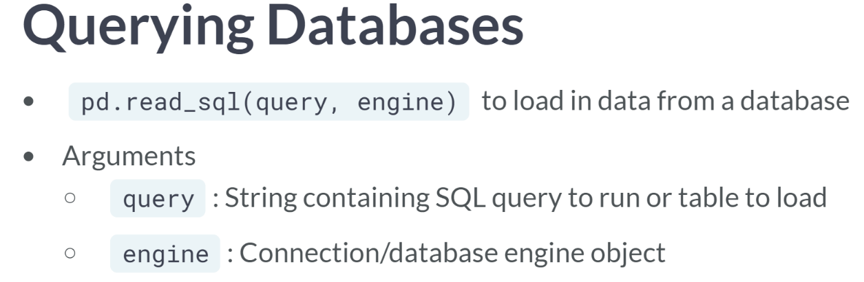

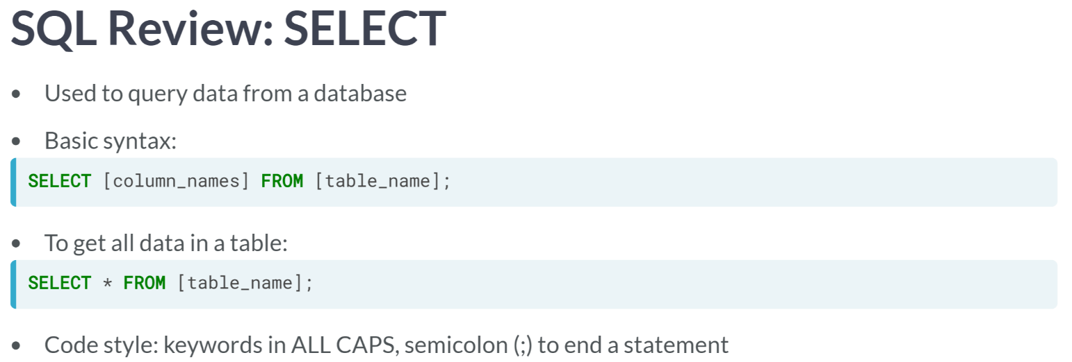

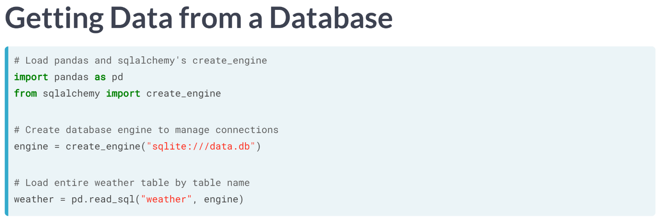  
Let's use what we've just learned to fetch weather data from SQLite database containing information about NYC. We import pandas as pd, plus the *create_engine* function from SQLAlchemy.

Then we make the engine object, passing the database URL string to create engine function. Since we want everything in the weather table, we can make the first argument to read SQL the table name as a string.

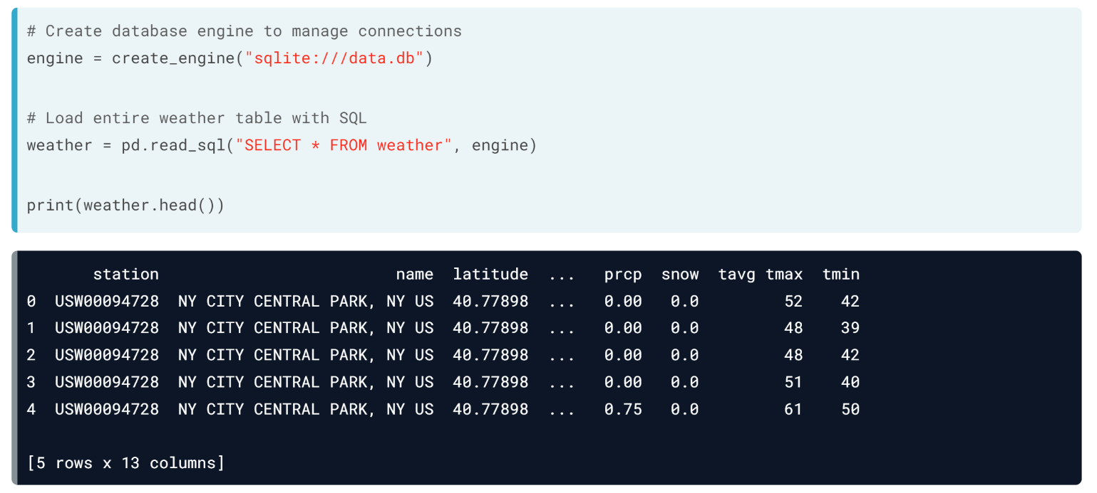  
Otherwise, we can use the SQL statement "SELECT * FROM weather" as the first argument while supplying engine object as the second argument. Then, we can check out our new data frame.

# Connect to a database

In order to get data from a database with pandas, you first need to be able to connect to one. In this exercise, you'll practice creating a database engine to manage connections to a database, data.db. To do this, you'll use sqlalchemy's create_engine() function.

create_engine() needs a string URL to the database. For SQLite databases, that string consists of "sqlite:///", then the database file name.

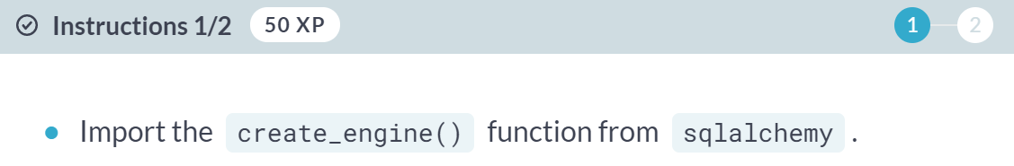

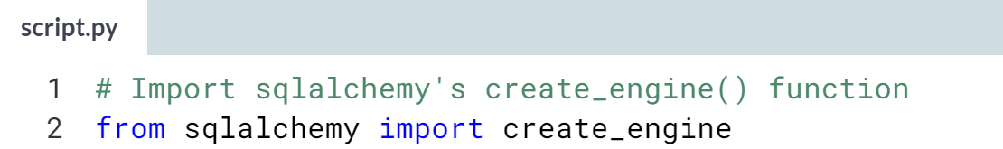

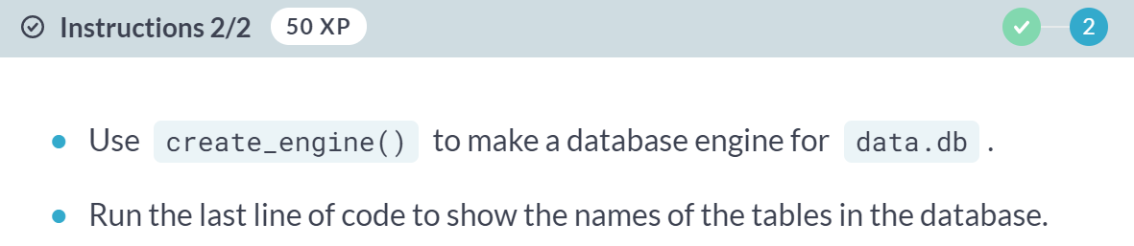

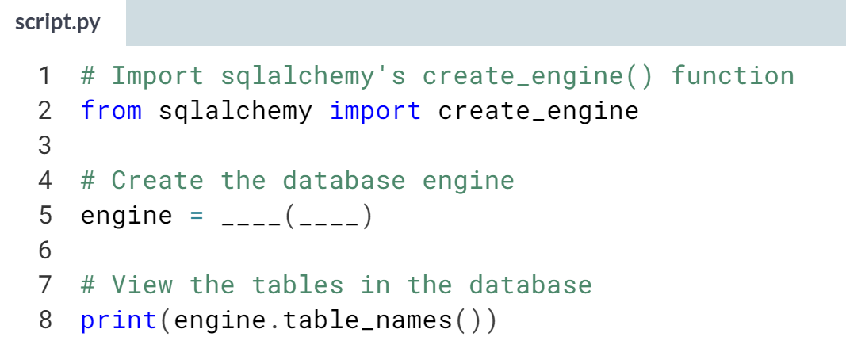

(Solution on the next page)

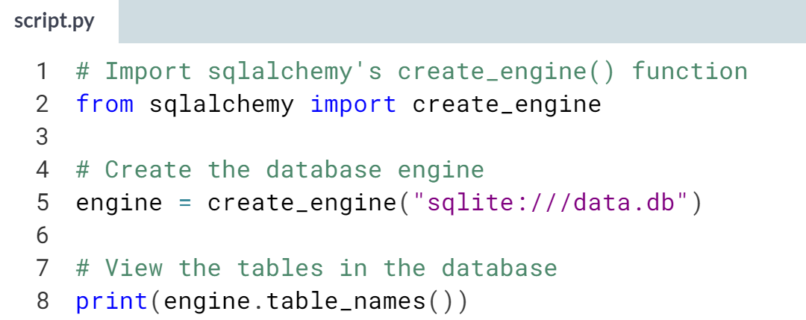

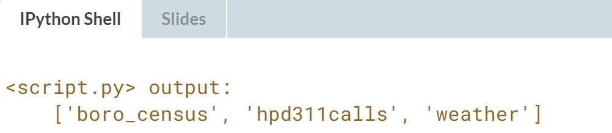

Well done! *sqlalchemy* is a powerful library that can be used with *pandas* to both query databases for analysis and write results back to database tables.

# Load entire tables

In the last exercise, you saw that data.db has two tables. weather has historical weather data for New York City. hpd311calls is a subset of call records made to the city's 311 help line about housing issues.

In this exercise, you'll use the read_sql() function in pandas to load both tables. read_sql() accepts a string of either a SQL query to run, or a table to load. It also needs a way to connect to the database, like the engine in the provided code.

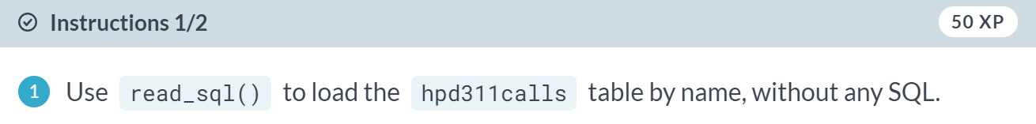

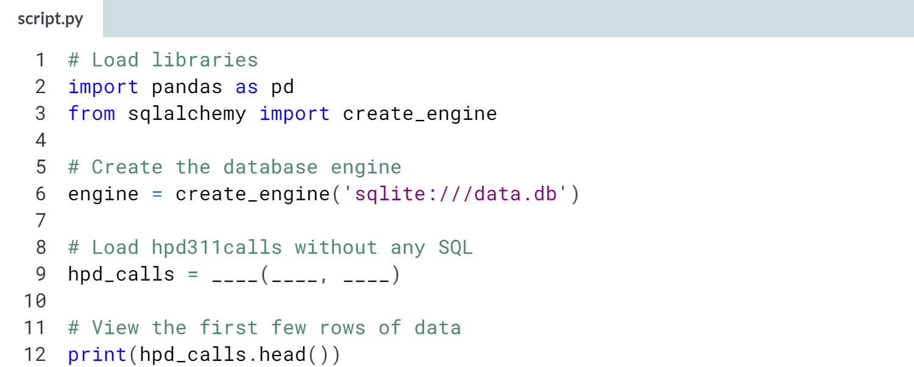

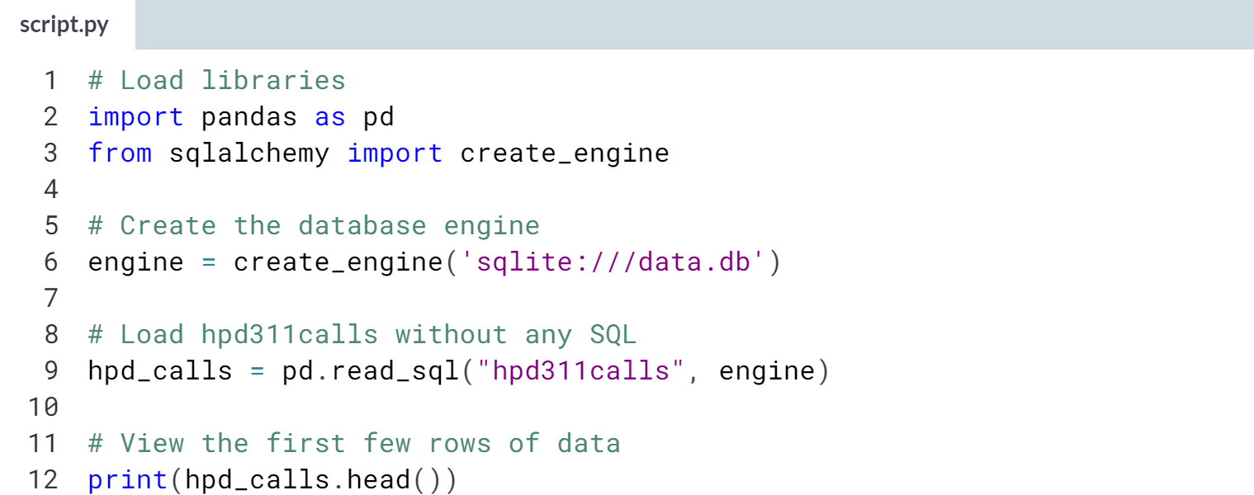  
(Result on the next page)

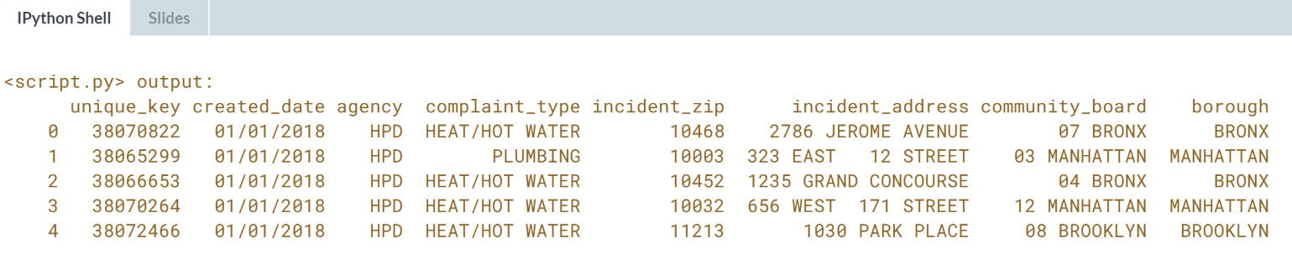

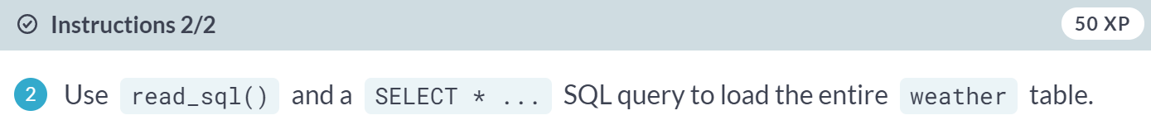

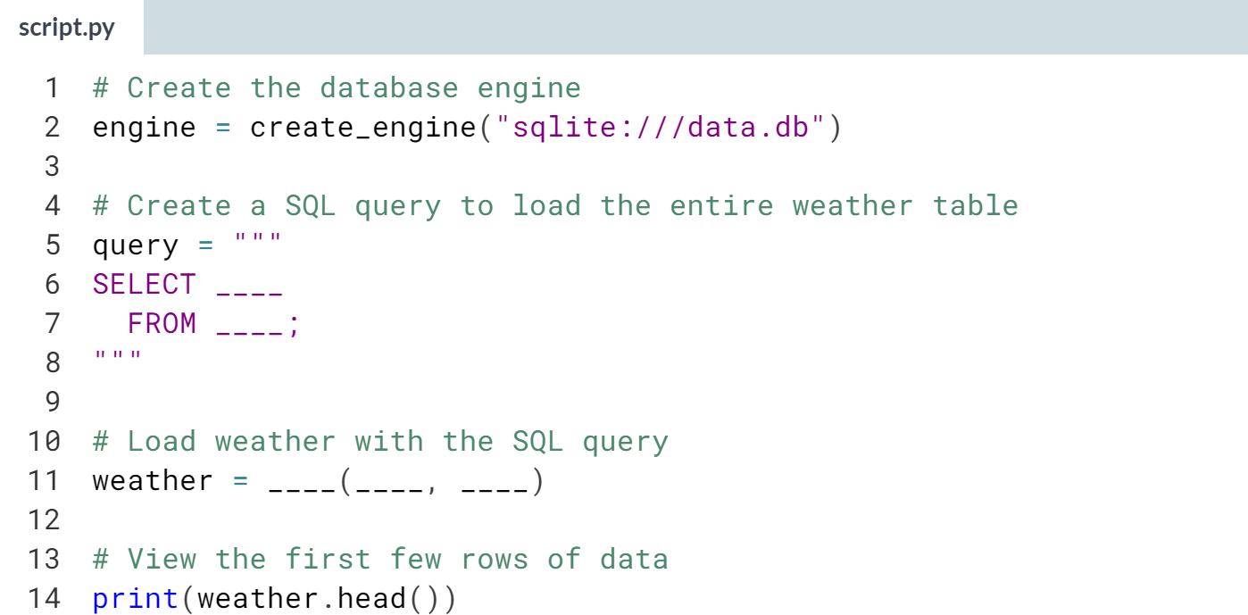

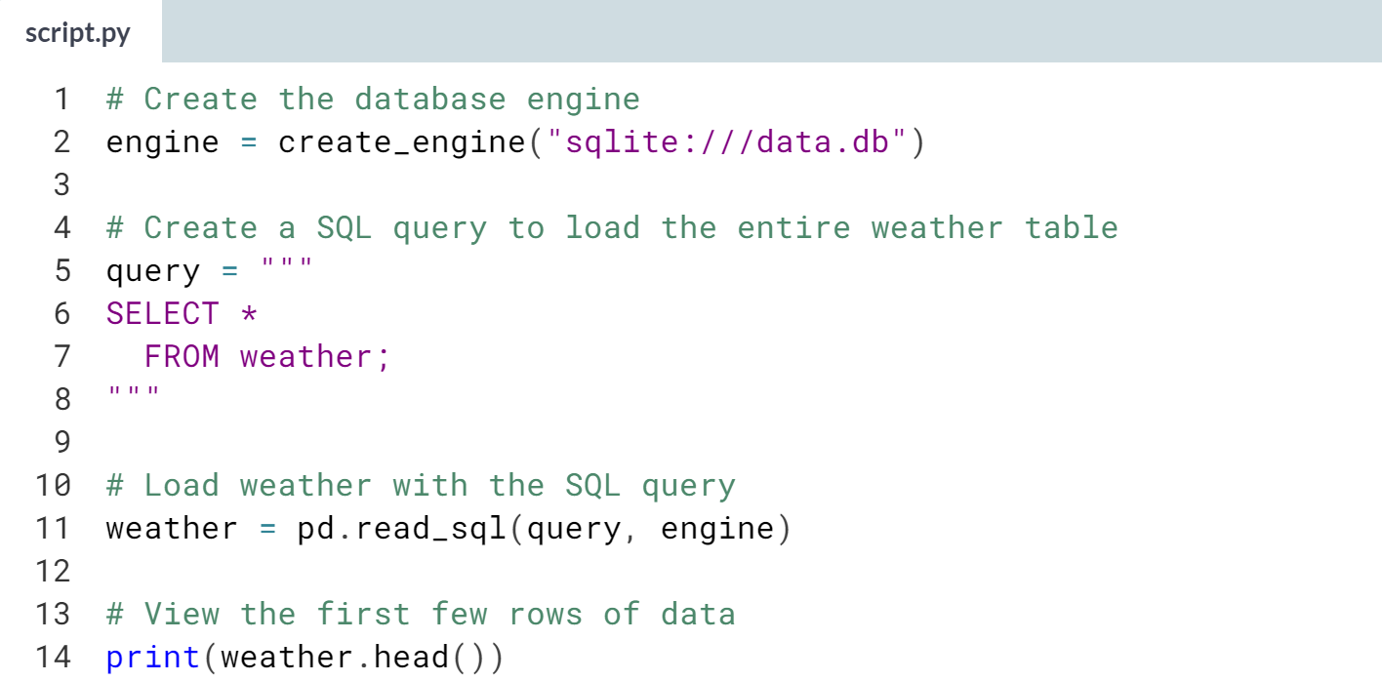

(Result on the page)

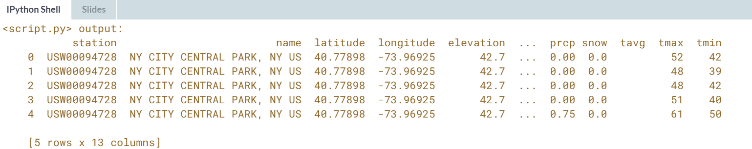

While it's convenient to load tables by name alone, using SQL queries makes it possible to fine-tune imports at the data acquisition phase of an analysis project.



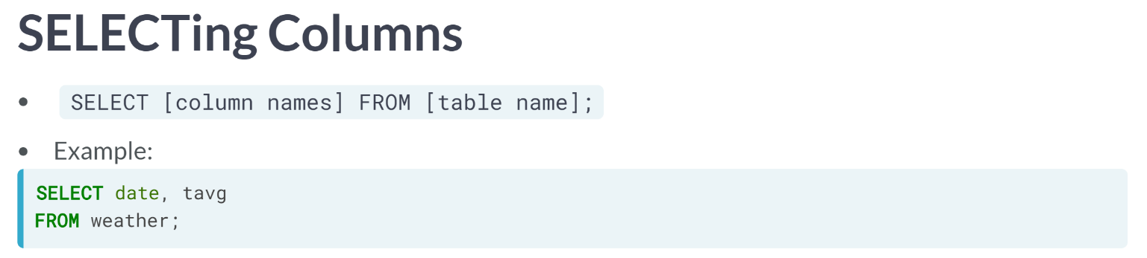

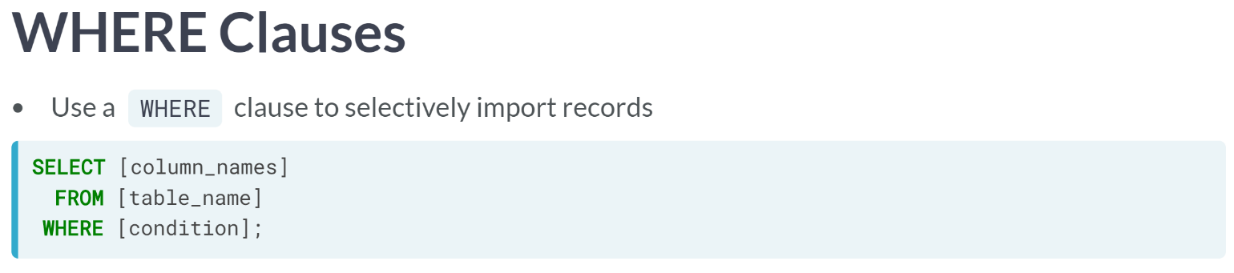

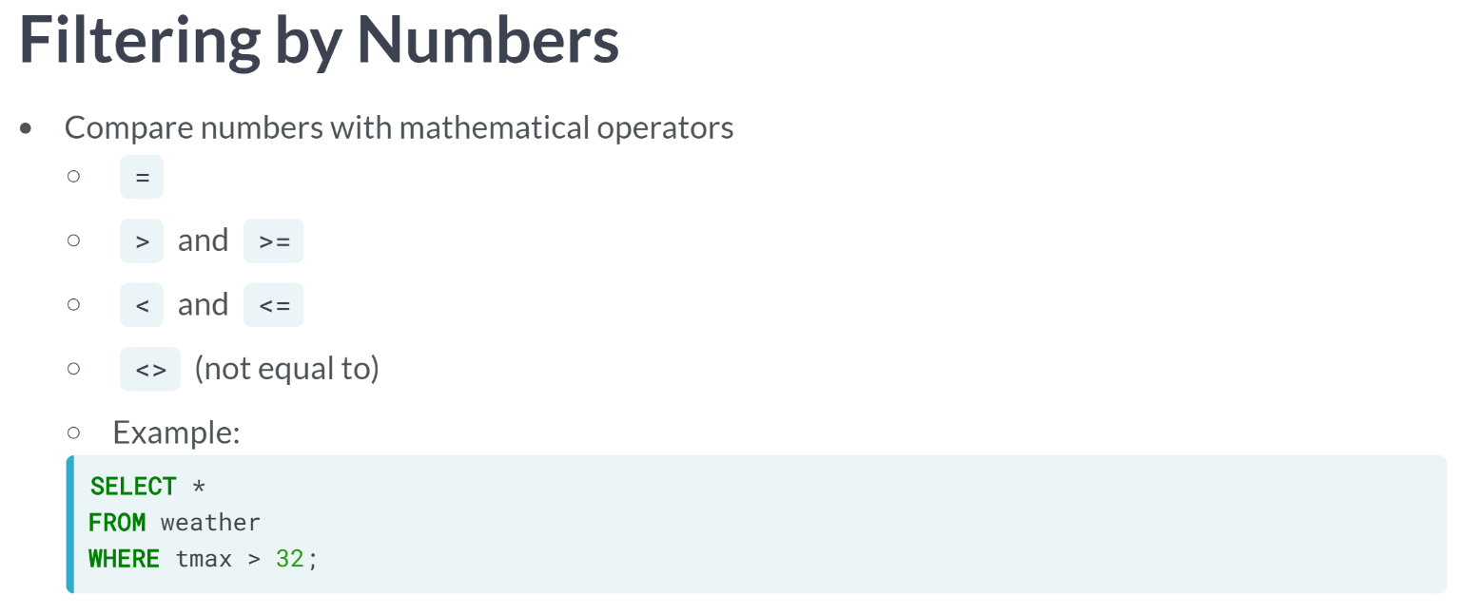  
The weather data contains Fahrenheit temperatures, so the SQL query to get all days with a high temperature above freezing would be as shown above.

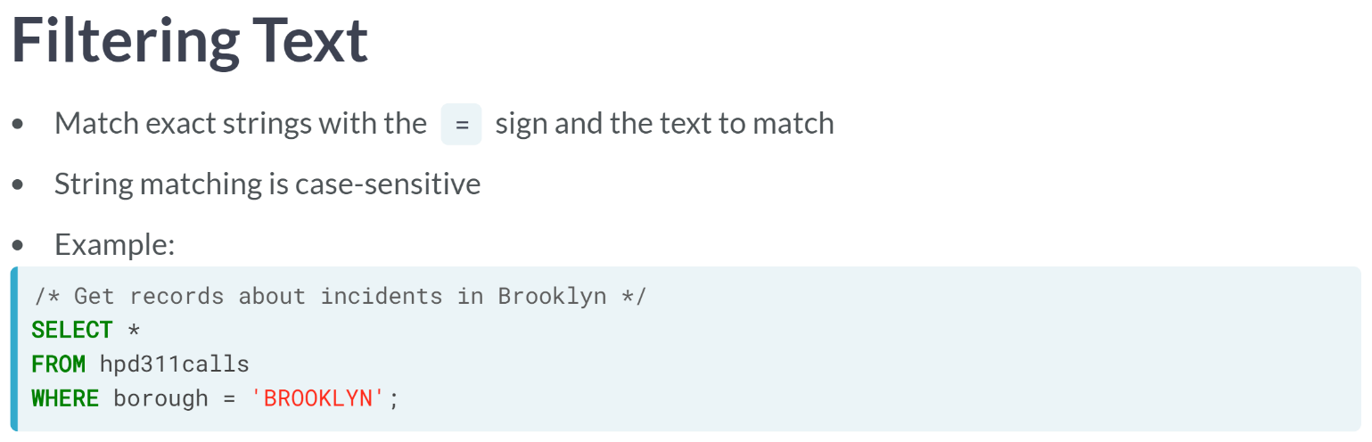  
To get call records about incidents in the borough of Brooklyn, the query would be as shown above.

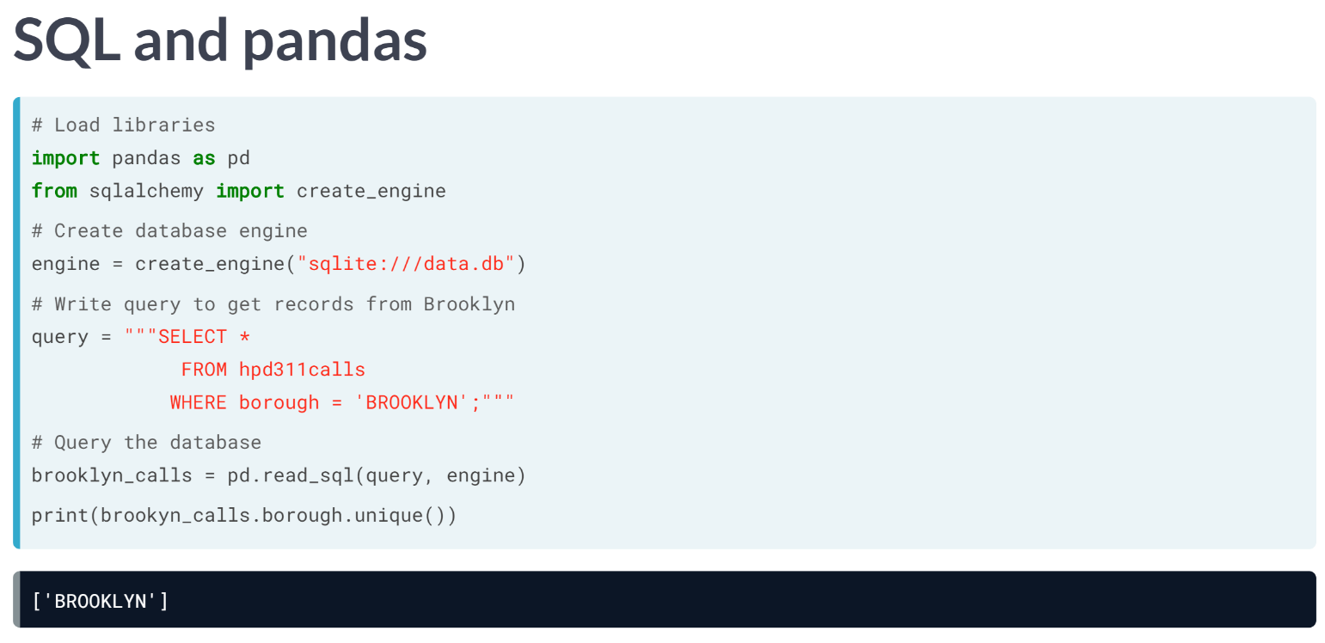  
Let's combine SQL and Python to get Brooklyn calls. We load libraries and create database engines as before, but since our SQL queries are getting more complicated, we'll write out the query first and assign it to the variable, "query".

Wrapping the string in triple quotes lets us split it between multiple lines so it's easier to read. Then, we pass the query and engine to read SQL. When we check the unique borough values in the resulting data frame, we see there are only Brooklyn calls.

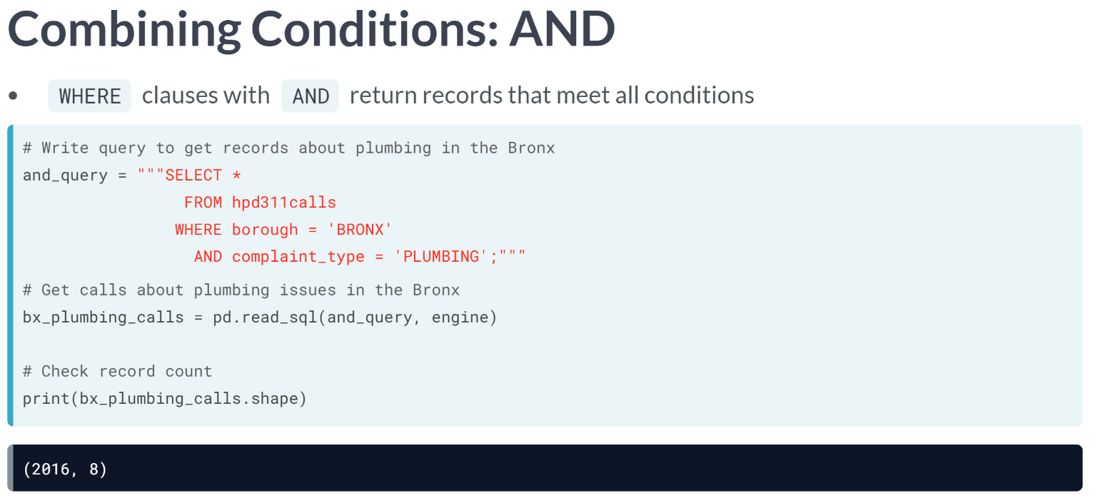  
We can even combine conditions with SQL's AND and OR operators. Passing the AND operator as shown above will query the data that is only related to Bronx and plumbing type.

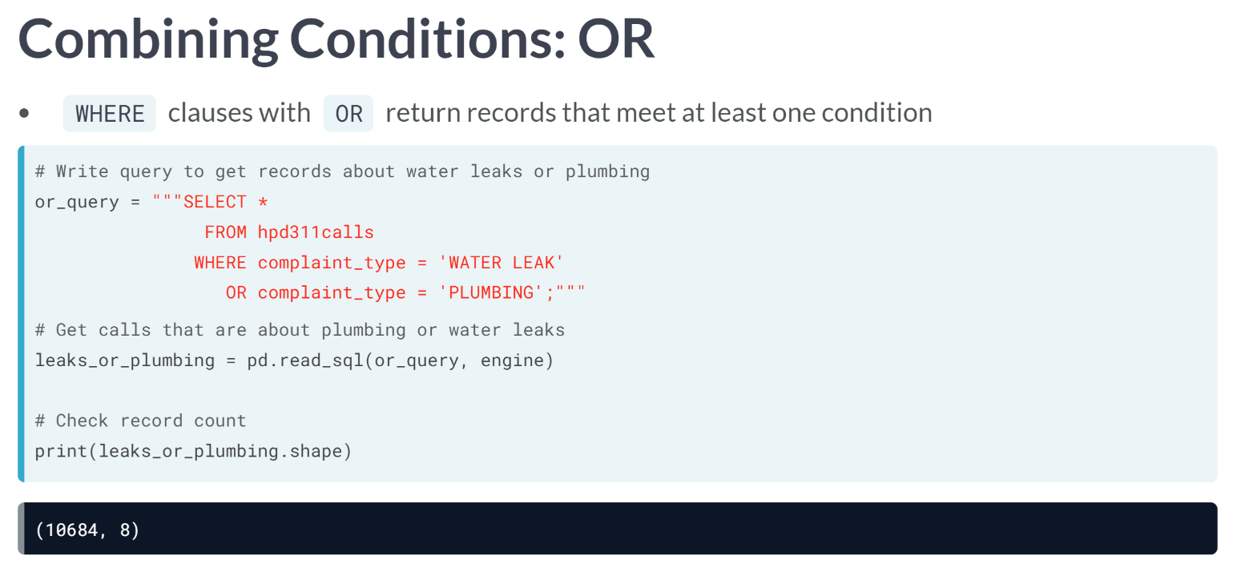

# Selecting columns with SQL

Datasets can contain columns that are not required for an analysis, like the weather table in data.db does. Some, such as elevation, are redundant, since all observations occurred at the same place, while others contain variables we are not interested in.

After making a database engine, you'll write a query to SELECT only the date and temperature columns, and pass both to read_sql() to make a data frame of high and low temperature readings.

pandas has been loaded as pd, and create_engine() has been imported from sqlalchemy.

**Note**: The SQL checker is quite picky about column positions and expects fields to be selected in the specified order.

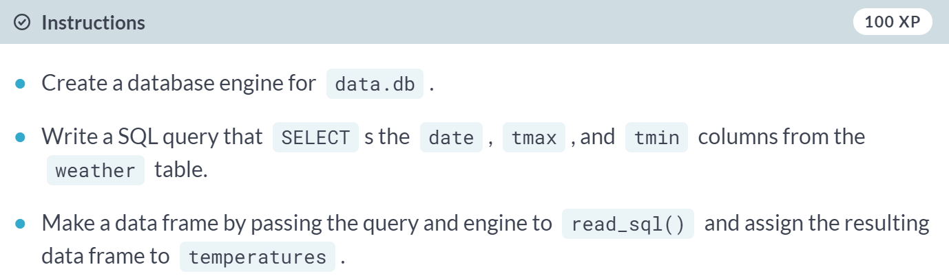

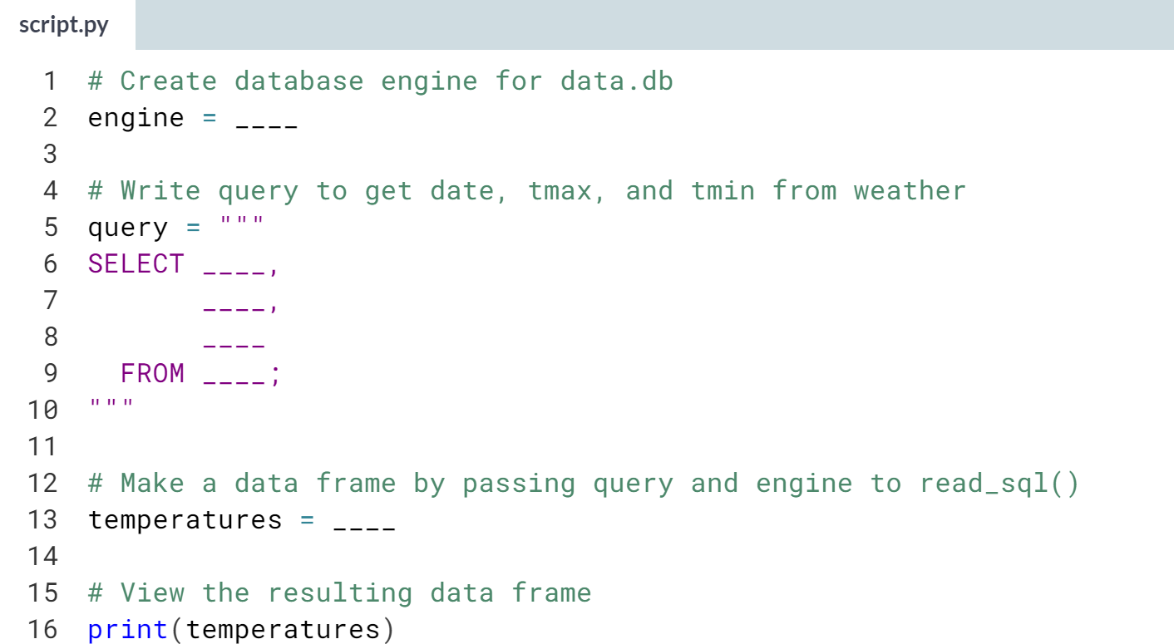  
(Solution on the next page)

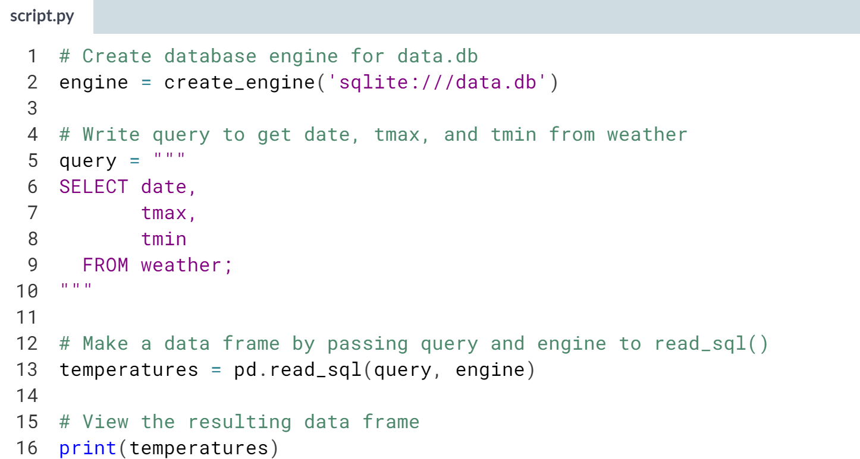  
Selecting columns is useful when you only want a few columns from a table. If you want most of the columns, it may be easier to load them all and then use pandas to drop unwanted columns.

# Selecting rows

SQL WHERE clauses return records whose values meet the given criteria. Passing such a query to read_sql() results in a data frame loaded with only records we are interested in, so there is less filtering to do later on.

The hpd311calls table in data.db has data on calls about various housing issues, from maintenance problems to information requests. In this exercise, you'll use SQL to focus on calls about safety.

pandas has been loaded as pd, and a database engine, engine, has been created for data.db.

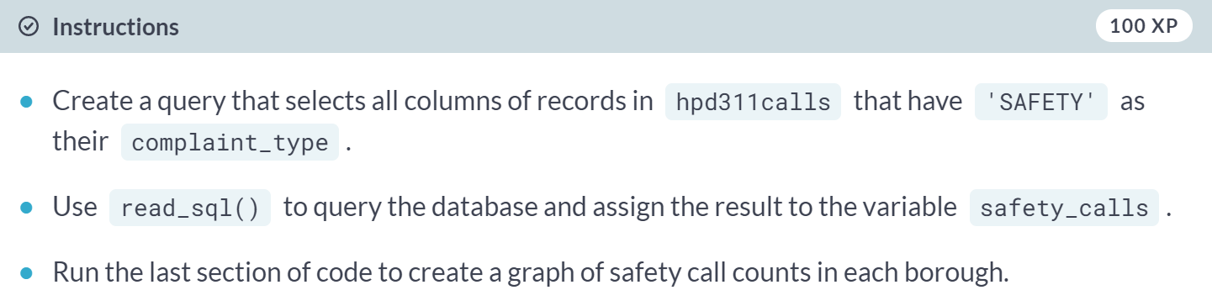

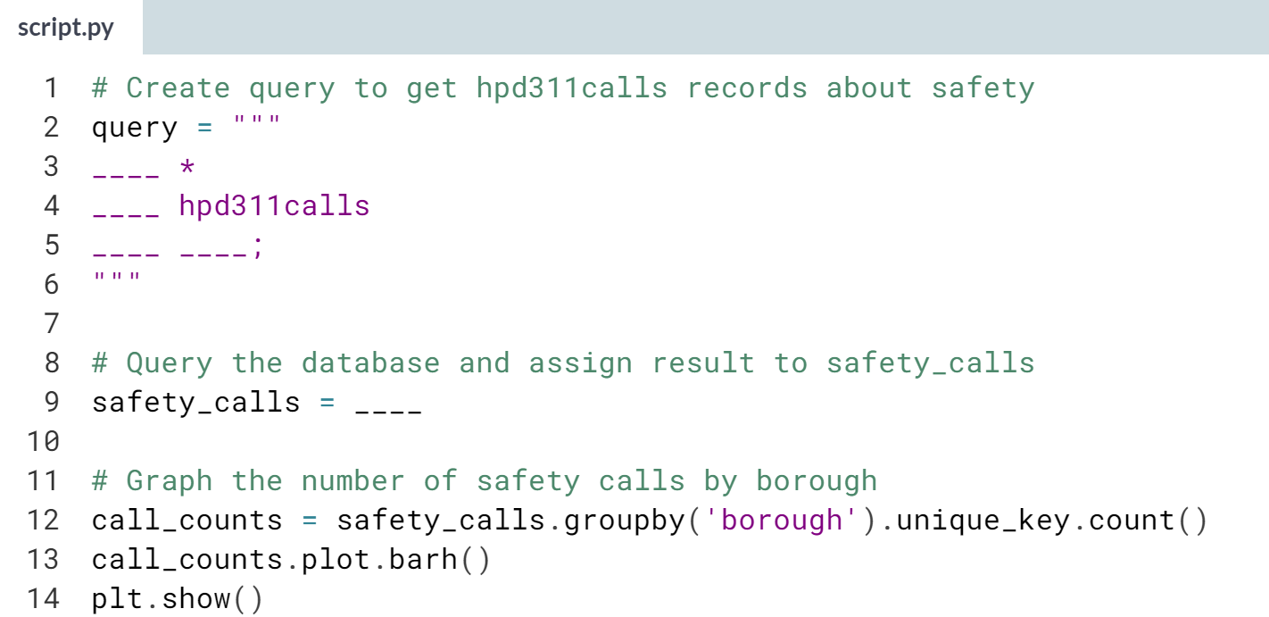

(Solution on the next page)

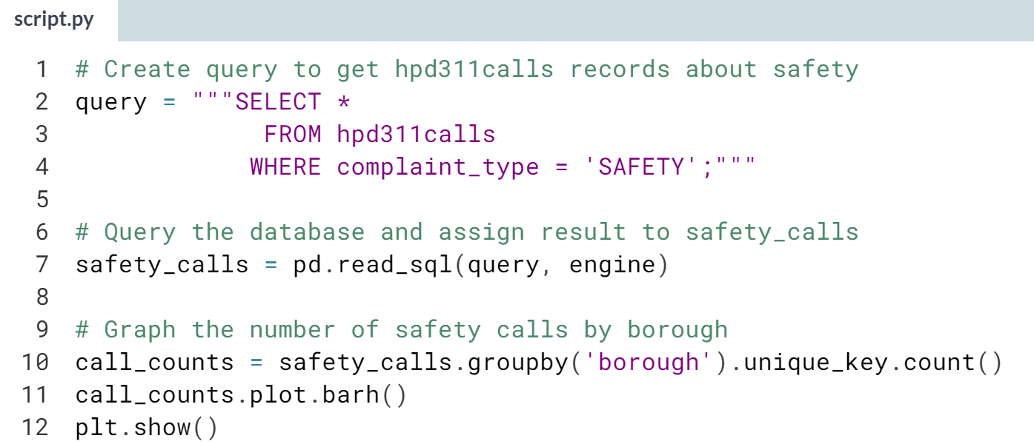

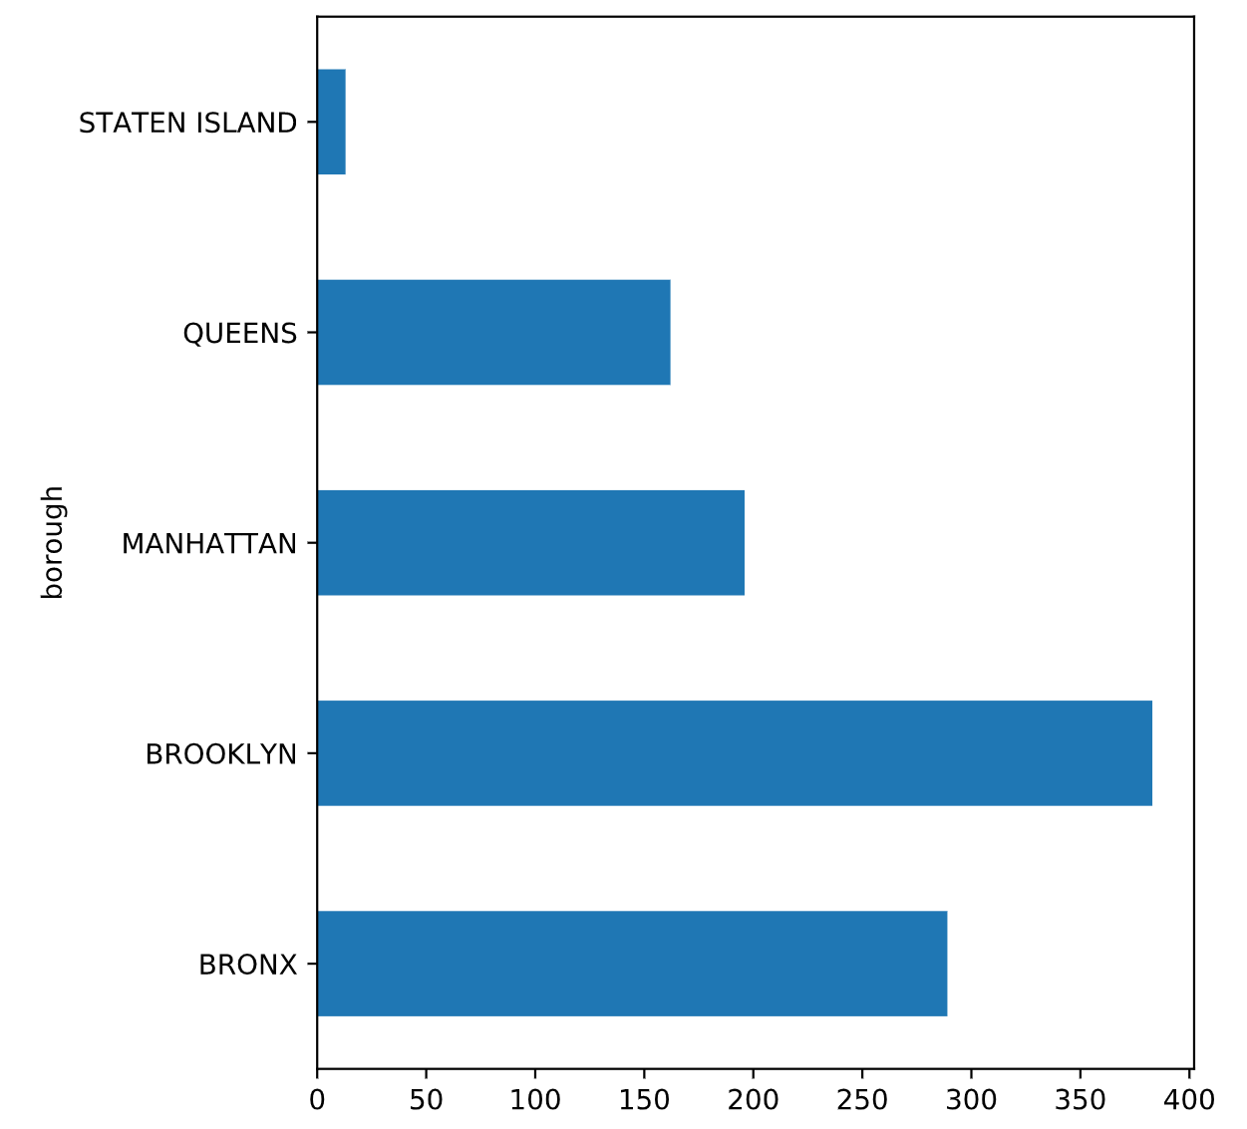  
Well done! Filtering data before importing can help you focus on specific records, but it can also be used as a data cleaning technique to exclude records with known errors or missing values.

# Filtering on multiple conditions

So far, you've selectively imported records that met a single condition, but it's also common to filter datasets on multiple criteria. In this exercise, you'll do just that.

The weather table contains daily high and low temperatures and precipitation amounts for New York City. Let's focus on inclement weather, where there was either an inch or more of snow or the high was at or below freezing (32° Fahrenheit). To do this, you'll need to build a query that uses the OR operator to look at values in both columns.

pandas is loaded as pd, and a database engine, engine, has been created.

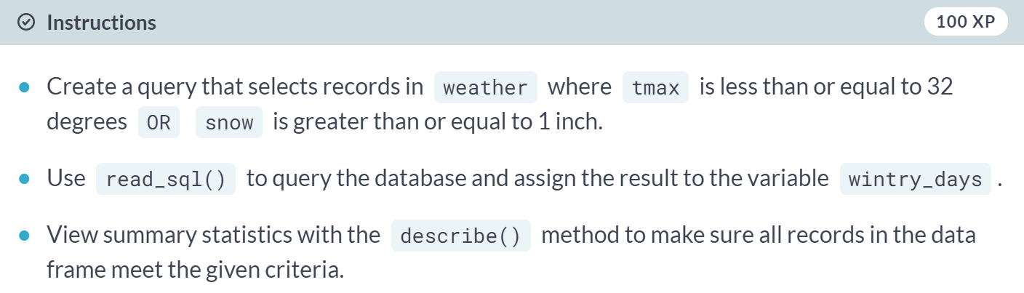

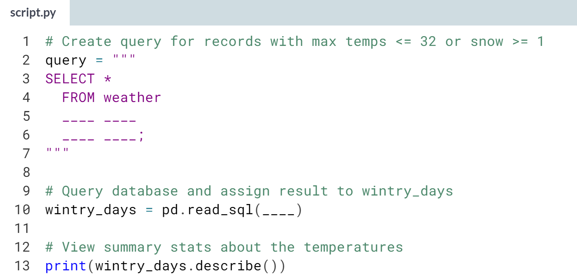

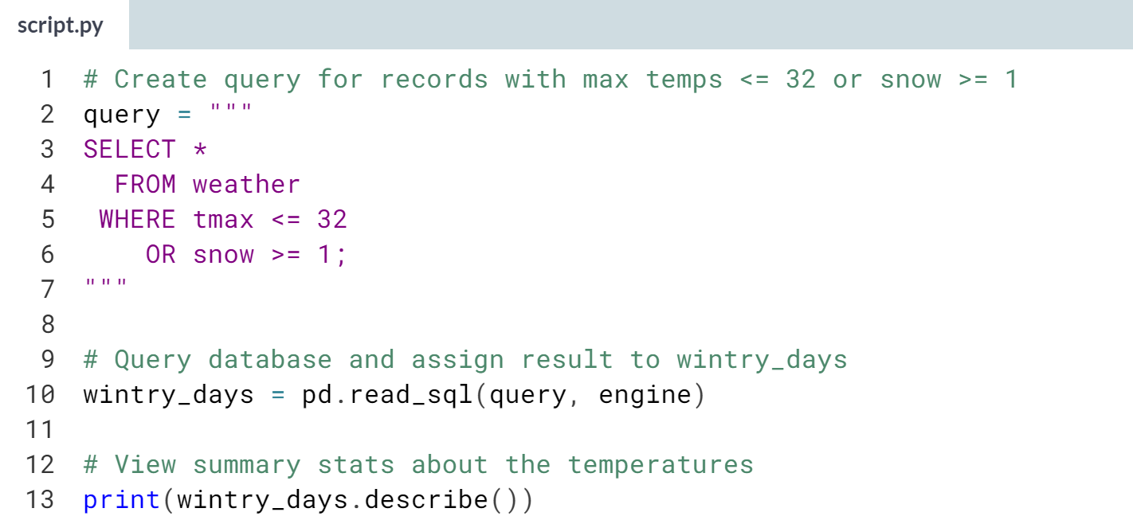

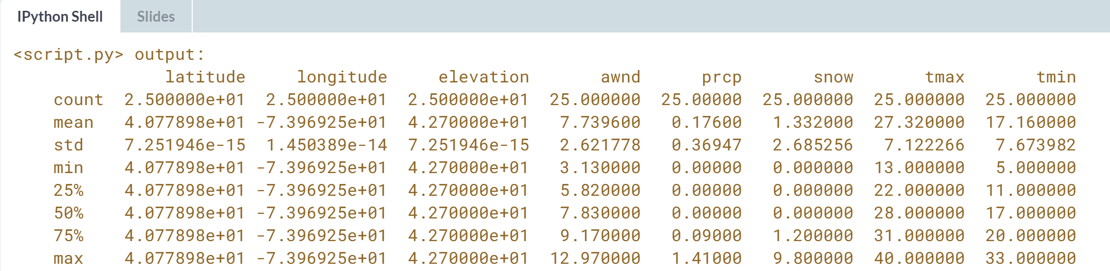

Nice work. SELECT statements can use multiple AND and OR operators to filter data. Like arithmetic, you can control the order of operations with parentheses.



We will take advantage of SQL's feature to wrangle data in ways that cannot be done at the import stage using pandas alone.

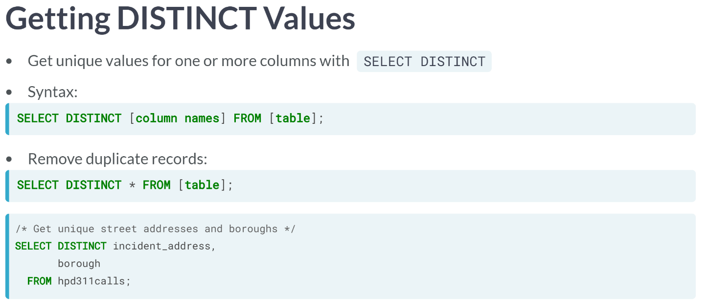

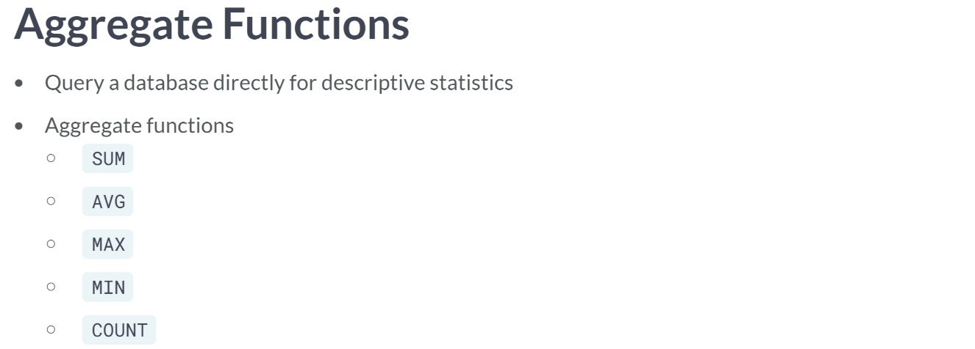  
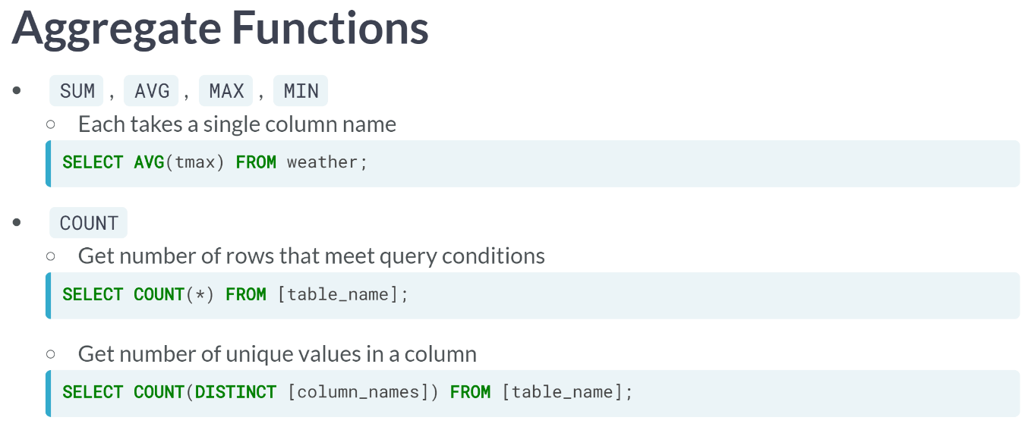

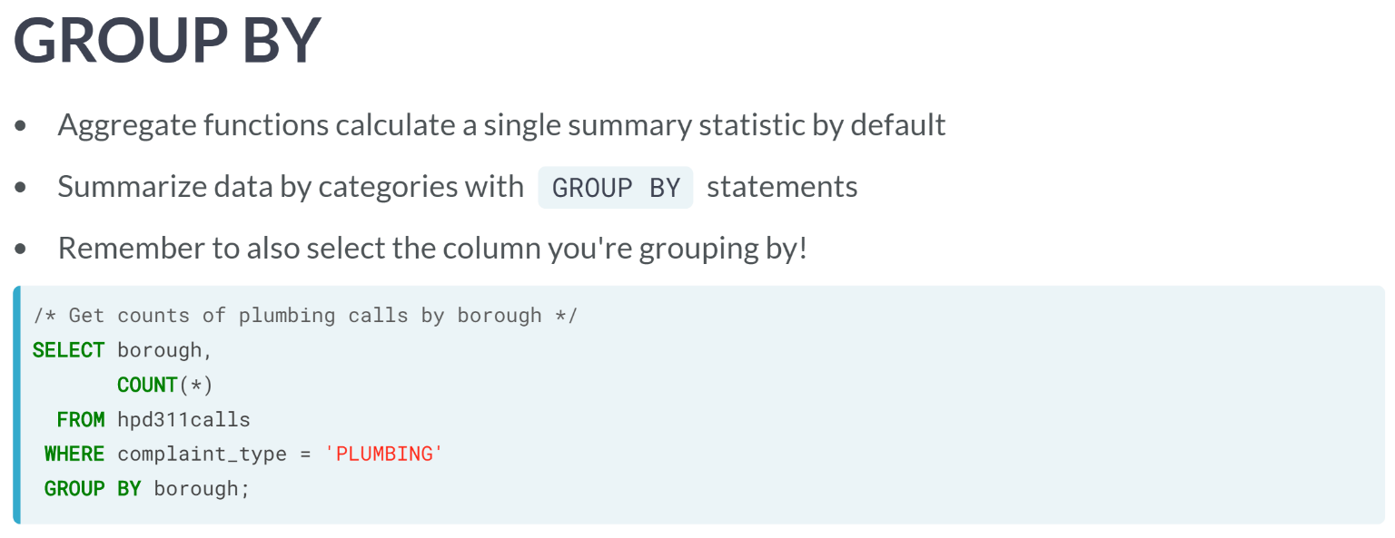  
The query to get count of plumbing complaints by borough is shown above.

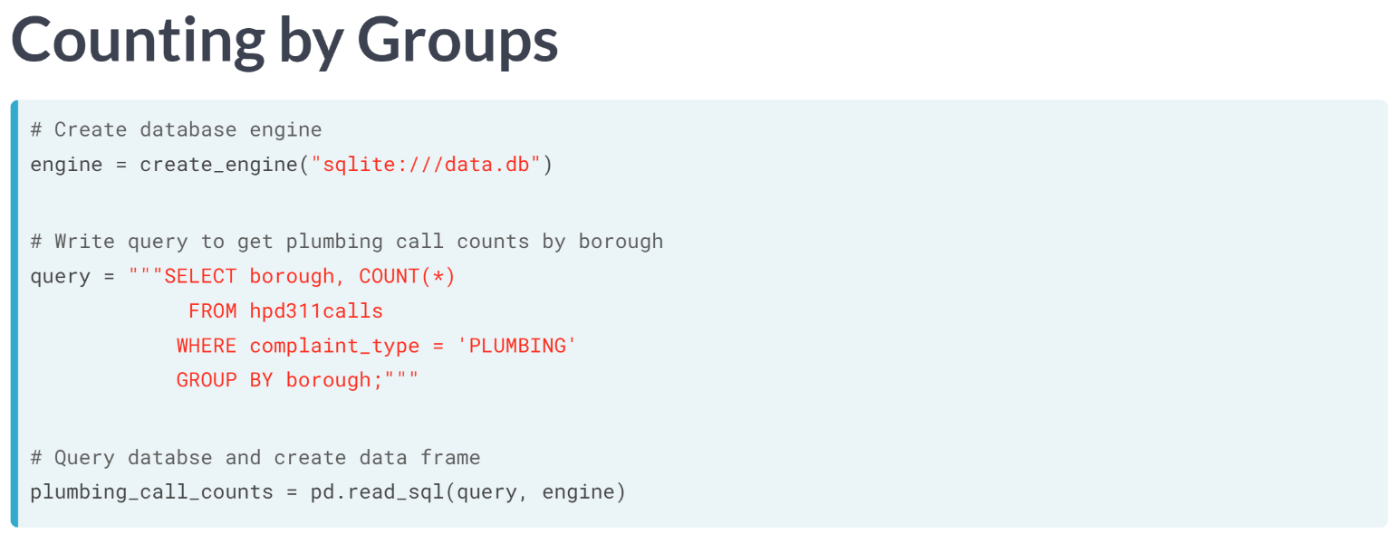  
Let's see what the result of that query looks like in a data frame. With the necessary libraries imported, we create the engine, write out the query, then pass the query and engine to pandas' read SQL function.

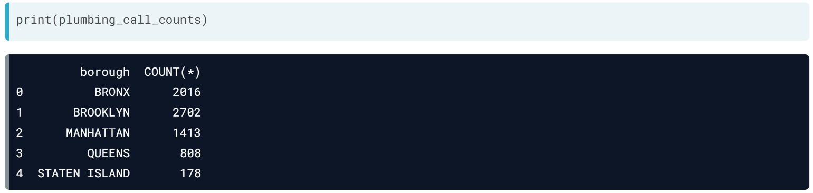  
When we check the results, we see that we have a neat summary data frame ready for plotting.

# Getting distinct values

Sometimes an analysis doesn't need every record, but rather unique values in one or more columns. Duplicate values can be removed after loading data into a data frame, but it can also be done at import with SQL's DISTINCT keyword.

Since hpd311calls contains data about housing issues, we would expect most records to have a borough listed. Let's test this assumption by querying unique complaint_type/borough combinations.

pandas has been imported as pd, and the database engine has been created as engine.

**Note**: The SQL checker is quite picky about column positions and expects fields to be selected in the specified order.

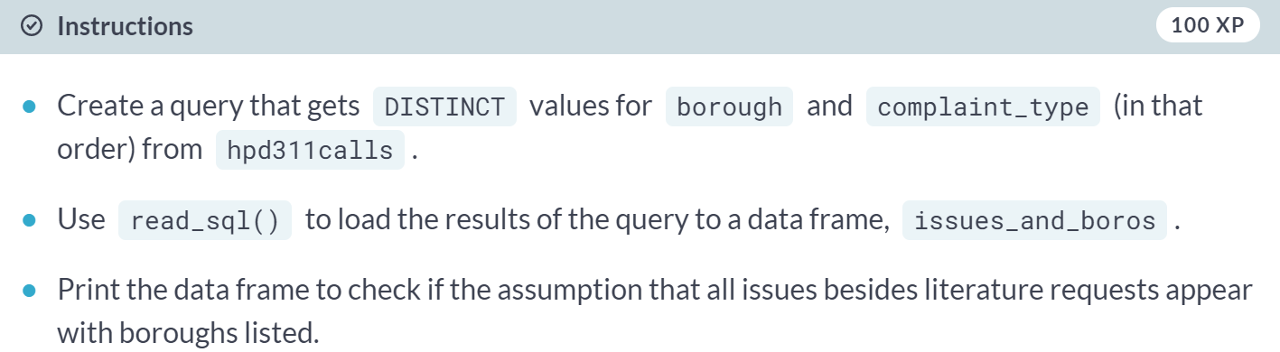

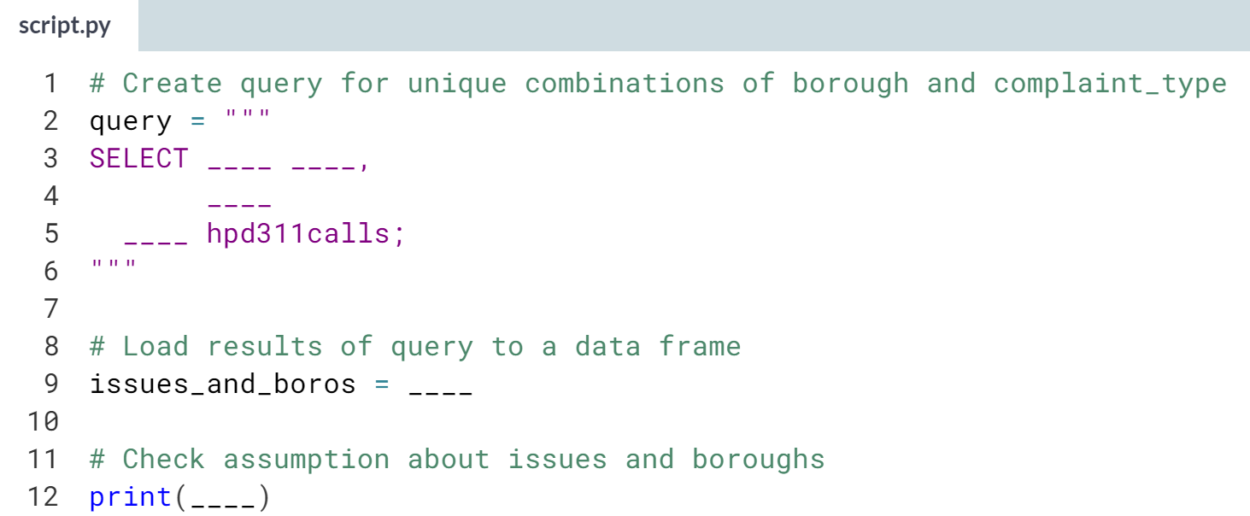

(Solution on the next page)

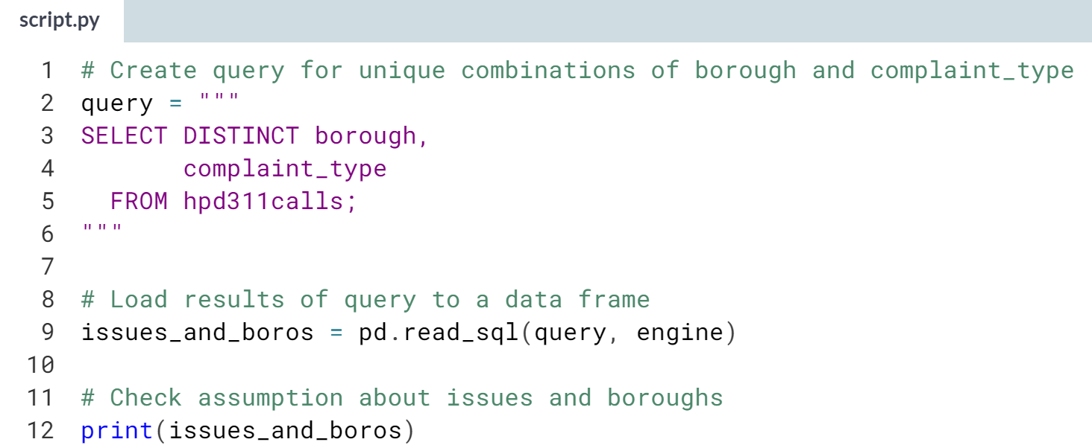

Looks like the only issues with no borough are requests for information, rather than housing complaints, which is okay. *SELECT DISTINCT* queries can be an easy way to find data quality issues like misspelled values or combinations of values that violate assumptions.

# Counting in groups

In previous exercises, you pulled data from tables, then summarized the resulting data frames in pandas to create graphs. By using COUNT and GROUP BY in a SQL query, we can pull those summary figures from the database directly.

The hpd311calls table has a column, complaint_type, that categorizes call records by issue, such as heating or plumbing. In order to graph call volumes by issue, you'll write a SQL query that COUNTs records by complaint type.

pandas has been imported as pd, and the database engine for data.db has been created as engine.

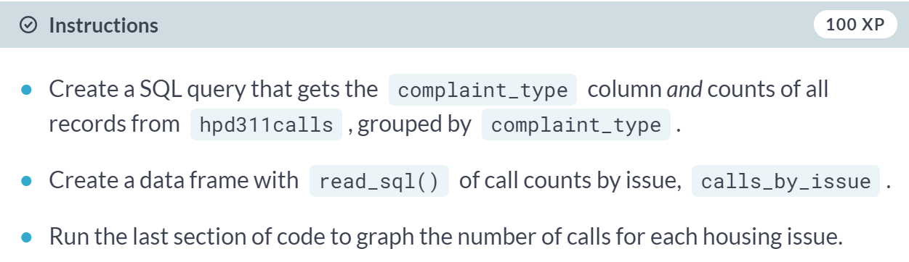

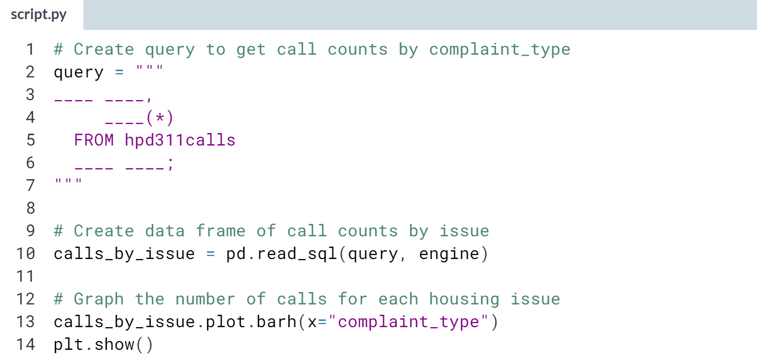

(Solution on the next page)

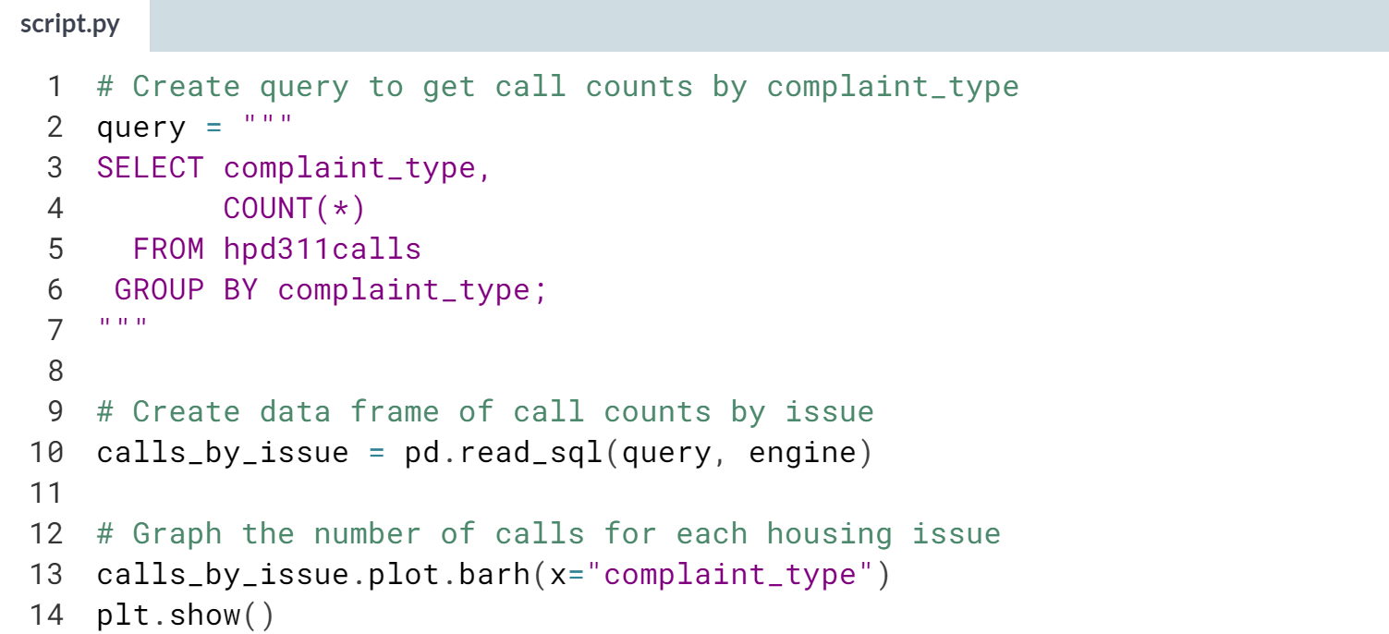

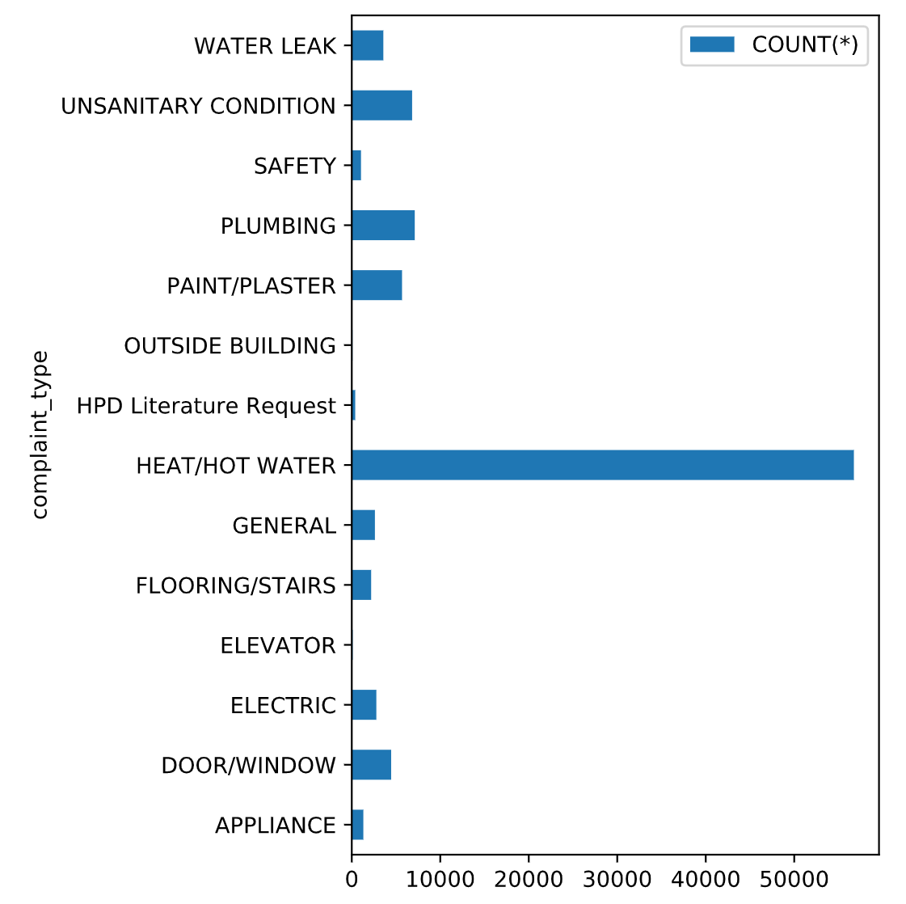  
Calls about heat and hot water issues vastly outnumber calls about all other issues. The data subset in the table comes from the winter, so this makes sense. We'll explore these calls more in the next lesson.

# Working with aggregate functions

If a table contains data with higher granularity than is needed for an analysis, it can make sense to summarize the data with SQL aggregate functions before importing it. For example, if you have data of flood event counts by month but precipitation data by day, you may decide to SUM precipitation by month.

The weather table contains daily readings for four months. In this exercise, you'll practice summarizing weather by month with the MAX, MIN, and SUM functions.

pandas has been loaded as pd, and a database engine, engine, has been created.

(Exercise starts on the next page)

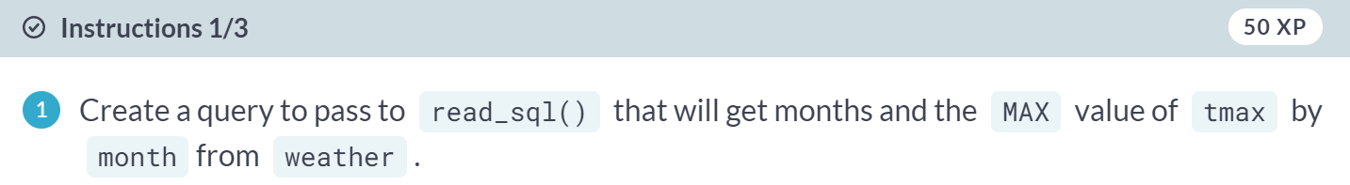

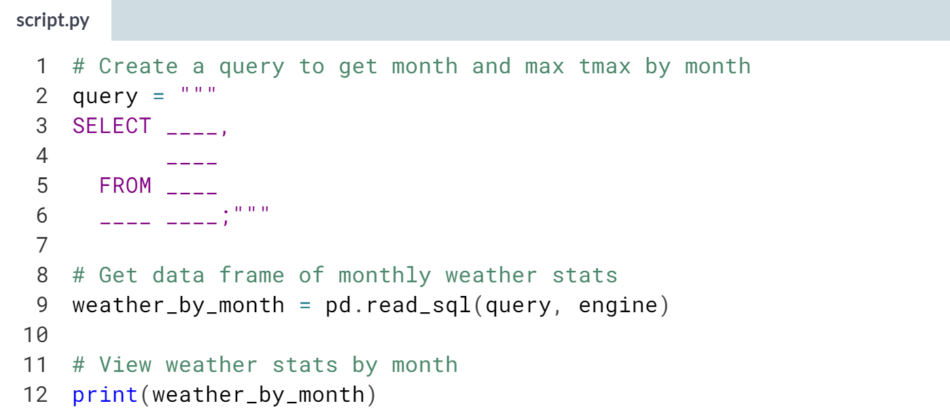  
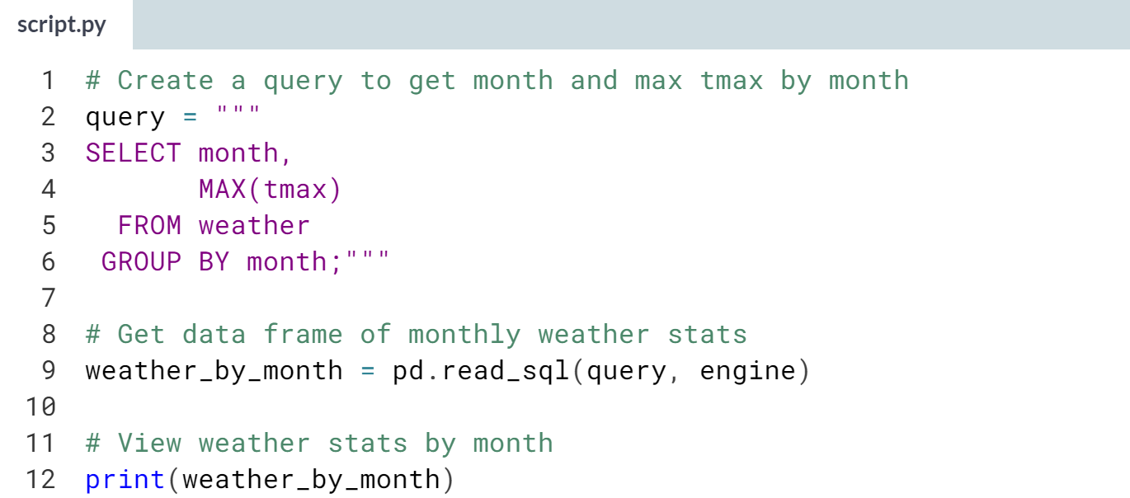

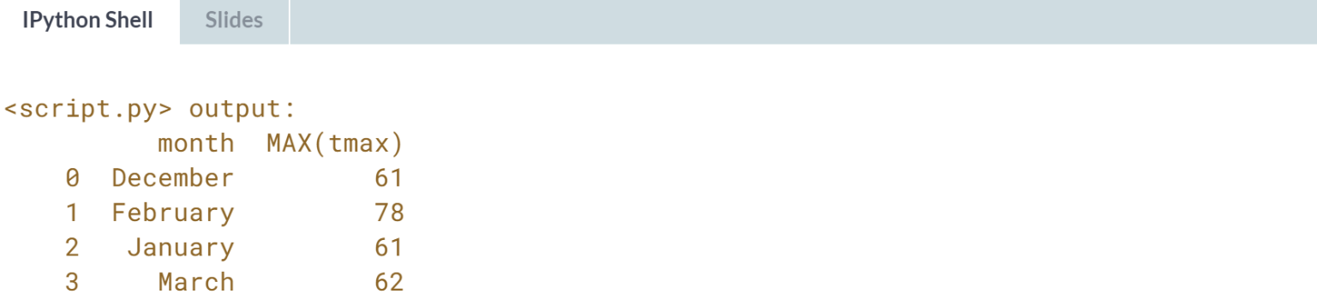

  
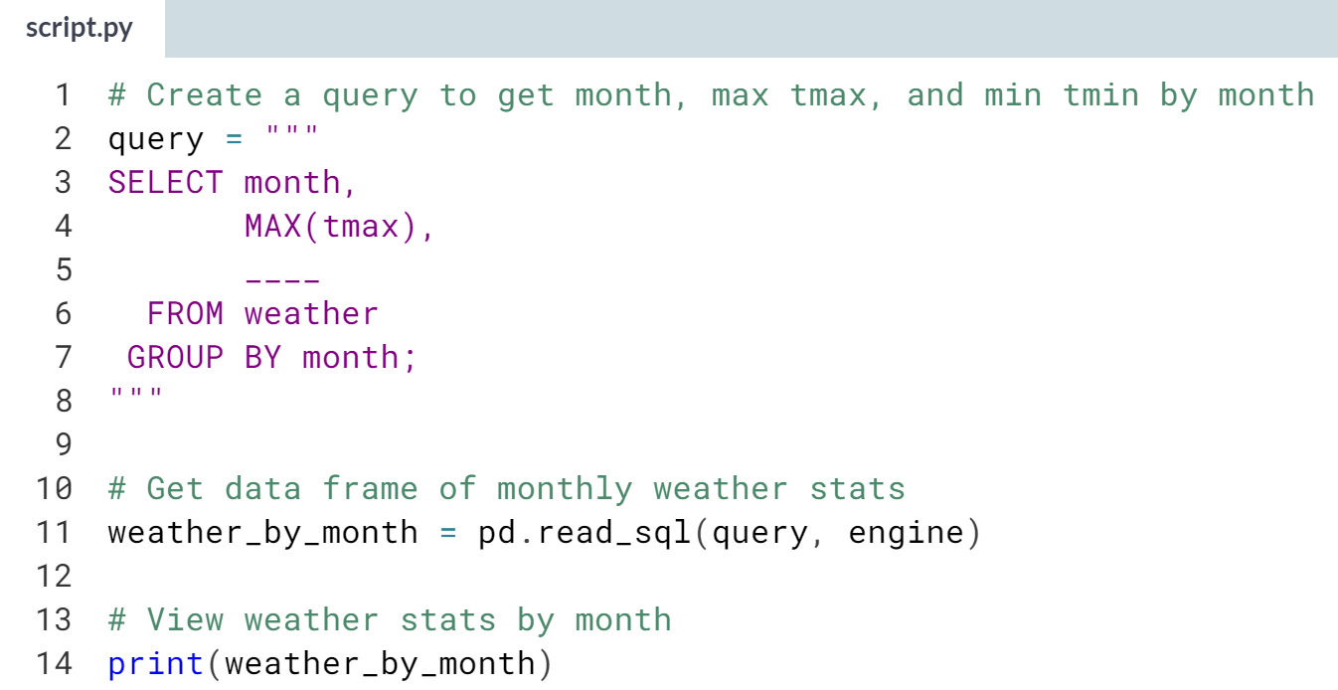  
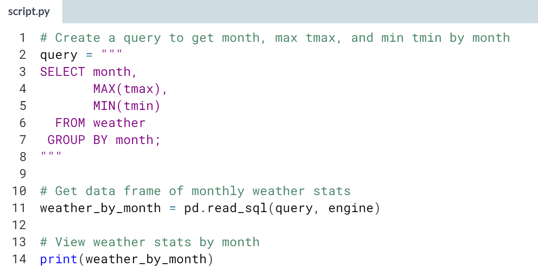

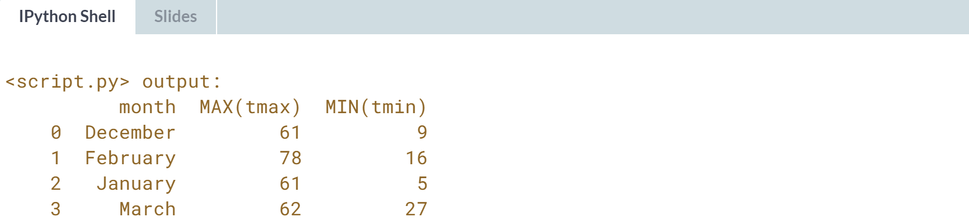

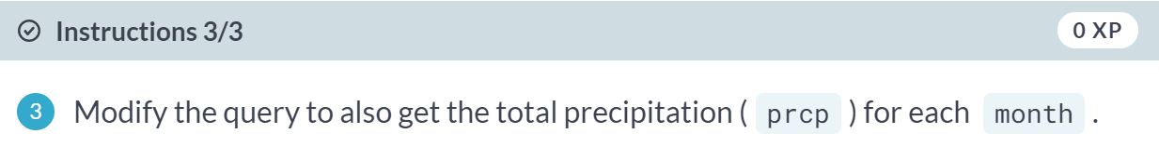

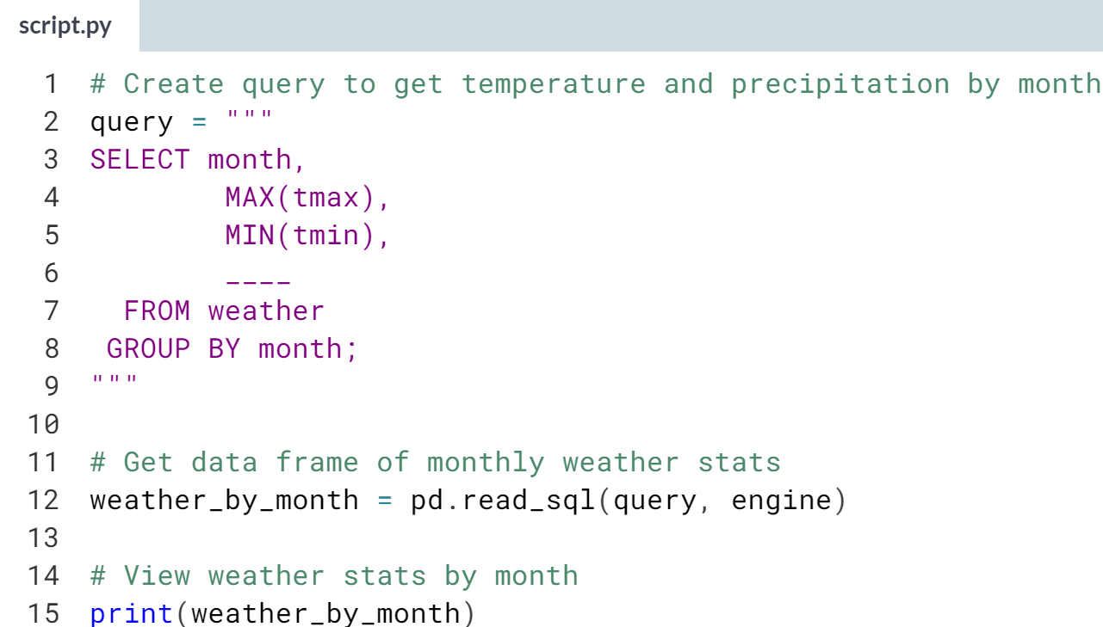  
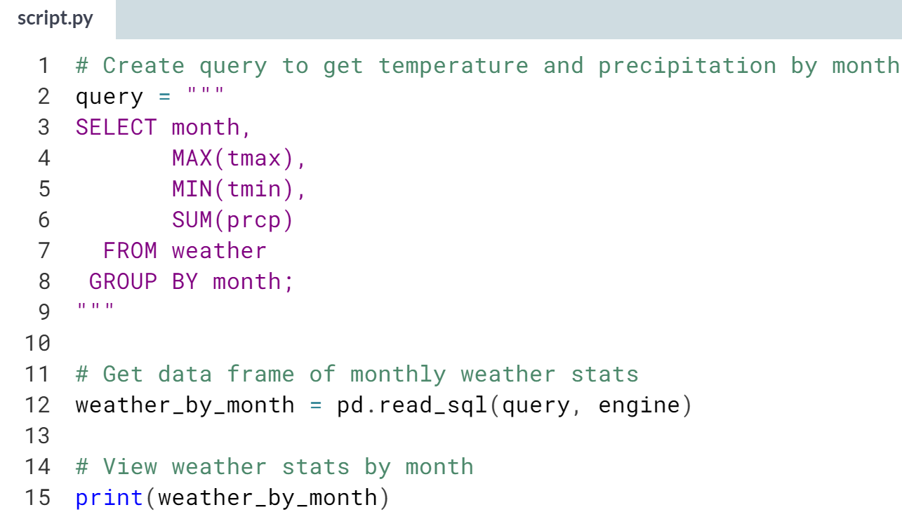

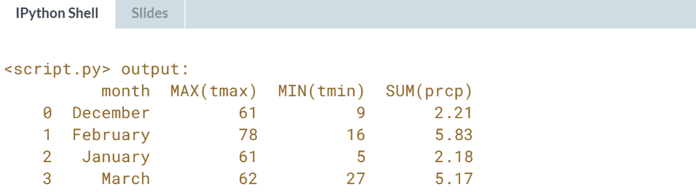  
Well done! Aggregate functions can be a useful way to summarize large datasets. Different database management systems even have SQL functions for statistics like standard deviation and percentiles, though these are non-standard and vendor-specific.



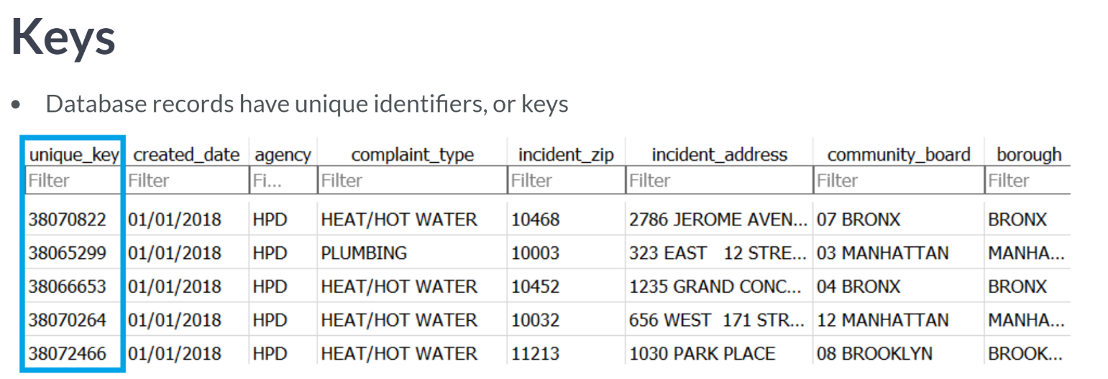  
At their simplest, keys can be automatically assigned row numbers, but they can also carry meaning, like university course numbers.

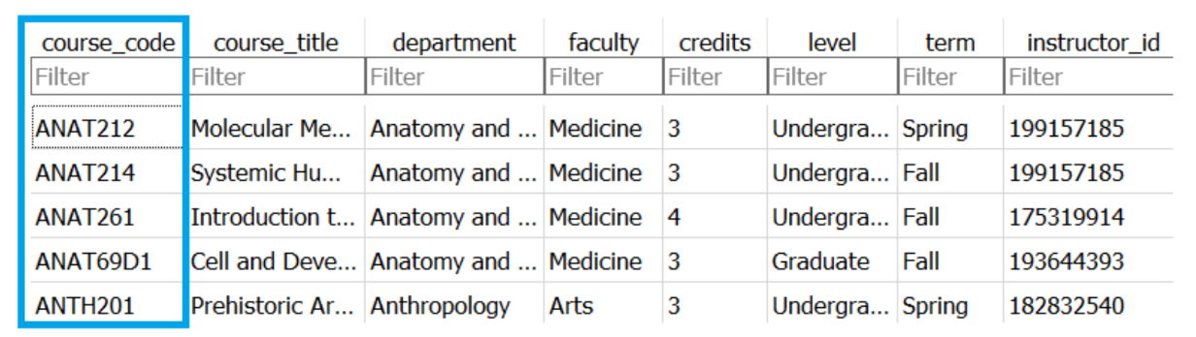

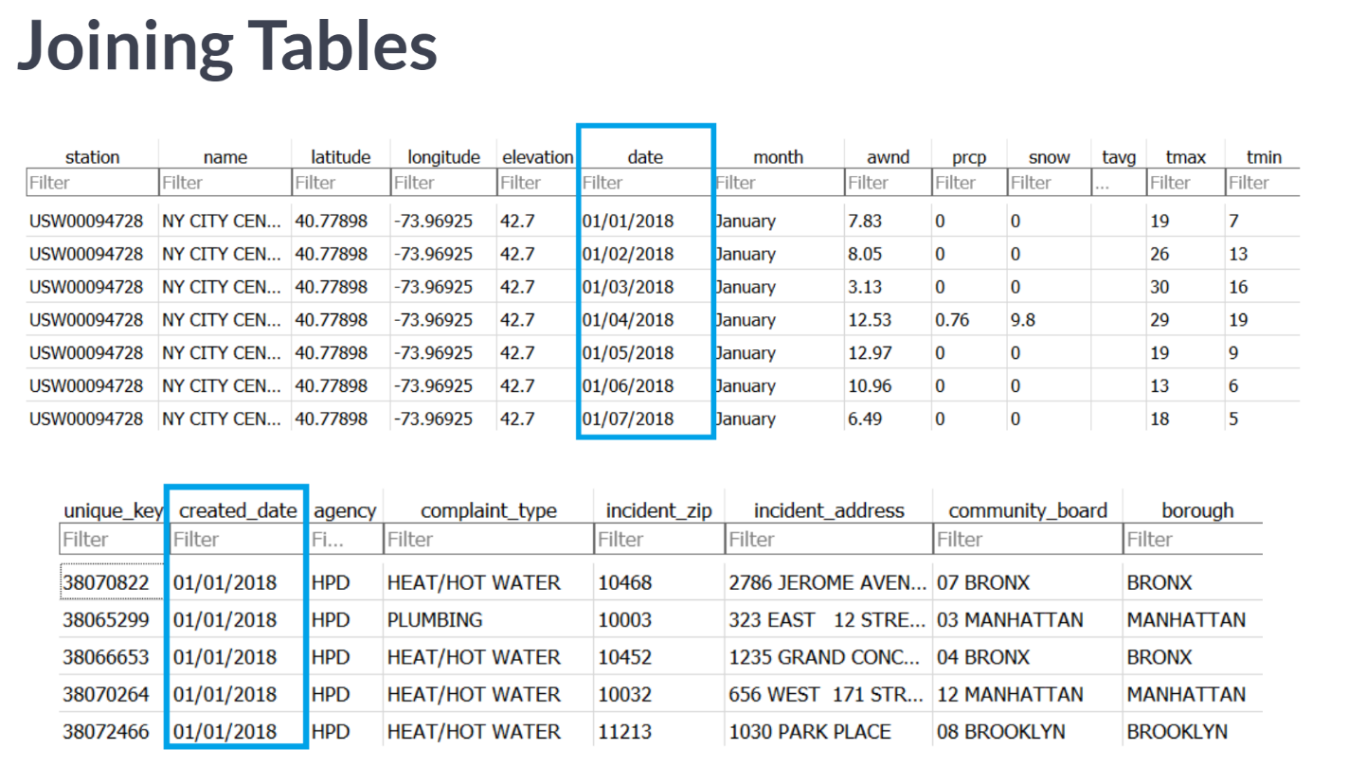

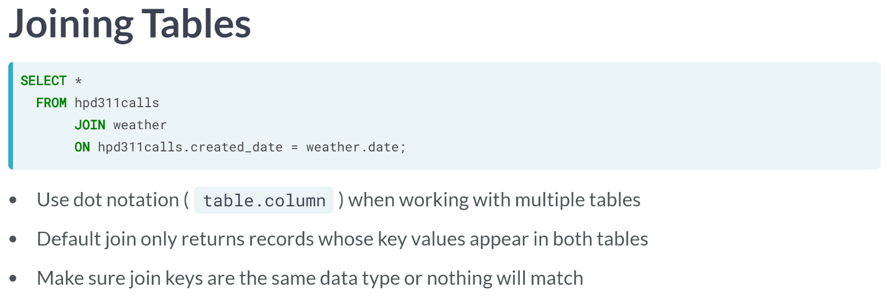

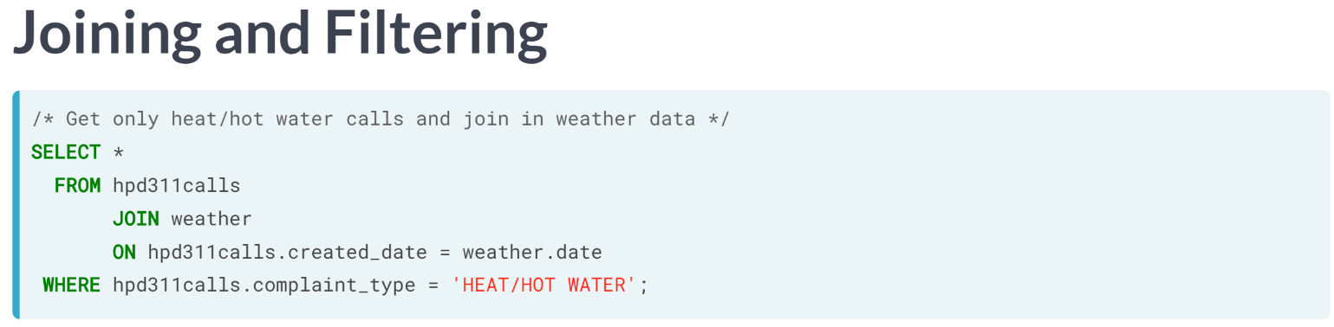  
Here, we filter the data to focus on heat and hot water calls, which probably spike in cold weather.

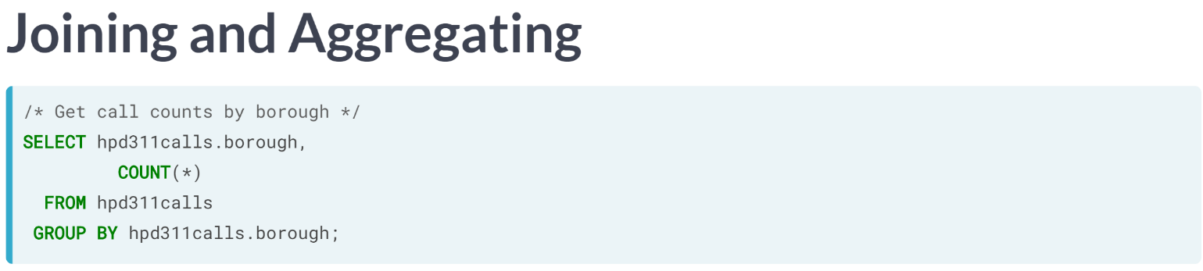  
It's even possible to summarize data and then join additional columns. Imagine we wanted to compare call counts by borough against census data about population and housing in another table, borough census.

Let's a build the query in parts. We first get call counts by borough by selecting hpd311calls.borough and count star from hpd311calls, grouping by hpd311calls.borough. Because both tables have borough columns, we have to specify the table here.

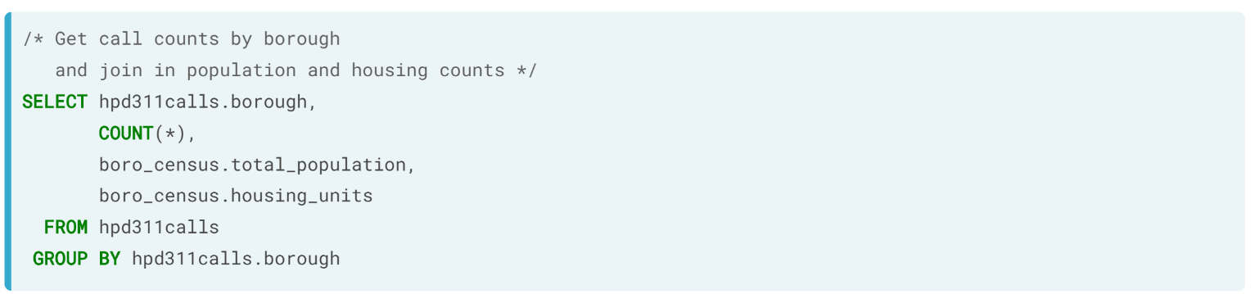  
The borough census table has more columns than we need, so we also select its total population and housing units columns.

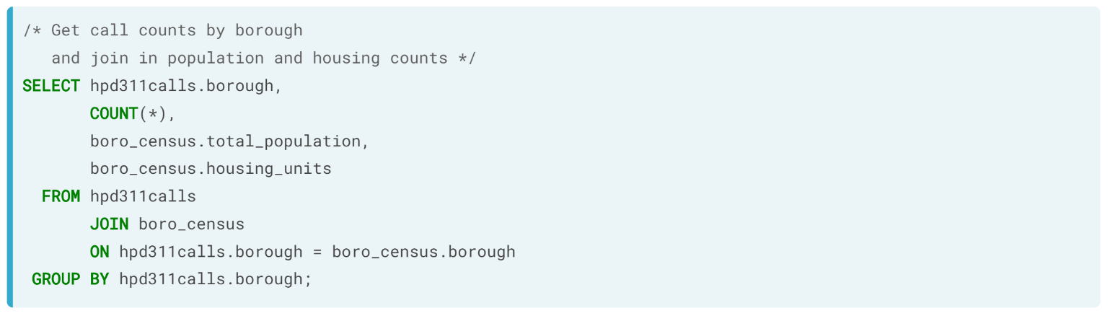  
Finally, we add the join clause between the from and group by clauses, joining on the borough columns.

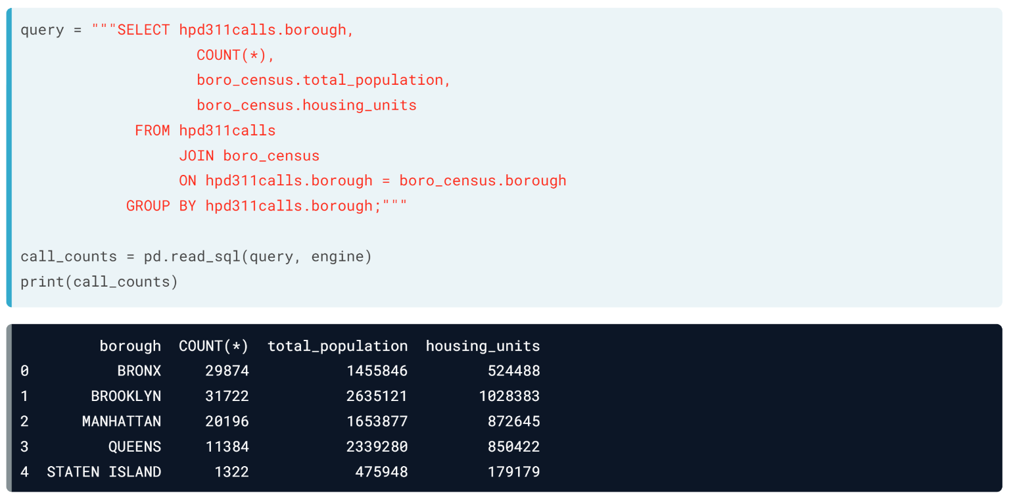  
Let's pass this query and the database engine to read SQL and check out the results. It looks like Bronx is overrepresented in our call data.

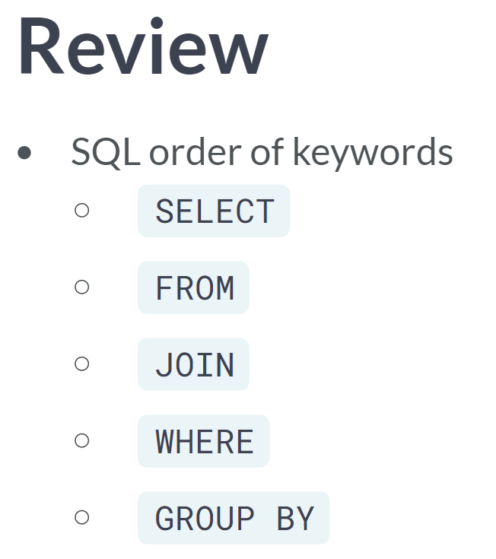

# Joining tables

Tables in relational databases usually have key columns of unique record identifiers. This lets us build pipelines that combine tables using SQL's JOIN operation, instead of having to combine data after importing it.

The records in hpd311calls often concern issues, like leaks or heating problems, that are exacerbated by weather conditions. In this exercise, you'll join weather data to call records along their common date columns to get everything in one data frame. You can assume these columns have the same data type.

pandas is loaded as pd, and the database engine, engine, has been created.

**Note**: The SQL checker is picky about join table order -- it expects specific tables on the left and the right.

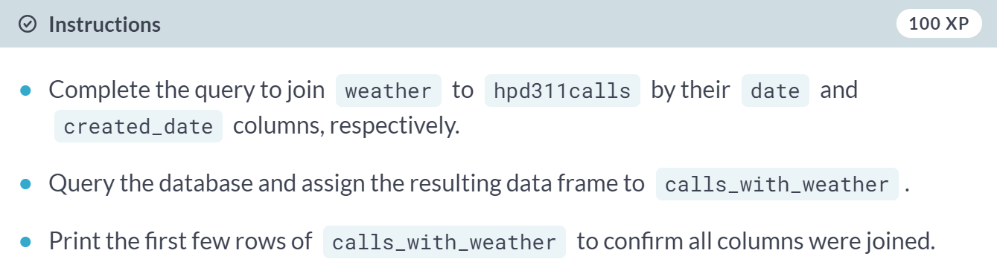

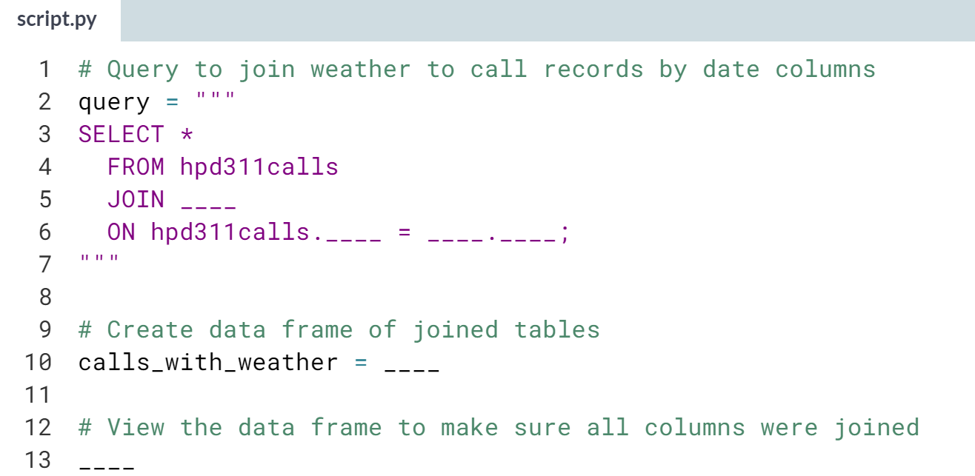

(Solution on the next page)

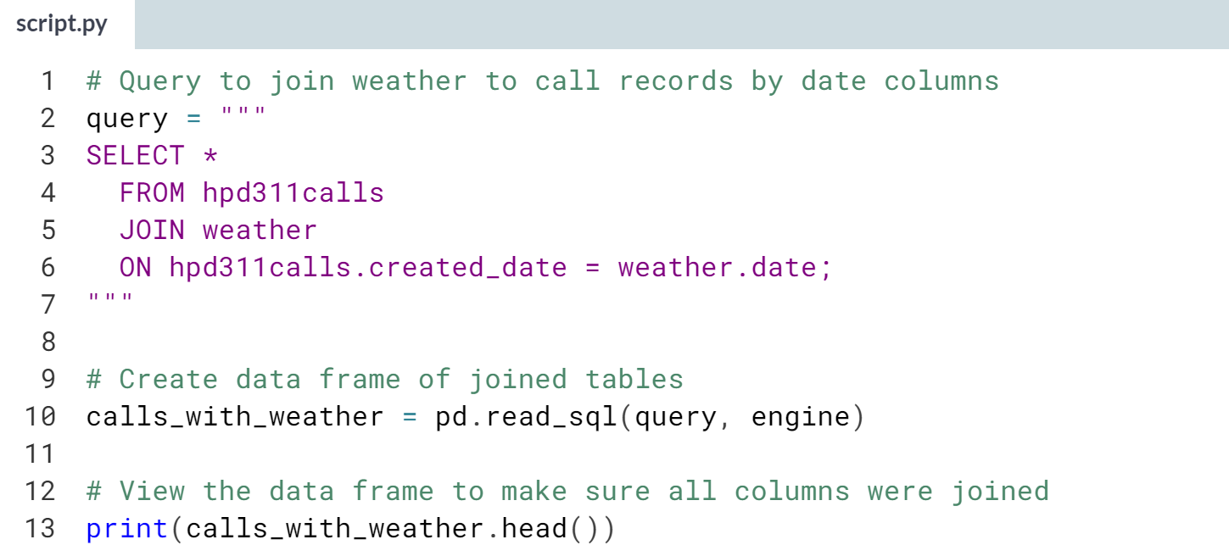

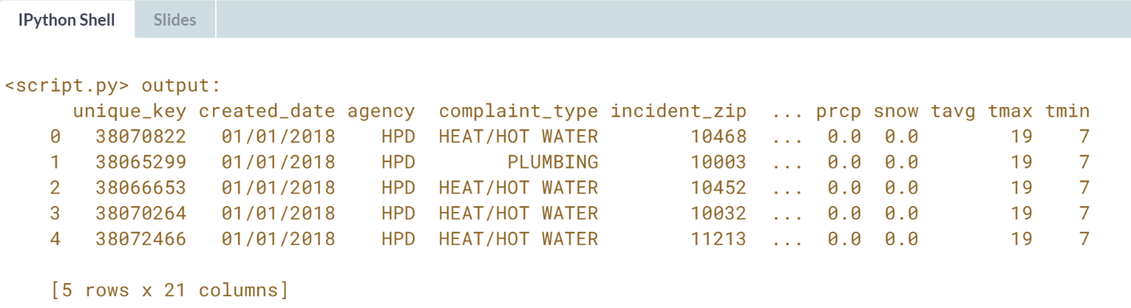

Well done! The joins you perform in this course only return records whose key values appear in both tables, which is why the resulting data frames have values for all columns. But there are other kinds of joins that can return records that don't have a match.

# Joining and filtering

Just as you might not always want all the data in a single table, you might not want all columns and rows that result from a JOIN. In this exercise, you'll use SQL to refine a data import.

Weather exacerbates some housing problems more than others. Your task is to focus on water leak reports in hpd311calls and assemble a dataset that includes the day's precipitation levels from weather to see if there is any relationship between the two. The provided SQL gets all columns in hpd311calls, but you'll need to modify it to get the necessary weather column and filter rows with a WHERE clause.

pandas is loaded as pd, and the database engine, engine, has been created.

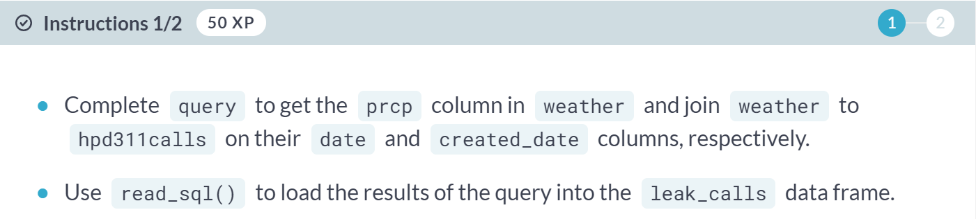

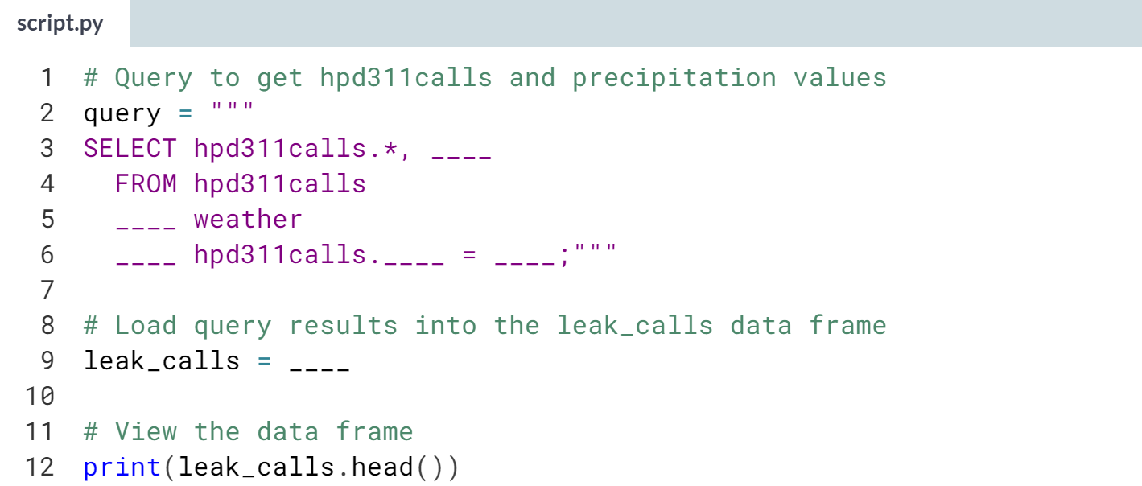

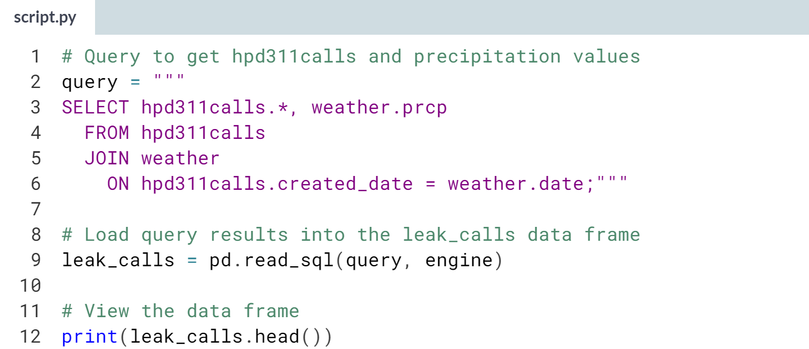

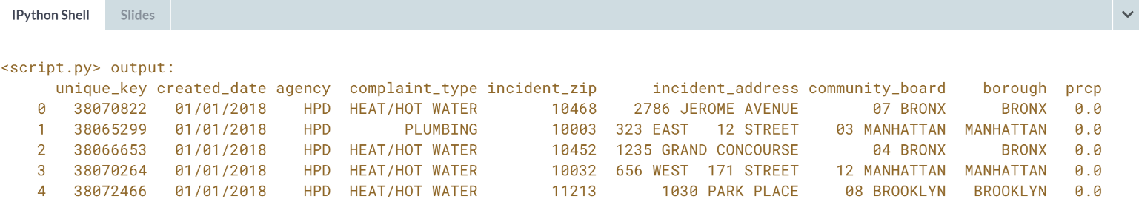

(Exercise continues on the next page)

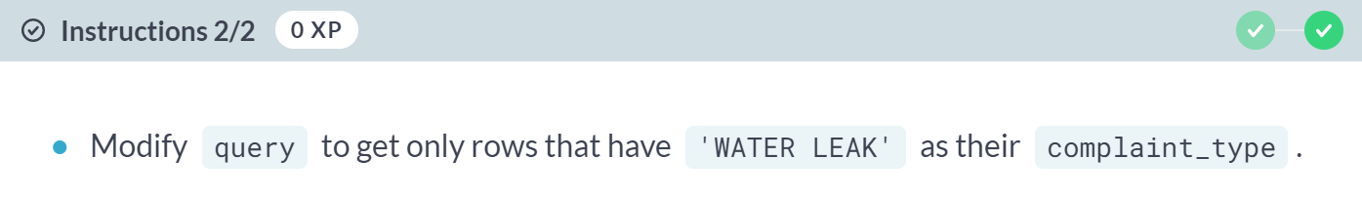

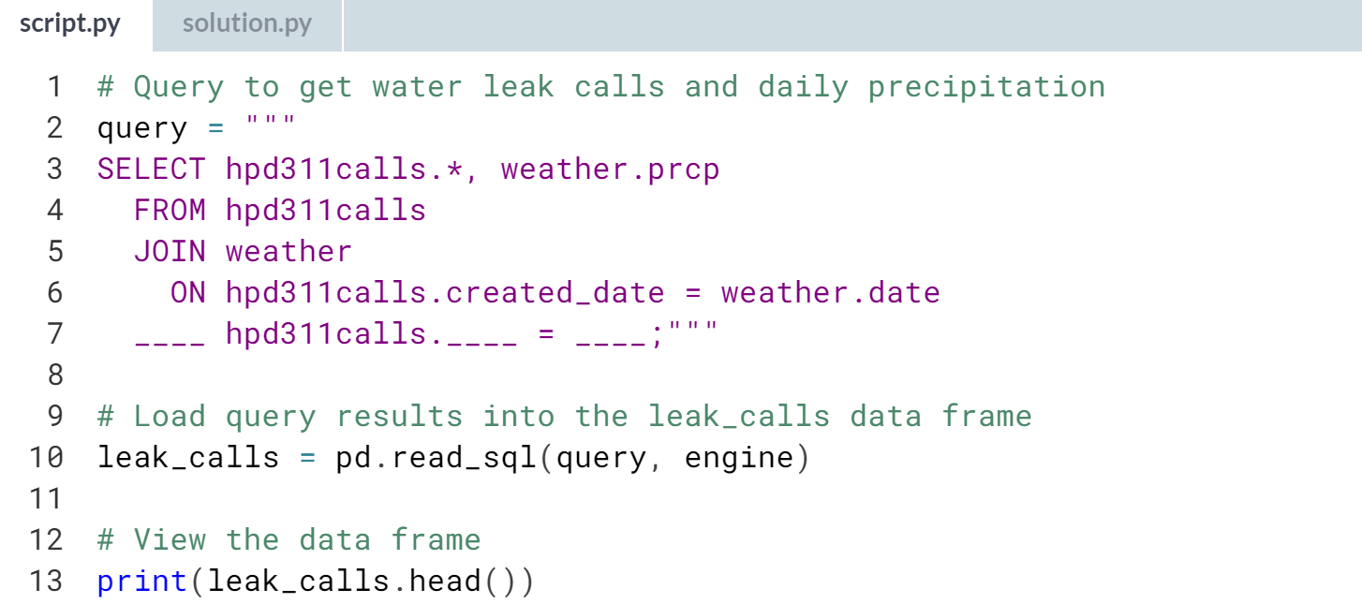

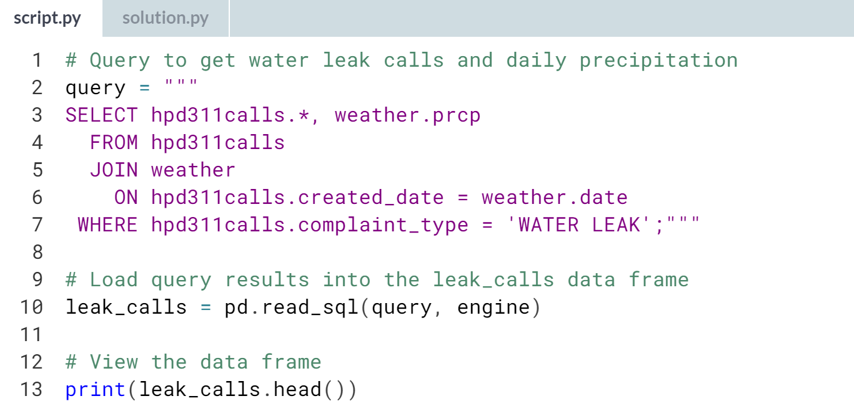

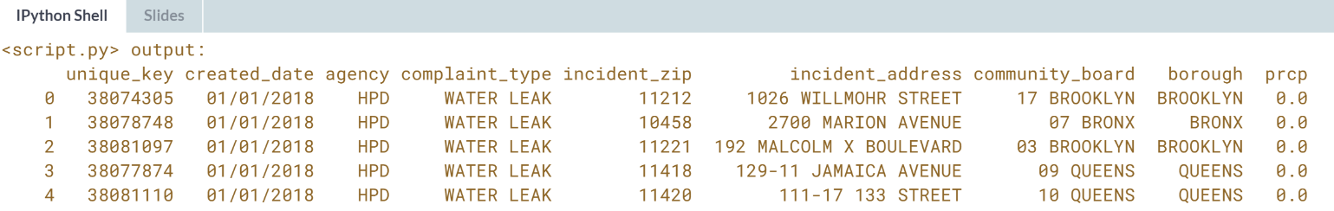  
Nice work! How you go about constructing a complicated SQL query can depend on what operators you need and how big the tables you're working with are. If your tables are very big, you may decide to filter or aggregate the data first before attempting a join.

# Joining, filtering, and aggregating

In this exercise, you'll use what you've learned to assemble a dataset to investigate how the number of heating complaints to New York City's 311 line varies with temperature.

In addition to the hpd311calls table, data.db has a weather table with daily high and low temperature readings for NYC. We want to get each day's count of heat/hot water calls with temperatures joined in. This can be done in one query, which we'll build in parts.

In part one, we'll get just the data we want from hpd311calls. Then, in part two, we'll modify the query to join in weather data.

pandas has been imported as pd, and the database engine has been created as engine.

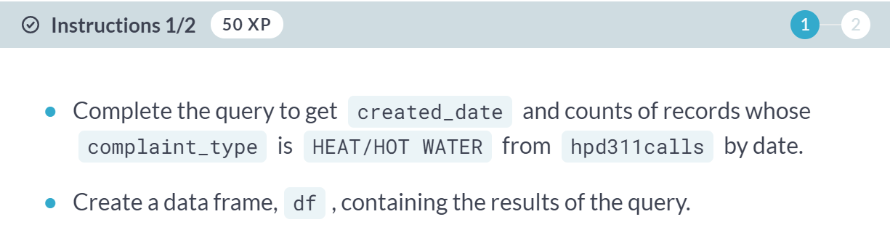

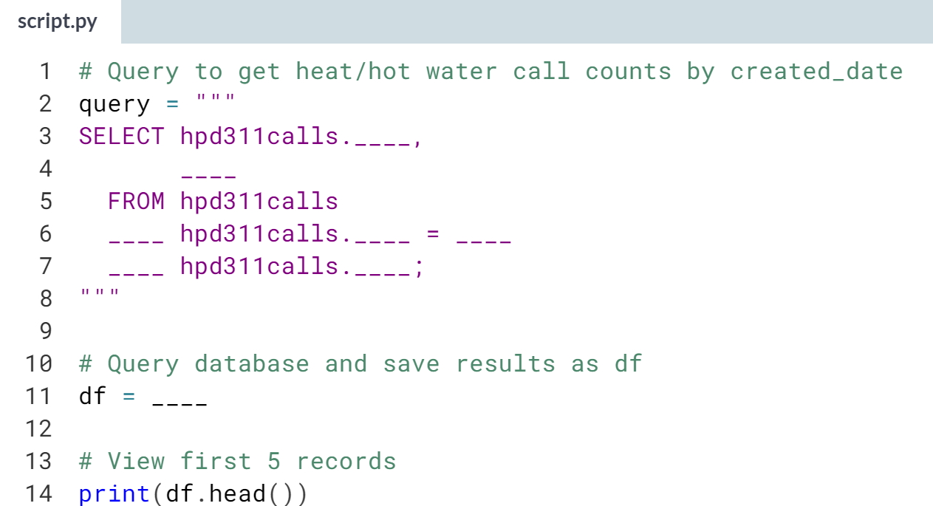

(Solution on the next page)

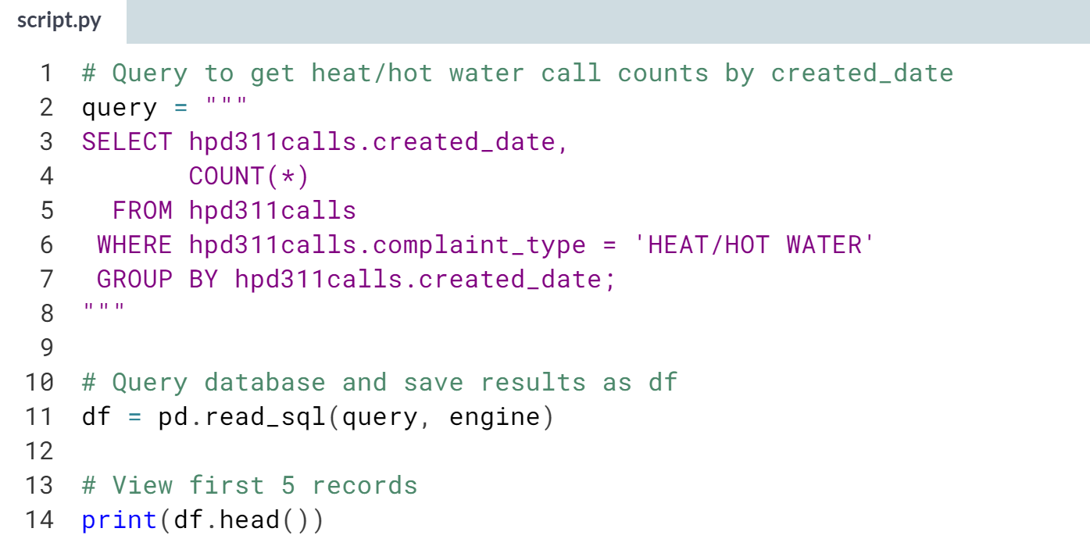

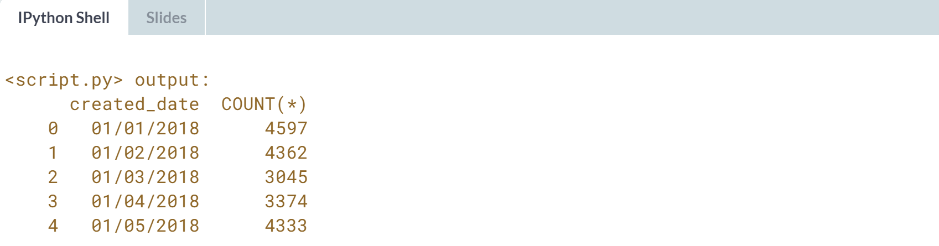

(Exercise continues on the next page)

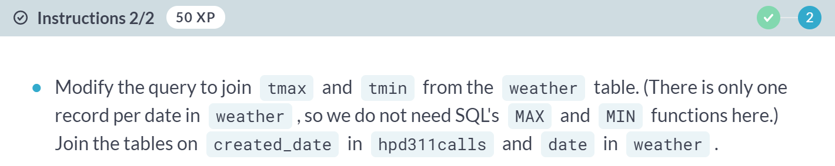

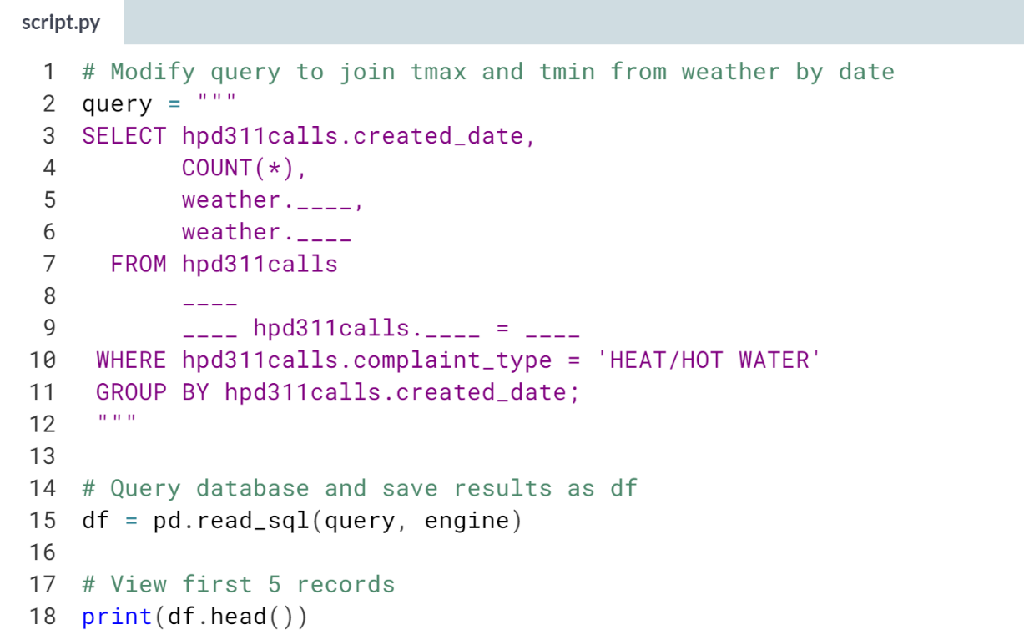

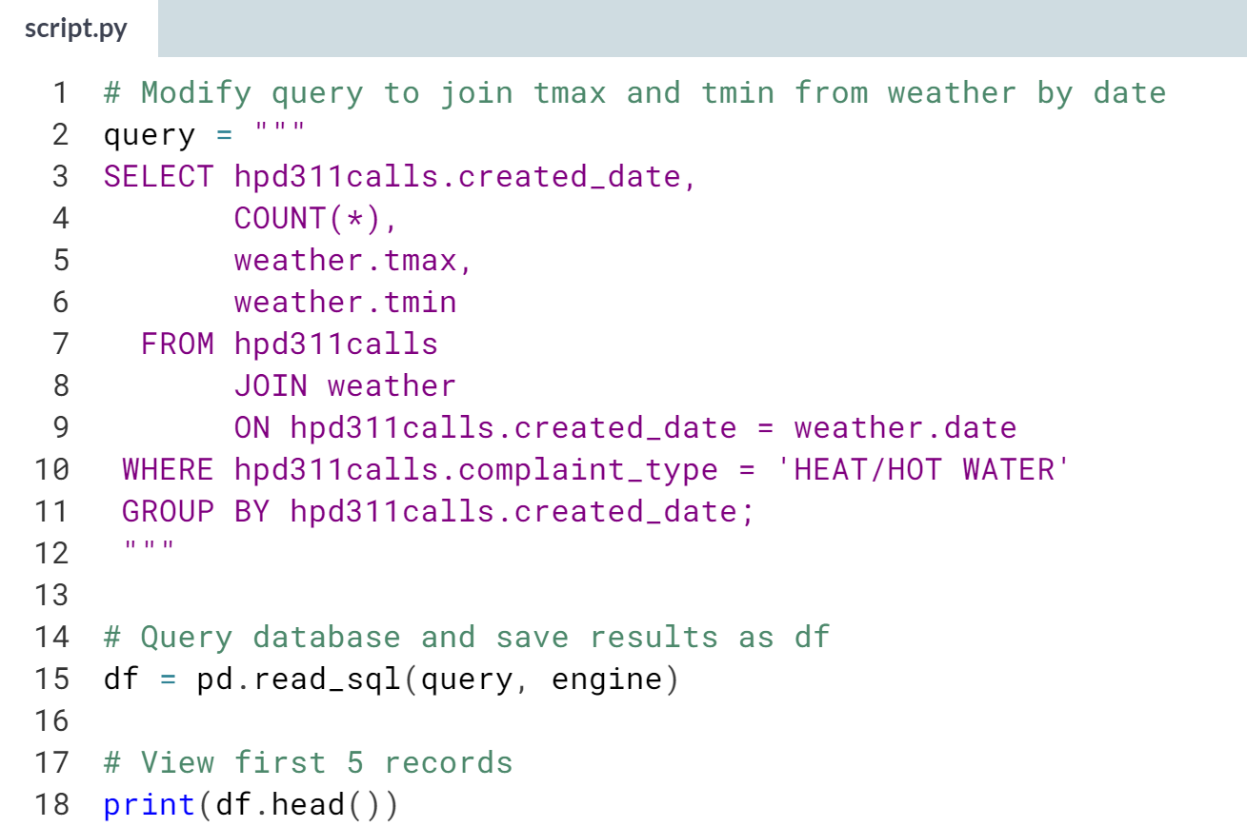

(Result on the next page)

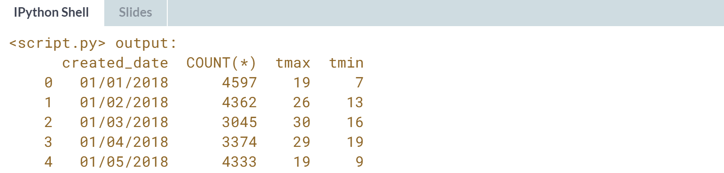

Whew! You've just written a pretty complicated query to wrangle data. While SQL joins can only be used in databases, there are analogous pandas operations to combine datasets.

**4. Importing JSON Data and Working with APIs**

Learn how to work with JSON data and web APIs by exploring a public dataset and getting cafe recommendations from Yelp. End by learning some techniques to combine datasets once they have been loaded into data frames.



JSON is based on JavaScript, but popular programming languages have versions of the data structures JSONs use, making them easy for programs to generate and parse while being human readable. And because of JavaScript’s role in web development, JSON is a common format for transmitting data through web.

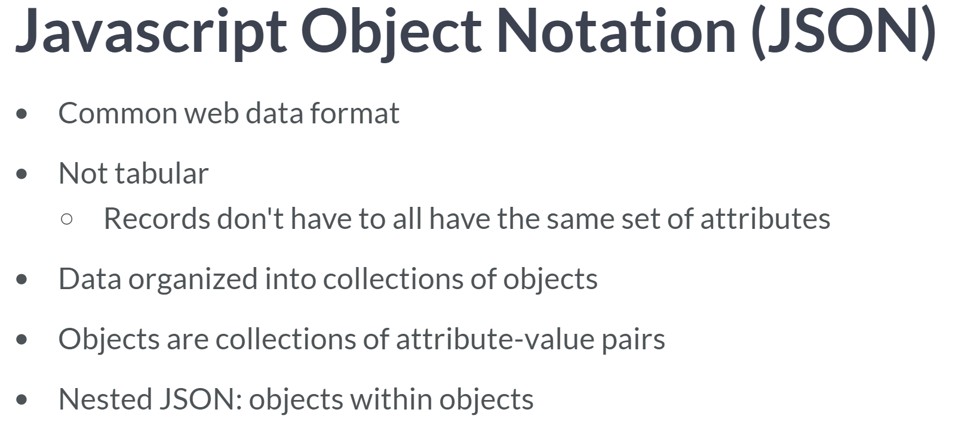

Since JSON is not tabular, this makes for more efficient data storage. If a value doesn't exist for a record, the attribute can be omitted instead of storing it with a null value. In other words, records don't all have to have the same set of attributes.

Instead, data is organized into collections of objects. Objects resemble Python dictionaries: they're enclosed in curly braces and contain attribute-value pairs.

One last feature of JSONs is that they can be nested - values themselves can be objects or lists of objects.

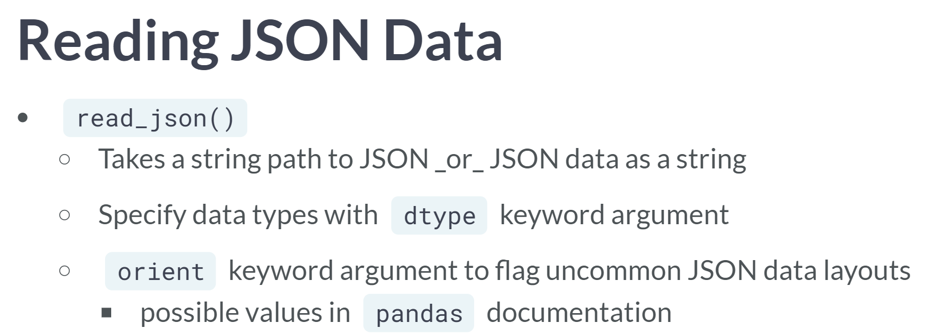  
Since JSON data isn't tabular, pandas makes assumptions about how it's arranged or oriented to load it into a data frame. pandas automatically detect record and column orientations, which you will encounter most often.

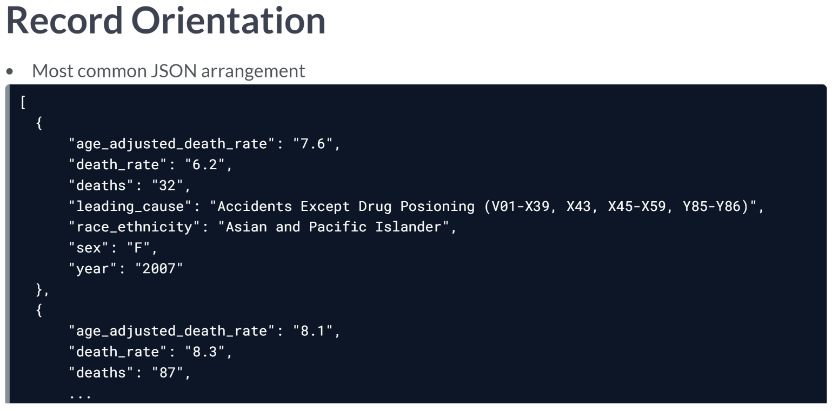  
A record oriented JSON consists of a list of dictionaries, each translating to a table record. For example, this JSON of causes of death from NYC's open data site is record oriented.

  
To reduce file size by not repeating attribute names, a JSON may be column-oriented. The entire JSON is a dictionary. Keys are column names. Values are lists of values for that column, or dictionaries of row indices and column values, like in this arranged version of the death causes data.

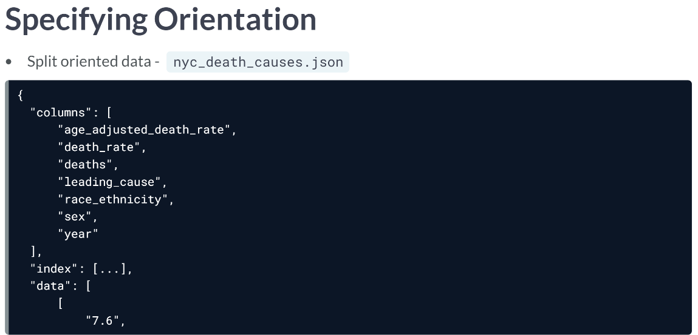  
However, other orientations are possible. This version of the death data is split oriented, with different lists for column names, indices, and values. Let's load it to a data frame.

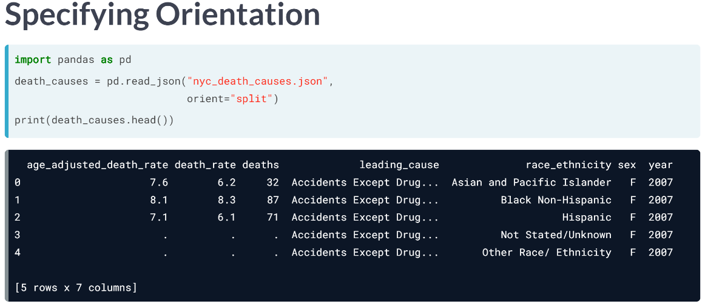  
We import pandas then load the data with read JSON, specifying orientation by passing one of a set of documented string values to the orient keyword argument. When we print the data, it looks like it loaded correctly.

# Load JSON data

Many open data portals make available JSONs datasets that are particularly easy to parse. They can be accessed directly via URL. Each object is a record, all objects have the same set of attributes, and none of the values are nested objects that themselves need to be parsed.

The New York City Department of Homeless Services Daily Report is such a dataset, containing years' worth of homeless shelter population counts. You can view it in the console before loading it to a data frame with pandas's read_json() function.

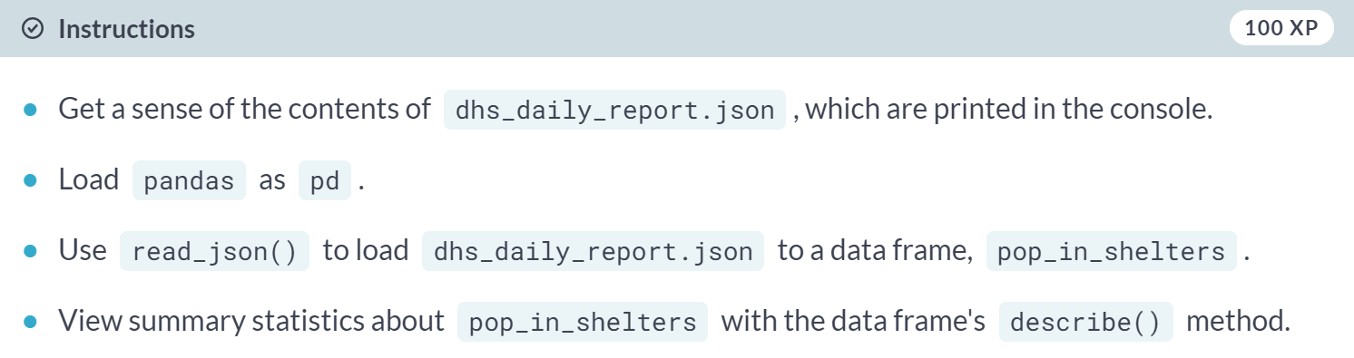

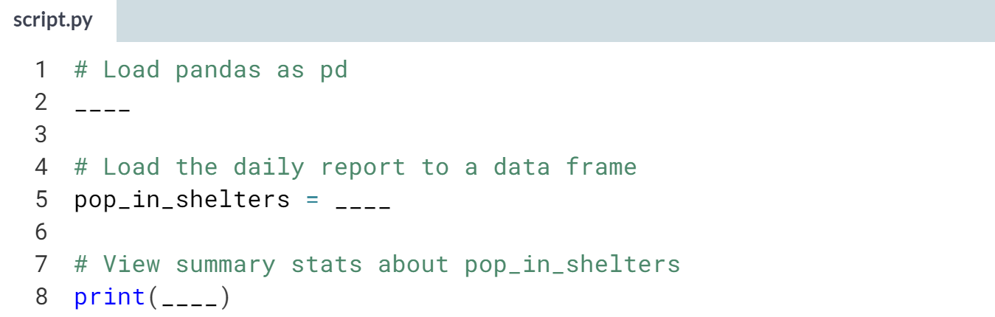

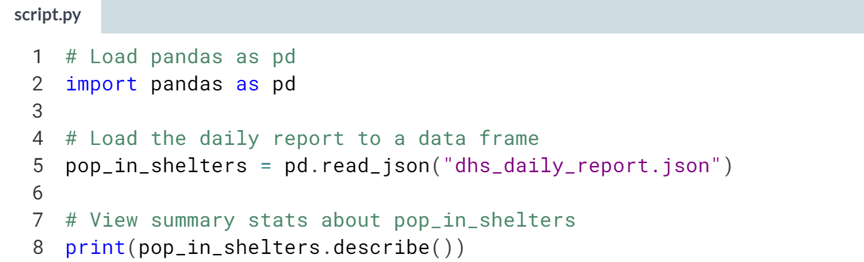

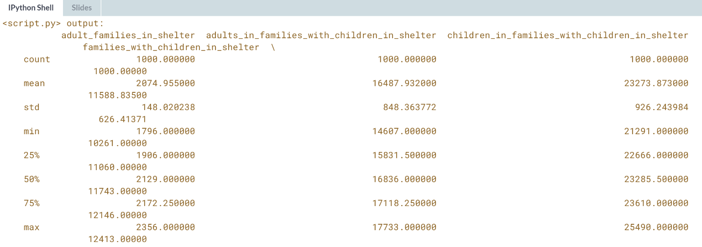

(more data below)

When getting data from a URL, like with open data portals, be mindful of how much data is being pulled and how often you do it. Requesting lots of data can strain shared resources.

# Work with JSON orientations

JSON isn't a tabular format, so pandas makes assumptions about its orientation when loading data. Most JSON data you encounter will be in orientations that pandas can automatically transform into a data frame.

Sometimes, like in this modified version of the Department of Homeless Services Daily Report, data is oriented differently. To reduce the file size, it has been split formatted. You'll see what happens when you try to load it normally versus with the orient keyword argument. The try/except block will alert you if there are errors loading the data.

pandas has been loaded as pd.



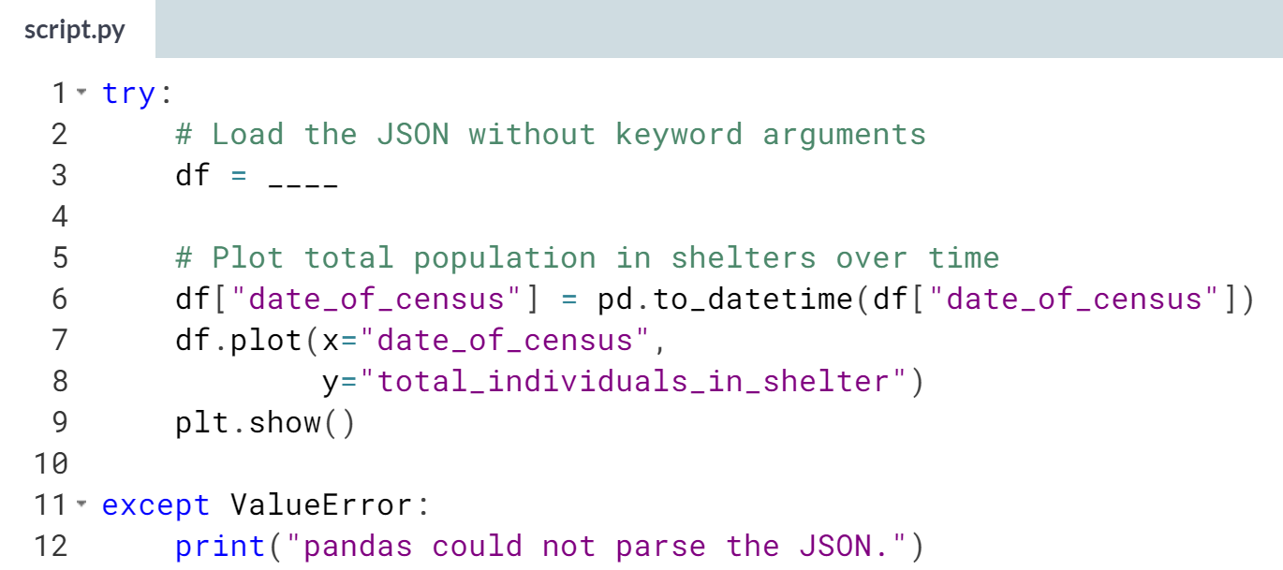

(Solution on the next page)

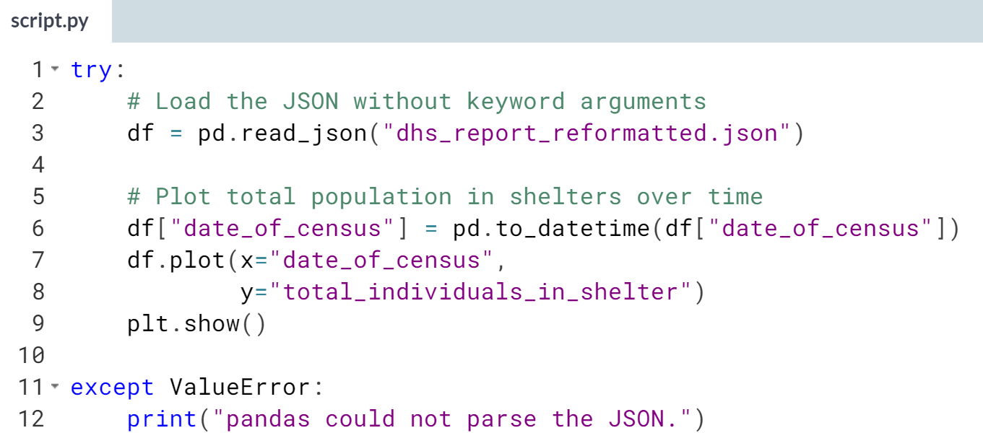

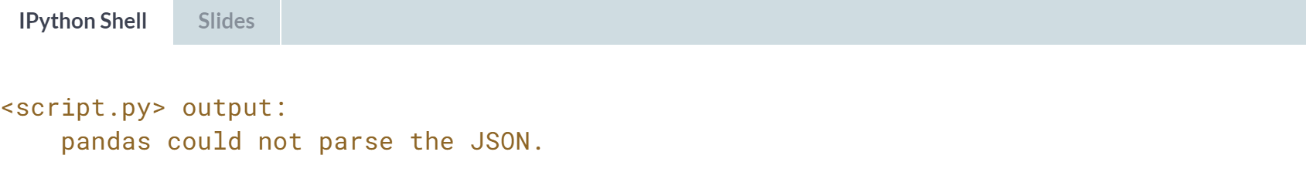

(Exercise continues on the next page)

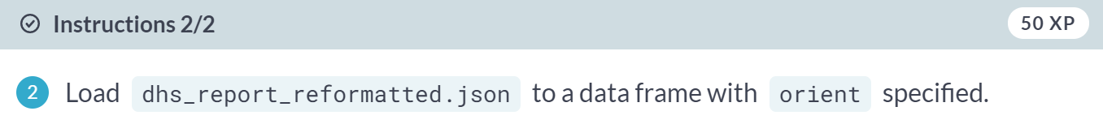

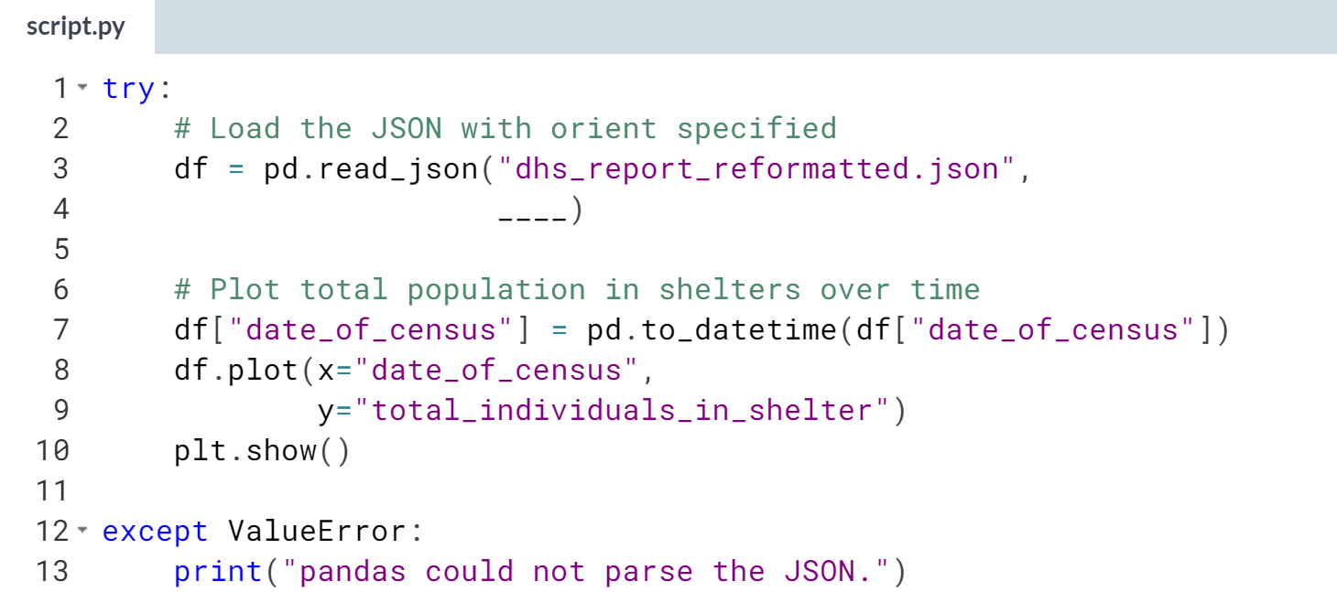

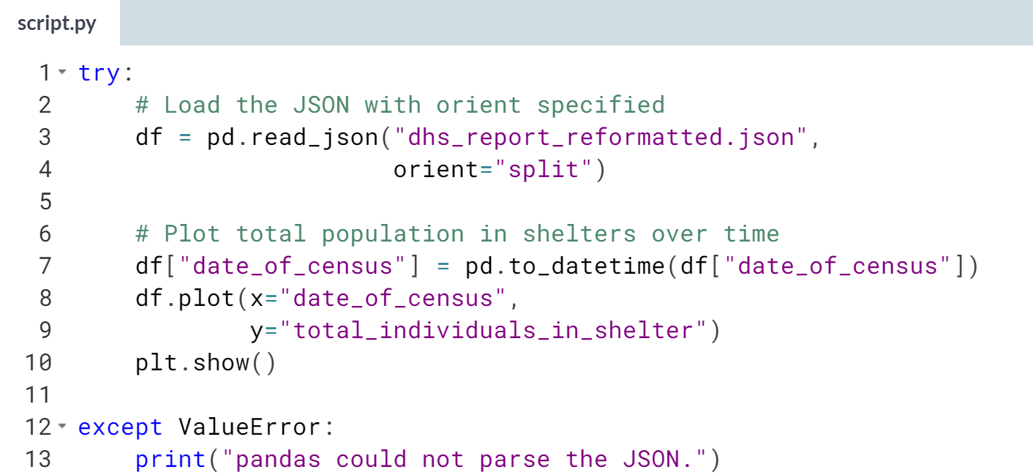

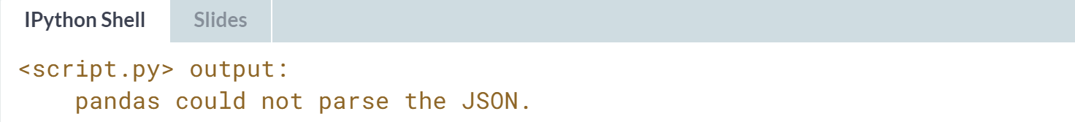

(Plot on the next page)

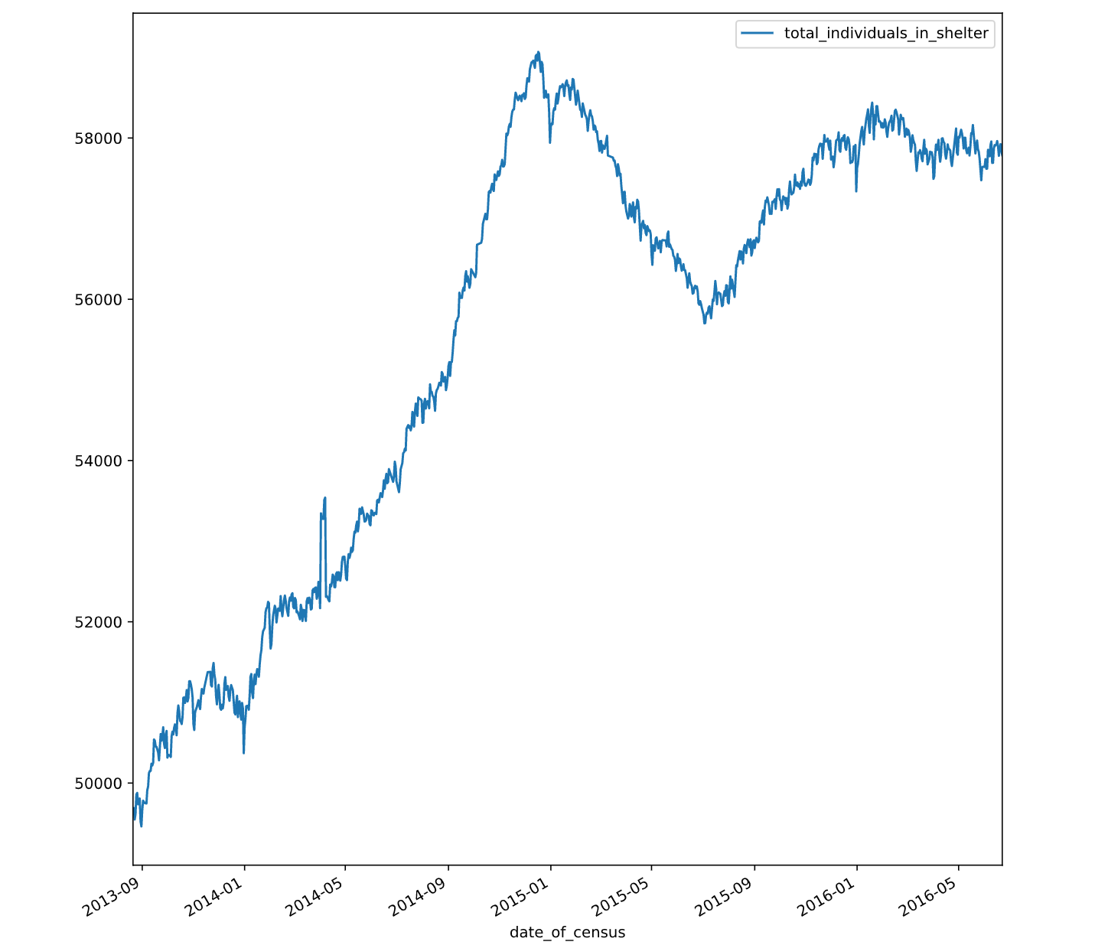

In this case, pandas could not parse the JSON at all without the orient keyword. For some other orientations, like index-oriented data, the data will load with transposed column and index names.



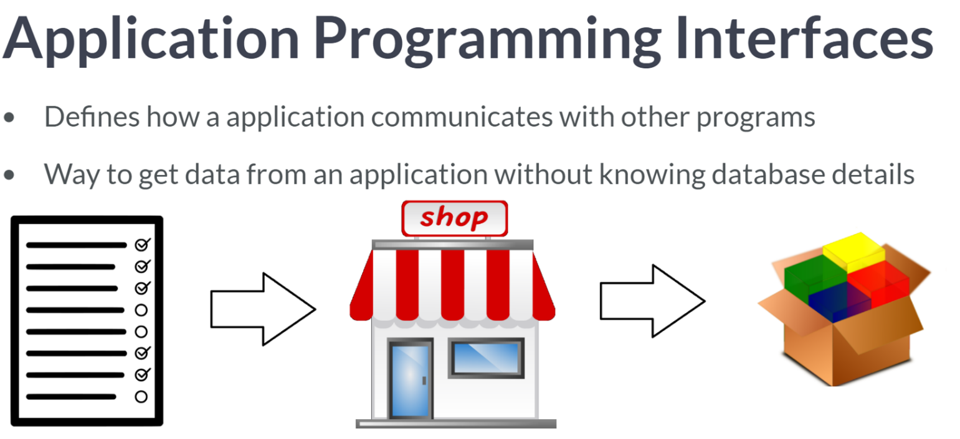One caveat of API is that they are shared resources and often limit how much data you can get in a specified timeframe. Using an API to get data is like using a catalog to order products. The catalog shows what's available and provides order instructions. You send a properly formed order to the right address and get back what you asked for.

Similarly, an API provides an endpoint to send request to, and documentation describes what a request should look like, such as parameters to include.

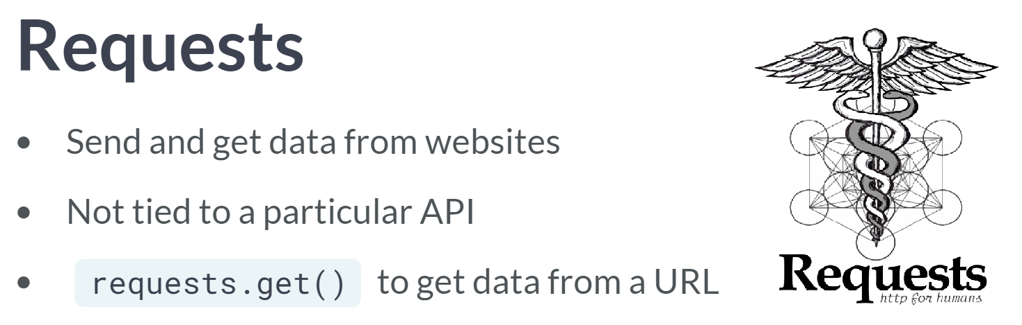  
While there are Python libraries geared towards popular APIs, we will use the Request library in this course.

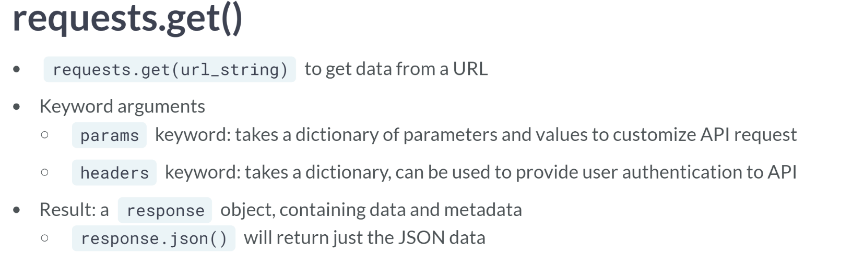

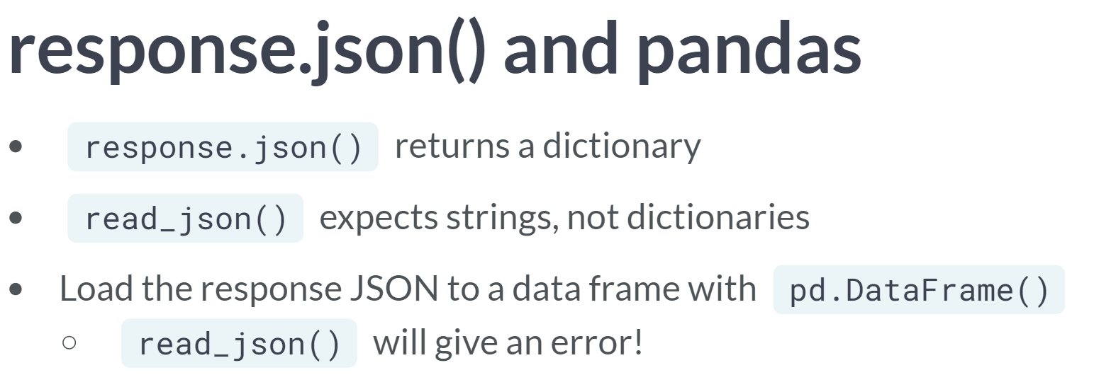  
Importantly, the JSON method returns a dictionary, which ***read_json()*** can't parse as it only expects a string. To load the data to a data frame, we need to use ***pd.DataFrame()*** instead.

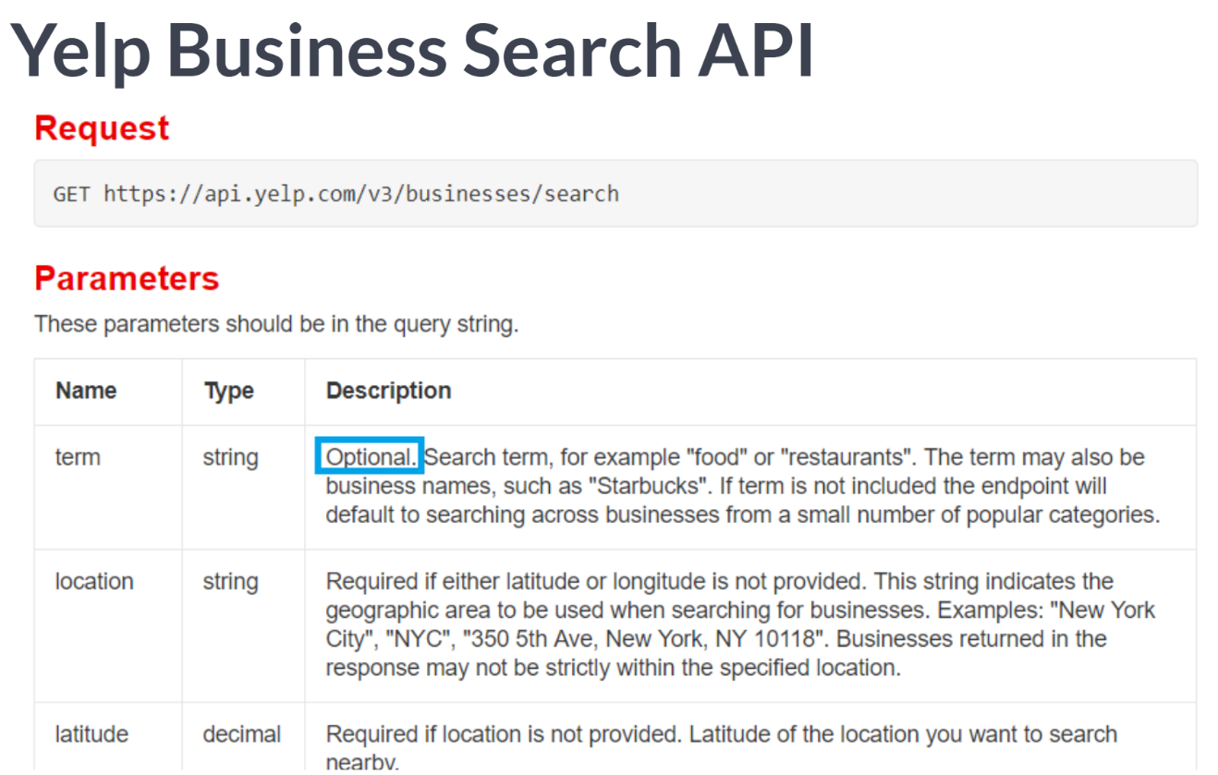  
Yelp lets users submit ratings and reviews for businesses and makes that data available via its APIs. In the API documentation, we see the end point URL, optional, and required parameters to use in a request. And even a sample response.

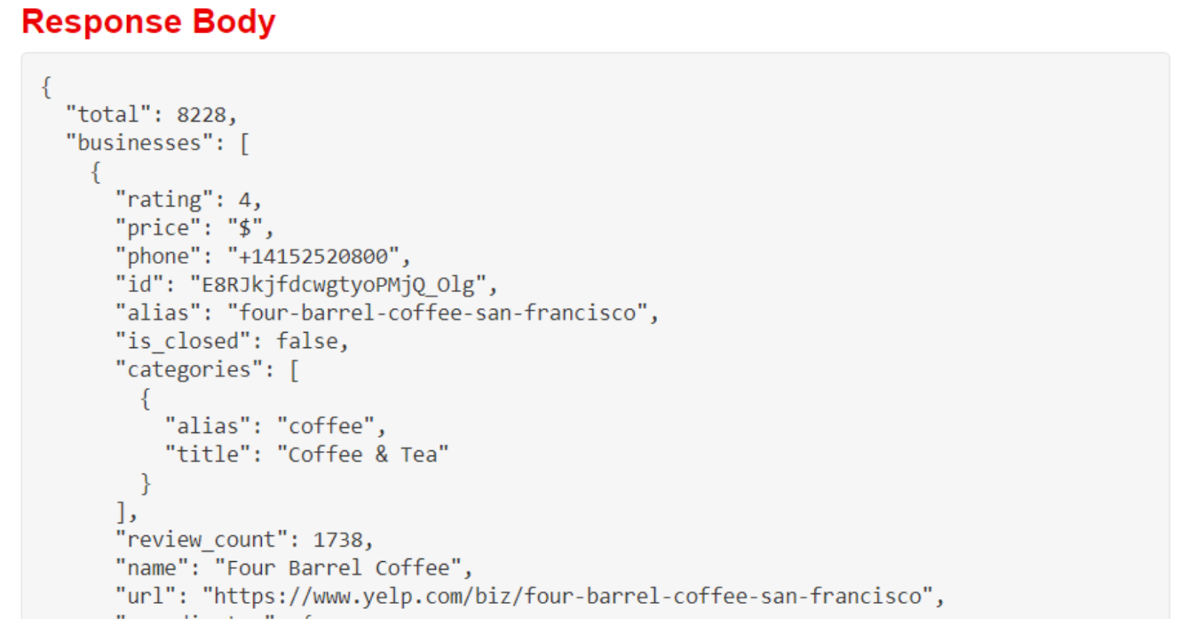  
Note that if we want business details, the data we need is nested under the businesses key.

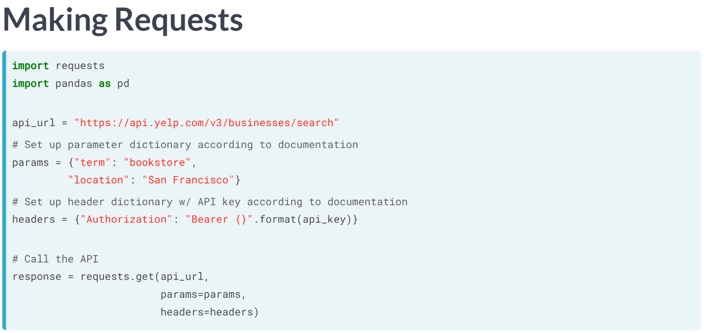  
Let's get data from the API about bookstores in San Francisco, California. We import pandas and the Request library, then create a variable for the API endpoint.

The API documentation indicated required parameters and authorization, so we also set up a dictionary of request parameter fields and values, plus a headers dictionary of authorization info. API keys are strings used to identify the program calling the API and confirm it can make the call.

They are sensitive information, so it's hidden behind the API key variable here. We pass the API url, params, and headers to requests.get() and store the result as response. Since response contain data and metadata, we use the JSON method to isolate the data.

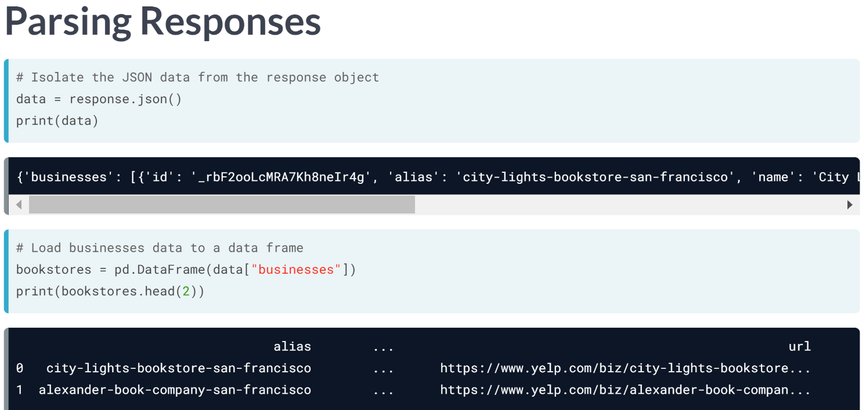  
Since responses contain data and metadata, we use the JSON method to isolate the data. We have a dictionary, with the information we want in a list under the businesses key. We pass data businesses to pd.DataFrame, not read_jason(), to create the data frame. When we check the head, we see we did get business details.

# Get data from an API

In this exercise, you'll use requests.get() to query the Yelp Business Search API for cafes in New York City. requests.get() needs a URL to get data from. The Yelp API also needs search parameters and authorization headers passed to the params and headers keyword arguments, respectively.

You'll need to extract the data from the response with its json() method, and pass it to pandas's DataFrame() function to make a data frame. Note that the necessary data is under the dictionary key "businesses".

pandas (as pd) and requests have been loaded. Authorization data is in the dictionary headers, and the needed API parameters are stored as params.

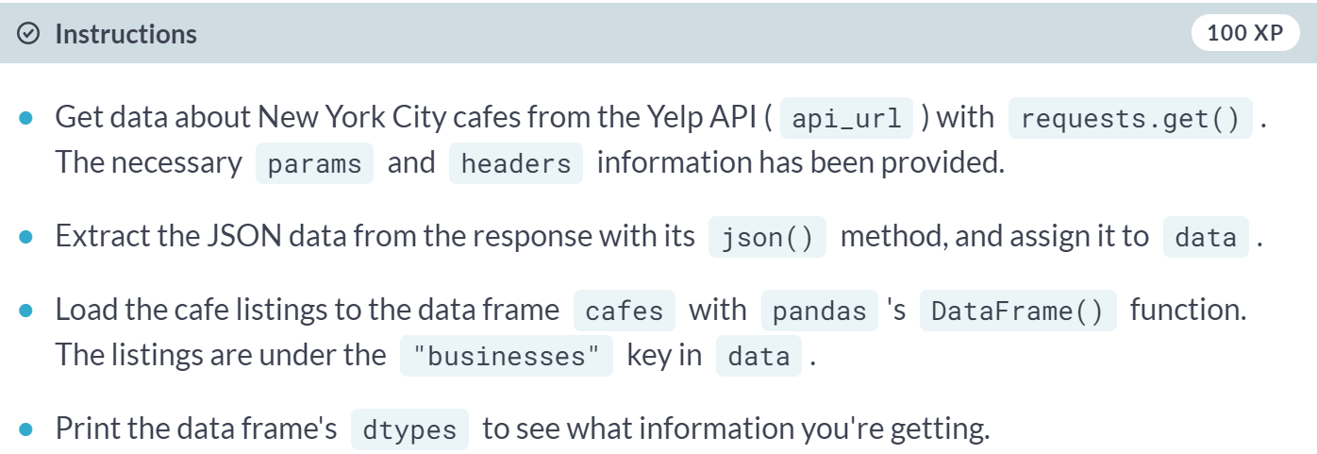

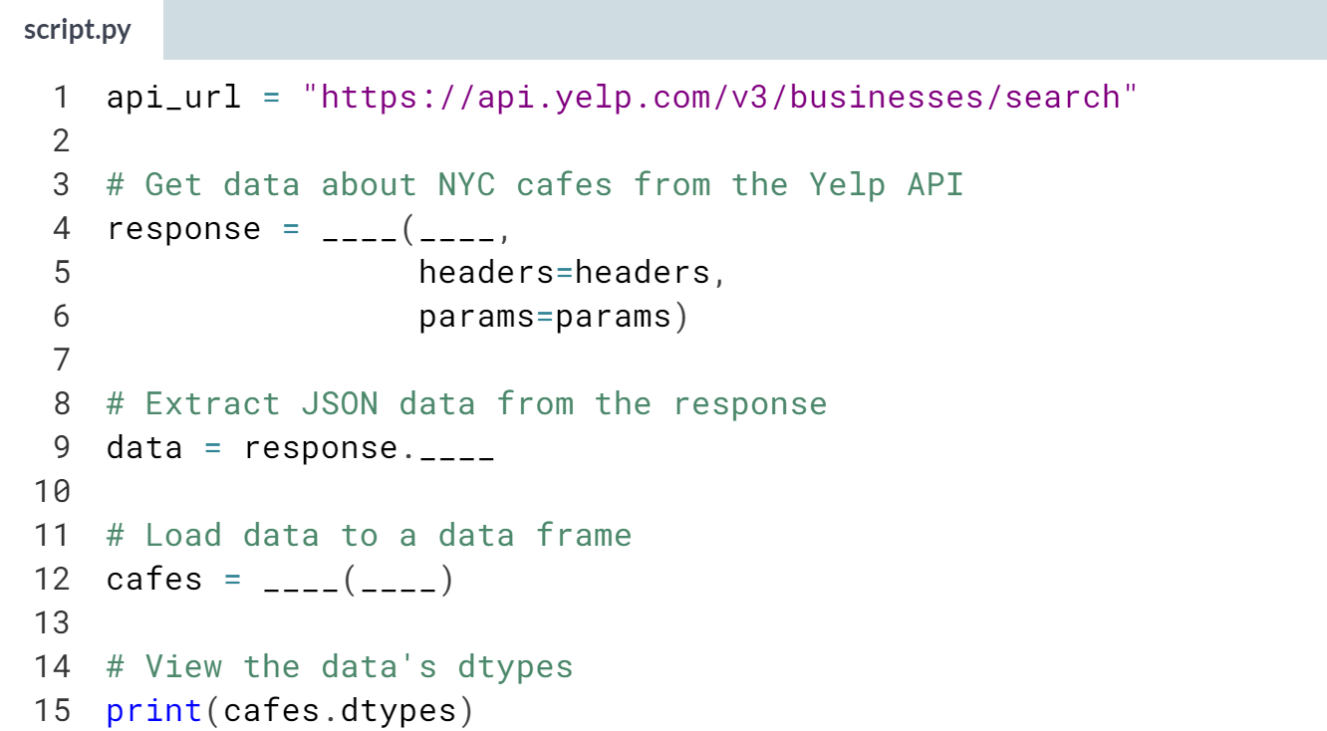  
(Solution on the next page)

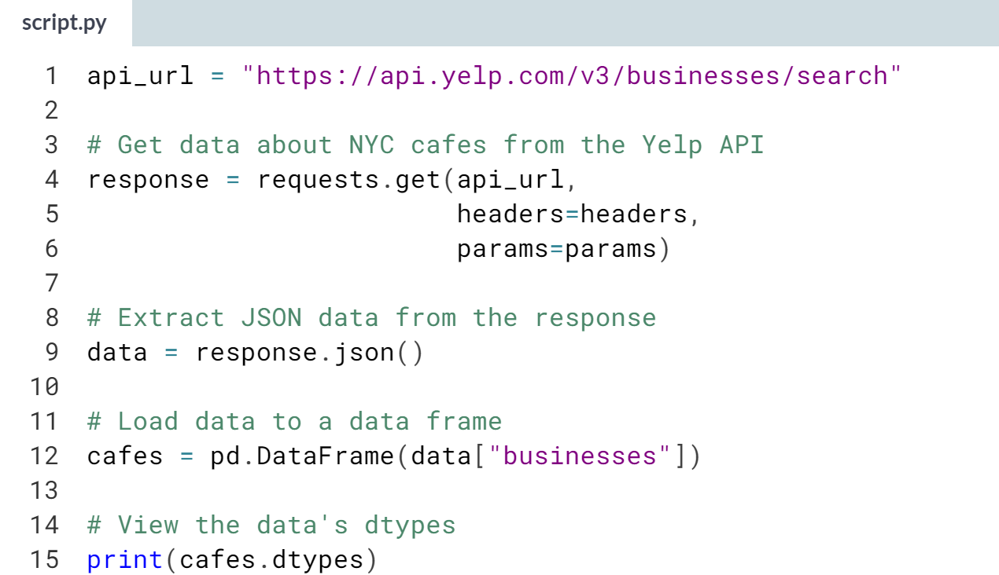

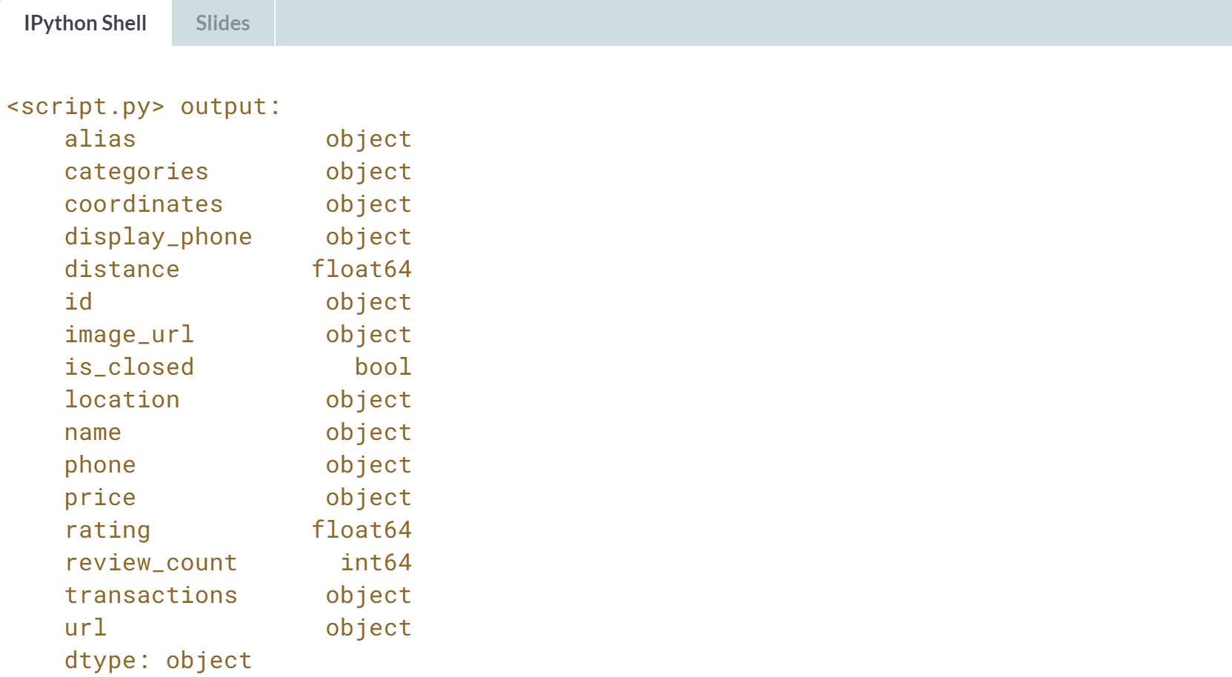  
Bravo! Check the response format whenever you work with a new API -- chances are the data you need is nested under a dictionary key, like here.

***One important note***: to avoid problems like hitting usage limits or potential connection issues, this course mimics API requests in the background, and, if you set up the code right, returns the corresponding response object. The code you'll write looks exactly like what you would use to interact with the actual API, though. If you're curious about how this works, check out this GitHub repo.

# Set API parameters

Formatting parameters to get the data you need is an integral part of working with APIs. These parameters can be passed to the get() function's params keyword argument as a dictionary.

The Yelp API requires the location parameter be set. It also lets users supply a term to search for. You'll use these parameters to get data about cafes in NYC, then process the result to create a data frame.

pandas (as pd) and requests have been loaded. The API endpoint is stored in the variable api_url. Authorization data is stored in the dictionary headers.

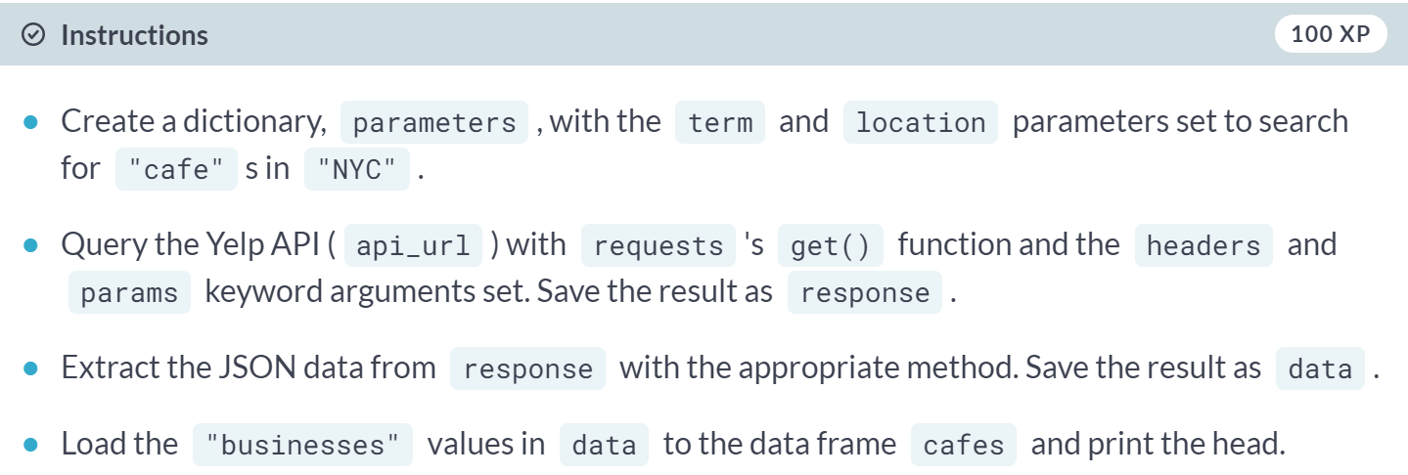

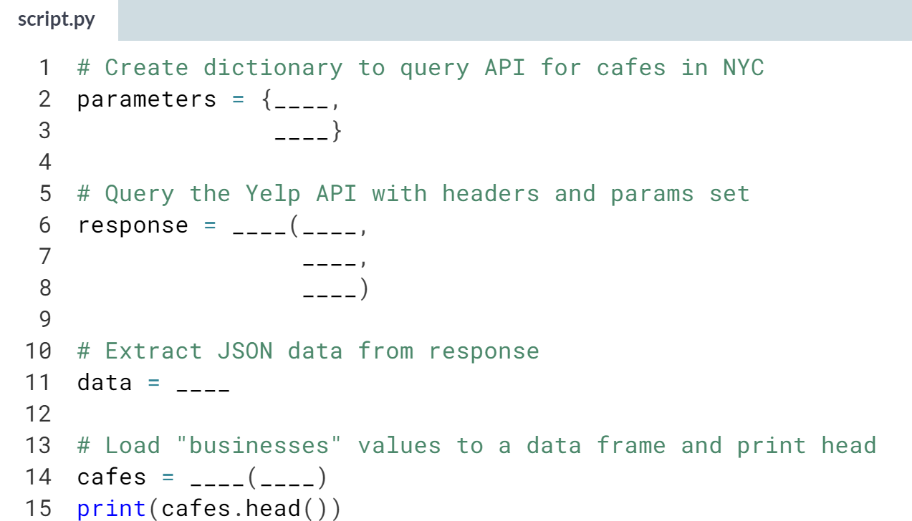

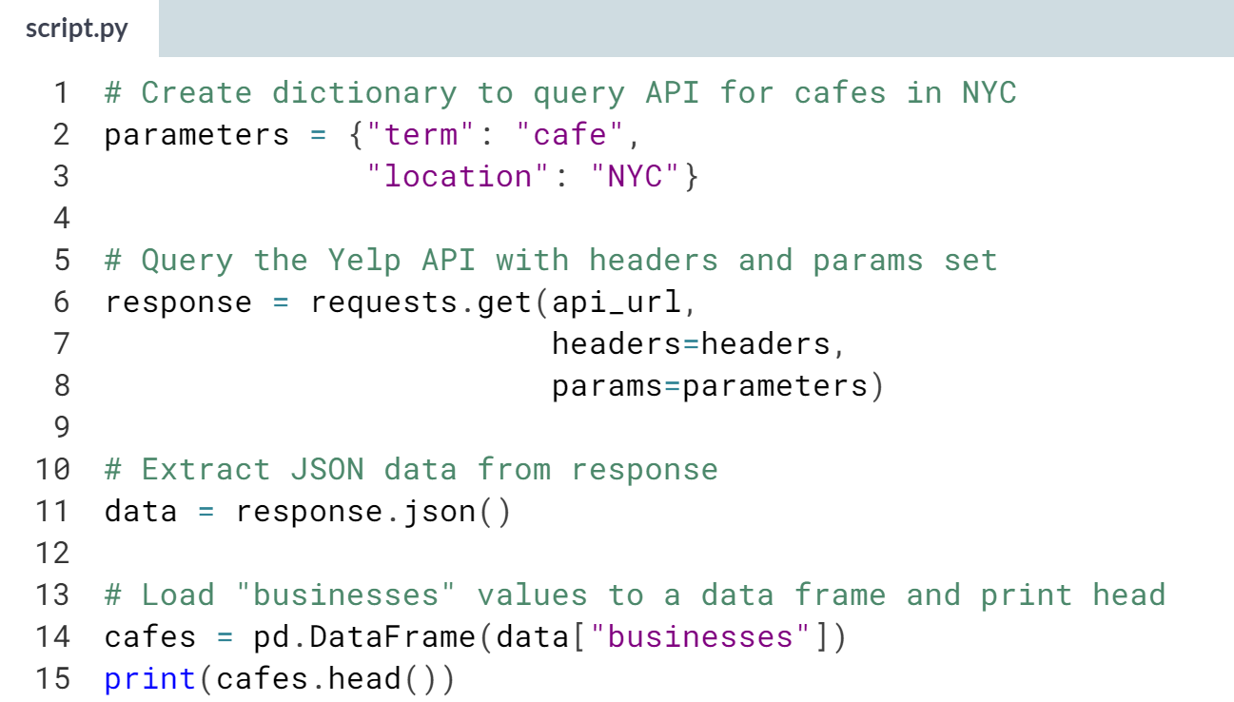

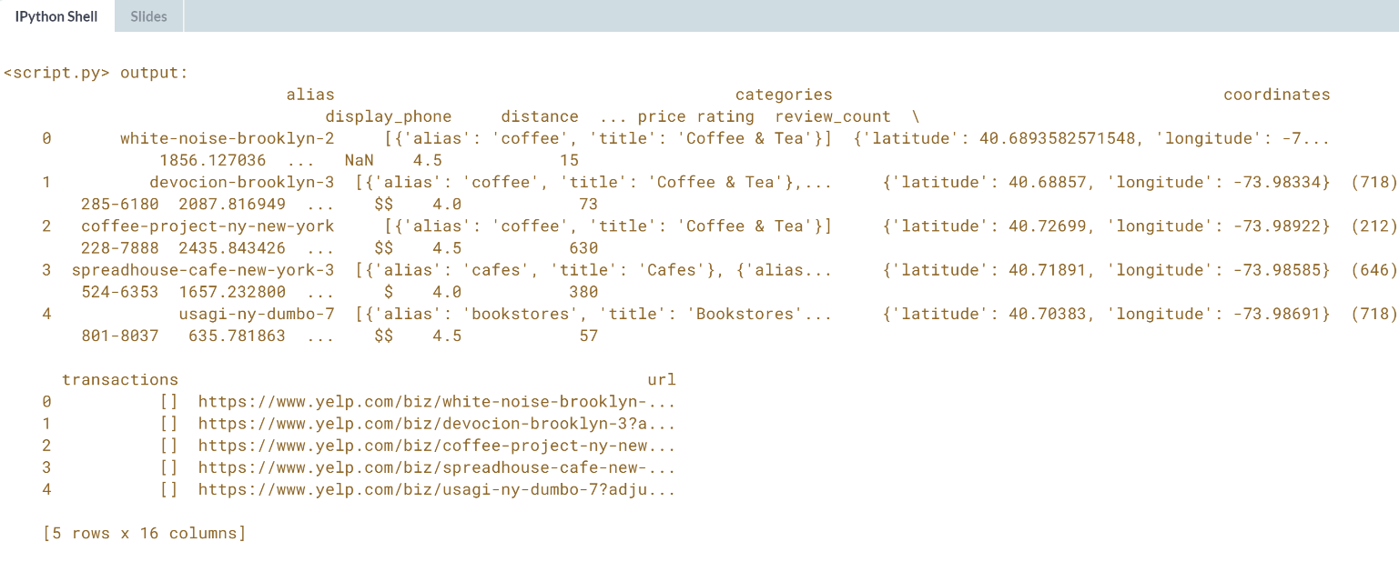

Great work! Notice that some of the values are themselves dictionaries, making them hard to analyze. We'll learn how to unpack those in a later lesson.

# Set request headers

Many APIs require users provide an API key, obtained by registering for the service. Keys typically are passed in the request header, rather than as parameters.

The [**Yelp API documentation**](https://www.yelp.com/developers/documentation/v3/authentication) says "To authenticate API calls with the API Key, set the Authorization HTTP header value as Bearer API_KEY."

You'll set up a dictionary to pass this information to get(), call the API for the highest-rated cafes in NYC, and parse the response.

pandas (as pd) and requests have been loaded. The API endpoint is stored as api_url, and the key is api_key. Parameters are in the dictionary params.

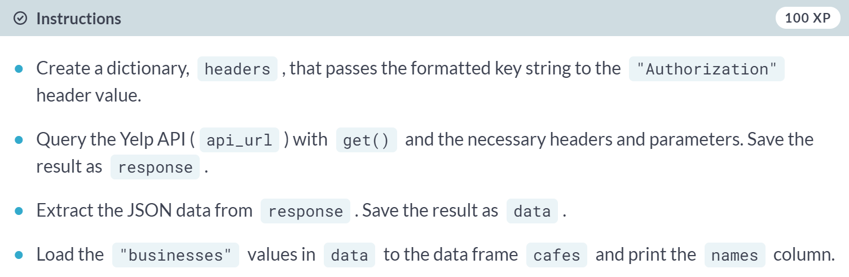

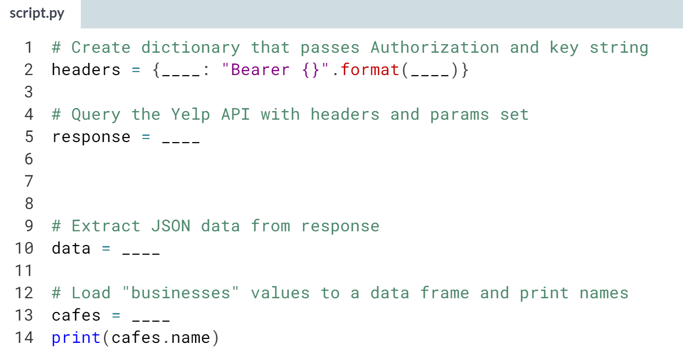  
(Solution on the next page)

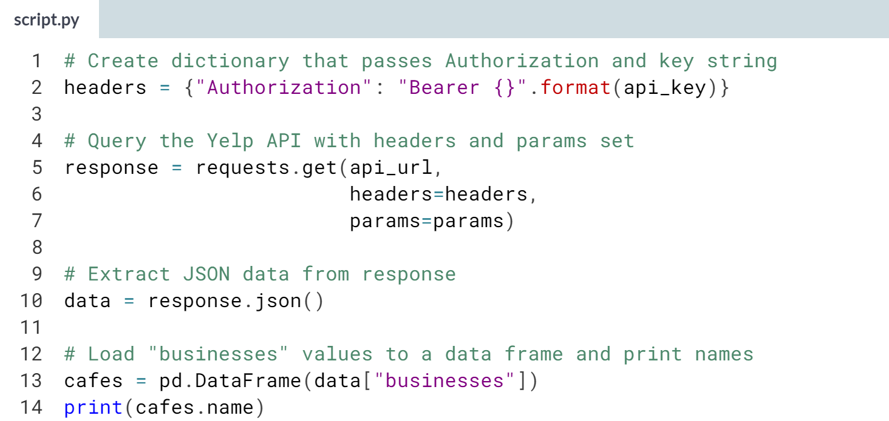

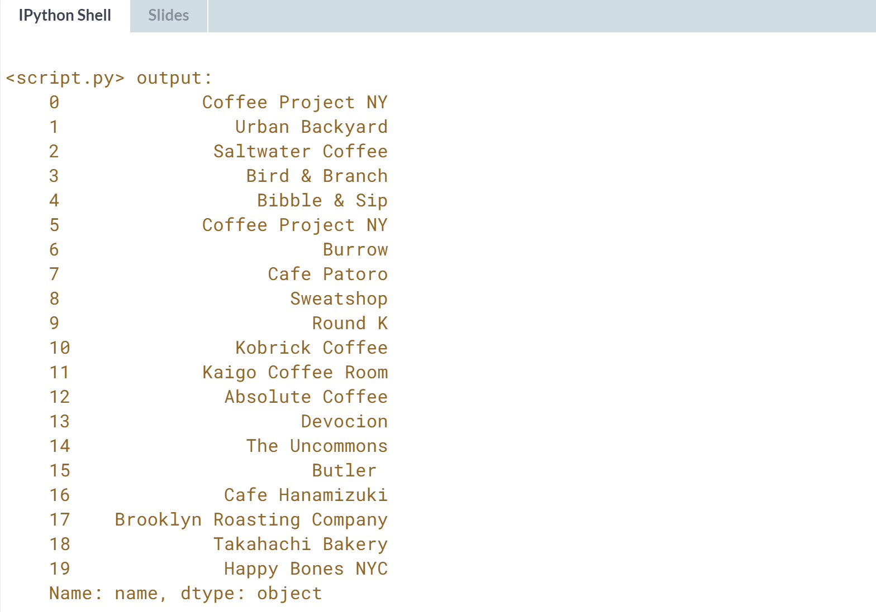

Great work! API keys are employed to track and moderate API usage. Be sure to keep keys private -- unscrupulous developers use others' keys to get around usage limits.



We will turn our attention to restructuring nested JSON data.



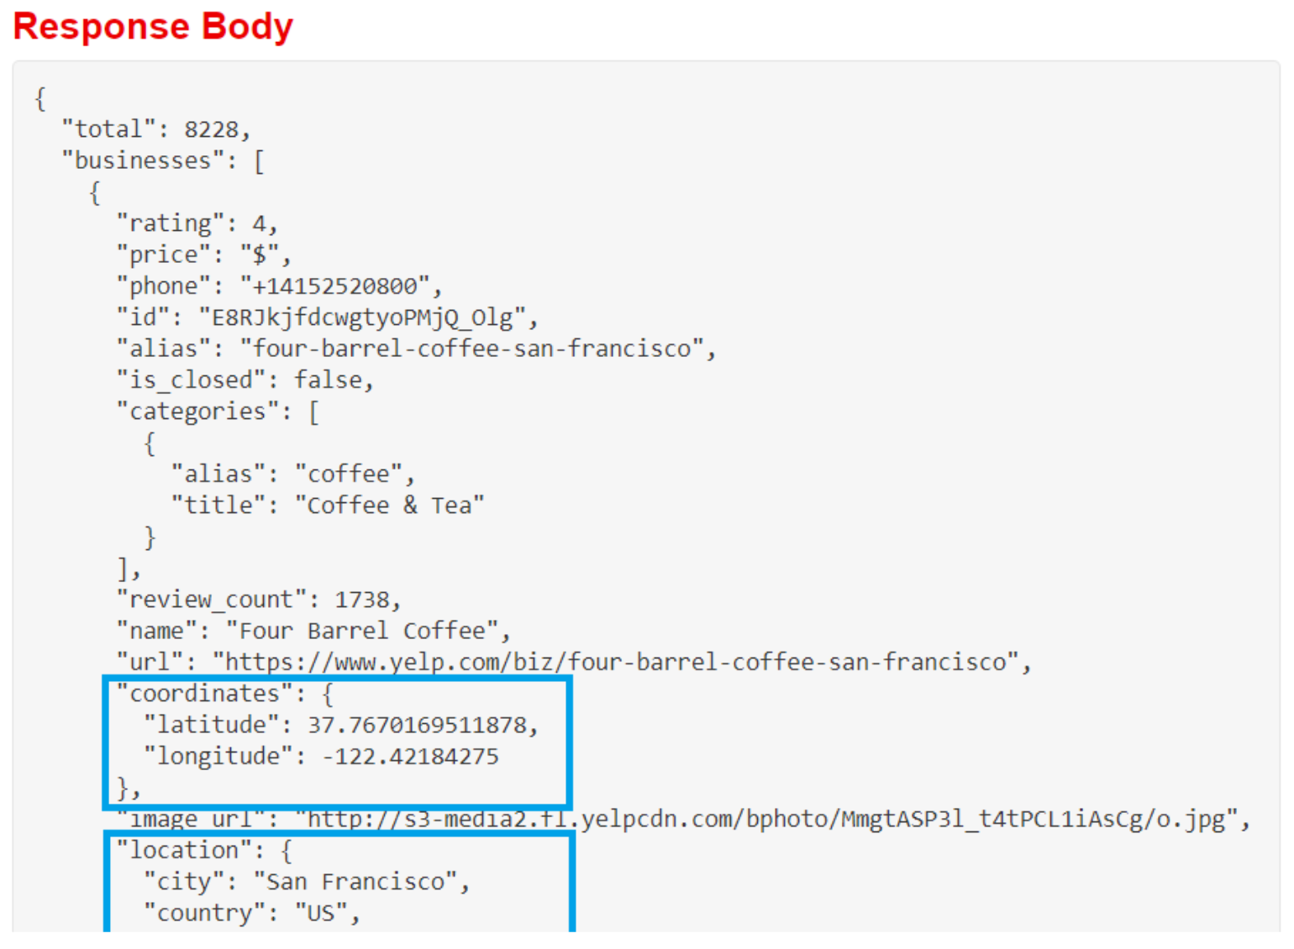  
The Yelp data has several examples of nesting. The coordinates and location attributes have objects for values.

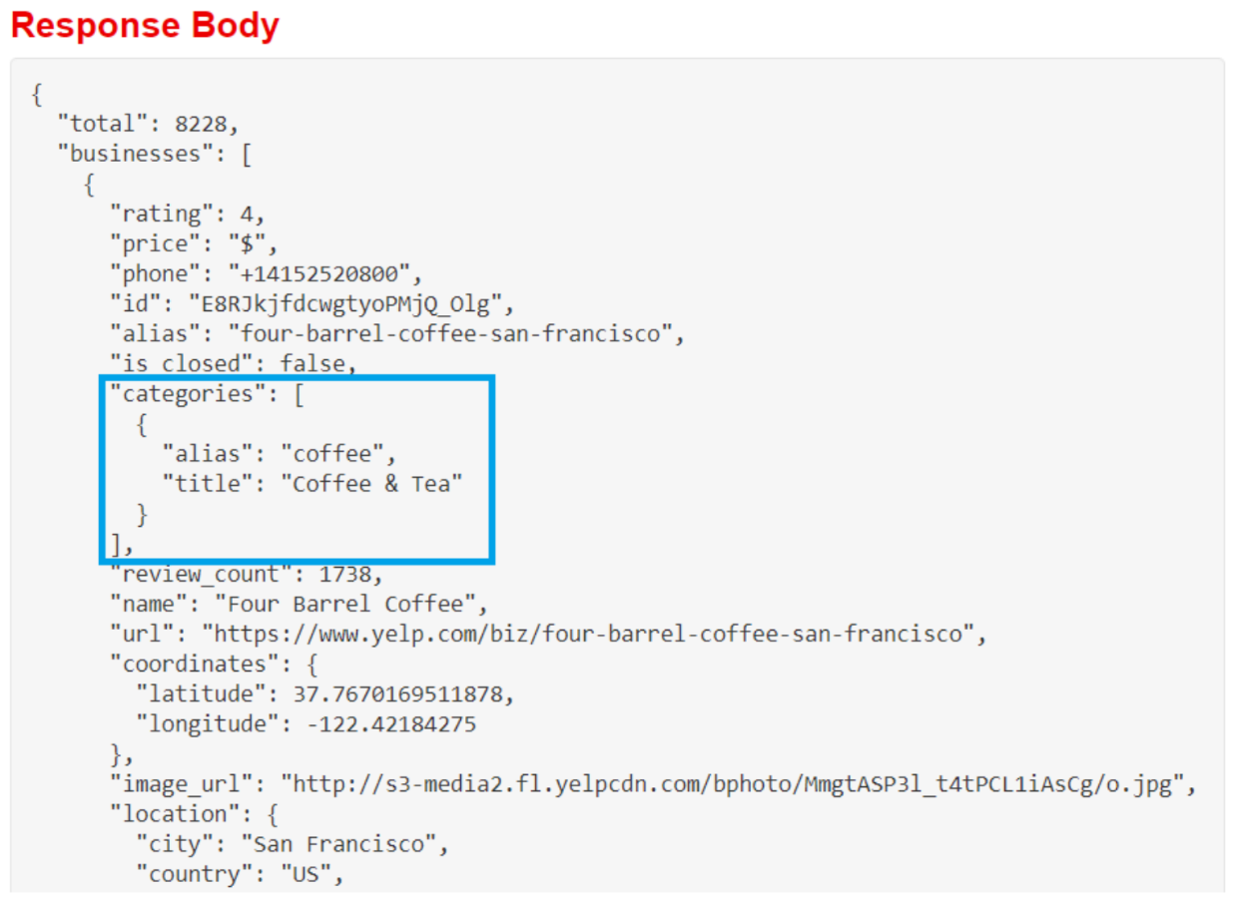  
Categories' values are lists of objects.

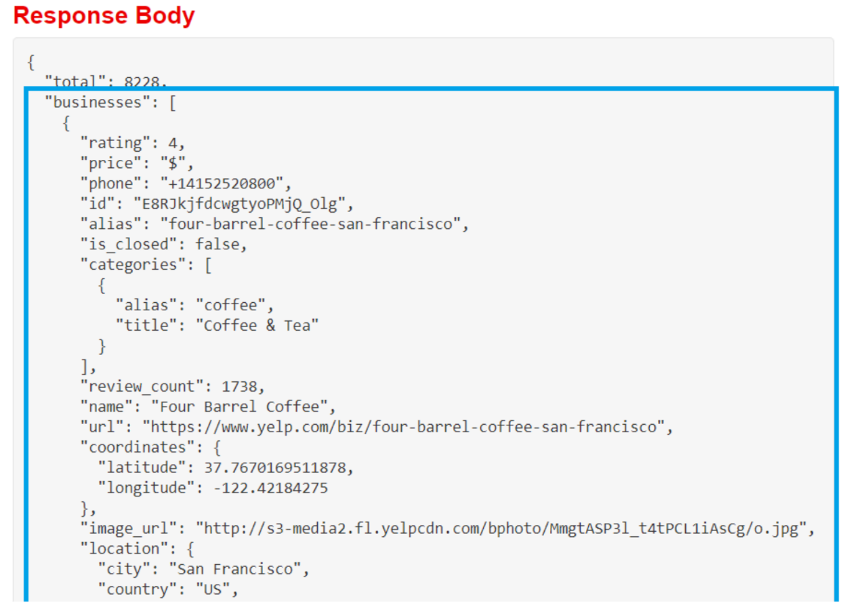  
And these records are all nested under businesses.

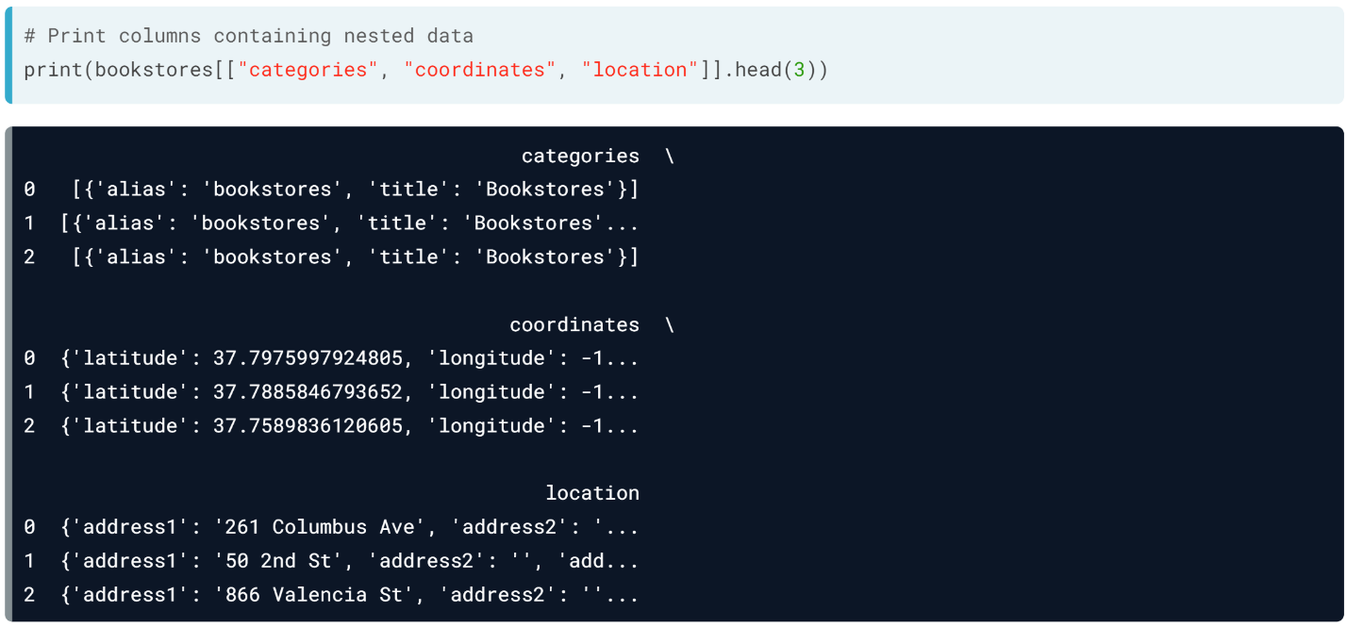  
Checking these columns in our data frame, we see dictionaries. The data would be easier to work with if nested attributes were in their own columns. Fortunately, pandas has a function to flatten nested JSONs. Unfortunately, it's in a submodule that doesn't normally load when importing pandas.

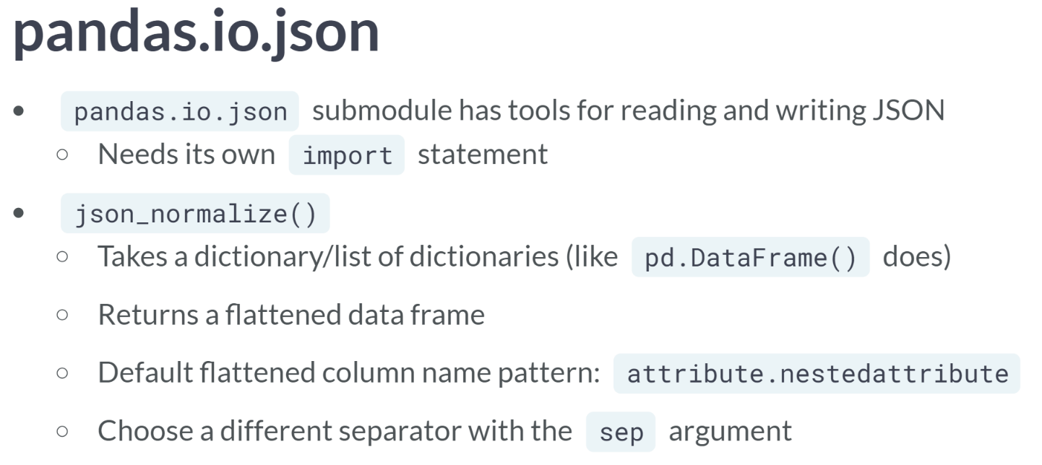  
The *pandas.io.json* submodule contains functions for reading and writing JSON beyond those in the primary pandas package, but it has to be imported explicitly. We will use its ***json_normalize()*** function to flatten nested data by taking a dictionary or list of dictionaries. This means that JSONs that load with ***pd.DataFrame()*** will load with JSON normalize. It returns a data frame.

Nested attribute column names follow the default pattern *attribute.nestedattribute*. The dot separator interferes with pandas' dot notation for column selection, so it's advisable to specify a different separator, like underscore, with the *sep* argument.

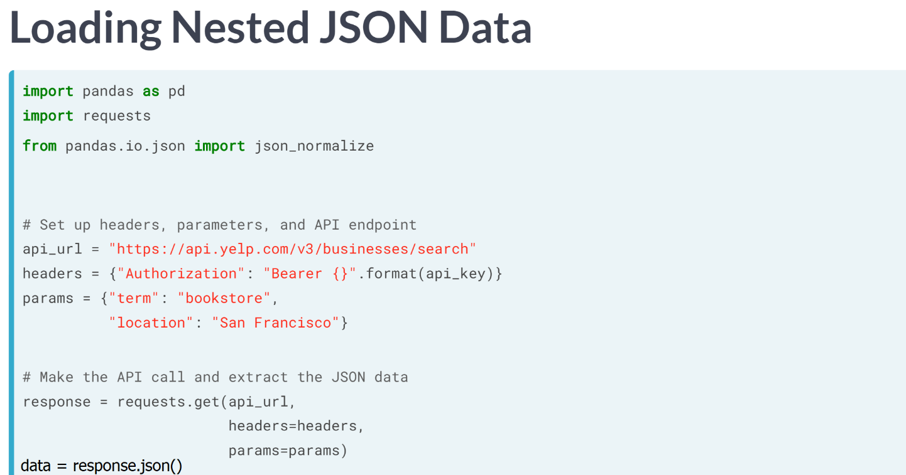

Let's use **json_*normalize*** to flatten nested data as we load it.

After importing pandas, requests, json_normalize, we create a variable for the API endpoint, as well as header and parameter dictionaries.

Then, we pass those to request to get and isolate the data with the ***response.json()*** method.

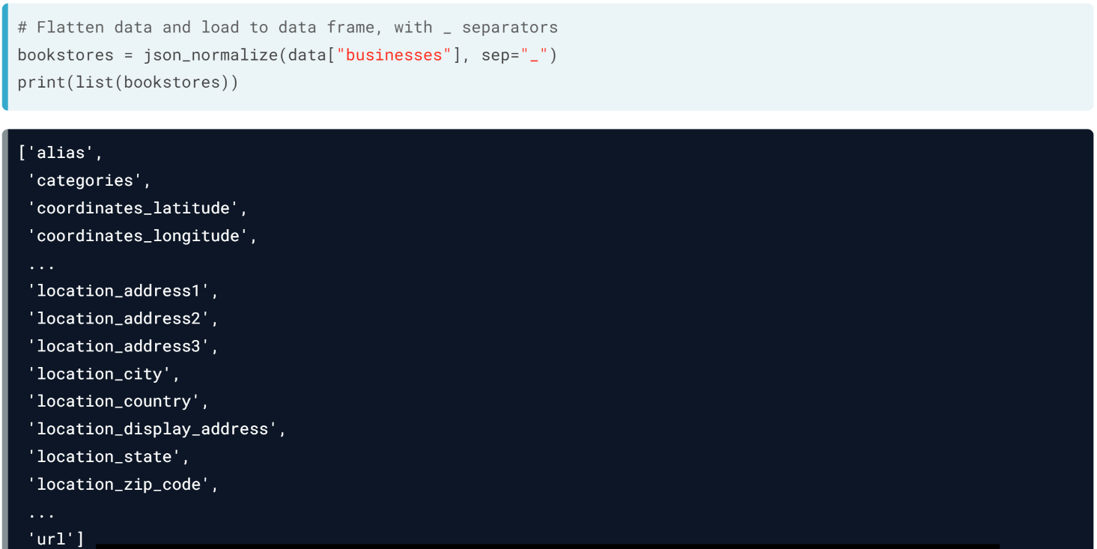  
We pass the data nested under businesses to JSON normalize, specifying underscores as the separator, and assign the resulting data frame to bookstores.

Printing the data frame's column names show that nested attributes have their own columns, like coordinates_latitude.

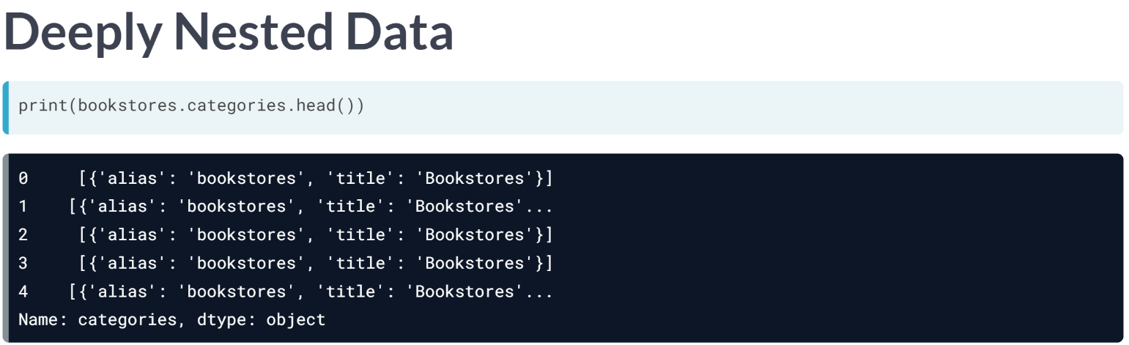  
Categories, however, is still nested.

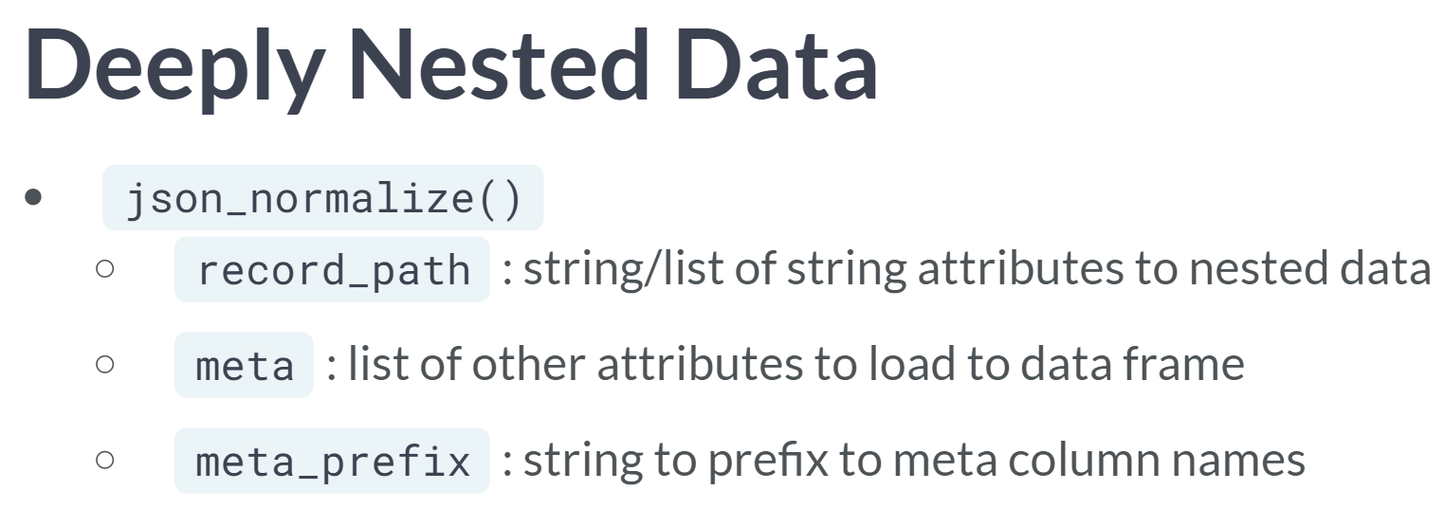  
There are a few approaches for deeply nested data. You may write a custom flattening function or decide its relevance to the analysis and leave it to be. Another option is to use ***json_normalize()***'s record path, meta, and meta prefix arguments.

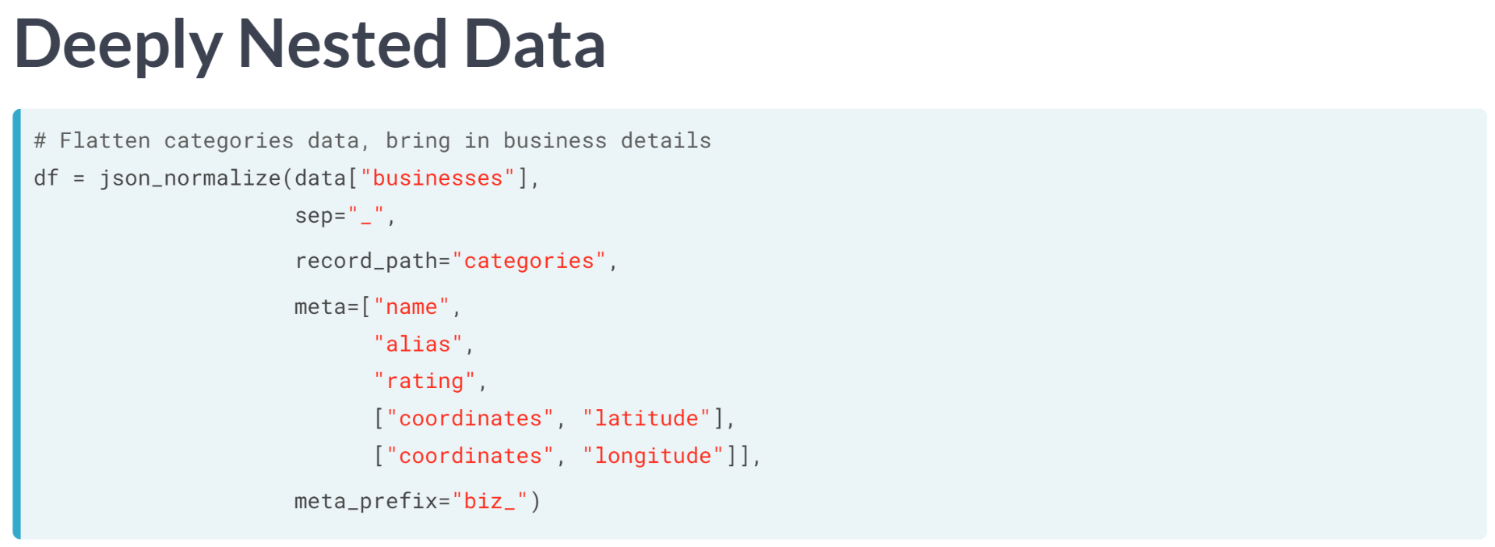

Let's see this in action with categories. We pass the businesses data to ***json_normalize()*** and specify the separator. We set record path to categories. We get business names, alias, ratings, and coordinates with the meta argument.

To flatten coordinates, we supply sub-lists containing paths to latitude and longitude. Businesses and categories both have alias columns, so we set a meta prefix to differentiate them.

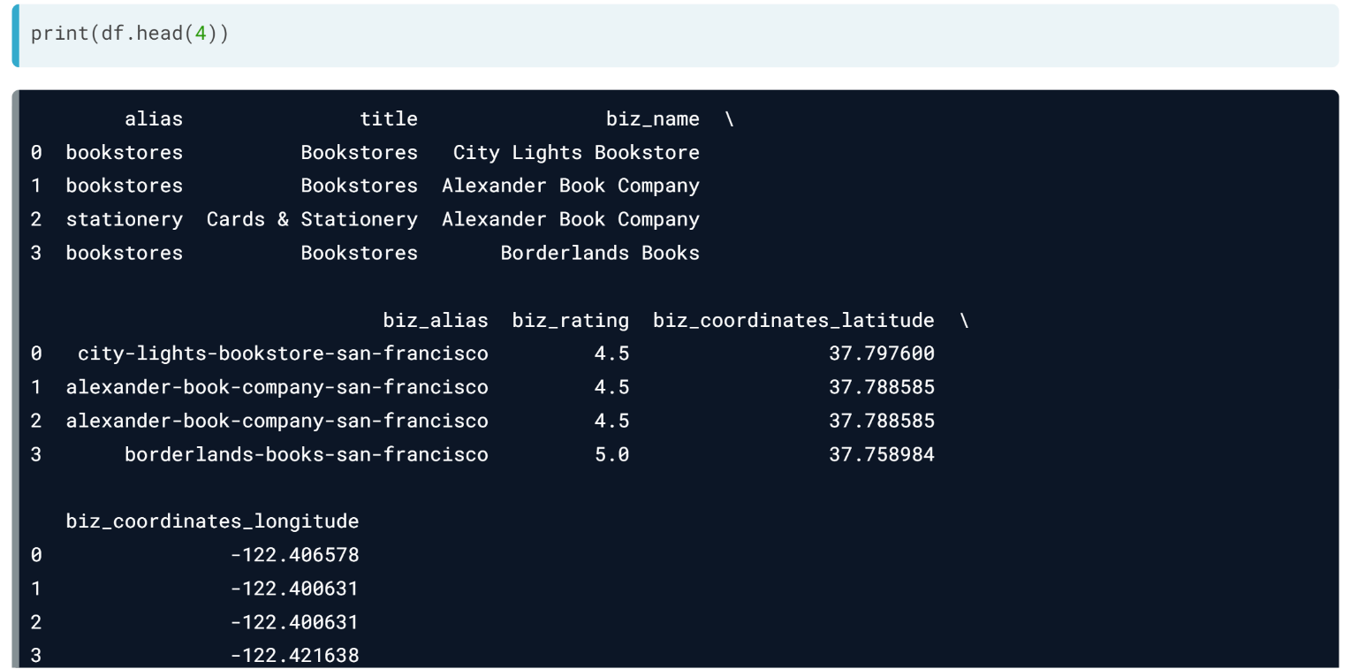  
Viewing the data, we see it's totally flat, but businesses with multiple categories repeat. Depending on the use case, this may be fine, or duplicates may need to be removed.

# Flatten nested JSONs

A feature of JSON data is that it can be nested: an attribute's value can consist of attribute-value pairs. This nested data is more useful unpacked, or flattened, into its own data frame columns. The pandas.io.json submodule has a function, json_normalize(), that does exactly this.

The Yelp API response data is nested. Your job is to flatten out the next level of data in the coordinates and location columns.

pandas (as pd) and requests have been imported. The results of the API call are stored as response.

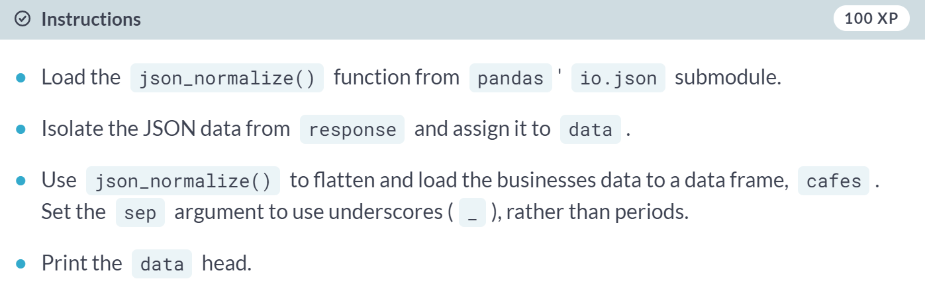

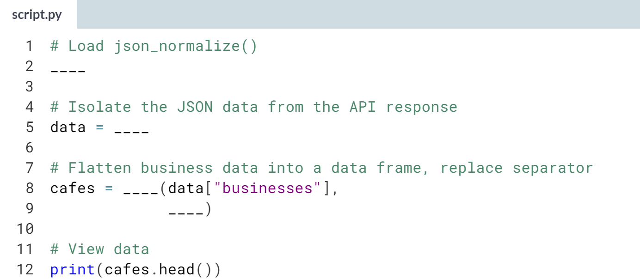

(Solution on the next page)

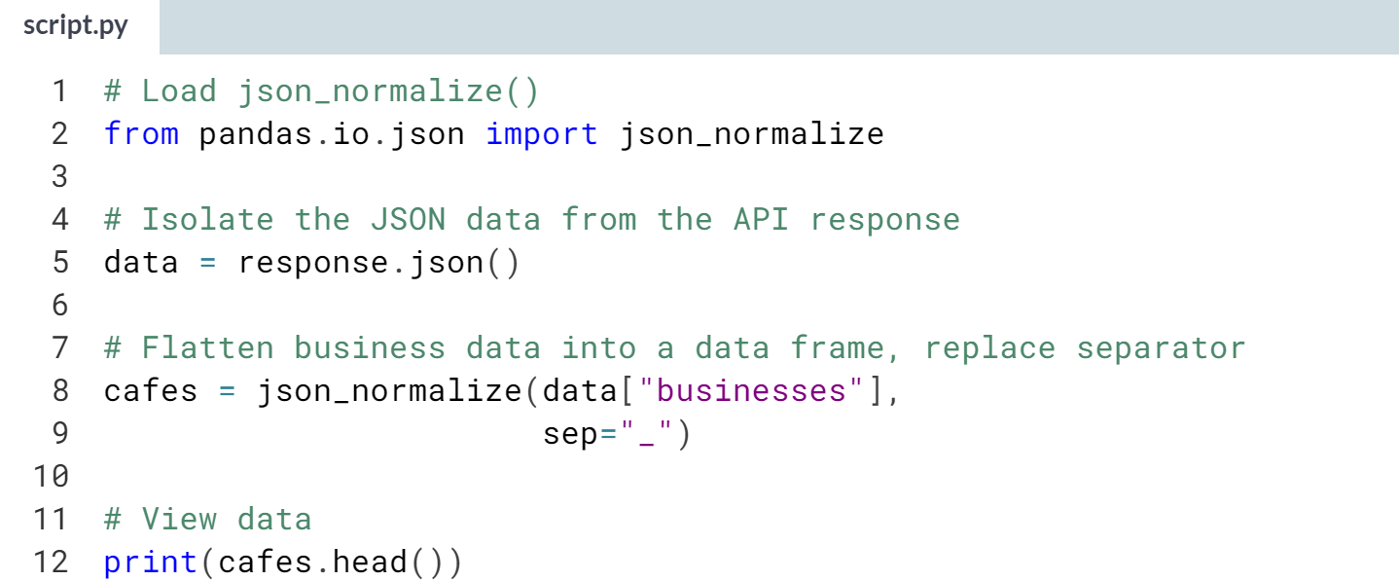

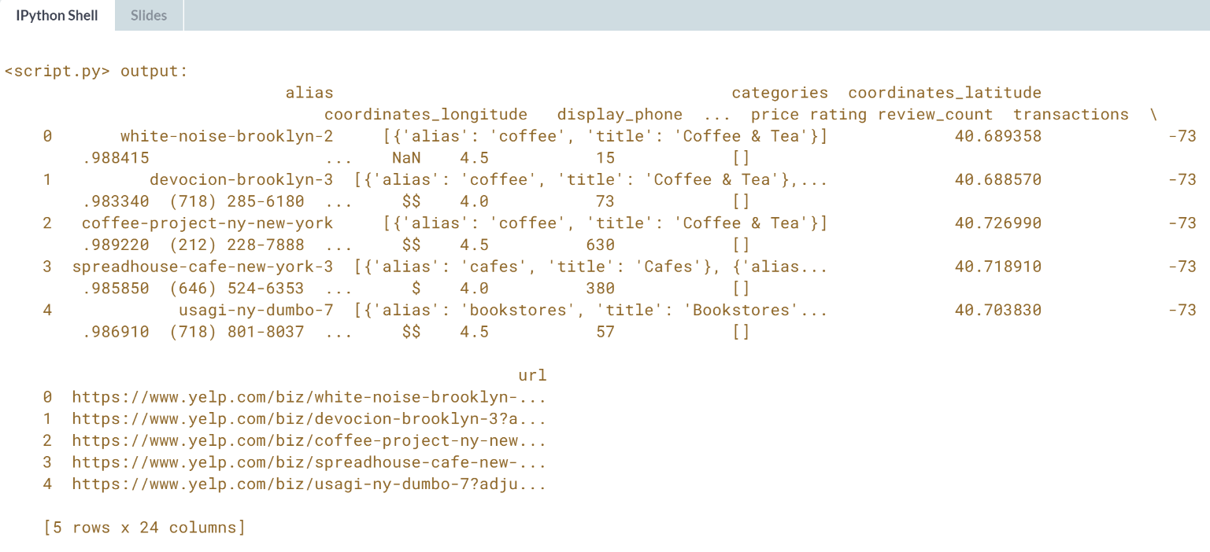

Nice! Notice that by accessing *data['businesses']* we're already working one level down the nested structure. *data* itself could be flattened with ***json_normalize()***.

# Handle deeply nested data

Last exercise, you flattened data nested down one level. Here, you'll unpack more deeply nested data.

The categories attribute in the Yelp API response contains lists of objects. To flatten this data, you'll employ json_normalize() arguments to specify the path to categories and pick other attributes to include in the data frame.

You should also change the separator to facilitate column selection and prefix the other attributes to prevent column name collisions. We'll work through this in steps.

pandas (as pd) and json_normalize() have been imported. JSON-formatted Yelp data on cafes in NYC is stored as data.

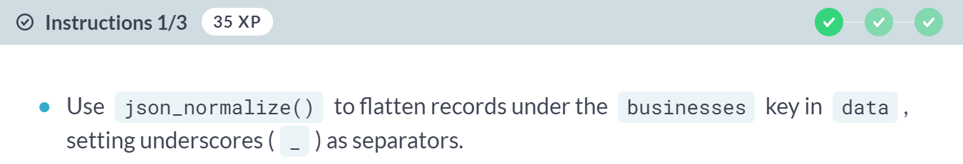

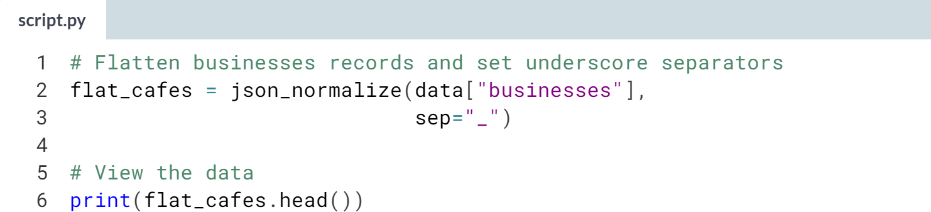

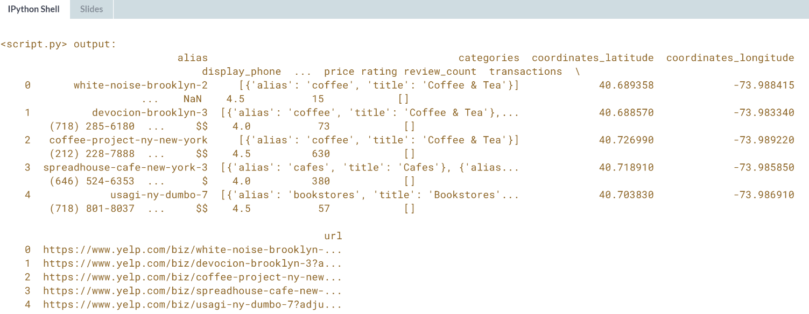  
(Exercise continues on the next page)

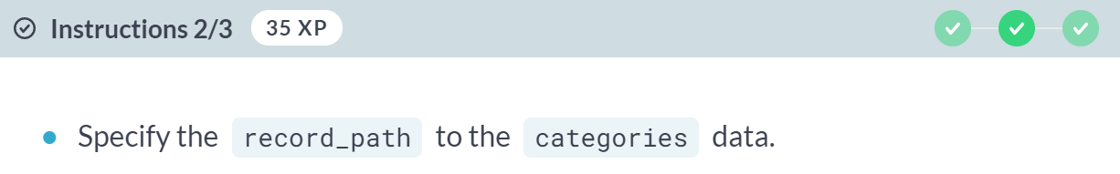

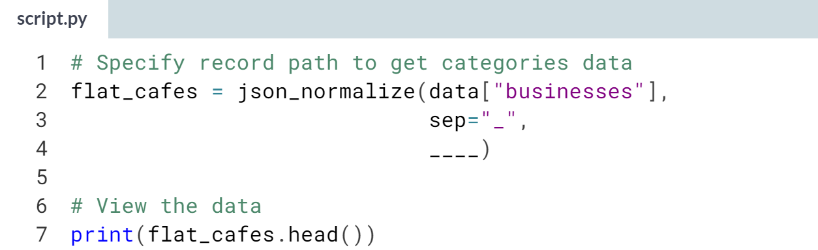

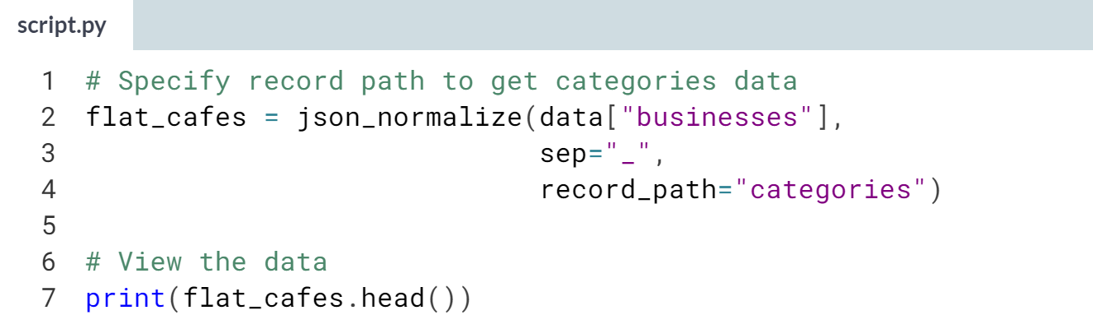

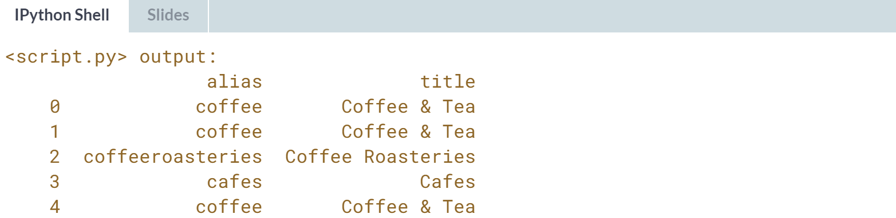

(Exercise continues on the next page)

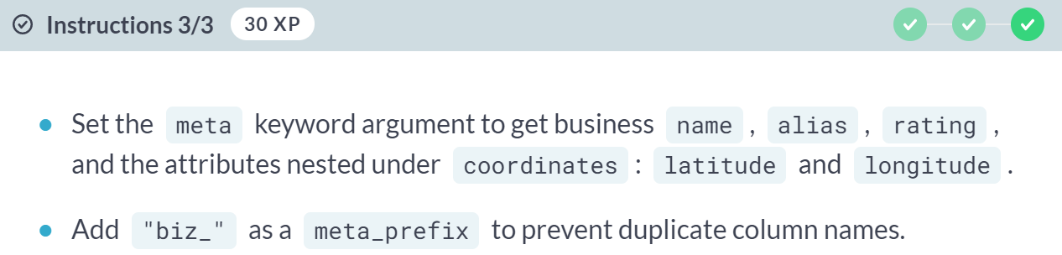

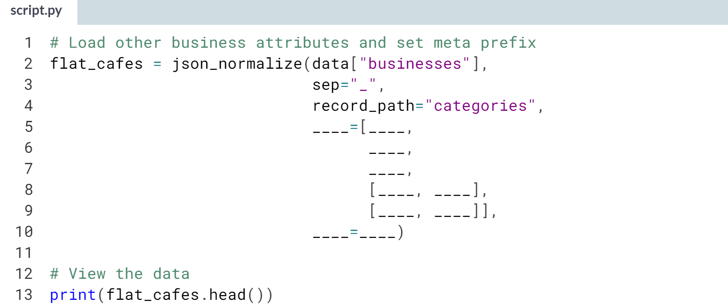

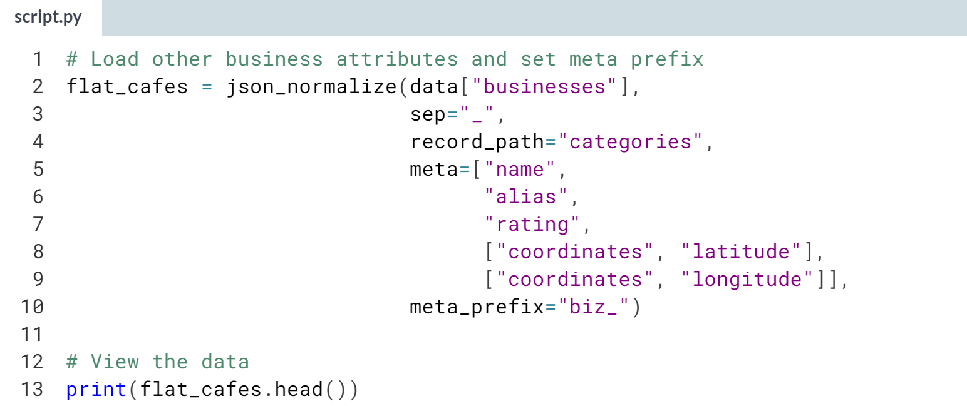

(Result on the next page)

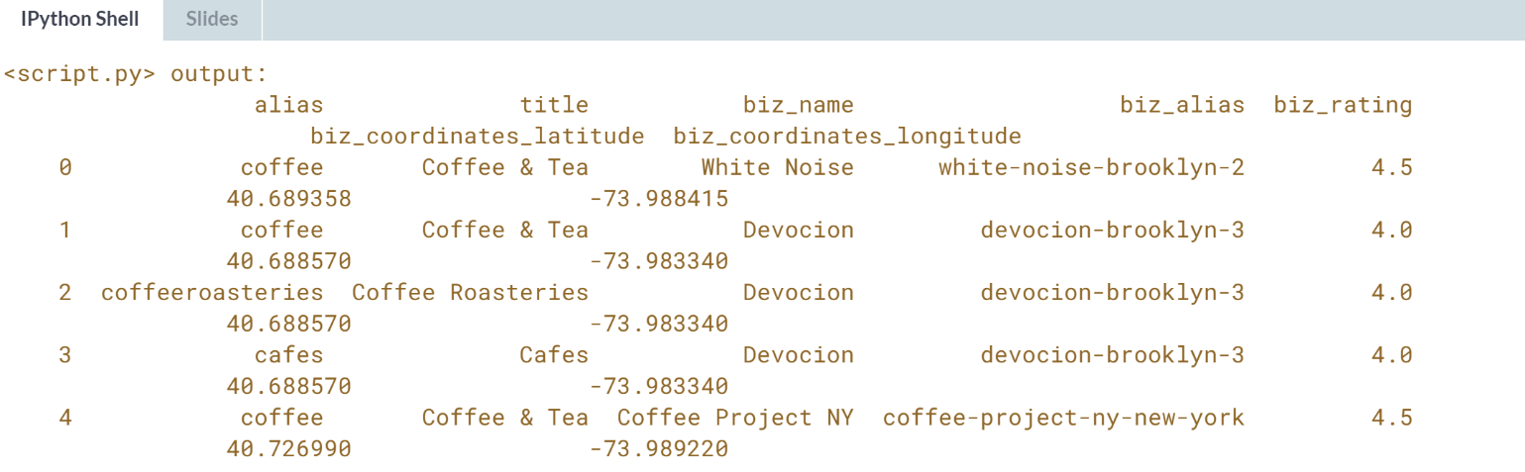

Great job! Naming meta columns can get tedious for datasets with many attributes, and code is susceptible to breaking if column names or nesting levels change. In such cases, you may have to write a custom function and employ techniques like recursion to handle the data.



So far, you've built pipelines to individual data sources; however, projects commonly draw data from multiple places. In this lesson, we will step back from JSON to look at pandas method for combining datasets.

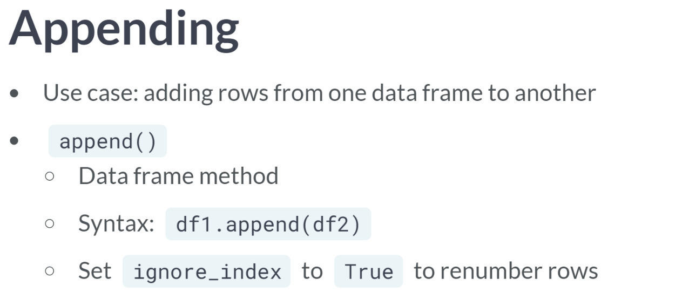

You encountered the method for adding rows from one data frame to another when compiling multiple spreadsheets - it's ***append()***, which is a data frame method that takes the data frame to add on as an argument. This syntax looks like *df1.append(df2)*.

If the data frames use pandas' default index of row numbers, you should also set append's *ignore_index* parameter to True so that the resulting data frame has relabeled rows, rather than two row 0s, two row 1s, and so on.

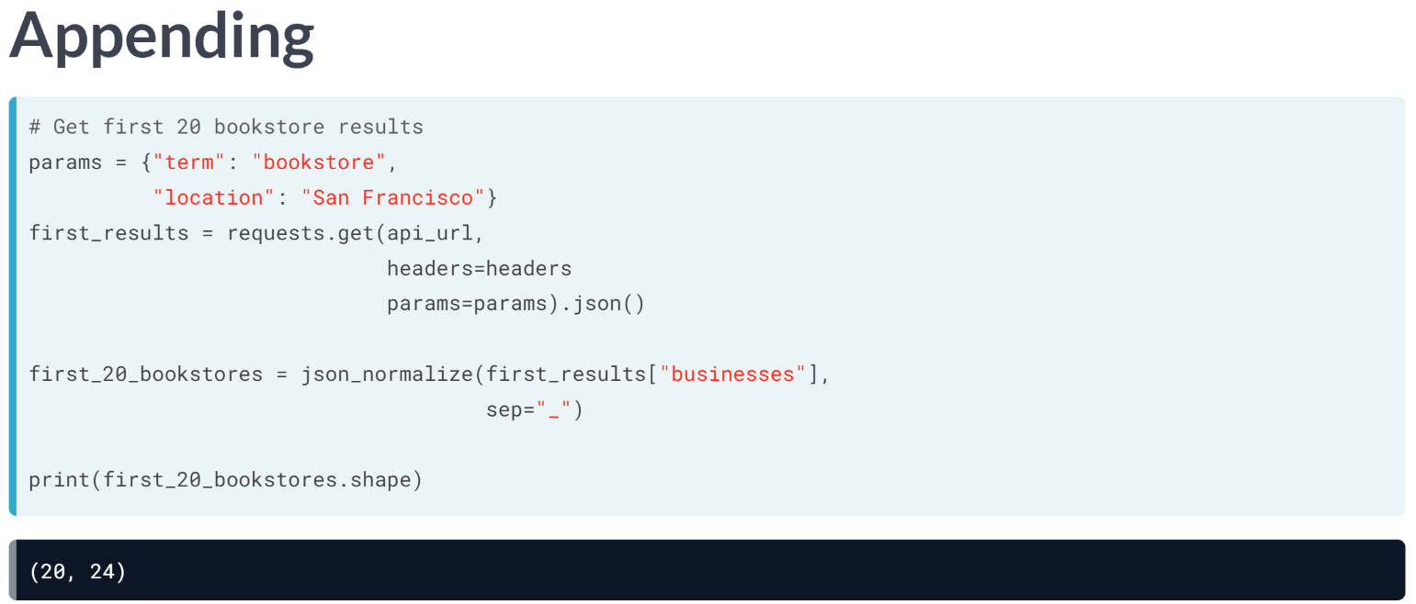  
APIs commonly limit the number of records returned in a single call to manage resource usage. The Yelp API returns 20 records at a time by default, but we can set the offset parameter to get the next 20.

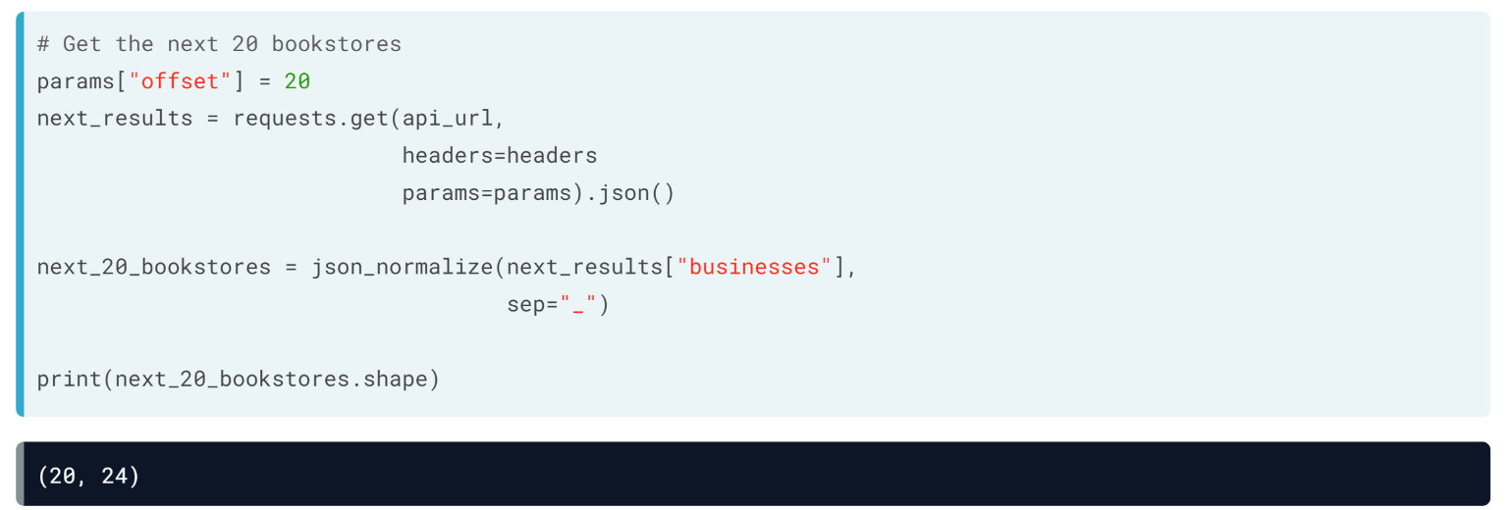

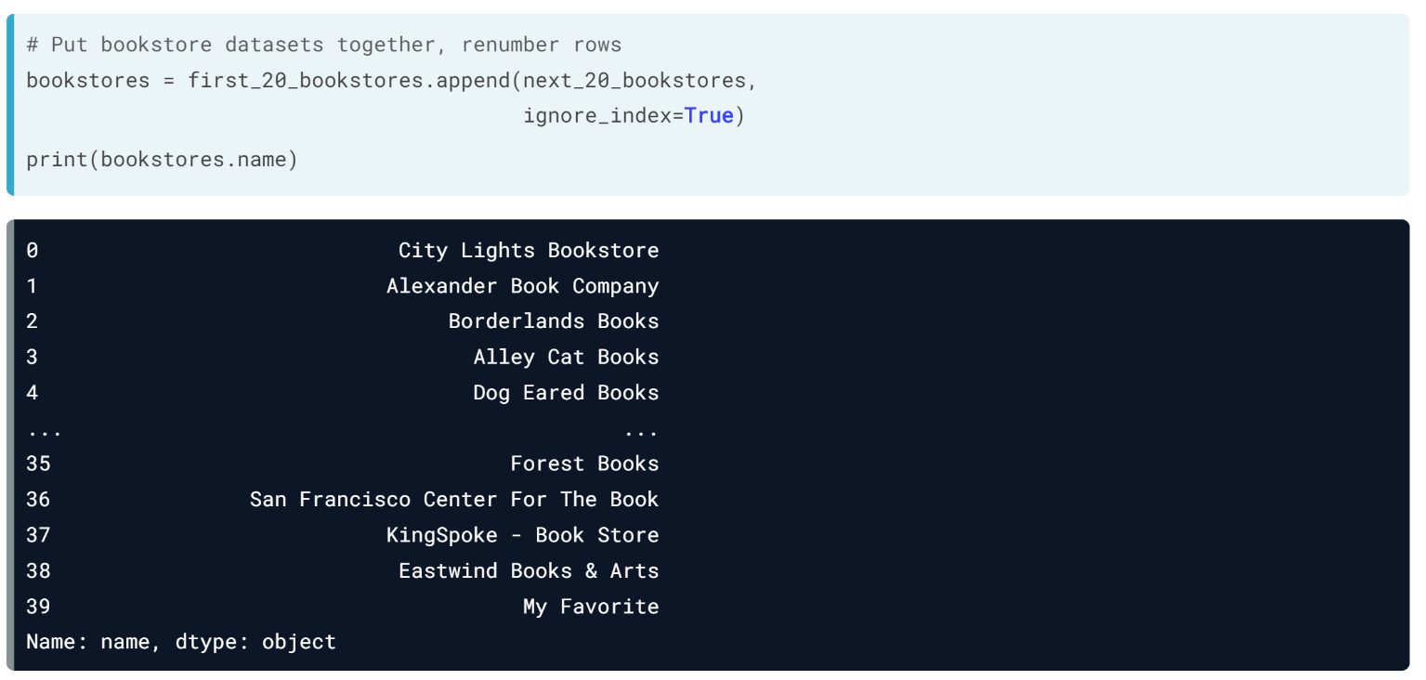  
From there, we append the second data frame to the first, setting ignore_index to True to relabel rows. We can print the name column to confirm the resulting data frame has 40 stores.

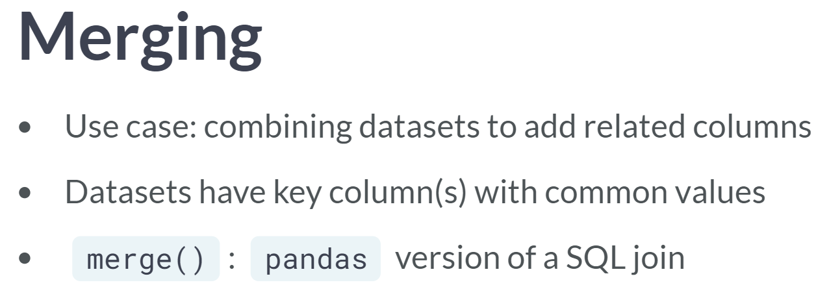  
Another way to combine data is by adding columns along a shared key column, like in the SQL joins covered last lessons. While SQL joins are only an option for tables in the same database servers, pandas has its own way to join data - ***merge()***.

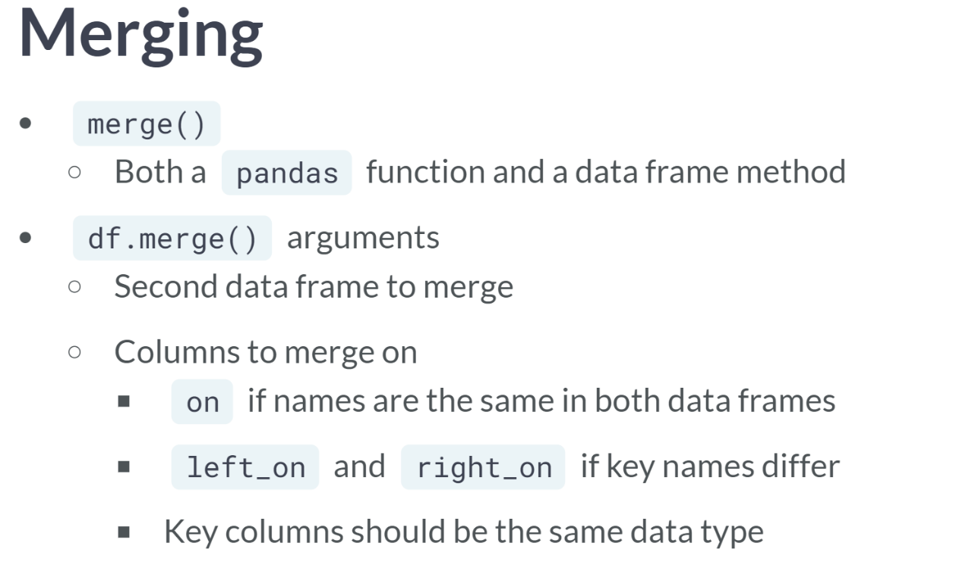  
***merge()*** is both a pandas function, like ***read_csv()***, and a data frame method, like ***append()***. We will use the data frame method, which takes the name of the other data frame to merge. It only needs strings of the columns to merge on.

If key columns names match in both data frames, you can specify the name with the *on* keyword argument. If they're different, use *left_on* and *right_on* to specify keys in the first and second data frames, respectively. Note that the key columns must be same data type for the merge to work properly.

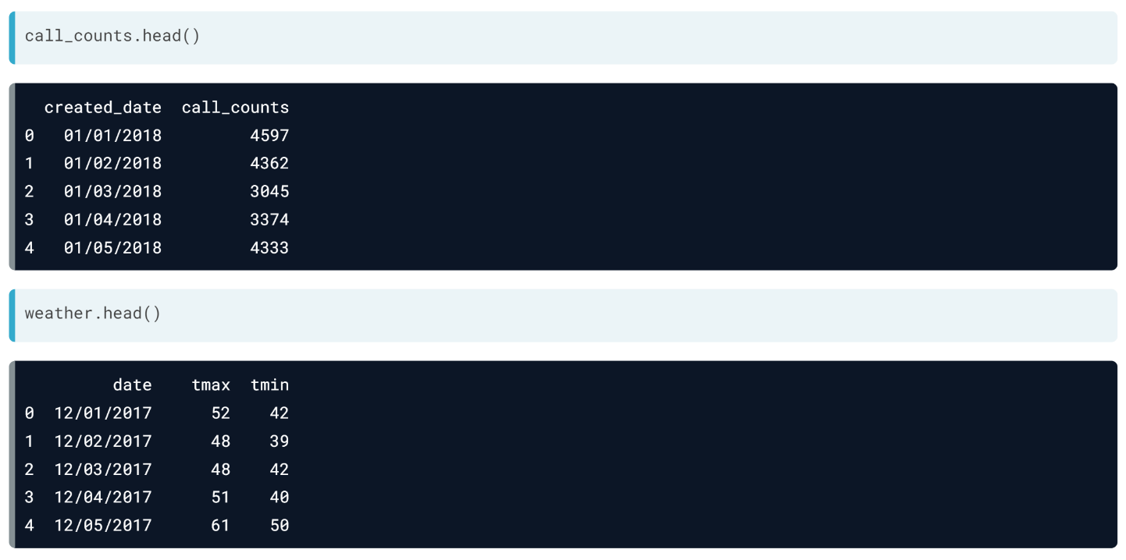  
These two datasets each have a date column which we can use as the ***merge()*** key.

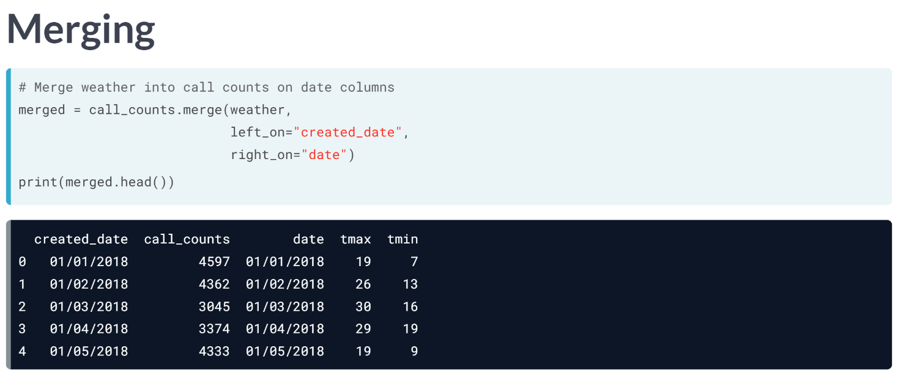  
We pass weather to call counts' ***merge()*** method, specifying to merge on created date in call counts and date in weather, and check the head to confirm the merge worked.

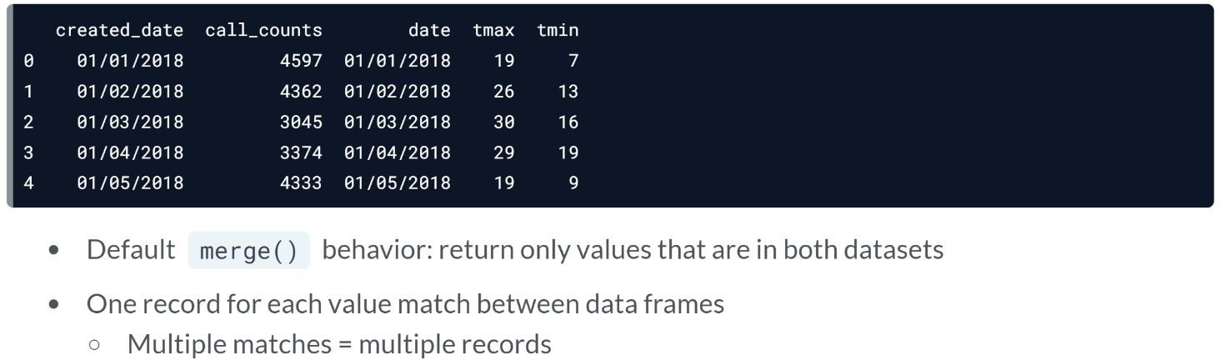

Let's take a closer look at the result. By default, ***merge()*** returns only rows with key values that exist in both datasets. There aren't call counts for December, so none of the December weather data appears here.

The call and weather data have what is called a one-to-one relationship - each call count record can be linked to only one weather record by date, and vice versa - so the result has one record for each date in both datasets.

If you merge data where a record in one data frame can be linked to multiple records in the other, the result will have one row for each possible link.

***Append()*** and ***merge()*** are just the tip of the iceberg when it comes to pandas' data wrangling capabilities, but they are useful function to start with, especially when combined with all the other tools you have for building data pipelines.

# Append data frames

In this exercise, you’ll practice appending records by creating a dataset of the 100 highest-rated cafes in New York City according to Yelp.

APIs often limit the amount of data returned, since sending large datasets can be time- and resource-intensive. The Yelp Business Search API limits the results returned in a call to 50 records. However, the offset parameter lets a user retrieve results starting after a specified number. By modifying the offset, we can get results 1-50 in one call and 51-100 in another. Then, we can append the data frames.

pandas (as pd), requests, and json_normalize() have been imported. The 50 top-rated cafes are already in a data frame, top_50_cafes.

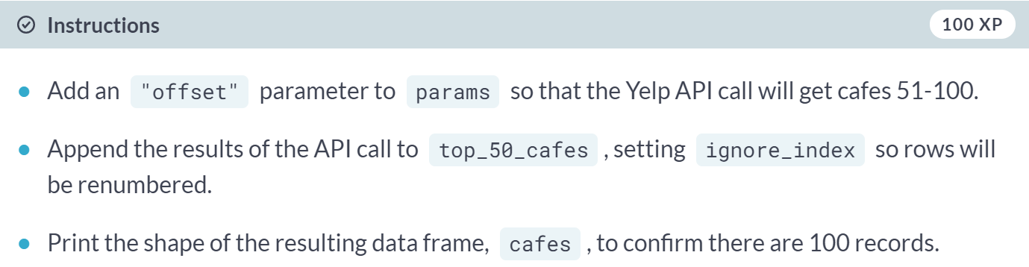

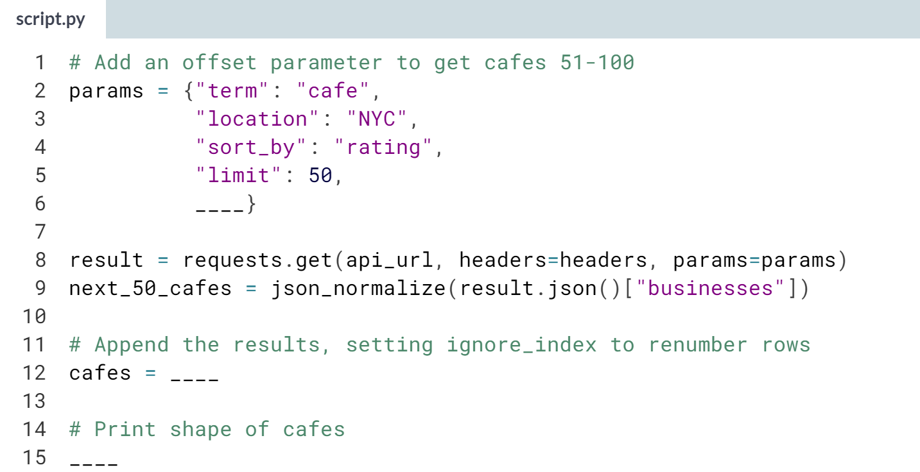

(Solution on the next page)

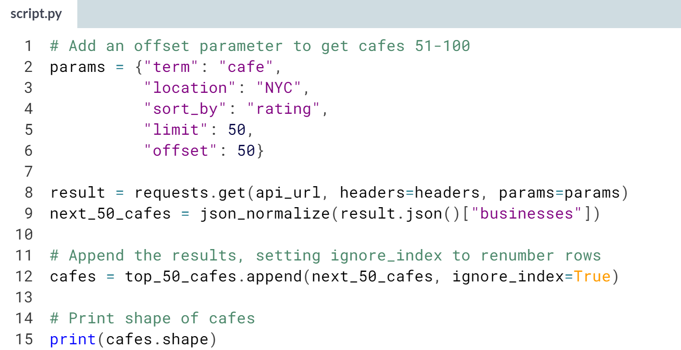

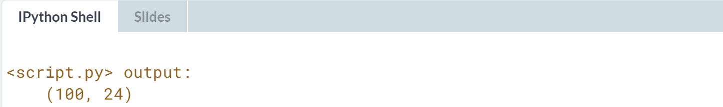  
Nice work! If you were putting multiple data frames together, one option would be to start with an empty data frame and use a for or while loop to append additional ones.

# Merge data frames

In the last exercise, you built a dataset of the top 100 cafes in New York City according to Yelp. Now, you'll combine that with demographic data to investigate which neighborhood has the most good cafes per capita.

To do this, you'll merge two datasets with the DataFrame merge() method. The first, crosswalk, is a crosswalk between ZIP codes and Public Use Micro Data Sample Areas (PUMAs), which are aggregates of census tracts and correspond roughly to NYC neighborhoods. Then, you'll merge in pop_data, which contains 2016 population estimates for each PUMA.

pandas (as pd) has been imported, as has the cafes data frame from last exercise.

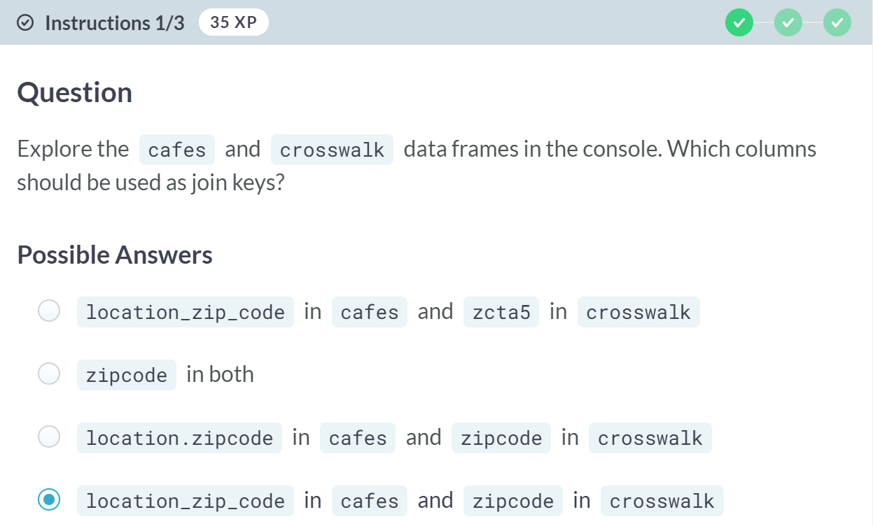

A: Nope! Datasets can have cryptic column names, but the ones we need to merge on are more clearly labeled.

B: Although we need to merge on ZIP code columns, they have different names in the two data frames.

C: Not quite. Pay close attention to the column names -- typos are a frustrating but common source of script errors.

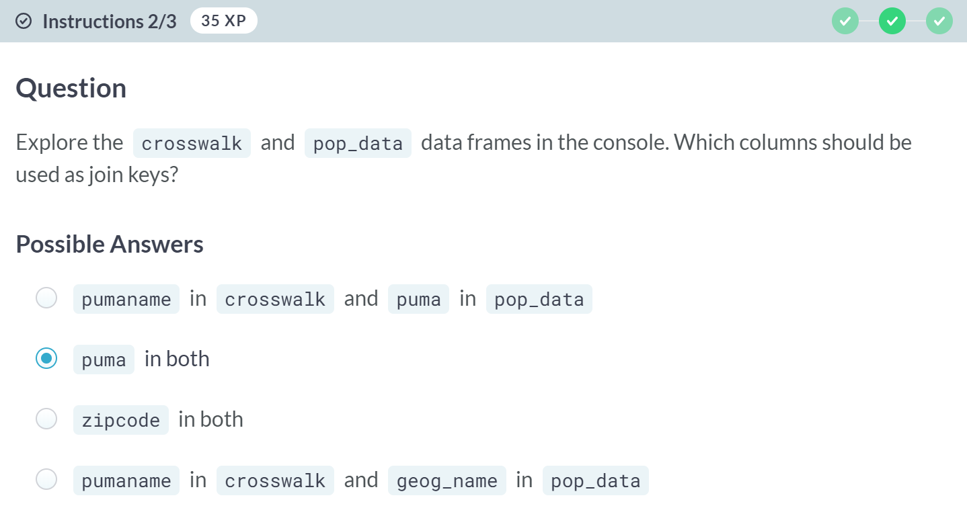

A: Try again. Both columns identify the same attribute, but one uses text names and another uses numeric codes.

C: *zipcode* was used to join cafe data to *crosswalk*, but the *population* data doesn't have a *ZIP code* column. We need another key.

D: Not quite. The values in *pumaname* and *geog_name* are similar, but not matching. Joining on them would give us an empty data frame.

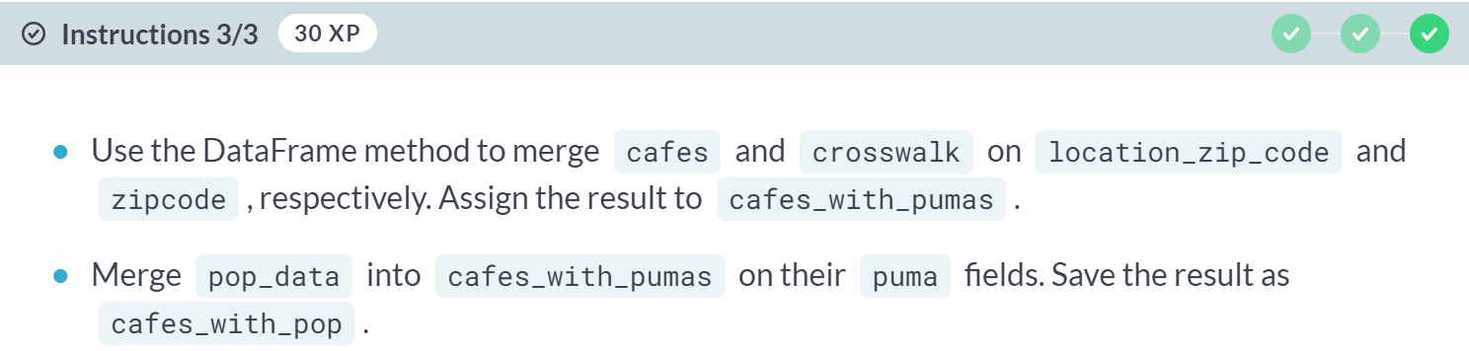

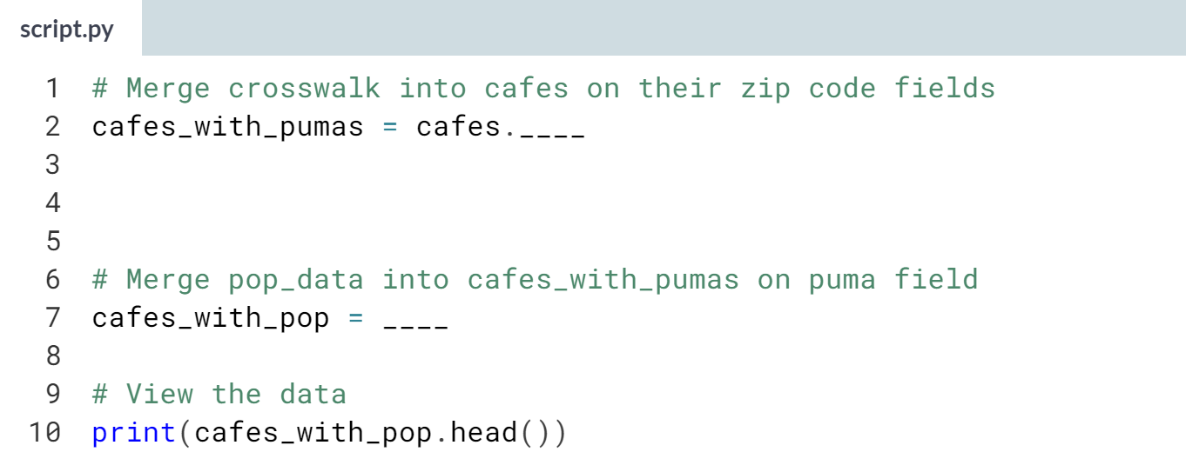

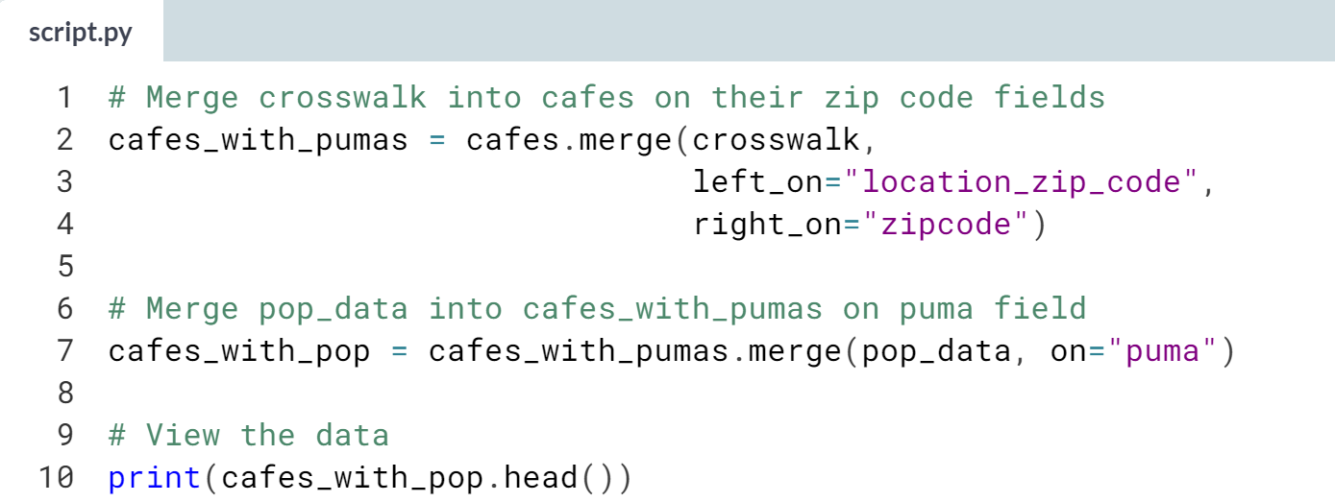

(Result on the next page)

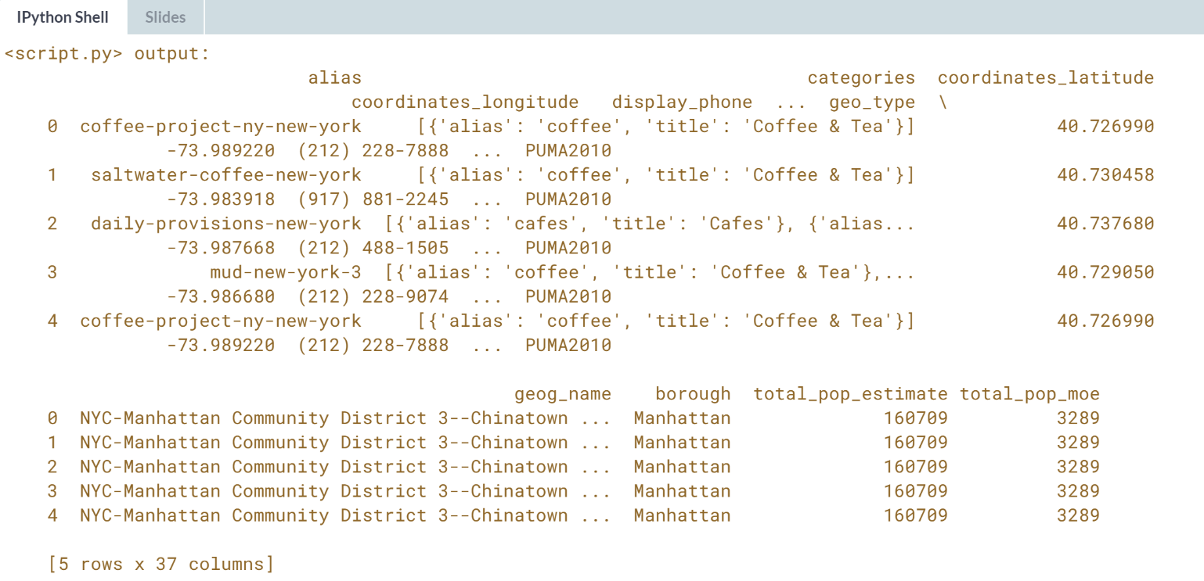  
Congratulations! You've built a pretty sophisticated pipeline that translates geographies to link data from multiple sources. While postal codes are a commonly used areal unit, there are often more meaningful ways to group spatial data, such as by neighborhood here.



